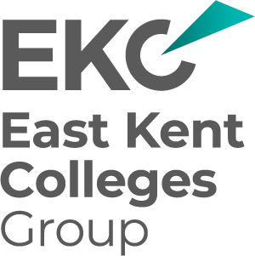
EKC Group – Tender for Legal Advice and Services
Tender Clarifications and Guidance 7
12 September 2025
We would like to raise the following queries in relation to the process and scope of work required:-

- Is the scope of the Tender to provide retained legal advice and services to the six community-based colleges and EKC Training only or does it extend to cover the schools within the EKC Schools Trust and the Nurseries within the Group?
EKC Group is one legal entity consisting of six community colleges, EKC Training and the nursery provisions within its purview. The retainer does not extend to or relate to EKC Schools Trust.

- In respect of Health & Safety advice please outline the type of advice you anticipate you would require and how that advice is currently provided to you.
The Health & Safety advice which may be required relates particularly to compliance with key legislation and regulations such as but not limited to: the Health and Safety at Work Act 1974 (HASAWA), Management of Health and Safety at Work Regulations 1999, Reporting of Injuries, Diseases and Dangerous Occurrences Regulations 2013 (RIDDOR), Control of Substances Hazardous to Health Regulations 2002 (COSHH), as well as, fire safety and other related issues pertaining to the management of commercial property.

_END_

