Natural England manages the Benacre National Nature Reserve, a site of 385ha in North East Suffolk
Easton Valley emergency overflow outfall installation TM 5185 9775

Background to the specific work area relevant to this purchase
At the current time the outfall at the southern end of Easton beach is not functioning effectively, to allow time for the longer term management to be investigated and actioned it is proposed to install a piped overflow through the beach as an emergency measure to both protect the habitat in the short term and allow measured decisions in the medium to longer term.

Requirement
Work will be carried out using a 360 degree tracked mechanical excavator of no more than 36 tonnes. The work will be carried out in October 2025 and the operation will last for no more than 7 days within the month.
The worksite consists of loose sand and sparse vegetation (15%) dominated by marram grass. The vegetation will be removed with the excavator bucket and put to one side, a trench excavated in 20 metre lengths will then have pipes levelled in and the material replaced with the vegetation replaced as the final part of the operation
3 x 600mm diameter twin wall pipes will be buried in the excavated trench through beach bank for a distance of 72m, to run from the existing dyke system to join with the beach at Mean High Water. Combined with a galvanised sloping weed screens on up-water end and galvanised bars to prevent entry at the outlet end.
The pipes will be installed in 10metres lengths set to drain the marsh levels to 150cm ODN, the pipes will not be connected to the remnant dyke system until all structures are installed and in place. To clear a further 100 metres of dyke vegetation to allow free movement of water to the new overflow outfall.
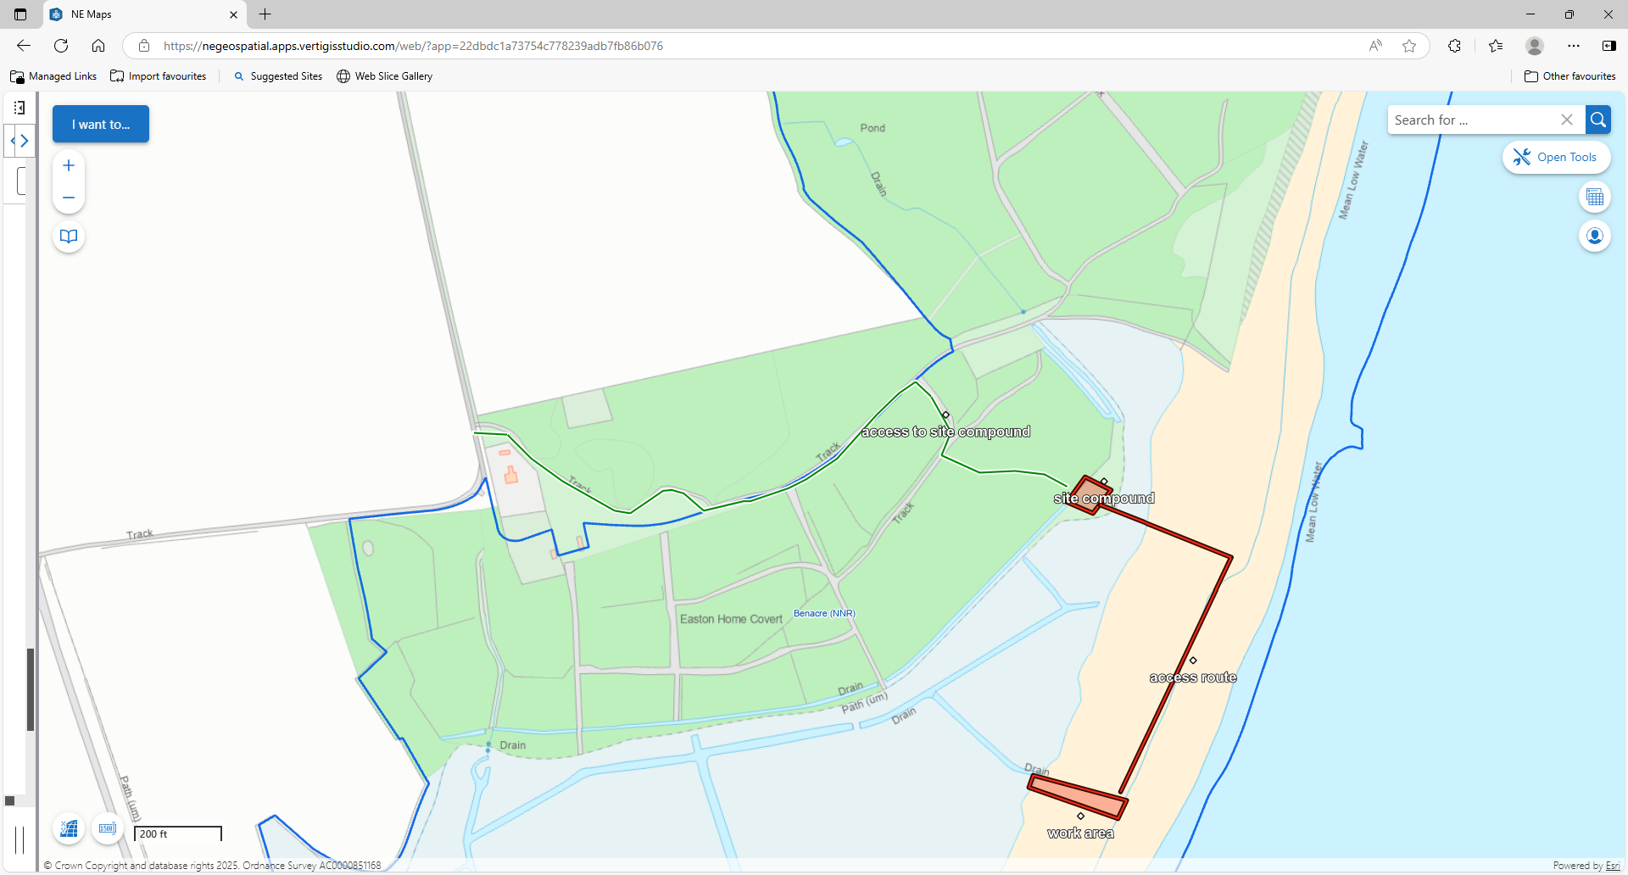
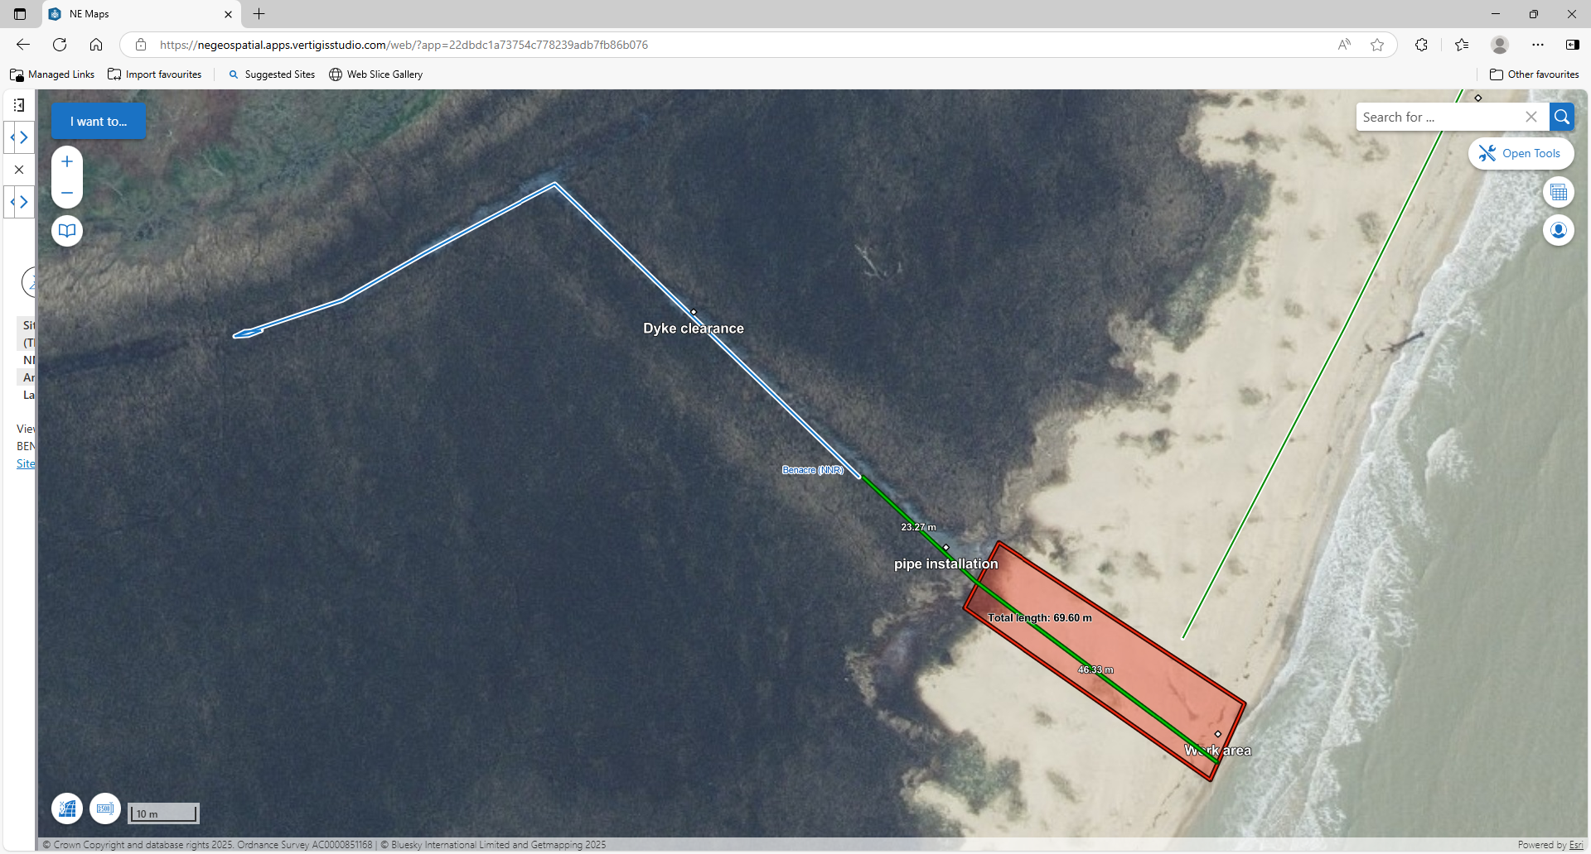

All works must be carried out in line with current CDM regulations.

Sustainability
Natural England protects and improves the environment and is committed to reducing the sustainability impacts of its activities directly and through its supply chains. We expect the Contractor to share this commitment and adopt a sound, proactive sustainable approach in keeping with the 25 yr environmental plan/our commitments compliant with all applicable legislation. This includes understanding and reducing direct and indirect sustainability impacts and realising opportunities, including but not restricted to; resilience to climate change, reducing greenhouse gas emissions, water use and quality, biosecurity, resource efficiency and waste, reducing the risk of pollution, biodiversity, modern slavery and equality, diversity & inclusion, negative community impacts.
As a delivery partner, the successful contractor is expected to pursue sustainability in their operations, thereby ensuring the Contracting Authority is not contracting with a supplier whose operational outputs run contrary to the Contracting Authority’s objectives. The successful contractor will need to approach the project with a focus on the entire life cycle of the project

Outputs and Contract Management

Reference | Deliverable | Responsible Party | Date of completion
 | Installation of pipes | Contractor | End October 2025

