**Installation of emergency overflow outfall in the Easton Valley**

**Background**

The Easton valley is currently the second largest reedbed in the UK and supports breeding and wintering bittern and marsh harriers (SPA). The saline lagoon supports starlet sea anemone, lagoon cockle and sand lagoon shrimp (SAC). The valley has a salinity and height gradient along its length from saline lagoons at sea level in the east to freshwater, floristically rich grazing meadows at its most landward extent, 140ha are phragmites dominated reedbeds.

The valley where it meets the sea has been subject to erosive processes for some time which have been particularly extreme over the last half century with rate of 8 to 10 meters a year, 41.86ha of the valley is expected to be lost to the sea by 2055. Because of the rapidly changing nature of the coast, water level control at the beach is difficult and without any functioning structures inland maintenance of these is characterised by periodic catastrophic failure which adversely affects the nature conservation interest of the site as well as flooding the B1127 road which crosses the lower part of the valley. Lack of water level control has also contributed to compromised delivery of the six agri environment schemes within the valley.

Since the 1950s the water levels in the Easton valley have been controlled by managing an outfall at the northern end of the North Warren, over time as the coast has retreated the outfall has also migrated inland being opened as required, usually mechanically. During this time the beach has periodically been overtopped by tides and on occasion has breached causing the water over the 140ha of reedbed to drain. If the outfall is not flowing freshwater can build up overtopping the beach from the landward side, the subsequent flow can then cut a channel again leading to the loss of the water across the valley. Should the breach not seal through coastal processes the lower part of the valley to Potters Bridge becomes tidal, the higher valley has no separate water control structure and so becomes dry, damaging the SSSI, SPA and SAC interests.

1954 2023

**Proposal**

At the current time the outfall at the southern end of Easton beach is not functioning effectively, to allow time for the longer term management to be investigated and actioned it is proposed to install a piped overflow through the beach as an emergency measure to both protect the habitat in the short term and allow measured decisions in the medium to longer term.

Easton valley

Proposed site of emergency overflow

**Rationale**

As the beach rolls back filling the current outfall channel it becomes increasingly challenging to keep this waterway open, when it blocks for long periods of time the freshwater build up can overtop the beach, cutting a channel and lead to a catastrophic emptying of the valley, and tidal conditions in the valley up to and including the B1127 road. To alleviate this problem an emergency overflow will be installed at a more accessible point in the frontage (TM 5185 9775). Pipes will be placed through the beach and connected to the existing dyke system, when water levels in the valley reach the desired maximum (probably 140cmODN) these pipes will provide additional capacity for water to exit the system, they will work in addition and independently to the existing outfall. The expectation is that the additional drainage will allow a return to water levels which support breeding bittern and marsh harrier and allow the B1127 to remain open except in the most extreme conditions.

**Design**

Install 3 x 600mm diameter twin wall pipes through beach bank for a distance of 70m, level to be set. To run from the existing dyke system to join with the beach at Mean High Water. Combined with a galvanised sloping weed screens on up-water end and galvanised bars to prevent entry at the outlet end. To clear a further 100metres of dyke vegetation to allow free movement of water to the new overflow outfall.

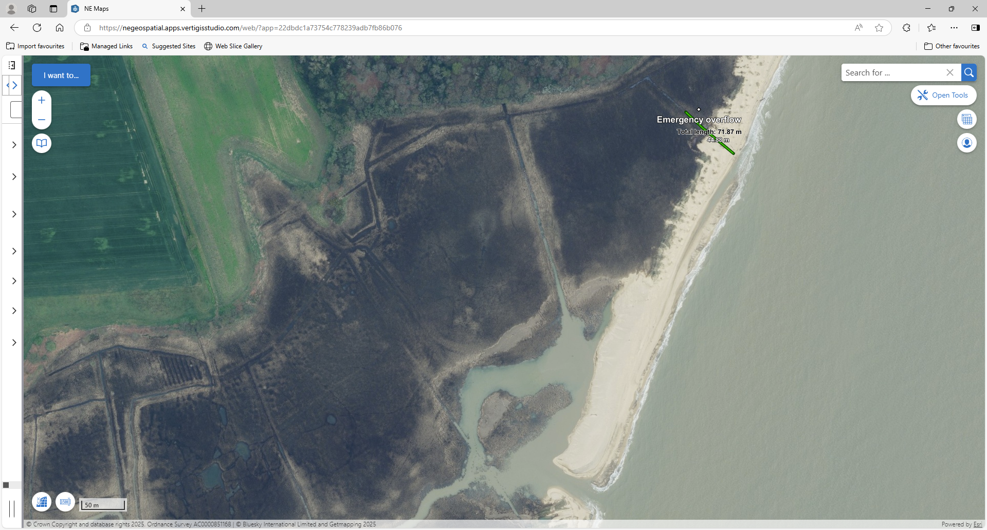

**Timing**

The be installed during October 2025

**Access**

