Thorpe Marriott Green Play Area Site Location Plan

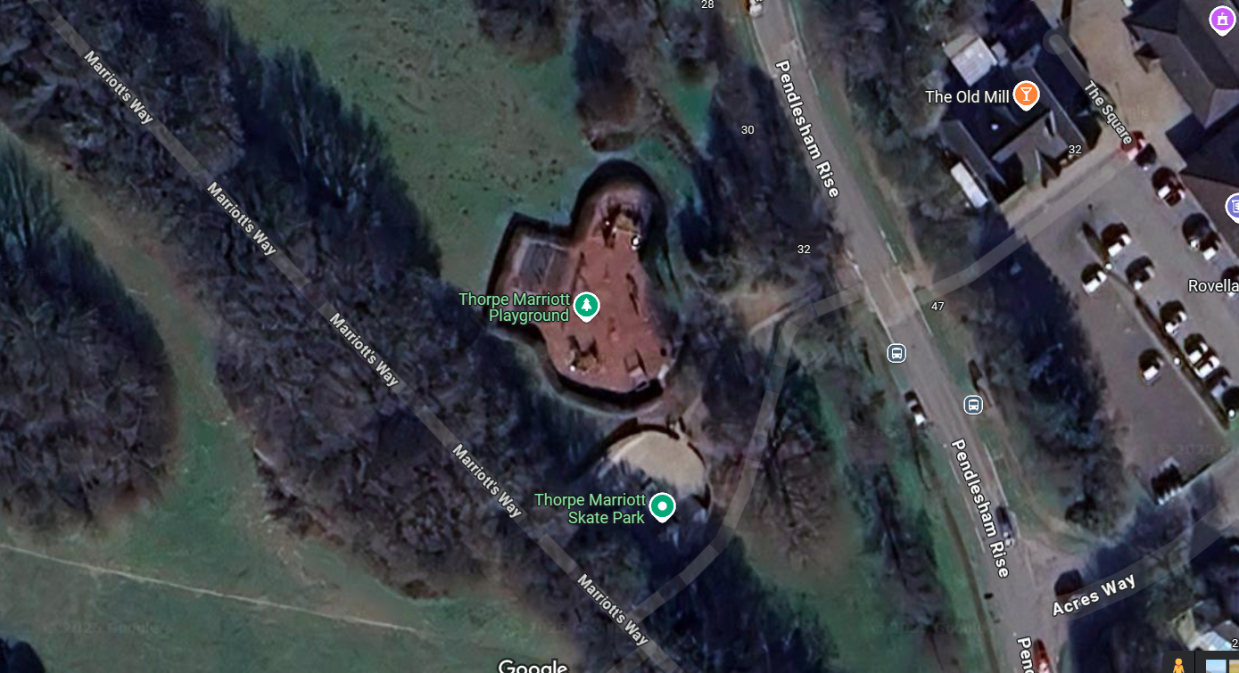

Aerial view of site

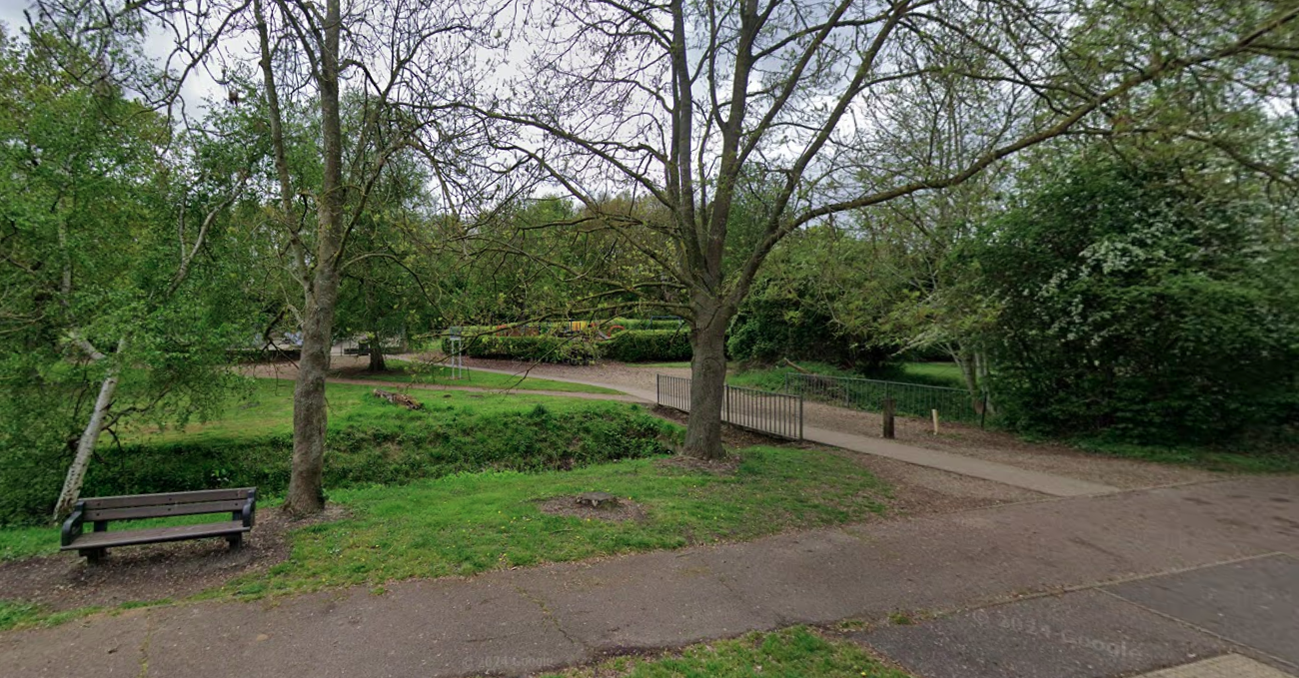

Street view of site

