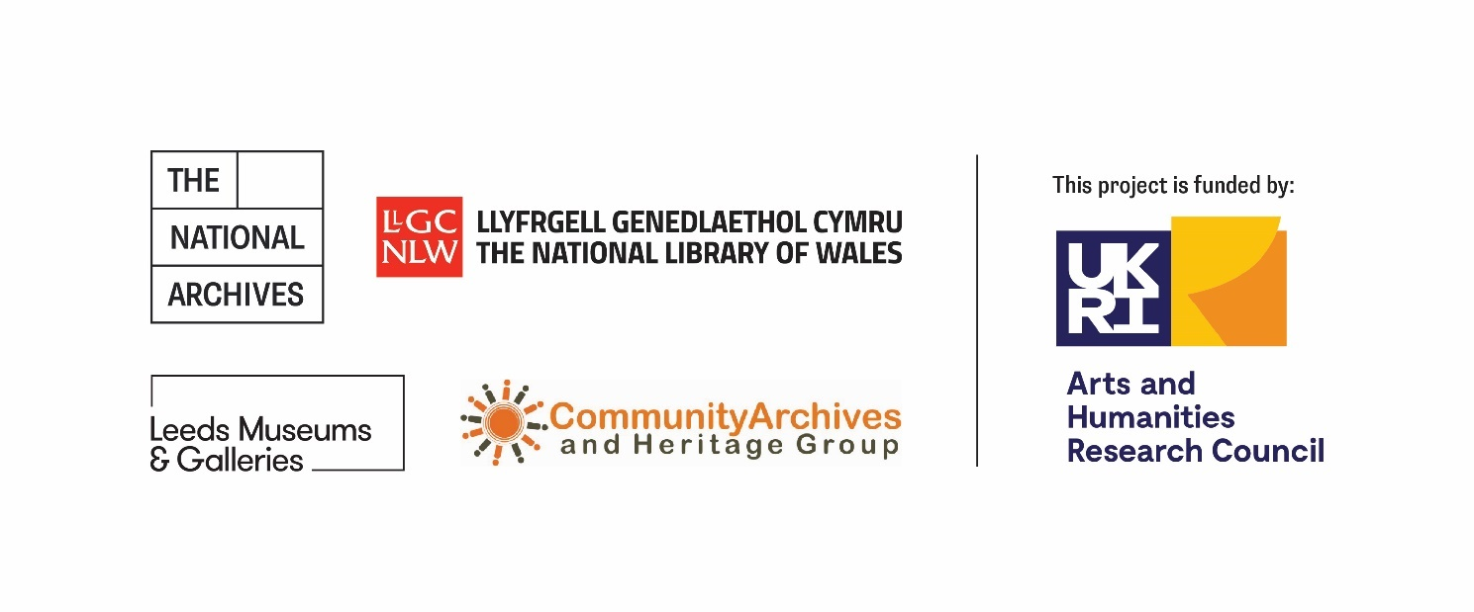

Invitation to Tender

Title: Evaluation of the ‘Spaces, Places and Belonging’ Community Hub 2025 - 2027
Date of Issue: 5th September 2025
Deadline for Receipt of Tenders: 24th October 2025
Return to: procurement@nationalarchives.gov.uk
Organisation: The National Archives, Kew, Richmond TW9 4DU
Website: The National Archives

Contents

1. Introduction 3
2. Overview 3
2.1 The National Archives 3
2.2 The ‘Spaces, Places and Belonging’ Community Hub 3
3. Evaluation aims and purpose 5
4. Stakeholders 5
5. Outputs / Deliverables 6
6. Indicative Timeline 7
7. Methodology 7
7.1 Outline 7
7.2 Skills 8
7.3 Our Values 9
8. Contract Management 9
8.1 Contract Details 9
8.2 How to respond 10
9. Evaluation Criteria 11
10. Procurement Timetable 13
11. Contract Terms 13
Appendix 1: ‘Spaces, Places and Belonging’ Community Hub Logic Model 14

1. Introduction
The purpose of this procurement process is to select a supplier to evaluate the AHRC-funded ‘Spaces, Places and Belonging’ Community Hub between 2025 and 2027. This invitation to tender outlines the requirements for potential suppliers.

2. Overview

2.1 The National Archives
The National Archives is a non-ministerial department, and the official archive and publisher for the UK Government. We are the guardians of over 1,000 years of iconic national documents, expert advisers in information and records management, and are a cultural, academic and heritage institution.
We also fulfil the leadership role for archives in England and have wider responsibilities for (c. 2,500) archives across the UK. To deliver our leadership role, we have provided grant funding to the archive sector, through open, competitive grant programmes, for over 15 years.
As an Independent Research Organisation, we are eligible to hold UKRI funding in the same manner as a university and have a large (c. £15m) portfolio of funded research and heritage projects, from the Arts and Humanities Research Council, National Lottery Heritage Fund, and other funders. Our areas of research focus are set out in our Research Vision.

2.2 The ‘Spaces, Places and Belonging’ Community Hub
The ‘Spaces, Places and Belonging’ Community Hub is a new national programme led by The National Archives in partnership with Leeds Museums & Galleries, the National Library of Wales, and the Community Archives & Heritage Group.
Funded by the AHRC (UKRI), the Hub will support inclusive, community-led research across the UK’s galleries, libraries, archives, and museums (GLAM) and heritage sectors.
It will offer three grant schemes – Seed Corn Grants, Skills Bursaries, and Project Grants – totalling £550,000, alongside a programme of training, digital skills development, and network-building. The Hub will also create a permanent digital platform to share resources, learning, and best practice, ensuring that community engagement becomes a lasting part of the national collection.
Designed to empower underrepresented communities and build confidence across the sector, the Hub will be a collaborative, flexible, and sustainable space for innovation and inclusion.
The Hub has four work packages:
- Work Package 1: grant-giving
- Work Package 2: skills-building, training, network formation and sector development
- Work Package 3: digital platform
- Work Package 4: evaluation, communication and future fundraising
The Hub builds on the work of two pilot projects, which each tested the delivery model of delivering community-led research through non-IRO cultural institutions. More information about the call for funding, including evaluation reports of the two pilot projects, can be found here: AHRC Community-led Heritage Research and Skills Hub – UKRI
The aims of the Community Hub are to:
1. Include: support GLAM sector organisations to interact with a wider range of audiences, including communities of all backgrounds, crossing lines of race, gender, class and sexuality, to connect, collaborate and interact.
2. Gather: address key gaps in the current provision made for community engagement across the GLAM sector, by providing a digital platform to harness existing know-how, resources and practice. Evaluation of the pilot projects suggested that the same learning continues to be repeated within the wider sector, with no effective vector to share or transmit learning or bring together practitioners. Provision of a central platform will remedy this gap.
3. Upskill: both evaluations mentioned the challenges in recruiting participants and in “demystifying research”. We will build networks and skills, fostering learning and the sharing of experience and expertise, and reducing repetition between and across GLAM sectors. We would build training packages and resources where necessary, building both capacity and confidence. Ultimately, we would like to cascade learning through a ‘train the trainer’ model for community-led research.
4. Resource: each pilot Hub evaluation mentioned the challenges of compressed timescales, lack of flexibility, low or no remuneration, and limited Hub support. We will generously and flexibly resource projects, evaluate them and feed their outputs into the proposed knowledge bank, ensuring their legacy, and fundraise for further funding of the Hub and to encourage projects to be taken forward to other funders.

We will partner with an evaluator throughout the lifetime of the programme (2025-27), to embed monitoring, evaluation, reporting and learning activity longitudinally throughout the programme’s delivery phase.
Further detail about the Community Hub programme can be found on the programme website: Community Hub - Portals.

3. Evaluation aims and purpose
The Community Hub team is seeking an evaluation partner to help us understand the (direct and indirect) impacts of the programme, explore the process of funding and training provision, and the contribution that the fund makes to defined outcomes and goals for its stakeholders.
This summative evaluation should gather learning about the programme as a whole, including both the grants awarded and the associated sector development activity. We want to develop our understanding of our grantees and applicants’ experience with the programme; consult with the GLAM (Galleries, Libraries, Archives and Museums) and heritage sector(s) and key stakeholders, generating quantitative and qualitative data to support its evolution and refinement; and create advocacy and knowledge products for the sector(s), and for existing and potentially future funders.
There are a variety of stakeholders who are potential audiences for the evaluation, and we
have listed these in the table below. The evaluation supplier should propose methods, measures and outcomes that relate to the aims of the stakeholder groups, and that are realistic and proportionate to the size of the grants offered and to the capacity of the cultural heritage sector. These should be shaped into an ambitious but viable evaluation plan.
The programme’s existing logic model is included as Appendix 1.
The evaluation will be used to:
- produce reliable and useful information to inform decision-making
- iteratively improve the programme’s delivery during implementation
- inform future funding provision and
- support advocacy for the fund and sector(s).

4. Stakeholders
Key to the evaluation process will be a participatory approach which values and understands programme stakeholders’ needs and desired outcomes. This list is not intended to be exhaustive, but key stakeholders may include:
Stakeholder
The delivery partnership (The National Archives, Leeds Museums & Galleries, the National Library of Wales, and the Community Archives & Heritage Group.)
The funder (the Arts and Humanities Research Council)
The cultural heritage sector, including particularly galleries, libraries, museums and archives which are not Independent Research Organisations
Community heritage groups and practitioners
Future funders
The capacity of grantees, including both non-IRO cultural heritage organisations and community heritage groups, is likely to vary widely. We are therefore looking for evaluators to engage with grantees to identify suitable measures and outcomes for individual projects and services. We would also like to support grantees to build in measures relevant to their own strategic objectives where possible.

5. Outputs / Deliverables
We expect the following key deliverables to be produced by the chosen supplier:
- (a) development of a monitoring and evaluation framework including agreed outcomes, evaluation methods and measures for the programme, and viable evaluation question sets for grantees to complete, with a plan for data analysis. The project’s logic model may be adapted as part of this work (March 2026)
(b) a baseline report, working with existing data to create baselines from which to measure impact (March 2026)
- A light-touch mid-term report, including results from stakeholder engagement, data analysis and recommendations for ongoing project delivery (December 2026);
- A final report detailing the impacts of funding, lessons learned, recommendations and proposals for the programme’s sustainability and future (December 2027);
in addition to ongoing consultation with the Community Hub team, key stakeholders and grantees.
Each report must be an honest, independent and practical assessment of the project, capturing both its successes and failures. Reports must be written in an accessible format, with the expectation that they will be made available publicly. The report’s format and content will be agreed in advance with the programme team.
For the avoidance of doubt, the copyright and IP in any evaluation outputs will be owned by The National Archives, however the chosen evaluation partner will be appropriately credited as the author of any material produced by them, wherever it appears.

6. Indicative Timeline
Indicative milestones for the evaluation are outlined below, subject to discussion with the chosen supplier before work begins:
- December 2025: supplier selected.
- December 2025 - March 2026: development of KPIs, agreed outcomes, evaluation methods and measures, including question sets for grantees to complete with a plan for data analysis.
- March 2026: submission of a monitoring and evaluation framework and baseline report, including the above.
- April 2026 - December 2026: data gathering, capacity-building (e.g. providing training and guidance), creation of case studies, and observation of processes to suggest improvements to operational delivery (Phase 1).
- December 2026: light-touch mid-term report.
- January 2027 - October 2027: data gathering, capacity-building (e.g. providing training and guidance), creation of case studies, and observation of processes to suggest improvements to operational delivery (Phase 2).
- December 2027: submission of a comprehensive final report, exploring the direct and indirect outcomes of grant funding and associated sector development work through mixed-methods analysis.

7. Methodology

7.1 Outline
Potential suppliers should set out proposals that will meet the aims of the brief and deliverables as set out in Sections 1-6 of this Invitation to Tender. We envision that, given the breadth of the brief and the longitudinal nature of the evaluation, a number of different methodologies will be deployed in a mixed-methods evaluation that generates both quantitative and qualitative evidence. We are open to discussing different methods of data capture.
Given the size of our sectors and number of grantees, sampling or surveys will need to be managed appropriately by the supplier. Your proposal should provide detail on your approach to sampling and data collection including information rights - in particular data protection - and analysis. You should also detail how you will manage ethics in research, ensuring that work with be conducted in a way that minimises harm and risks.
In completing their evaluation, providers may want to use:
- Grant applications, supporting documents, case papers or the minutes of the grant panels;
- Materials generated by funded projects;
- Monitoring data recorded over the delivery period;
- Social media and other online outputs created by grantees throughout the project;
- Observational reflections of the assessment and awarding process;
- Visits to projects and events associated with the Community Hub programme;
- Consultations and interviews with the programme’s management function (including its Advisory Board), funders, applicants and grantees including operational staff and volunteers, as well as other key stakeholders as directed by the funders;
- Feedback from project and other stakeholder meetings;
- Any other evidence, information or data gathered directly by the supplier.
Suppliers should be conscious of the requirement to evaluate the programme’s package of sector development, training, mentoring and communications, as well as the funded projects delivered by our grantees.
The suppliers will work closely with the Community Hub Principal Investigator, Co-Investigators and Hub Manager throughout, with the Community Hub Manager acting as lead officer for the delivery of the contract.
The National Archives will:
- provide the chosen supplier with access to relevant literature, research reports and data that it holds;
- support the chosen supplier in sampling and identifying stakeholders and interviewees, using its existing sector knowledge and segmentation, and its stakeholder mapping;
- act as a point of liaison between the chosen supplier and its funders, stakeholders, partners, grantees and the wider cultural heritage sector(s), where necessary.

7.2 Skills
The successful supplier should possess, or be able to access, the specialist knowledge, skills and expertise required to deliver this work.
This must include:
- Experience in developing and implementing monitoring, evaluation systems and frameworks.
- Experience of analysing monitoring, evaluation and impact assessment data to draw meaningful conclusions and reports.
- Understanding of Theory of Change and the logic-model approach to evaluation.
- Knowledge of methodologies for evidence metrics in the creative and cultural sectors (collection, analysis and dissemination).
- Facilitation and consultation skills, including conducting purposeful interviews.
- Research and analytical skills.
- Previous experience of supporting programmatic development.
- Expertise in presenting complex data in a compelling manner.
- Knowledge of or a willingness to learn about the archive sector.
- Strong report writing, presentation writing and presentation delivery skills to engage a wide range of internal and external stakeholders.

7.3 Our Values
The Community Hub project will be offering funding and training to a wide range of stakeholders. This will include small cultural institutions, community heritage groups, and individual practitioners.
We recognise, as part of our funding practice, that these stakeholders often exist in resource-poor environments. Cultural institutions may have limited budgets, and community groups may be entirely volunteer-run and led. Individuals may be unwaged and/or in receipt of benefits.
We also recognise that we are working with stakeholders who may have been traditionally excluded from cultural heritage programmes and funding. This may include stakeholders with protected characteristics as defined by the Equalities Act 2010, who may have been traditionally underrepresented in cultural heritage practice and collections, and/or who may have never applied for a grant or participated in a funded project.
Our programme has at its core the value of respect for all of our stakeholders, including respect for their expertise and skills in preserving, managing and researching their own heritage. We are here to learn from them, as much as we are here to provide training and financial resource.
Any evaluation should place these values at its core, making clear how any evaluative activity including data collection is (a) proportional to the capacity of relevant stakeholders and (b) sensitive to the cultural contexts in which it is operating.
We would welcome submissions which engage with these values, for example by proposing capacity-building or training with our stakeholders; or which use co-production / co-design to determine evaluative methods and measures; or which can incorporate differing forms of data collection, e.g. through audio or video submissions from grantees.

8. Contract Management

8.1 Contract Details
The contract period will be from December 2025 to the programme’s closure in December 2027.
The budget for evaluation will be £37,553 over the 24-month period inclusive of VAT, travel and all other expenses.
The day-to-day management of the evaluation will be led by The National Archives, with the appointed organisation also having accountability to partners and to the Arts and Humanities Research Council as the programme’s funder.
Payments may be linked to milestone delivery, and an indicative payment schedule is included below – however, we are open to additional payment stages or other payment schedules, subject to negotiation with the chosen supplier:
- Contract signature – 10% contract value (December 2025)
- Client approval of the monitoring and evaluation framework and baseline report – 30% contract value (March 2026)
- Delivery of a client-approved mid-term report – 25% contract value (December 2026)
- Delivery of a client-approved final report – 35% contract value (December 2027)

8.2 How to respond
If you have any clarification questions related to your Tender Response, please submit these to procurement@nationalarchives.gov.uk by 5pm, Wednesday 1st October.
Please submit your Tender Response to procurement@nationalarchives.gov.uk by 5pm, Friday 24th October.
It is for you to determine what format your Tender Response should take, so as to describe your offer in a clear, comprehensive fashion. However please ensure that your Tender Response includes the following as a minimum:
- Methodology and timeframe: provide a project proposal outlining in detail the approach, methodology and timeframe you would propose to deliver this project and engage with the internal project team.
- Team composition: please explain your experience in providing similar services and provide at least two examples of recent outputs and evaluation reports. These will only be used for assessing suppliers as part of the evaluation process.
- Experience: please explain your track record in the provision of monitoring and evaluation services; how this aligns with the heritage sector and with our programme’s funding recipients; and provide examples of previous customers. Please include the contact details of one relevant organisation from whom we can obtain a telephone or written reference, should we choose to do so.
- Pricing: this should include whether VAT is included, a breakdown of each person working on the project and what their day rates are, as well as how many days each member of the team will be allocated, as well as any budgeted expenses.

9. Evaluation Criteria
Your Tender Response will be evaluated using the following criteria:
Criteria | Maximum available unweighted score | Weighting | Maximum available weighted score
Methodology and timeframe | 10 | x4 | 40
Team composition and management | 10 | x2 | 20
Experience in similar projects | 10 | x3 | 30
Pricing | 10 | x2 | 20
The bidder submitting the lowest price will be awarded the maximum of 10 (unweighted) points in the Pricing category. All other bidders will be awarded a (unweighted) points score by applying the following formula:

(lowest submitted price/bidder’s submitted price)*10

Other categories will be evaluated according to the table below, however a minimum unweighted score of at least 7 must be achieved against the ‘methodology and timeframe’ criterion, and a minimum unweighted score of at least 7 must be achieved against ‘experience in similar projects’, for the proposal for to be considered. Proposals that do not achieve these minimum scores will be considered a fail.

10 Points | Outstanding:  - Potential Supplier has provided a response that addresses all parts of the requirement  - Potential Supplier has provided evidence to support all elements of their response  - The evidence supplied is convincing and highly relevant to the requirement  - Potential Supplier’s response is clear and easy to understand  - Where relevant, Potential Supplier has demonstrated a high level of capability to deliver new and innovative service approaches
7 Points | Good:  - Potential Supplier has provided a response that addresses all parts of the requirement  - Potential Supplier has provided evidence to support most elements of their response  - The evidence supplied is good and relevant to the requirement  - Potential Supplier’s response is clear and easy to understand  - Where relevant, Potential Supplier has demonstrated some level of capability to deliver new and innovative service approaches
4 Points | Average:  - Potential Supplier has provided a response that addresses some parts of the requirement  - Potential Supplier has provided evidence to support some elements of their response, but not all  - The evidence supplied has some limited relevance to the requirement  - Potential Supplier’s response is not always clear and easy to understand  - Where relevant, Potential Supplier has demonstrated limited capability to deliver new and innovative service approaches
1 Point | Poor:  - Potential Supplier has provided a response that fails to address most parts of the requirement  - Potential Supplier has provided little or no evidence to support most elements of their response  - The evidence supplied is very weak and has very limited relevance to the requirement  - Potential Supplier’s response is not always clear and easy to understand  - Where relevant, Potential Supplier has demonstrated little or no capability to deliver new and innovative service approaches

The top three ranked bidders will be shortlisted for interview, as referred to in item 5 of the timetable below. Once these interviews have been completed, the shortlisted bidders’ submissions will be re-evaluated and a contract award decision made.

10. Procurement Timetable
The procurement timetable is as follows:
Ref | Description | Date
1 | Invitation to Tender published | Friday 5th September
2 | Deadline for Potential Suppliers to submit clarification questions to procurement@nationalarchives.gov.uk | 5pm, Wednesday 1st October
3 | Deadline for Potential Suppliers to submit Tender Responses to procurement@nationalarchives.gov.uk | Friday 24th October
4 | Evaluation of submissions completed | w/b 10th November
5 | Interviews with shortlisted suppliers | w/b 24th November
6 | Contract Award | December 2025
* Any clarification question received that TNA deems to be relevant to more than one Potential Supplier may be shared with all Potential Suppliers

11. Contract Terms
The contract will be awarded subject to our standard terms and conditions, which can be found at Information for our suppliers - The National Archives
The National Archives reserves the right not to award and to complete its objects through other means.

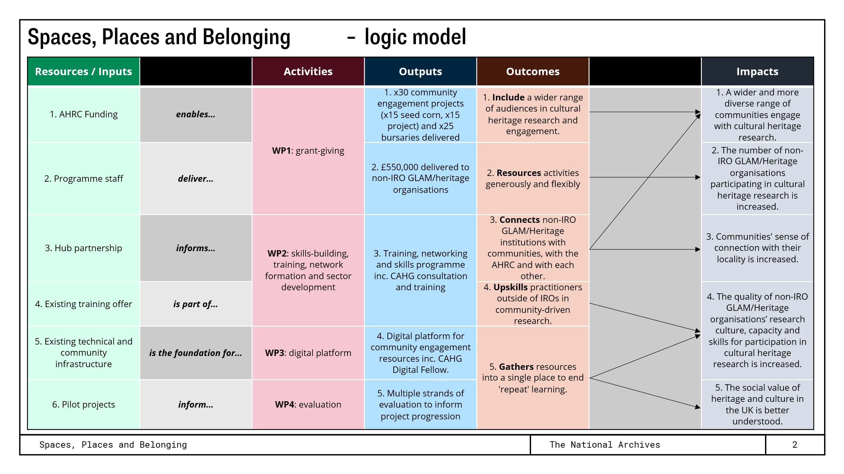
Appendix 1: ‘Spaces, Places and Belonging’ Community Hub Logic Model

