|  |  |  |
| --- | --- | --- |
| From: Jessica Harper | To: Haley Walker |  |
| Ref: MDDC202305-008B | Date:31/08/2025 |  |

**MDDC202305-008B – Access Control for Leisure Centres**

**Procedure: Open Tender**

**Public Procurement Reference: MDDC202305-008B**

**ProContract Reference: DN778230**

# Contract Details

|  |  |
| --- | --- |
| Department | Leisure Services |
| Contract Manager | Haley Walker |
| Procurement Officer | Jess Harper |
| Length of Contract | 48 months |
| Any Extensions | No extensions |
| Potential Start of contract | 25/08/2025 |
| Contract End date | 24/08/2029 |
| Annual Value | £30,000.00 |
| The total value of the contract is estimated at | £120,000.00 |
| Confirm contract type Goods/ Works/ Services. | Goods |
| CPV Code | 42961100 |
| Cost Code | CA655 |
| Finance Business Partner | Keiran Knowles |
| Confirm purchasing arrangements (lease/ contract hire/ outright purchase/ options for both) | Outright purchase |
| Which route to market is to be taken? | Open Tender |
| I**s the tender to be divided into Lots?** If so how many? (include headings/titles) ( Mandatory for Contracts Register) | No |
| Incumbent Supplier(s) | N/A |
| **Will the award need to go before Cabinet Y/N** (Contracts in excess of £250k will require approval by Cabinet) (or if the winning bid is more than 10% over the agreed budget) | No |

# Tender Background

# This tender is inviting providers of access control systems to respond to the requirements of Mid Devon District Council (MDDC) for installing access control points, for the Leisure Service, with continued support and maintenance service.

# Tender Information

Short-Form Terms and Conditions for the purchase of services are being used for this contract.

The weightings for this tender is 60% quality, 40% price

Certificates needed - NICEIC

Key words used – Access - Access Gate - Access Control - Security

Insurances required:

Employer’s (Compulsory) Liability Insurance = £5M

Product Liability Insurance = £100K

Haley Walker and Andy Mackie are to answer clarification questions via ProContract.

# TUPE Considerations

N/A

# Participating Authorities

N/A

# The Tender Process

A Tender Notice under PA23 was published on Monday 16th June 2025. A Tender advertisement was also placed in ProContract. The Invitation to Tender was issued via ProContract on Monday the 16th June 2025. The tender return deadline was Wednesday 23rd July 2025.

# Open Procedure Selection Criteria

The selection criteria published in the invitation to tender was as follows:

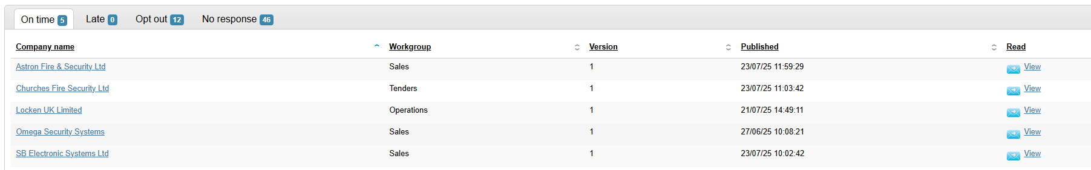



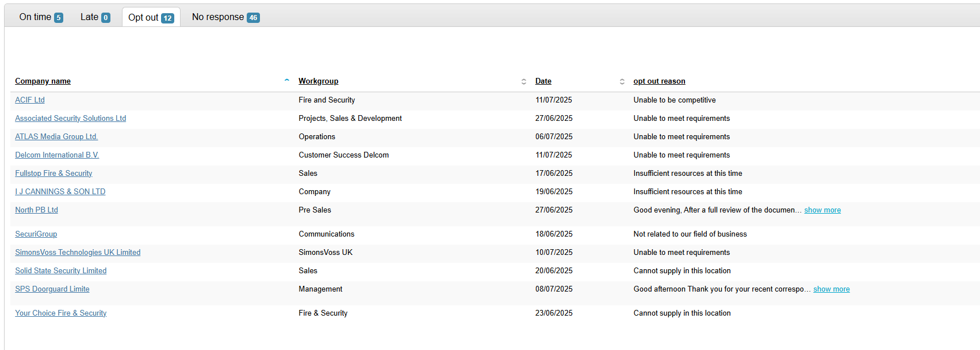

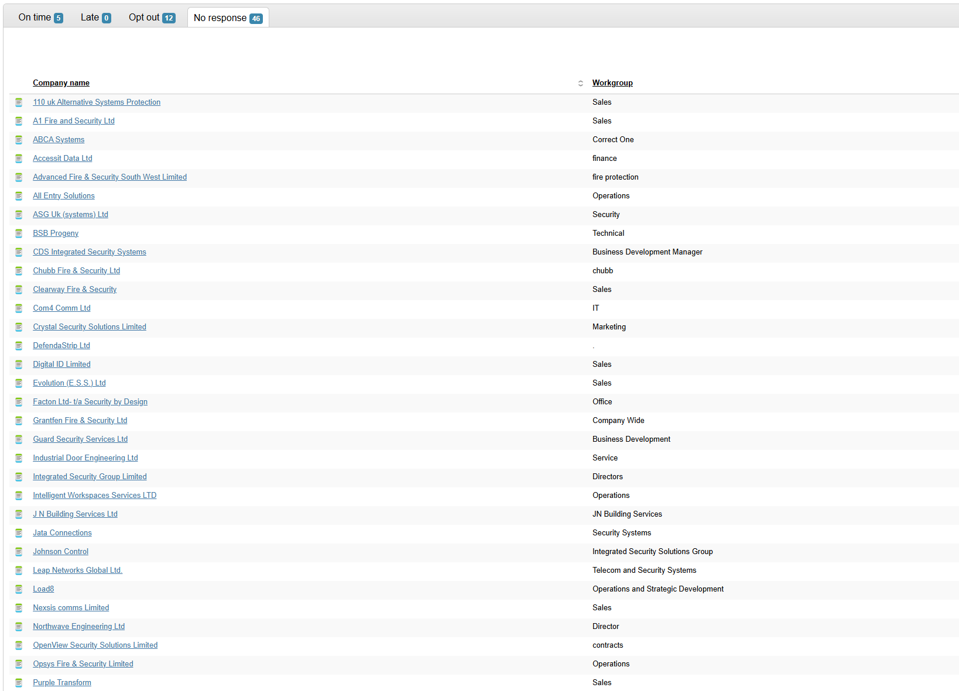

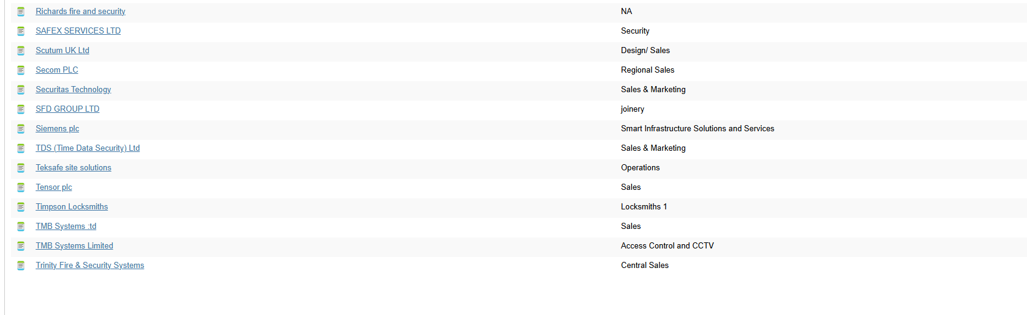

63 invitations to tender were issued.

5 candidates submitted a completed tender return:

* Astron Fire & Security Ltd
* Churches Fire Security Ltd
* Locken UK Limited
* Omega Security Systems
* SB Electronic Systems Ltd

Locken UK Ltd and SB Electronic Systems Ltd passed the suitability Assessment Questionnaire.

There were no late submissions.

Astron Fire & Security Ltd and Omega Security Systems were disqualified as they did not submit the completed ITT document.

Churches Fire Security Ltd were disqualified as their bid exceeded the budget which we stated in the tender documentation.

# Tender Evaluation

The tender evaluation panel consisted of:

* Haley Walker – Service Delivery Manager
* Andy Mackie – Leisure Services Manager
* Keith Ashton – Operations Manager for Corporate Property and Commercial Assets

**Tender Evaluation Process**

The evaluation was completed independently of each other and then they attended a moderation meeting (held by procurement) to agree a census score based on what they had all scored.

# Summary of Tenderers

Quality Scoring:





















Quality Scoring:

|  |  |  |
| --- | --- | --- |
| **Tenderer** | **Tendered Price** | **Score** |
| ISEO UKI Ltd | £100,219.00 | 39.86% |
| SB Electronic Systems Ltd | £99,867.00 | 40.00% |
|  |  |  |
| Lowest Tender |  | £99,867.00 |

Summary of the quality and price results and the overall outcome:



SB Electronic Systems Ltd have come out on top of the scoring in the combined scoring of quality and price so are the overall winner of the bid.

# Contract Award Recommendations

This paper recommends awarding the contract to SB Electronic Systems Ltd based upon them submitting the most economically advantageous tender as detailed above.

Approved by:-

Haley Walker

Service Delivery Manager

Leisure

Submitted for review by:-

Jessica Harper

Procurement and Contracts Officer

Finance