**Tender Notice for**

**The Provision of Leakage & Repair Products**

Issue Date: 21/08/2025

Closing Date and Time: 16/09/2025 - 5pm

**NGN Primary Contact:** Elle Flood

[eflood@northerngas.co.uk](mailto:eflood@northerngas.co.uk)

**NGN Secondary Contact:** Joanna Palmer

[jpalmer@northerngas.co.uk](mailto:jpalmer@northerngas.co.uk)

# Contents

Guidance. Please read carefully on how to proceed with event 3

Introduction…………………………………. 4

Northern Gas Networks Geographic Area 5

NGN Core Values 5

Scope of Requirements 6

# Guidance

This Tender Notice is issued by Northern Gas Networks (NGN) and is live until 16/09/2025 until 5pm.

The aim of this Tender Notice is to:

* Ensure we provide bidders with adequate information to determine if they wish to proceed with this tender event.

* Provide NGN with a more detailed understanding of the interest within the market.

The Tender Notice process is the first stage of multistage procurement process.

All interested suppliers must follow the below steps in order to proceed with the conditions of participation and PQQ stages of this procurement event:

Sign up or Sign in to NGNs Tendering Portal – Market Dojo. Follow this link to do so: [sign-up - Market Dojo](https://secure.marketdojo.com/signup)

When you have logged in to your dashboard, you'll need to click the '**Show all or enter invite code**' button under the Event Invitations section, as per below screenshot:

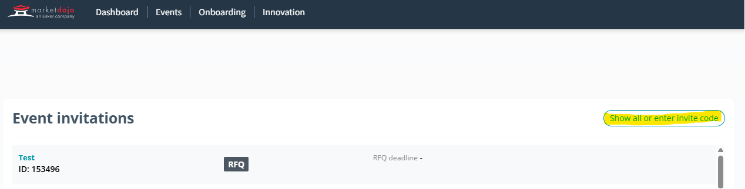

You’ll need to enter this code: **C9AAD9651A**

It will then notify NGN to approve you onto the tender event. Once approved you will be given access to the event, where you’ll be taken to the Conditions of Participation stage, this stage is a pass/fail and will be locked until after the 1st stage submission deadline. Any supplier who fails this stage will automatically be withdrawn from the process and will not gain access to the 1st stage of the event. All suppliers who pass this stage will be automatically taken to the 1st stage of the event (Accreditation Questionnaire) where they will be given a deadline and detail to complete.

Once the 1st stage has been evaluated by NGNs internal evaluation team all those who meet the criteria will be sent to the subsequent stages where NGN will assess against award criteria.

# Introduction

Northern Gas Networks Limited (NGN) is the company responsible for distributing gas to homes and businesses across the North of England. As part of the restructuring of the gas distribution business in England, NGN successfully acquired the North of England gas Distribution Network (DN) and took control of the assets on 1st June 2005. NGN has been responsible since then for the transportation of gas to the North of England via 36,000Km of pipelines.

The DN is located in the North of England and extends south from the Scottish border to South Yorkshire and has coastlines on both the East and West sides of the region. The DN contains a mixture of large cities such as Newcastle, Middlesbrough, Leeds and Bradford and a significant rural area including North Yorkshire and Cumbria. The area covers around 6.7 million inhabitants and has approximately 2.5 million customers. The DN is supplied via 23 off takes from the national Transmission System.

## Northern Gas Networks Geographic Area

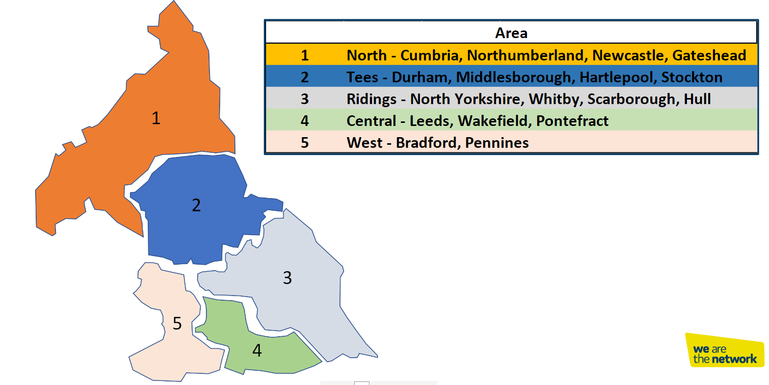

# NGN Core Values

NGNs dream is to become the UK’s most loved, admired and respected company, and to establish a reputation for doing business really well through a united and empowered team that is mind-blowingly great. We recognise the important role that our supply chain partners having in supporting NGN to achieve our dream.

Our dream lies at​​ the centre everything we do and has been translated into a unique set of values that reflect and reinforce our culture.

* Trailblazing
* Intellectually Curious
* Community Focused
* Empowered
* Heartfelt
* Happy

Every member of our team is passionate about the contribution they make to our growing reputation as a pioneering, effective, conscious and enlightened business that is focused on changing the way that things are done.

We expect our suppliers to share our vision and values and our way to support NGN in achieving our goals.

# 

# Scope of Requirements

**Overview**

Northern Gas Networks require multiple suppliers on a framework agreement to provide products that will be used throughout the NGN network.

The purpose of this framework is to ensure continuity of supply of the sealant and associated equipment to the business at agreed rates, lead times and to ensure products conform to the correct specification and standards.

Items under the framework agreement must meet the necessary Gas Industry Standards in line with all new guidance and standards published.

The suite of products required have been split into 5 lots, indicated below:

**Lot 1 - Annular sealants**

This sealant material is for internal application of sealant materials (which may be applied externally, being pumped into the annulus from an external source) used to prevent the passage of gas along the annulus formed between an inserted plastic pipe and an existing metallic pipe.

**Lot 2 - Leakage Sealants**

Materials used to make a full permanent repair on either metallic or PE pipe by means of either internal or external application.

**Lot 3 - Bar Hole Sealing**

A bar hole is a hole made in the soil or pavement with a hand-operated bar for the specific purpose of testing the subsurface atmosphere with a combustible gas indicator. The Materials used to plug a hole following bar hole work to provide a full permanent seal of the surface.

**Lot 4 - Flow Stopping**

The objective is to temporarily stop the flow in a specific area of the network without disrupting the remainder of the local network.

**Lot 5 - Live Insertion**

Utilising a gland box, the old main is kept live throughout the insertion process and the new PE is gassed up to maintain gas supplies to individual customers. After the new main is inserted, the main is still kept live to supply customers via the annular space between the two mains until it is convenient to transfer the services to the new main

Suppliers are able to bid for any of the above lots.

Suppliers can bid for one, all or any number of lots they wish.

***A Product List can also be found in this tender package within the Market Dojo Documents section.***

It is at the discretion of NGN to amend requirements of the scope if there is a need to do so. Any changes to the scope will be communicated to all Bidders.

*Please note that substantial amendments will not be made.*