Warminster Town Council

Invitation to Tender for Pavilion Café Concession

# 2026 – 2029 (option to extend to 2031)

## Pavilion Café Concession

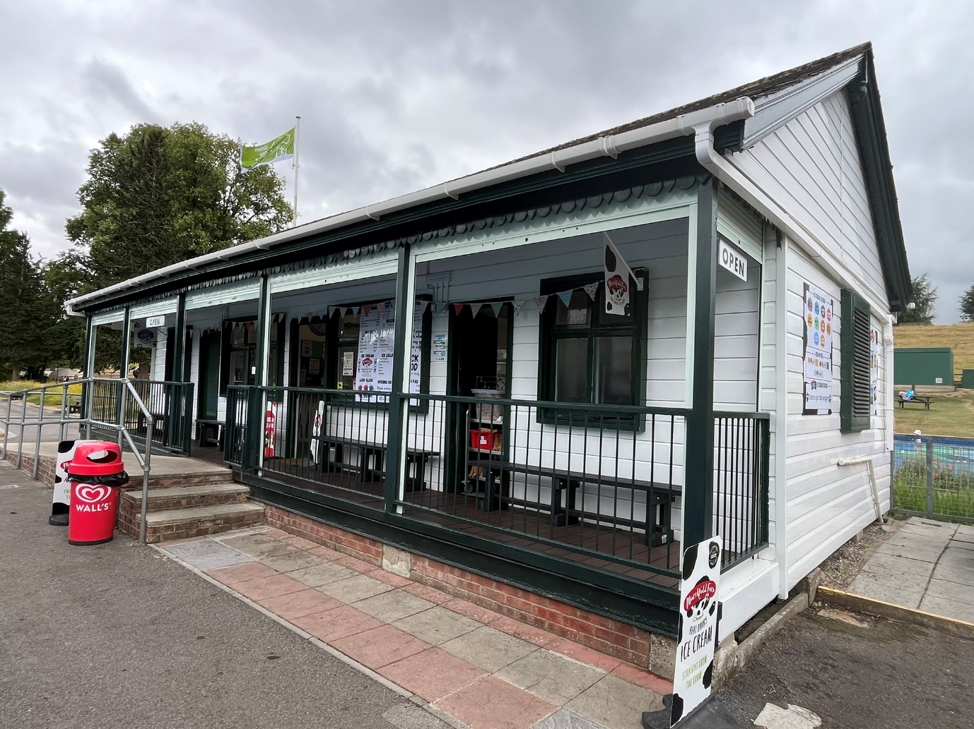

Introduction

Warminster Town Council are inviting tenders from competent interested parties to lease the Pavilion Café in the Lake Pleasure Grounds, Warminster. Tenderers will be asked to submit a comprehensive business plan.

Location

The Pavilion Café is centrally located in the Lake Pleasure Grounds close to the play area and tennis courts.

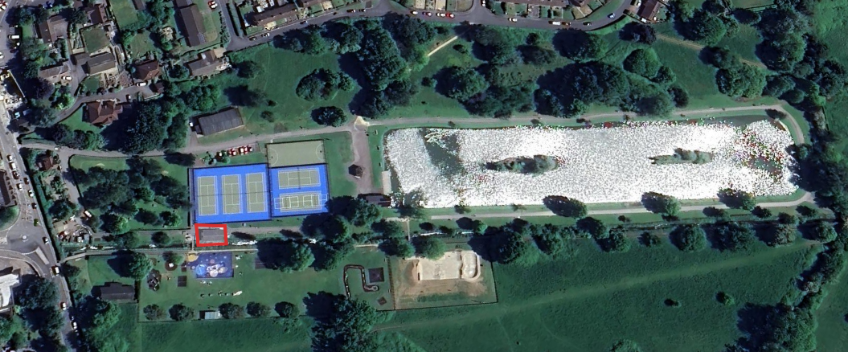

### History

The Warminster Lake Pleasure Grounds have been a cherished recreational area for the local community for many years. Opened in 1924 the Lake Pleasure Grounds has always been at the heart of the town. The Pavilion Café, situated within the Lake Pleasure Grounds, has a rich history dating back to its original function as a tennis pavilion. The café building has seen various uses over the decades, and its current role is to provide refreshments and a welcoming space for visitors to the park.

### Development of the Café and Lake Pleasure Grounds

In recent years, Warminster Town Council has undertaken efforts to refurbish and revitalize the Pavilion Café to better serve the community and enhance the visitor experience at the Lake Pleasure Grounds. The town council has spent close to £1 million in the Lake Pleasure Grounds since 2018 and has plans to spend a further £2 million in the coming years. With the recent addition of a new skate park and splash pad, as well as the refurbishment on the tennis courts the Lake Pleasure Grounds is a destination for many residents and visitors from out of town.

Events

The Lake Pleasure Grounds holds many events every year. The list of events in 2025 is attached. See appendix A.

## Facilities

### Kitchen

The café is equipped with a small kitchen, including stainless steel sink with drainer, separate handwash sink, mobile base unit, base units with roll over worktop with space for a under counter fridge and wall mounted shelving units.

A selection of fridges and freezers (both display and storage) are available to purchase by separate negotiation. See appendix B

Storage area

There are two storage rooms within the café. One larger room off the main café area with a smaller room off this.

## Outdoor Seating

Close to the café there is the parks picnic area with picnic benches, as well as bench seating throughout the park.

## Toilets

A toilet in the pavilion. Public seasonal toilets are available next door to the café with further toilets available at the Boathouse.

## Water supply

Water cost is included.

## Electric Supply

The successful applicant will be charged £0.586 per kWh for electricity used at the café, a rate tied to the council's current contract until 2026. Once a new contract is signed, the updated cost will be passed on to the winning tenderer. The council will deduct electricity supplied from the café to the unmetered seasonal toilets next door (6.32kWh per day)

## Refuse

The successful applicant will need to put in place their own waste management agreement. (The town council will provide an area within the park compound for bin storage.)

## Outside Space

There is no outside space for café furniture apart from the café veranda.

## Car Parking

There is limited parking within the Lake Pleasure Grounds. There is no dedicated staff parking. Delivery times can be arranged with town council staff.

## Financial Information

The Pavilion Café will be closed from October 2025. All current staff are on fixed term or casual contracts therefore TUPE rules will not apply.

### Key Annual Financials (net)

* Current rateable value (1 April 2023 to present): £6,900
* Gross Income / Turnover 2022/23: £103,069
* Gross Income / Turnover 2023/24: £96,761
* Gross Income / Turnover 2024/25: £100,599

Timeline

w/c 18th August 2025 tender documents made available

12.00 noon, Friday 31st October tender closes.

Tuesday 19th November selected tender interviews.

w/c 24th November winning tenderer informed.

Lease start: Before 1st March 2026

Tender Submissions

Warminster Town Council require tenderers to submit a full business plan including 3-year financial projections with covering letter.

Assessment of Submission

It is the intention of the Town Council to assess the bids through the use of a quality matrix with a weighting of 70% quality and 30% price. A copy of the quality matrix criteria and weighting is attached to the tender. See appendix C.

Interview

After the closing date the tenders will be assessed against the matrix. The top 3 scoring tenders will be invited to meet with and present their business plans to the council.

The Town Council does not bind itself to accept the lowest or any tender, nor will it pay any expenses which may be occurred by any Tenderer in the preparation of this tender.

All recipients of these documents, whether or not they submit a tender, shall treat them as private and confidential. Tenders which do not conform to the foregoing instructions will not be considered. All rates and prices must be, and will deem to have been, tendered exclusive of VAT.

Conditions of Contract

The Town Council will enter into a formal contract with the successful tenderer for the lease of the café.

The lease will commence as soon as practicable but before 1 March 2026, and will be for a period of **five years**. There will be a **break clause** allowing for termination of the contract after **three years**.

For Heads of Terms see appendix D

Conditions of Tender

The completed Form of Tender and written submission, as specified in the schedule of Documents below, are to be returned to the Town Clerk at the offices of Warminster Town Council by **12 noon, 31st October 2025.** Email address [**townclerk@warminster-tc.gov.uk**](mailto:townclerk@warminster-tc.gov.uk)

The tenderer must not contact councillors or staff other than the specified point of contact for the Town Council as identified above for any reason at all.

The tenderer must not contact councillors or staff to encourage or support their tender outside the prescribed process.

The tenderer is to provide an electronic copy of the submission to the email address above. The electronic copy may be via email. **Any tenders delivered outside of these times will not be accepted.**

Please note, the comprehensiveness and quality of the documents will be used to assess the tender returns.

Schedule of Documents

The documents listed below will be required as part of the submission for assessment.

1. A. Full Business plan
2. Including financial projections for 3 years. To also include:

B. Experience

Please submit details of your relevant experience and qualifications.

1. D. Insurances
2. Please submit copies of your relevant insurances.

E. Health and Safety

Please submit examples of RAMs or qualifications.

1. F. Additional Information

Please submit any additional information that would be beneficial to the assessment of the tender.

## Contact Information

For further details and queries, please contact jhalls@warminster-tc.gov.uk

Appendix A

**Park Events 2025**

|  |  |
| --- | --- |
| **Event** | **Date** |
| Spring in the Park | Sunday 4th May |
| Skate event 1 | Saturday 24th May |
| WOLT Canoeing | Thursday 27th May |
| Warminster Book Festival | Saturday 7th & Sunday 8th June |
| Bands in the Bandstand | As and when |
| Skate Event 2 | Saturday 21st June |
| Inspire | Sunday 6th July |
| Food & Drink Festival | Saturday 12th & Sunday 13th July |
| RBL 80th Anniversary of VE day | Saturday 26th & Sunday 27th July |
| Skate Event 3 | Saturday 2nd August |
| Ice Cream & Bubbles Festival | Saturday 2nd August |
| ATB Shop Skate event | Tuesday 5th August |
| WOLT Climbing wall | Thursday 21st August |
| Skate Park Jam | Wednesday 27th August |
| Carnival Chase | Sunday 31st August |
| Carnival Fun Day | Sunday 7th September |
| Pumpkins in the Park | Wednesday 29th October |
| Santa Fun Run | Sunday 27th December |

Appendix B

Pavilion Café equipment for sale by separate negotiation

|  |  |  |
| --- | --- | --- |
| Reference | Equipment | Image |
| 1 | Under Counter Fridge |  |
| 2 | Under Counter Fridge |  |
| 3 | Under Counter Fridge |  |
| 4 | Potato Oven |  |
| 5 | Water Boiler |  |
| 6 | Hot holding counter top display unit |  |
| 7 | Electric Microwave |  |
| 8 | Counter top display fridge |  |
| 9 | Upright Display Drinks Fridge |  |
| 10 | Display stands x 3 |  |
| 11 | Marshfields display freezer x 2 |  |
| 12 | 10 tennis rackets and selection of tennis balls |  |
| 13 | 35 Golf putters and a selection of low bounce golf balls |  |
| 14 | 12 Pickleball paddles and selection of balls |  |
| 15 | Upright Freezer |  |
| 16 | Chest Freezer x3 |  |
| 17 | Storage racking x3 |  |
|  |  |  |
|  |  |  |
|  |  |  |

Appendix C



Appendix D

**Heads of Terms for Lease of Pavilion Cafe**

**Date:** XXX

**THIS DOCUMENT IS NOT INTENDED TO BE LEGALLY BINDING AND IS SUBJECT TO CONTRACT.**

These Heads of Terms set out the principal terms agreed between the Landlord and the Tenant for the proposed lease of the cafe premises. A formal lease agreement will be prepared by the Landlord's solicitors incorporating these terms and other standard commercial lease provisions.

**Information for prospective tenants**

As part of the Landlords long term improvement plans for the Pleasure Grounds, it is the Landlords intention to demolish the Premises and rebuild to a higher standard, but this is subject to funding and planning, and a timescale is therefore currently unknown.

Upon necessary consents and monies being available, negotiations will be entered into with the Tenant for a new Lease including a review of the rent and repair liability to reflect the standard of the new building.

An Agreement for Lease will be entered into, to record the agreed Lease terms, and the current Lease then formally surrendered by the Landlord exercising their break clause.

Once works have been completed, the new agreed form of Lease will be completed.

The intention is to work with the Tenant to agree all terms before the Lease comes to an end, and the works start, with a view to the same Tenant taking on the new building and continuing to make a success of the business.

**1. Parties**

* **Landlord:**
  + **Name:** Warminster Town Council
  + **Address:** Warminster Civic Centre, Sambourne Road, Warminster,

BA12 8LB

* + **Contact Person:** Tom Dommett, Town Clerk
  + **Email:** tom.dommett@warminster-tc.gov.uk
* **Tenant:**
  + **Name:** TBC
  + **Address:** TBC
  + **Contact Person:** TBC
  + **Email:** TBC

**2. The Premises**

* **Address:** Pavilion Café, Lake Pleasure Grounds, Weymouth Street, Warminster, BA12 9NP as edged red on the attached plan
* **Description:** Café with kitchen and serving area, storage area and toilet. Totalling approx. 60m2
* **Fixtures & Fittings:** stainless steel sink with drainer, separate handwash sink, mobile base unit, base units with roll over worktop with space for an under counter fridge and wall mounted shelving units. (Other equipment is available via separate negotiation.)
* **Shared Areas:** The council will provide space in the park compound for a commercial bin for café refuse.

**3. The Term**

* **Length of Lease:** The lease will be for a period of **five years**.
* **Commencement Date:** As soon as practicable but before 1 March 2026
* **Security of Tenure:** The lease will be contracted out of the Landlord and Tenant Act 1954, Part II (as amended)

**4. Break Clause**

* **Tenant's Break Option:** The Tenant may break the lease on the 3rd anniversary of the Commencement Date by giving not less than 6 months' prior written notice to the Landlord, provided all rent and covenants are complied with.
* **Landlord's Break Option:** The Landlord will have a rolling break clause giving not less than 3 months’ prior written notice to the tenant (see information above).

**5. Rent**

* **Initial Annual Rent:** TBC
* **Payment Frequency:** Monthly by direct debit
* **Payment Due Dates:** TBC

**6. Rent Review**

* **Review Period:** On the 3rd anniversary of the Commencement Date and annually thereafter (if the works referred to above have not yet been implemented).
* **Basis of Review:** Inline with the Consumer Price Index
* **Upward Only Review:** Rent will be reviewed upwards only.

**7. Permitted Use**

* **Use:** Cafe with ancillary takeaway sales.
* **Planning Permission:** The Tenant is responsible for obtaining any necessary planning permissions for their specific use, if different from existing.

**8. Repairing Obligations**

* **Tenant's Obligations:** The Tenant is responsible for repairs to the interior and exterior of the Premises, subject to a Schedule of Condition.
* **Landlord’s obligations:** The Landlord will be responsible for the repair and maintenance of the electric shutters at the Premises.

**9. Insurance**

* **Landlord:** To insure the building structure and common parts against usual perils (e.g., fire, flood, explosion), with the cost recoverable from the Tenant via the service charge.
* **Tenant:** To be responsible for insuring its own trade contents, stock, and public liability insurance.

**10. Service charge**

* The Tenant will pay service charge to include a fair proportion of maintenance of the surrounding Pleasure Grounds and the buildings insurance for the Premises.

**11. Assignment and Subletting**

* **Assignment:** Permitted with the Landlord's prior written consent, such consent not to be unreasonably withheld or delayed, subject to conditions (e.g., assignee providing satisfactory references, guarantor if required, suitability to community ethos for the property).
* **Subletting:** Not permitted

**12. Alterations**

* **Structural Alterations:** Not permitted.
* **Non-Structural / Internal Alterations:** Permitted with Landlord's prior written consent, not to be unreasonably withheld, subject to conditions (e.g., reinstatement at end of term).

**13. Rent Deposit / Security Deposit**

* **Amount:** Equivalent to 3 months' rent, depending on the successful applicant.
* **Conditions:** To be held by the Landlord as security for the Tenant's obligations under the lease. Refundable at the end of the term, subject to any deductions for breaches of covenant.

**14. Legal Costs**

* **Landlord's Costs:** Each party to bear their own legal costs.

**15. VAT**

* **VAT on Rent:** rent and other sums due under the lease will be subject to VAT at the prevailing rate.

**16. Conditions Precedent**

* **Minimum Opening hours**- 1st April to 30th September 10.00-17.00. 7 days per week.
* **Penalties for not opening- £100 per Day unless otherwise agreed?** (In Exceptional circumstances.)
* **The tenant must provide 10 Tennis rackets, 12 Pickleball paddles and 35 Golf putters for hire**. (at a cost agreed with the council) The tenant must also maintain and put out 9 putting flags out daily throughout the season and replace any rackets, paddles, putters or flags that are damaged or go missing during the season.

**17. Governing Law**

* **Law:** The lease will be governed by the laws of England and Wales.

**18. Confidentiality**

* The parties agree to keep the terms of these Heads of Terms confidential, except as required by law or for professional advice.

**19. Non-Binding Nature**

* **IMPORTANT:** These Heads of Terms are for discussion purposes only and create no legal obligations on either party. A legally binding agreement will only come into existence upon the execution and exchange of a formal lease document.

**Agreed and Accepted (Subject to Contract):**

**For the Landlord:**

**For the Tenant:**