Background to Natural England
Natural England is the government’s advisor on the natural environment. We provide practical advice, grounded in science, on how best to safeguard England’s natural wealth for the benefit of everyone.
Our remit is to ensure sustainable stewardship of the land and sea so that people and nature can thrive. It is our responsibility to see that England’s rich natural environment can adapt and survive intact for future generations to enjoy.
Natural England are also responsible for the management National Nature Reserves (NNRs). There are currently 225 NNRs in England with a total area of over 98,600 hectares. Natural England manages about two thirds of England's NNRs, the remaining reserves are managed by organisations approved by Natural England, for example, the National Trust, Forestry Commission, RSPB, Wildlife Trusts and local authorities.
National Nature Reserves (NNRs) were established to protect some of our most important habitats, species and geology, and to provide ‘outdoor laboratories’ for research. Natural England’s National Nature Reserves are open to the public, and we welcome all our visitors to connect with nature and be inspired by our fantastic wildlife, habitats, geology and landscapes.

Replacement of Borehole water pump and pumphouse
Parsonage Down National Nature Reserve is 480 acres of some of the finest chalk grassland in England and 200 acres of improved farmland. It is a designated SSSI and SAC for its CG2 habitat and vascular plant assemblage. Over 150 species have been recorded including salad burnet, dropwort, devil’s-bit scabious and kidney vetch. Wiltshire specialities include field fleawort, early gentian and dwarf sedge. The Down is especially important for orchids, with burnt tip, green winged, frog, fragrant and pyramidal all abundant.
Parsonage Down is also attached to Cherry Lodge Farm, a working organic farm home to the oldest herd of pedigree English Longhorn cattle; known as the Stoke Herd. Both the cattle and sheep are used for conservation grazing on NNR to maintain the short grassland sward and create the right conditions for CG2 habitat and its associated species to thrive.
Parsonage Down NNR’s water supply comes from a borehole located at Cherry Lodge Farm. A pump extracts water from the borehole on the farm to supply the drinking water for the livestock out on the down. A functioning pump is critical for the farm and wider NNR, which would otherwise have no water supply for the cattle. This would pose immediate animal welfare issues and would cause the ceasing of conservation grazing management of the SSSI.
The pump is now 30 years old and whilst currently still functioning, NNR staff have been advised that the pump is coming to the end of its life and it would be wise to replace it now, before there is a serious breakdown which can’t be fixed.
The shed which houses the pump lacks insulation and is in a poor state of repair, causing the pump to be susceptible to frost in the winter. The current solution to this issue is the use of a tubular heater run into the housing on an extension cord, to keep the pump above freezing when necessary.
Natural England has advised that we replace the whole system and house it within a new plastic unit.

Requirement
- To replace the existing pump and Keraflo system with a system compatible or superior to what is already in place.

- To replace the shed with a new plastic shed

- Ensure the pump is well insulated so it cannot freeze over the winter months

- The pump itself is contained within a hole in the ground (see picture 3.) so there will be some confined space work.

- The site is surrounded by Ash Trees which are being surveyed for Ash Dieback annually. At present we have no concerns

- When replacing the pump, it is vital that the water is never turned off so any solution must include a temporary measure to supply water to the troughs for livestock throughout the whole project.

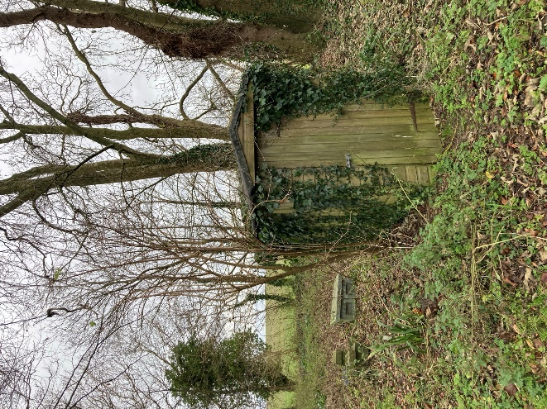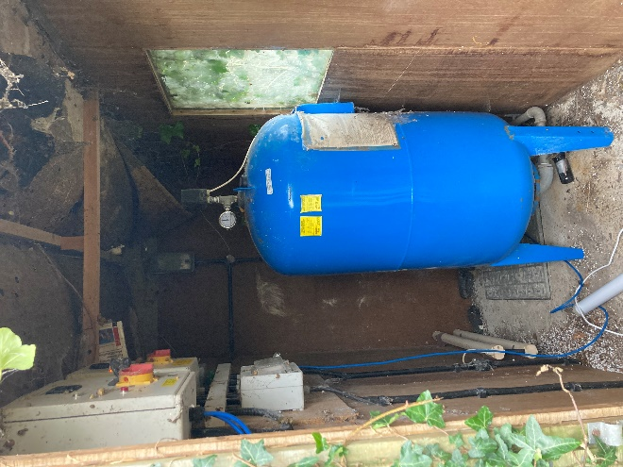
Picture 1 – Current Shed Picture 2 – Expansion Tank

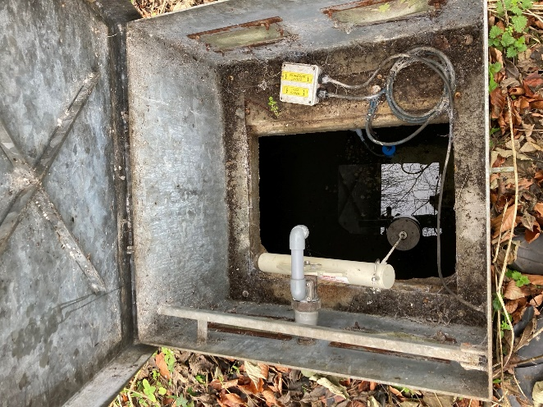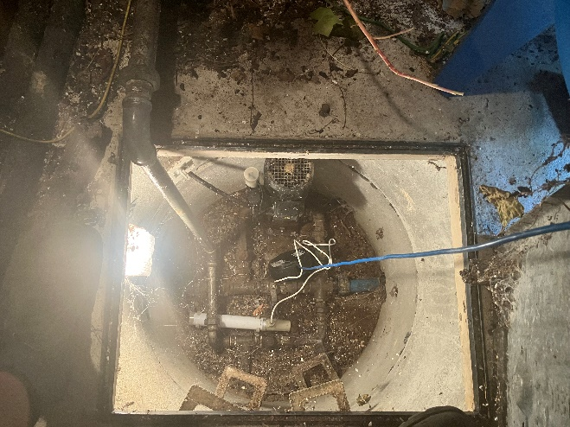

Picture 3 - Keraflo pump Pump 4 – Water Pump

- Contractors wishing to quote must have experience and qualifications relating to civil engineering and water management

- Contractors will ideally by part of the CHAS or SMAS scheme however it isn’t mandatory

- Contractors must comply with Construction Design and Management regulations (2015). Its is desirable that contractors have experience in delivering projects that have worked to CDM regulations.

- Any plant machinery all specialist power tools required for the job must have operatives that are trained and certified.

- It will be expected that the contractor will provide a working method statement, risk assessments and evidence of public liability and insurance (level of evidence with depend on whether the contractor is CHAS/SMAS approved)

- Contractors wishing to quote must attend a site visit prior to submitting their tender.

Sustainability
Natural England protects and improves the environment and is committed to reducing the sustainability impacts of its activities directly and through its supply chains. We expect the Contractor to share this commitment and adopt a sound, proactive sustainable approach in keeping with the 25 yr environmental plan/our commitments compliant with all applicable legislation. This includes understanding and reducing direct and indirect sustainability impacts and realising opportunities, including but not restricted to; resilience to climate change, reducing greenhouse gas emissions, water use and quality, biosecurity, resource efficiency and waste, reducing the risk of pollution, biodiversity, modern slavery and equality, diversity & inclusion, negative community impacts.
As a delivery partner, the successful contractor is expected to pursue sustainability in their operations, thereby ensuring the Contracting Authority is not contracting with a supplier whose operational outputs run contrary to the Contracting Authority’s objectives. The successful contractor will need to approach the project with a focus on the entire life cycle of the project

Outputs and Contract Management
Reference | Deliverable
Deadline for submitting quotes | 19th September 2025
Deadline for site visits | 18th September 2025
Award of Contract | 1st Ocotober 2025
Start Date | 2nd October 2025
Last Date work can be completed | 15th March 2026

