Tender:
Provision of
Internal Audit Services

August 2025

NORTHERN STAR ACADEMIES TRUST (NSAT)

Provision of Internal Audit Services

Contents

Section Number Description

1. Introduction and background to NSAT
2. Requirement
3. Response
4. Timetable
5. Questions and Clarifications
6. Evaluation

Introduction and Background to Northern Star Academies Trust

  - Northern Star Academies Trust (NSAT) is a multi-academy trust in North and West Yorkshire. Formed in 2015, the Trust has grown steadily to its current membership of 15 schools. The Trust has established strong central services covering finance, HR, IT and business management, with all academies working collaboratively within a shared framework of values and priorities. Background to the Trust’s purpose and ethos can be found at www.nsat.org.uk The Trust’s five year strategy, “Future Forward”, is attached to this document.

  - The Trust has a current annual revenue of around £44m.

NSAT Academies

Academy | Location | Phase | NOR | No. Staff
Byron Primary School | Bradford | Primary | 684 | 106
Denholme Primary School | Keighley | Primary | 210 | 38
Eastwood Community Primary School | Keighley | Primary | 488 | 79
Greatwood Community Primary School | Skipton | Primary | 209 | 33
Harrogate High School | Harrogate | Secondary | 721 | 99
Holycroft Primary School | Keighley | Primary | 370 | 64
Hookstone Chase Primary School | Harrogate | Primary | 287 | 34
Lapage Primary School | Bradford | Primary | 690 | 114
Meadow Bank Community Primary School | Bradford | Primary | 350 | 59
New Park Primary Academy | Harrogate | Primary | 203 | 26
Parkwood Primary School | Keighley | Primary | 222 | 41
Skipton Girls’ High School | Skipton | Secondary | 884 | 124
Starbeck Primary Academy | Harrogate | Primary | 233 | 36
Victoria Primary School | Keighley | Primary | 333 | 52
Willow Tree Community Primary School | Harrogate | Primary | 458 | 64

  - The Trust is led by an Executive Team comprising a Chief Executive, Chief Education Director, Chief Operating Officer and Chief Finance Officer.

  - The following chart sets out the current structure of the Trust’s core team.

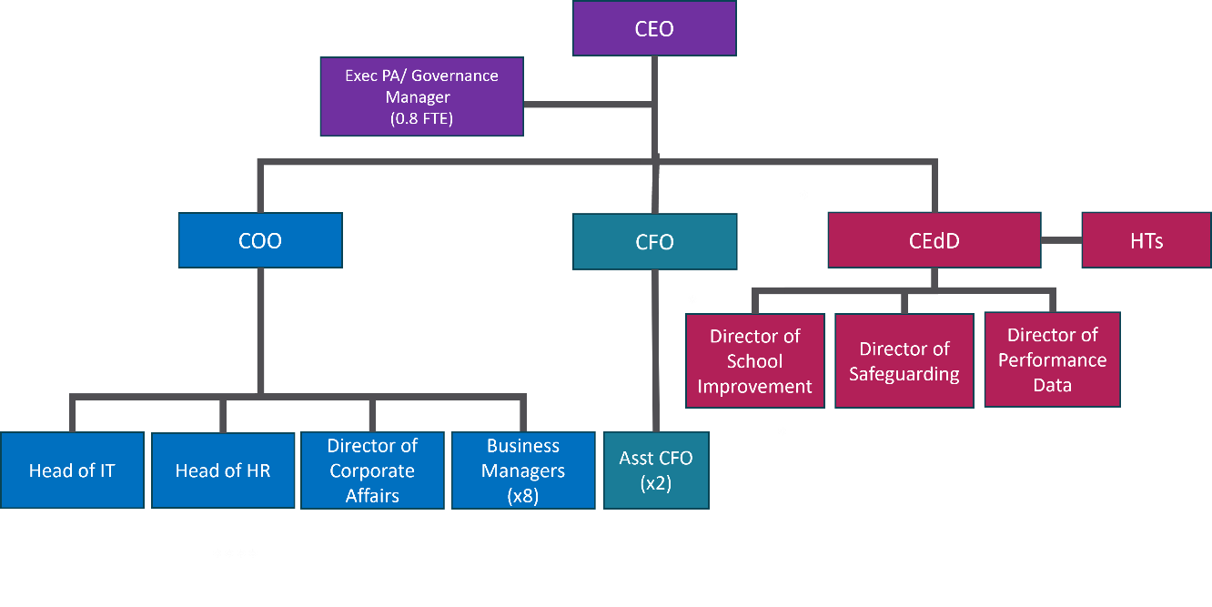

  - The Trust Board of Trustees has separate Finance and Audit & Risk Committees. The latter has specific responsibility for oversight of internal audit (IA) and overall assurance. The Trust’s newly approved Board Assurance Framework accompanies this tender specification as background. It illustrates how IA fits into the Trust’s wider risk management and scrutiny/assurance programmes.

- Requirement

  - This brief is for the provision of internal audit services to deliver third line assurance within the Trust’s overall Board Assurance Framework.

  - The Framework assumes up to three internal audits per calendar year, organised around a five year planning cycle. The focus of internal audits will be reviewed and refined annually by Trustees, informed by the Trust’s risk profile.

  - It is expected that:

- persistent high risk areas will be subject to annual scrutiny, particularly in areas where risks are constantly evolving. It is expected that cyber security will fall into this category. This means that potential providers must be able to demonstrate competence to audit in this area, either directly or via a partner.

- at least one audit each year will focus on an aspect of financial or HR management, as the areas carrying the highest ongoing risk to the Trust.

- other areas will be audited on a five yearly cycle.

An example plan is set out in the accompanying Board Assurance Framework. Whilst this plan provides starting assumptions for each year’s scrutiny schedule, Trustees may adjust it in light of changing risk profiles. In some circumstances, this could mean combining the audit time available to conduct (say) one deeper audit into a particular business area rather than two short audits in different areas.

For reasons of budget and practicality, it is expected that proposed annual cyber security audits will focus on specific areas of cyber risk such as: patch/vulnerability management; access controls; incident management planning and response; resilience planning; staff training and testing.

  - Providers will be expected to:

- work with the Chief Operating Officer to produce an annual audit schedule for approval by Trustees in December of each year. (The audit period for each year will be 1 Jan – 31 Dec)

- produce written scope of works for each intended audit and work with the NSAT business lead for relevant areas to request and gather the audit material needed (including arranging any meetings/visits where relevant).

- produce written reports for each audit undertaken and the annual scrutiny summary report for the Trust’s Annual Report and Accounts.

- attend the Audit & Risk Committee at least annually to report directly to Trustees on recent audit reports. These dates will be booked at the start of each year.

  - The overall approach will be informed by the Trust’s Risk Management Policy (attached to this brief). The Trust maintains its risk register via the “Every” online system. The Trust will take a risk-based approach to setting the scope for each audit.

  - On a day to day basis, internal auditors will work with the Trust’s Chief Operating Officer and/or Chief Finance Officer to facilitate audit processes. Audit reports will be to Trustees (and the Chair of the Audit & Risk committee in particular).

  - The Trust’s annual budget for internal audit is £11k (exc VAT). The contract for will be for three years (1 January 2026 – 31 December2028), cancellable with the provision of six months’ notice on either side.

- Response

3.1 Responses are sought from potential partners to this brief. Written responses should include:

- details of experience of undertaking internal audit/scrutiny in general, with reference to any experience in the academy sector in particular.

- an outline of proposed audit methodologies.

- the experience and/or qualifications of lead personnel who may be undertaking audits (including how specialist expertise will be secured to meet the range of audit requirements in the Trust’s likely internal audit cycle).

- examples of reporting format, including the form of recommendation.

- any proposals for tracking and closing recommendations from audits.

- names and contact details of two client referees able to provide information about their experience of working with the provider.

3.2 Responses should provide a fixed annual cost for the duration of the three year contract with a description of what is included. Any potential additional charges should be referenced.

Timetable

Activity | Date
Tender specification issued | 22 August 2025
Deadline for responses to tender | 29 September 2025 (10:00)
Shortlisting of responses (if required) | w/c 6 October 2025
Presentations (via Teams) | Friday 17 October 2025
Board meeting to ratify recommendation of selection panel | 24 October 2025
Contract begins | 1 January 2026

Questions and Clarifications

Suppliers may raise questions or seek clarification regarding any aspect of this tender process. Questions should be raised by email to: paddisonchild@nsat.org.uk by 5pm on Friday 12 September.

To ensure that all suppliers have equal access to information regarding this competition, the Trust will publish all its responses to questions raised by suppliers on an anonymous basis, and circulate them via email in w/c 15 September.

Evaluation

6.1 Responses will be considered on the information contained within or obtained by the Trust as a direct result of this tender process. Evaluation will be based on:

relevance of the proposed audit methodology and delivery model to the Trust’s context;

the skills and experience of the key personnel delivering the audit programme;

the presentation; and

overall value for money.

Attachments

Board Assurance Framework

NSAT Five Year Strategy

NSAT Risk Management Policy

