Clarifications

Price: As per the notice is 40% of evaluation marks
Assessing Price
The lowest cost will be awarded the maximum 40% of evaluation marks. All other bids will be evaluated by dividing the lowest cost by the bidder comparison cost and multiplying the proportion by 40% to give the bid their percentage of the total evaluation marks available.
A worked example can be found below:
Bid A is £300 so automatically gets 40 marks.
Bid B is £500 so gets 24 marks.
(The lowest cost divided by the comparison cost multiplied by 40 equals their percentage of the total evaluation marks available. 300/500 x 40 = 24)

Pricing: We expect a budgetary price for each play park within the total budget allowed for.

Could you clarify please which play area at Galmington Recreation Ground is part of the tender - the red or yellow ones, or both?
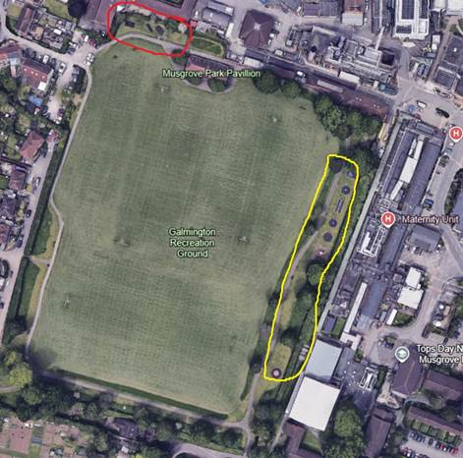

Response: Both are part of this tender, We would want to bring them together as one, so can they propose an option on how best to do this.

Retention payments: A 5% retention will be placed on all payments for playpark installations

One initial question would be whether you are looking to remove everything and start again or to retain some pieces and add to the play offer? We are seeking to add to the play offer, not to start again.

Grants to be applied for: We have a grants officer who will complete all applications however he will need support in completion of the applications ie results of public consultations.

Access and surfacing, many current play items do not have the relevant or required access or surfacing. We realise that this is the case and expect the equipment to be made accessible and have suitable surfacing added not necessarily to just get rid of good and serviceable equipment.

Many have requested the latest ROSPA reports which are now available,

