Natural England Species recovery project
Contract Specification

1. About the Project:

The Sefton Coast is home to the largest metapopulation of natterjack toads in north-west England, and it is also a major stronghold for sand lizard, however, both species are considered endangered and numbers continue to decline at Cabin Hill NNR.
This project aims to create and enhance new and existing dune slacks, providing new breeding opportunities for Natterjack toad. This essential habitat creation and enhancement is considered key to achieving favourable condition for the species and the project will help restore this site to conditions that support natterjack toads and encourage thriving populations within the Sefton Coast area. Whilst this is a locally focussed project, it will benefit the national population by building future resilience through improved habitat quality and connectivity to adjacent sites, contributing significantly to overall national population numbers.
By creating more bare sand and ‘corridors’ we will also improve habitat connectivity across the site for sand lizard - in the fixed dune grassland we will be connecting the site with neighbouring sand lizard foci, encouraging natural recolonisation of the site and local population recovery, strengthening overall population resilience.

Location – Cabin Hill NNR
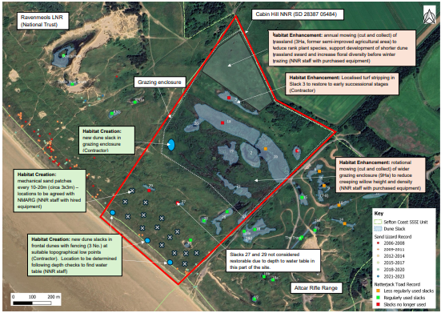
Annex 1. Map of work area and details of project works

Address and access to site:
Location
The worksite lies within Cabin Hill NNR, Formby, Merseyside.
Grid ref SD 283 050
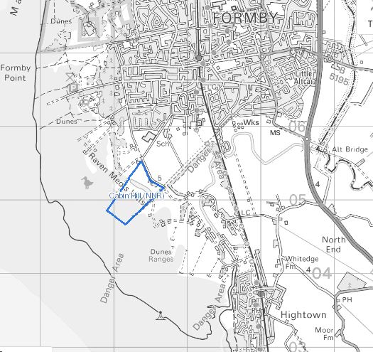
Annex 2. OS map of Cabin Hill NNR
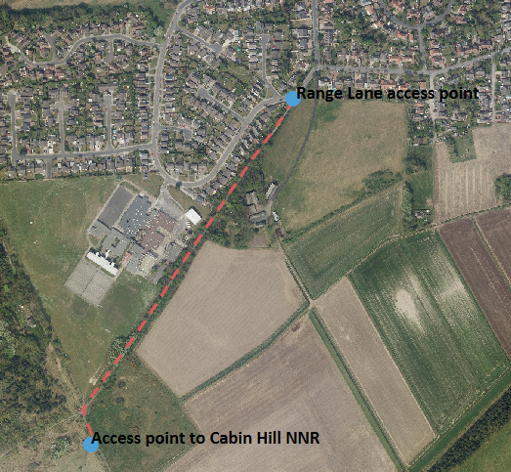
Annex 3. Access to reserve via Range Lane in Formby
Alternative access – There may be an option to access Cabin Hill NNR via tracks on a neighbouring site (Altcar rifle range). Options can be discussed during site visit.
Timing of works: Work to begin in early September 2025

2. Requirement
Dune slack restoration

Create four new dune slacks within Cabin Hill NNR – three will be located in the frontal/embryo dunes and one will be situated in the north-west corner of the grazing enclosure. Approx locations are included in Annex 1 and grid references are provided below.

Three dune slacks in frontal dunes - SD 28168 04751 SD 28066 04809 SD 28013 04914

Use an excavator to mechanically remove all surface vegetation, roots and topsoil from within these areas to expose bare sand and continue towards water table – Actual size, depth and amount of sand removed will be dependent on site conditions (height of water table and topography) this can be discussed and agreed with NNR site staff during site visit and at the time of these works. All organic matter should be buried and covered with at least 1 metre of bare sand. Where possible removed sand can be contoured into the existing dunes to create sandy south facing slopes.

One dune slack inside grazing enclosure – SD 28175 05108

Use an excavator to mechanically remove all surface vegetation, roots and topsoil from within this area to expose bare sand and continue towards the water table – Again, actual depth and amount of sand removed will be dependent on site conditions (height of water table and topography) this can be discussed and agreed with NNR site staff at the time of these works. All organic matter should be buried and covered with at least 1 metre of bare sand.

Sand removed from this slack and burial area is to be transported in a dumper (tracked or low ground pressure tyres) to infill and profile two wet slack areas on the northern edge of grazing area. To be discussed during site visit.

Dune slack rejuvenation – SD 28324 05284

Use an excavator to mechanically remove all surface vegetation, improving the slack by turf stripping approx 40m x 30m area, removing all surface vegetation including willow scrub, roots and topsoil from within area to expose bare sand - ensuring existing levels and appropriate gradients are maintained to form a shallow pool. All organic matter should be buried and covered with at least 1 metre of bare sand - fresh sand can also be used to cover the new pool surface.

Sand lizard bare sand corridor creation – locations to be agreed.

Use an excavator to create five 100m x 1m wide corridors between two frontal dune ridges. Removing all surface vegetation, roots and topsoil from within designated areas to expose bare sand. All organic matter should be buried and covered with at least 1 metre of bare sand.
Prerequisites
Prior to provision of a bid the contractor must visit the site accompanied by the contract supervisor, in order to;
- Determine access routes
- Clarify the extent of the work
- Discuss proposed design and specification details
Health & Safety issues
Safe site access – in particular around general public access and avoiding disturbance to wildlife and sensitive areas of habitat. Access to Cabin Hill NNR is shown in the maps above, an access route to the work areas should be agreed with the contract supervisor prior to work commencing.
Further requirements
The contractor is to supply all labour and equipment for proper execution of the work. All operators must hold the relevant NPTC certificates (or equivalent) and these must be available for inspection if required. Operators should be aware of, and comply with all relevant health and safety legislation and wear necessary protective clothing, as outlined in task specific risk assessment(s). Safety equipment must adhere to current requirements and should be used at all times.

3. Outputs and Contract Management

The contract outlined in this specification will be undertaken in Autumn 2025 with work starting in early September 2025.

This contract will be overseen at all times by Natural England reserve staff, the contractor will be required to liaise directly with the reserve staff member(s) managing the project.

Payment will be made on completion of works and receipt of relevant invoice(s).

4. Supporting documentation

The following supporting documentation is essential:

Details/case studies of previous work carried out on protected sites.

Risk Assessments
Lone working practices
Health & safety Policies/certificates
VAT registration number
Public Liability Insurance
Professional Indemnity Insurance

5. Evaluation criteria

The contract will be awarded to the most economically advantageous tender, this will be determined on the basis of price and quality in equal measure:

50% - Overall price.
50% - Qualification, experience and expertise in working on a protected site.

6. Format

The quote should be in letter or e-mail format, and should provide detail on the following elements:

An understanding of the proposed works and in particular show an understanding of the risks and control measures required for this specific contract.

A clear statement of the total cost for the proposed works. The quotation should also include the number of days needed to undertake the work.

7. Key contacts
Barry Smith or Pete Gahan
Ainsdale sand dunes NNR
2 West End lodge
Pinfold Lane
PR8 3QW

Telephone : Barry Smith - 07780 338 173 or Pete Gahan – 07780 338 104
e-mail: barry.smith@naturalengland.org.uk
e-mail: pete.gahan@naturalengland.org.uk

8. Timescale

Attend site visit before 31st July 2025.
Submit quotation for works before 14th August 2025.
Work to commence in early September 2025.

