Performance Management Process & Reporting Schedule
for NCCT43213 Electrical & Mechanical Servicing for all Hot Water & Heating Service Assets & Associated Plant

Contract Objective | KPI | Target Score | Frequency Measured | Minimum Score
To ensure regular on time services, | Attendance within the service due date | 99% | Ad hoc Spot Checks | 96%
To ensure compliance paperwork is up to date and removes chasing and performance management requirements from NCC | Documentation received and accepted within 10 working days of the service | 99% | Regular monitoring as and when services are completed | 96%
To ensure critical services are up and running within the maximum response time stated | Respond and make safe on reactive work 4-hour response, | 99% | when the response time has not been met. Vs total number of jobs undertaken. | 99%
Quality of workmanship and technical solutions are fit for purpose and meet required standards | Time taken to repair or provide temporary solution to restore heating | 99% | when temporary solutions are required on a specific job and NCC class those undertaken as unreasonable in time length vs total number of jobs performed. | 96%
Enable NCC to forecast and see clearly progress against the delivery plan | Contractor to produce a monthly report on attendance and deliverables, with updated 2-month schedule of planned visits. | PASS | Number of completed submissions against requirement total | PASS = 100% submission of bimonthly progress update.
Monitor Quality of Work and service received with an aim of reducing complaints. | Number of CINs / complaints issued and Observation report by NCC officer monitoring. | 99% | As and when performance issued occur | (No tolerance as a CIN constitutes a critical failure)  Where a Complaint form has been issued these are for less impactful failures and the tolerance is therefore 96%

Assessment of a supplier’s performance shall be based on and reported by the following Ratings & Descriptions.
Performance Measure Rating | Description
Good | Performance is meeting or exceeding the key performance indicators
Approaching Target | Performance is close to meeting the key performance indicators
Requires Improvement | Performance is below the key performance indicators
Inadequate | Performance is significantly below the key performance indicators
Other | Where performance cannot be described as good, approaching target, requires improvement or inadequate (eg where no data is available or where relevant service delivery has not taken place)

Where specific instances of Poor performance is experienced by Norfolk County Council (NCC) the following CIN template will be issued to the supplier with timeframes to respond appropriate to the circumstances of the CIN. It is noted that a CIN will only be issued for High Risk/High Impact Performance issues. Where a complaints form is issued these will be for lower risk/medium impact performance issues. (See templates provided)
It is expected that the supplier will respond to both CINs and Complaints in a proactive and enabling manner that will manage risk and remove the likelihood of the same performance issues from reoccurring.
If persistent CINs are issued and / or are not being responded to effectively to reduce the likelihood of similar problems arising in the future.
NCC reserve the right to invoke formal notice and termination rights at its discretion following 3 such instances of repeated failure in any given 12 month period.
Where NCC incur a severe high impact performance related issue ie) Safety risk instance/ risk to property/life etc NCC reserves the right to immediately suspend the supplier and seek alternative supply sources until such a time termination takes effect.

Template 1 CIN (Contractor Improvement Notice)
Template 2: Complaint Form

Template 1
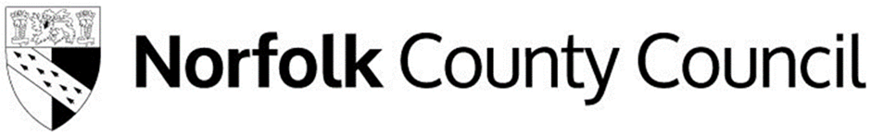
CONTRACTOR IMPROVEMENT NOTICE
Supplier Name:
Date
Description of Fault/Issue

RAG Red = Serious Default
Default Classification
Amber = Moderate Fault
Green = CIN Closed
E: Next Step Actions

Supplier Response to Default & Root Cause of Occurrence
(Please expand the box if you require more space)

Supplier Signature & Agreement Date Signed
Council Representative:
Contract Name :

Default Classification
CIN/ RED Number of Times Issue Has Occurred

Escalation Action Confirmed Yes/No Internal Reference Number
Date
Template 2
COMPLAINT FORM TEMPLATE
This form is designed to be an operational tool for submission to the Supplier when there are issues regarding performance occurring.
This compliant form will be used where the impact of the problem is not deemed to warrant a CIN ie) the consequence is Low to Medium impact to the Council. Where a significant impact is incurred, a CIN will be the appropriate method of escalation.
Council Representative:
Contract Name :

Category / nature of Complaint

Supplier Corrective Action Required to Resolve Complaint

Date Complaint Submitted
Date Complaint Closed by Supplier
Assessment of Supplier Closure of Actions & Complaint Closure Recommendation

Date Complaint Submitted
Did the Action Resolve your Complaint YES / NO

