Request for Quotation

Fal and Helford SAC: maerl side scan sonar and drop-down video survey, analysis and report writing

31/07/2025

Request for Quotation

Fal and Helford SAC: maerl side scan sonar and drop-down video survey, analysis and report writing

You are invited to submit a quotation for the requirement described in the specification, Section 2.

Please confirm by email, receipt of these documents and whether you intend to submit a quote or not.

Your response should be returned to the following email address by:

Email: [marine-southwest@naturalengland.org.uk](mailto:marine-southwest@naturalengland.org.uk)

Date: 31st July 2025

Time: 17:00

Ensure you include the name of the quotation and ‘Final Submission’ in the subject field to make it clear that it is your response.

Contact Details and Timetable

Esther Hughes will be your contact for any questions linked to the content of the quote or the process. Please submit any clarification questions via email and note that, unless commercially sensitive, both the question and the response will be circulated to all tenderers.

|  |  |
| --- | --- |
| Action | Date |
| Date of issue of RFQ | 31-JULY-2025 at 17:00 GMT |
| Deadline for clarifications questions | 19-AUG-2025 at 17:00 GMT |
| Deadline for receipt of Quotation | 22-AUG-2025 at 17:00 GMT |
| Intended date of Contract Award | 01-SEPT-2025 |
| Intended Contract Start Date | 08-SEPT-2025 |
| Intended Delivery Date / Contract Duration | 27-FEB-2026 for delivery of final report and data products |

Section 1: General Information

Glossary

Unless the context otherwise requires, the following words and expressions used within this Request for Quotation shall have the following meanings (to be interpreted in the singular or plural as the context requires):

|  |  |
| --- | --- |
|  |  |
| “Authority” | means Department for Environment, Food and Rural Affairs acting as part of Natural England who is the Contracting Authority. |
| “Contract” | means the contract to be entered into by the Authority and the successful supplier. |
| “Response” | means the information submitted by a supplier in response to the RFQ. |
| “RFQ” | means this Request for Quotation and all related documents published by the Authority and made available to suppliers. |

Conditions applying to the RFQ

You should examine your Response and related documents ensuring it is complete and in accordance with the stated instructions prior to submission.

Your Response must contain sufficient information to enable the Authority to evaluate it fairly and effectively. You should ensure that you have prepared your Response fully and accurately and that prices quoted are arithmetically correct for the units stated.

By submitting a Response, you, the supplier, are deemed to accept the terms and conditions provided in the RFQ. Confirmation of this is required in Annex 2.

Failure to comply with the instructions set out in the RFQ may result in the supplier’s exclusion from this quotation process.

**Acceptance of Quotations**

By issuing this RFQ the Authority does not bind itself to accept any quotation and reserves the right not to award a contract to any supplier who submits a quotation.

**Costs**

The Authority will not reimburse you for any costs and expenses which you incur preparing and submitting your quotation, even if the Authority amends or terminates the procurement process.

**Self-Declaration and Mandatory Requirements**

The RFQ includes a self-declaration response (Annex 1) which covers basic information about the supplier, as well as any grounds for exclusion. If you do not comply with them, your quotation will not be evaluated.

Any mandatory requirements will be set out in Section 2, Specification of Requirements and, if you do not comply with them, your quotation will not be evaluated.

**Clarifications**

Any request for clarification regarding the RFQ and supporting documentation must be submitted via email no later than the deadline for clarifications set out in the Timetable. The Authority shall be under no obligation to respond to queries raised after the clarification deadline.

The Authority will respond to all reasonable clarifications as soon as possible but cannot guarantee a minimum response time. The Authority will publish all clarifications and its responses to all suppliers via email unless deemed commercially sensitive.

If a supplier believes that a request for clarification is commercially sensitive, it should clearly state this when submitting the clarification request. However, if the Authority considers either that:

● the clarification and response are not commercially sensitive; and

● all suppliers may benefit from its disclosure,

then the Authority will notify the supplier (via email), and the supplier will have an opportunity to withdraw the request for clarification by sending a further message requesting the withdrawal of the clarification request. If not withdrawn by the supplier within 2 working days of the Authority’s notification, the Authority may publish the clarification request and its response to all suppliers and the Authority shall not be liable to the supplier for any consequences of such publication.

The Authority reserves the right to seek clarification of any aspect of a quotation and/or provide additional information during the evaluation phase to carry out a fair evaluation. Where the Authority seeks clarification on any aspect of the quotation, the supplier must respond within the timeframe requested by the Authority.

**Amendments**

The Authority may amend the RFQ at any time prior to the deadline for receipt. If it amends the RFQ the Authority will notify you via email.

Suppliers may modify their quotation prior to the deadline for Responses. No Responses may be modified after the deadline for Responses.

Suppliers may withdraw their quotations at any time by submitting a notice via the email to the named contact.

**Conditions of Contract**

The Authority’s

* Low Value Terms & Conditions (used for purchases under £10k)
* Standard Good and Services Terms & Conditions (used for purchases under £50k)

can be located on the

**[NATURAL ENGLAND WEBSITE](https://www.gov.uk/government/organisations/natural-england/about/procurement)**

and will be applicable to any contract awarded as a result of this quotation process. The Authority will not accept any changes to these terms and conditions proposed by a supplier.

Suppliers should note that the quotation provided by the successful bidder will form part of the Contract.

Prices

Prices must be submitted in £ sterling, exclusive of VAT.

Disclosure

All Central Government Departments, their Executive Agencies and Non Departmental Public Bodies are subject to control and reporting within Government. In particular, they report to the Cabinet Office and HM Treasury for all expenditure. Further the Cabinet Office has a cross-Government role delivering overall Government policy on public procurement, including ensuring value for money and related aspects of good procurement practice. For these purposes, the Authority may disclose within Government any details contained in your quotation. The information will not be disclosed outside Government during the procurement.

In addition, the Authority is subject to the Freedom of Information Act 2000 and the Environmental Information Regulations 2004, which provide a public right of access to information held by public bodies. In accordance with these two statutes, the Authority may be required to disclose information contained in your quotation to any person who submits a request for information pursuant to those statutes.

Further to the Government’s transparency agenda, all UK Government organisations must advertise on Find a Tender Service (FTS) in accordance with the following publication thresholds:

* Central Contracting Authority’s: £12,000
* Sub Central Contracting Authority’s and NHS Trusts: £30,000

For the purpose of this RFQ the Authority is classified as a Central Contracting Authority with a publication threshold of £12,000 inclusive of VAT.

If this opportunity is advertised via FTS, we are obliged to publish details of the awarded contract.

A copy of the contract must also be published with confidential information redacted.

By submitting a Response, you consent to these terms as part of the procurement.

Disclaimers

Whilst the information in this RFQ and any supporting information referred to herein or provided to you by the Authority have been prepared in good faith the Authority does not warrant that this information is comprehensive or that it has been independently verified.

The Authority does not:

* make any representation or warranty (express or implied) as to the accuracy, reasonableness or completeness of the RFQ;
* accept any liability for the information contained in the RFQ or for the fairness, accuracy or completeness of that information; or
* accept any liability for any loss or damage (other than in respect of fraudulent misrepresentation or any other liability which cannot lawfully be excluded) arising as a result of reliance on such information or any subsequent communication.

Any supplier considering entering into contractual relationships with the Authority following receipt of the RFQ should make its own investigations and independent assessment of the Authority and its requirements for the goods and/or services and should seek its own professional financial and legal advice.

**Information Security requirements**

The Government Security Classification Policy (GSCP) sets out the administrative system used by HM Government (HMG) to protect information and data assets appropriately against prevalent threats through the use of ‘classification tiers’. HMG uses three classification tiers; OFFICIAL, SECRET and TOP SECRET. Each tier provides a set of recommended baseline behaviours and a set of protective controls, which are proportionate to the threat profile for that tier AND the potential impact of a compromise, accidental loss or incorrect disclosure of information held within that tier.

Tenderers and suppliers must ensure that appropriate protective security controls are in place to comply with the GSCP and manage the information shared and received as part of this tender exercise.

A full suite of guidance documents is available on GOV.UK, with specific guidance for tenderers and suppliers set out in [Guidance 1.6 - Contractors and Contracting Authorities.docx (publishing.service.gov.uk).](https://assets.publishing.service.gov.uk/government/uploads/system/uploads/attachment_data/file/1166155/Guidance_1.6_-_Contractors_and_Contracting_Authorities.pdf)

**Use of Artificial Intelligence**

The Authority expects suppliers to declare where they have used AI software in the creation of Tender responses or intend to use AI software in the performance of the contract. How any AI software was, or will be, used should be to be declared within the technical submission part of the tender. We may require you to answer specific question/s on this topic, particularly where the Authority expects that usage is highly likely or clearly relates to the contract requirements.

Suppliers must follow any guidelines or regulations related to AI use and declarations as indicated in the [PPN 2/24 Improving Transparency of AI use in Procurement](https://www.gov.uk/government/publications/ppn-0224-improving-transparency-of-ai-use-in-procurement/ppn-0224-improving-transparency-of-ai-use-in-procurement-html).

Any information, instructions, or data provided by the Authority to suppliers as part of this tender, the requirements, or contract should not be directly inserted into Generative AI software (such as Gemini, ChatGPT, or CoPilot) without prior permission, unless this information is clearly published in the public domain.

Use of any Authority confidential tender information for training AI software is prohibited. it is advised that Defra’s data or instructions, or anything marked as confidential should not be directly inserted into AIs. For example, putting Authority’s instruction email into Gemini, ChatGPT, or CoPilot is not recommended.

If you intend to use AI to provide goods or services to the Authority, then you are required to complete a declaration which is simply answering the question stated within the 'Information to be returned’. The answer to this question will not be used in scoring your quote.

Protection of Personal Data

In order to comply with the General Data Protection Regulations 2018 the supplier must agree to the following:

You must only process any personal data in strict accordance with instructions from the Authority.

* You must ensure that all the personal data that we disclose to you or you collect on our behalf under this agreement are kept confidential.
* You must take reasonable steps to ensure the reliability of employees who have access to personal data.
* Only employees who may be required to assist in meeting the obligations under this agreement may have access to the personal data.
* Any disclosure of personal data must be made in confidence and extend only so far as that which is specifically necessary for the purposes of this agreement.
* You must ensure that there are appropriate security measures in place to safeguard against any unauthorised access or unlawful processing or accidental loss, destruction or damage or disclosure of the personal data.
* On termination of this agreement, for whatever reason, the personal data must be returned to us promptly and safely, together with all copies in your possession or control.

General Data Protection Regulations 2018

For the purposes of the Regulations the Authority is the data processor.

The personal information that we have asked you provide on individuals (data subjects) that will be working for you on this contract will be used in compiling the tender list and in assessing your offer. If you are unsuccessful the information will be held and destroyed within two years of the award of contracts. If you are awarded a contract it will be retained for the duration of the contract and destroyed within seven years of the contract’s expiry.

We may monitor the performance of the individuals during the execution of the contract, and the results of our monitoring, together with the information that you have provided, will be used in determining what work is allocated under the contract, and in any renewal of the contract or in the award of future contracts of a similar nature. The information will not be disclosed to anyone outside the Authority without the consent of the data subject, unless the Authority is required by law to make such disclosures.

Equality, Diversity & Inclusion (EDI)

The Client is striving to create a diverse and inclusive working environment where every individual has equality of opportunity to progress and to apply their unique insights to making the UK a great place for living. The Service Provider is expected to respect this commitment in all dealings with Defra/NE staff and service users.

Suppliers are expected to;

* support Defra group to achieve its Public Sector Equality Duty as defined by the Equality Act 2010, and to support delivery of [Defra group’s Equality & Diversity Strategy](https://www.gov.uk/government/publications/defra-group-equality-diversity-and-inclusion-strategy-2020-to-2024/defra-group-equality-diversity-and-inclusion-strategy-2020-to-2024).
* meet the standards set out in the [Government’s Supplier Code of Conduct](https://www.gov.uk/government/publications/supplier-code-of-conduct)
* work with Defra group to ensure equality, diversity and inclusion impacts are addressed (positive and negative) in the goods, services and works we procure, barriers are removed and opportunities realised.

Sustainable Procurement

Addressing global sustainability impacts and realising additional community benefits within commercial activity is core to Defra group’s approach, working with its supply chain is key to achieving sustainable outcomes. In addition to supporting Defra group to meet its outcomes we look to understand and reduce negative sustainability impacts associated with our commercial activity and realise benefits.

The Client encourages its suppliers to share these values, work to address negative impacts and realise opportunities, measure performance and success.

Suppliers are expected to have an understanding of the Sustainable Development Goals, the interconnections between them and the relevance to the Goods, Services and works procured on the Client’s behalf.

Conflicts of Interest

The concept of a conflict of interest includes but is not limited to any situation where an Involved Person or Relevant Body has directly or indirectly, a financial, economic or other personal interest which might be perceived to compromise their impartiality and independence in the context of the procurement procedure and/or affect the integrity of the contract award.

We expect suppliers to mitigate appropriately against any real or perceived conflict of interest through their work with government. A supplier with a position of influence gained through a contract should not use that position to unfairly disadvantage any other supplier or reduce the potential for future competition

Where the supplier is aware of any circumstances giving rise to a conflict of interest or has any indication that a conflict of interest exists or may arise you should inform the Authority of this as soon as possible (whether before or after they have submitted a quotation). Tenderers should remain alert to the possibility of conflicts of interest arising at all stages of the procurement and should update the Authority if any new circumstances or information arises, or there are any changes to information already provided to the Authority. Failure to do so, and/or to properly manage any conflicts of interest may result in a quotation being rejected.

Provided that it has been carried out in an open, fair and transparent manner, routine pre-market engagement carried out by the Authority should not represent a conflict of interest for the supplier.

Section 2: The Invitation

## Specification of Requirements

## 1. Introduction

The **Fal and Helford SAC** was designed designated on 1st April 2005 and contributes to the UK’s suite of National Sites and overall MPA network. The site was designated for six qualifying habitats (and their associated sub-features), as well as one qualifying plant feature.

|  |
| --- |
| The SAC was designated (under the EC Habitats Directive) for the following habitats and species |
| H1110 Sandbanks which are slightly covered by sea water all the time |
| H1130 Estuaries |
| H1140 Mudflats and sandflats not covered by seawater at low tide |
| H1160 Large shallow inlets and bays |
| H1170 Reefs |
| H1330 Atlantic salt meadows (Glauco-Puccinellietalia maritimae) |
| S1441 Shore dock, Rumex rupestris |

For full site details please see: [Designated Sites View (naturalengland.org.uk)](https://designatedsites.naturalengland.org.uk/SiteGeneralDetail.aspx?SiteCode=UK0013112&SiteName=fal%20and%20helford&countyCode=&responsiblePerson=&SeaArea=&IFCAArea=)

The **Falmouth Bay to St Austell Bay SPA** was designated on 31 October 2017 and contributes to the UK’s suite of National Sites and overall MPA network. The site was designated for three qualifying bird species, and offers protection to both the bird species and their supporting habitats.

|  |
| --- |
| The SPA was designated (under the EC Habitats Directive) for the following Annex I species |
| Black-throated diver, *Gavia arctica* - A002, nb |
| Great northern diver, *Gavia immer* - A003, nb |
| Slavonian grebe, *Podiceps auritus* - A007, nb |

For full site details please see: [Designated Sites View (naturalengland.org.uk)](https://designatedsites.naturalengland.org.uk/SiteGeneralDetail.aspx?SiteCode=UK9020323&SiteName=falmouth%20bay&countyCode=&responsiblePerson=&SeaArea=&IFCAArea=)

The **Manacles MCZ** was designated on 29th January 2016 under the Marine and Coastal Access Act 2009 and contributes to the UK’s suite of MPA network. The site was designated for the following qualifying habitats and species.

|  |
| --- |
| The MCZ was designated (Marine and Coastal Access Act 2009) for the following Annex I habitats and species |
| Intertidal coarse sediment |
| Maerl beds |
| Moderate energy circalittoral rock |
| Moderate energy infralittoral rock |
| Moderate energy intertidal rock |
| Pink sea-fan (Eunicella verrucosa) |
| Sea-fan anemone (Amphianthus dohrnii) |
| Spiny lobster (Palinurus elephas) |
| Stalked jellyfish (Haliclystus spp) |
| Subtidal coarse sediment |
| Subtidal macrophyte-dominated sediment |
| Subtidal mixed sediments |
| Subtidal sand |

For full site details please see: [Designated Sites View](https://designatedsites.naturalengland.org.uk/ConservationAdvice.aspx?SiteCode=UKMCZ0018&SiteName=manacles&SiteNameDisplay=The%20Manacles%20MCZ&countyCode=&responsiblePerson=&SeaArea=&IFCAArea=&HasCA=1&NumMarineSeasonality=1&SiteNameDisplay=The%20Manacles%20MCZ)

## 1.1 Survey area

In 2023 and 2024, maerl habitats in the outer part of the SPA (areas not overlapping with the SAC) were surveyed by contractors using side-scan sonar and drop-down camera methods (see examples in figures 2, 3 and 4). This survey targets areas within the Fal and Helford SAC and overlapping Falmouth Bay to St Austell Bay SPA, and Manacles MCZ (see figure 1a, 1b, and 1c) which have not been previously surveyed to fill gaps and create a standardised map across all known maerl beds on the south coast of Cornwall

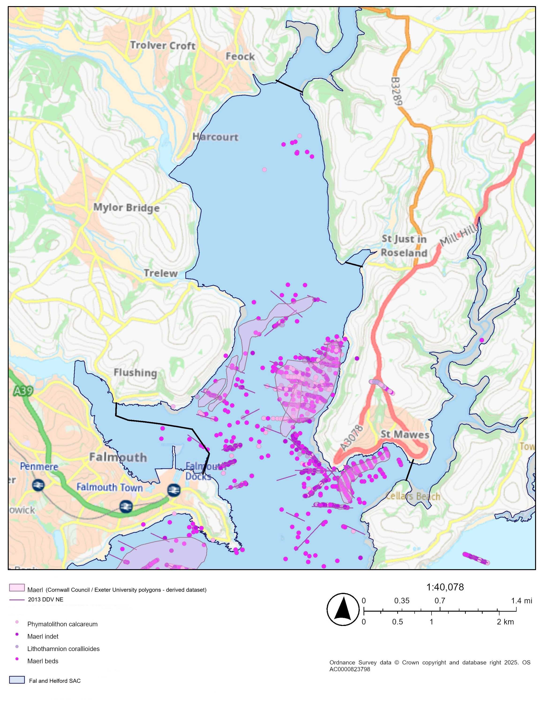

Figure 1a. Proposed survey location – Carrick Roads (Fal and Helford SAC) within boundary of the SAC and/or up to the black lines marked on the map (South of Turnaware Point (midpoint of black line SW833382), at St Mawes (mid-point of black line SW851327), and to include the area south of Flushing (approx location SW813334)).

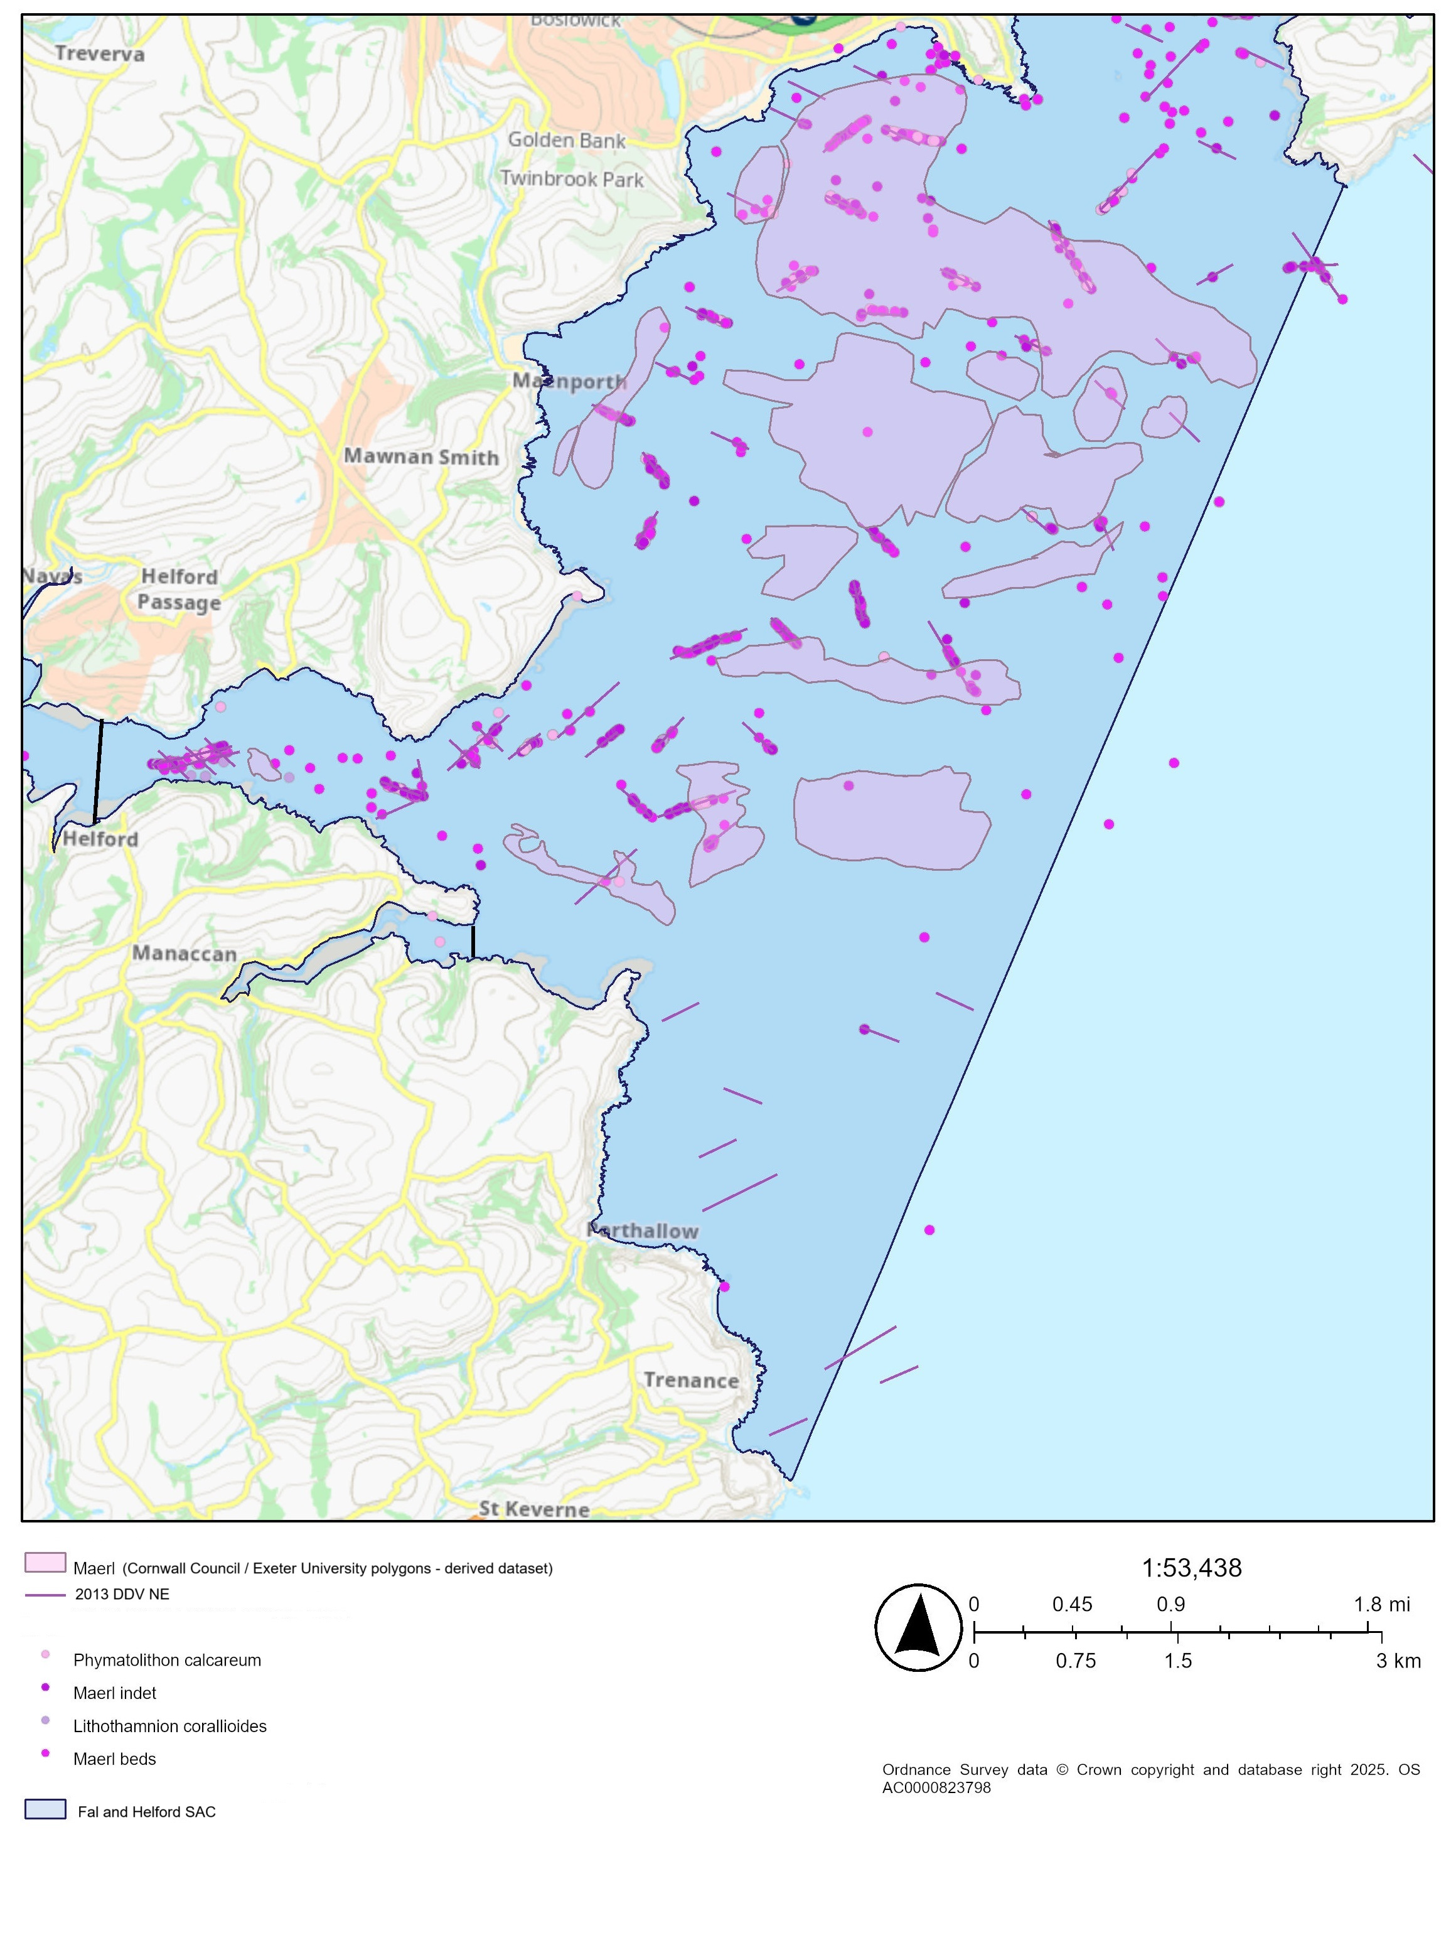

Figure 1b. Proposed survey location – Falmouth Bay (Fal and Helford SAC) - within boundary of the SAC and/or up to the black lines marked on the map (at the middle of the Helford (midpoint of black line SW761266) and at the mouth of Gillan Creek (mid-point of black line SW789254)).

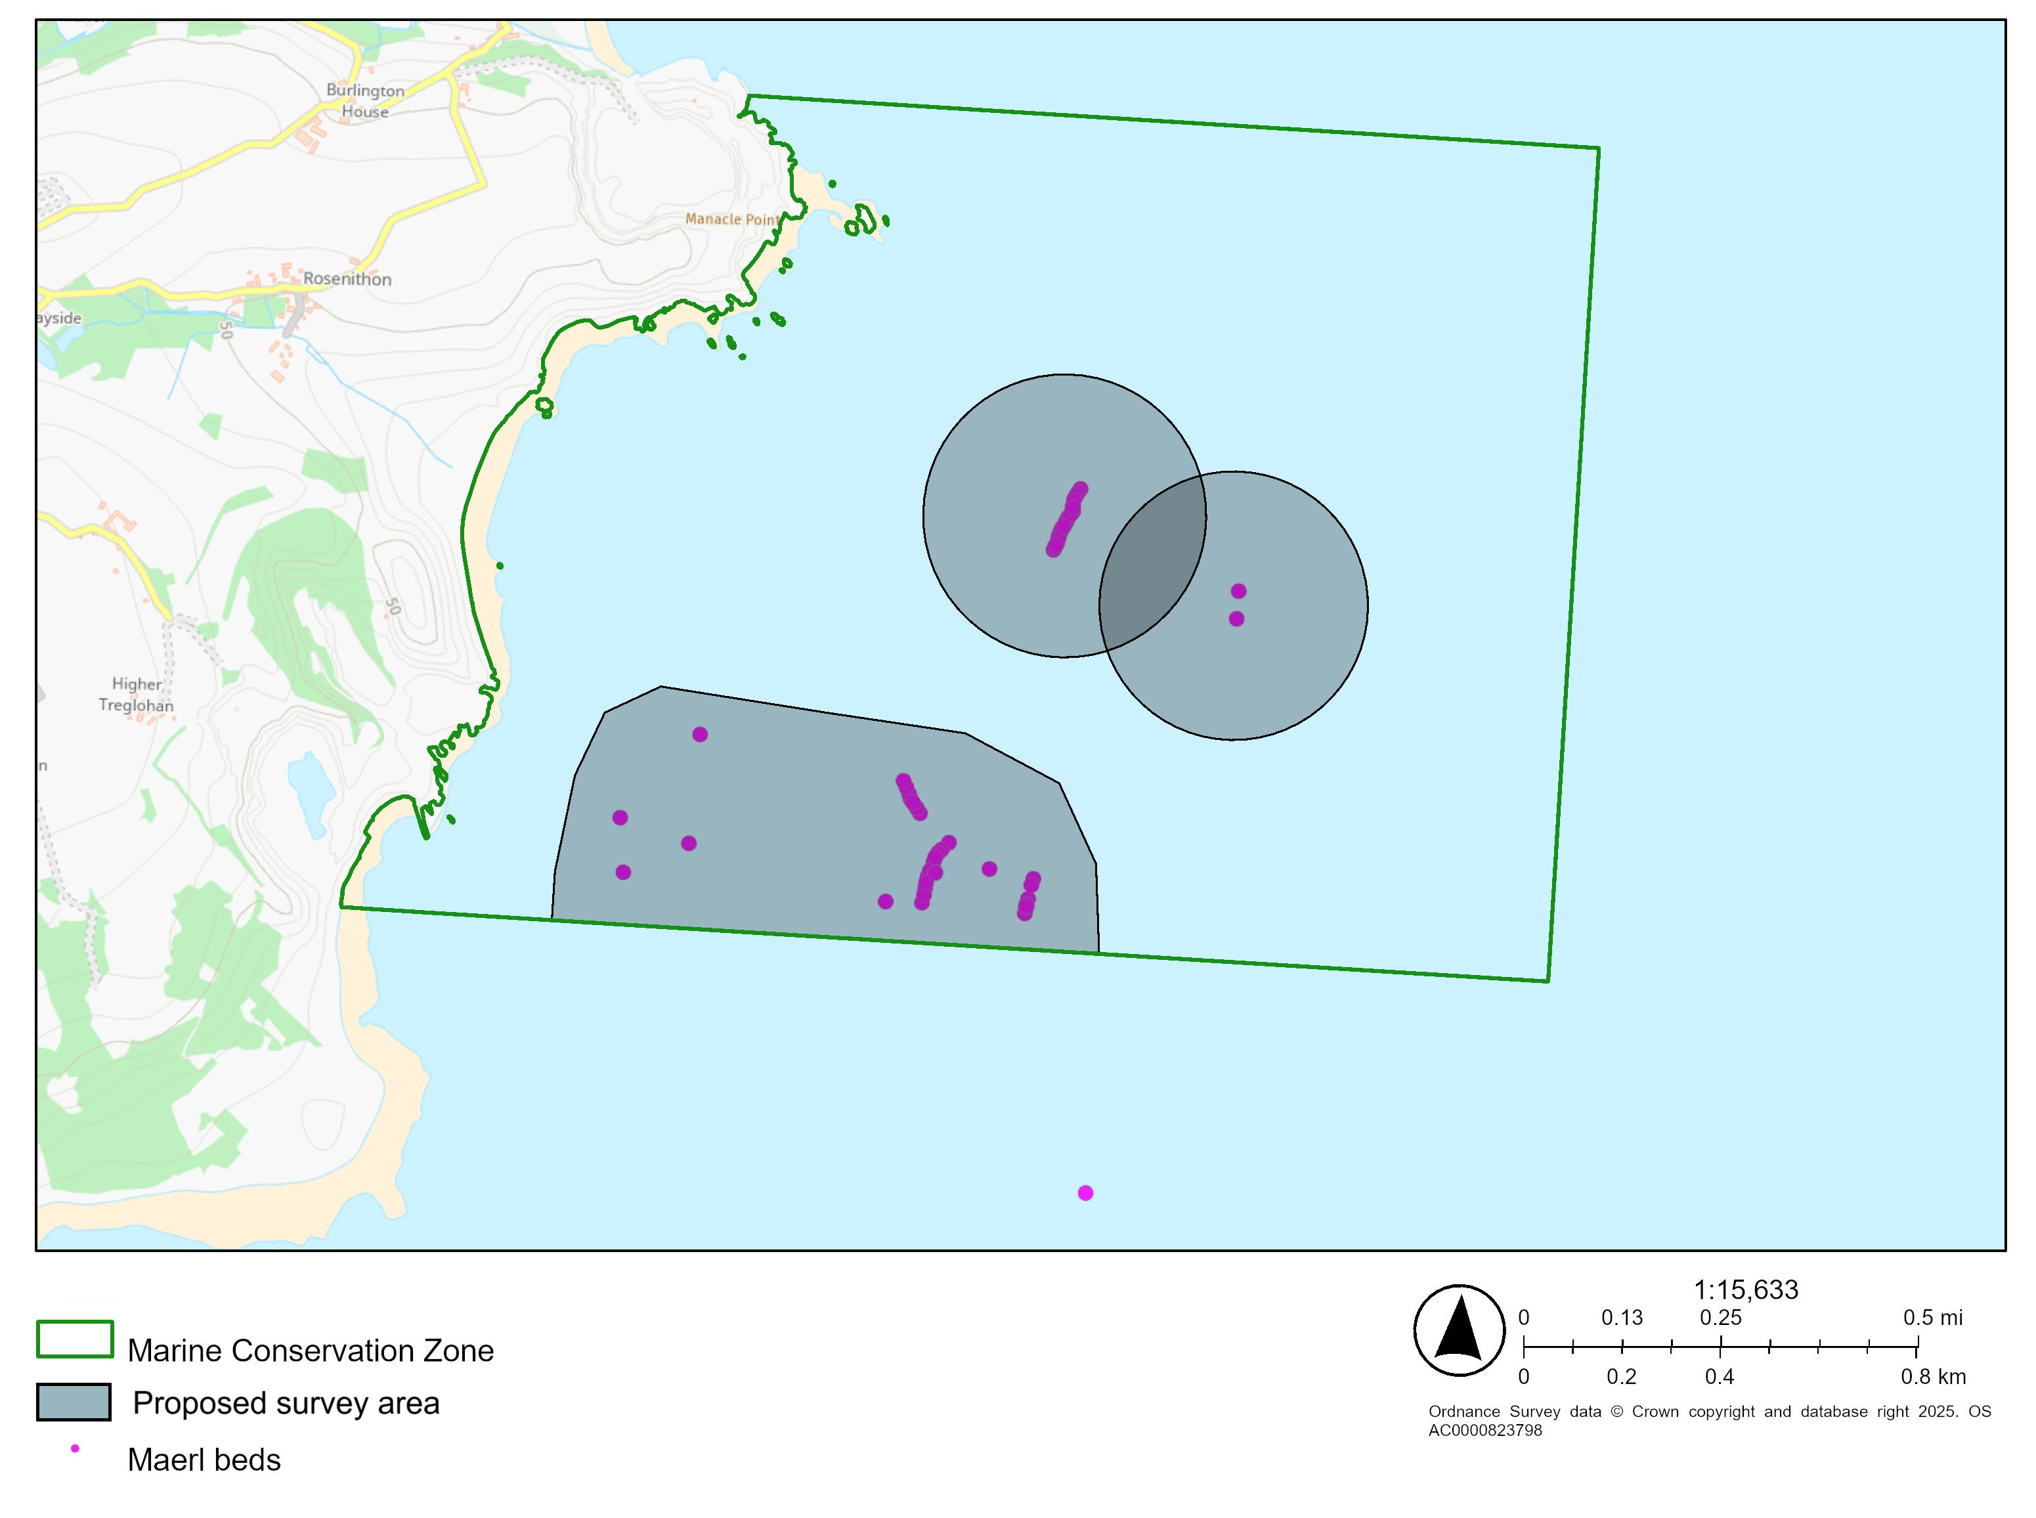Figure 1c. Proposed survey location (secondary survey) - Manacles MCZ (with survey areas shaded in grey)

## 1.2 Previous Surveys and existing data

The Fal and Helford SAC has been well studied, and a number of reports have been published. The CIFCA 2021/22 survey carried out side-scan sonar in a large portion of the SAC (Falmouth Bay) available to support this work (figure 4). Please see [21-FalmouthBay-SSS-Field.pdf](https://secure.toolkitfiles.co.uk/clients/17099/sitedata/Research_Reports/21-FalmouthBay-SSS-Field.pdf) (Sturgeon et al. 2021)

Previous surveys to be directly included in this project:

Envision Marine Ltd and Cornwall Inshore Fisheries and Conservation Authority (CIFCA) have carried out extensive SSS and DDV in the Falmouth Bay to St Austell Bay SPA (Jenkins et al, Sturgeon et al, and Envision Marine Ltd 2023 and 2024). Specifically, the **methodological, spatial and analytical components** should be followed so that the future dataset can be amalgamated into the standardised dataset.

Please note that, where possible, these datasets should be used to plan your proposed survey design. The outputs of this survey may be used by NE for a number of different purposes, including Condition Assessment, the formulation of Conservation Advice and to improve our understanding of Ecosystem Assets pursuant to the Natural Capital approach. Therefore, ideally datasets must be comparable with historic data and methodologies to enable analyses, however different and novel approaches will be considered where a rationale is provided.  Recommendations from previous surveys should be referred to, where relevant.

Figure 2. Map showing maerl and habitats with <5% maerl alone, with the percentage of live maerl recorded in each still image during analysis of the imagery, from St Austell Bay (from Envision Marine Ltd. 2024).

Figure 3. Predicted habitat/biotope distribution within the FBSAB SPA (Gerrans Bay; one of four survey areas within the SPA mapped in the project), mapped at MNCR Level 3/4 (from Envision Marine Ltd 2025 In publication).

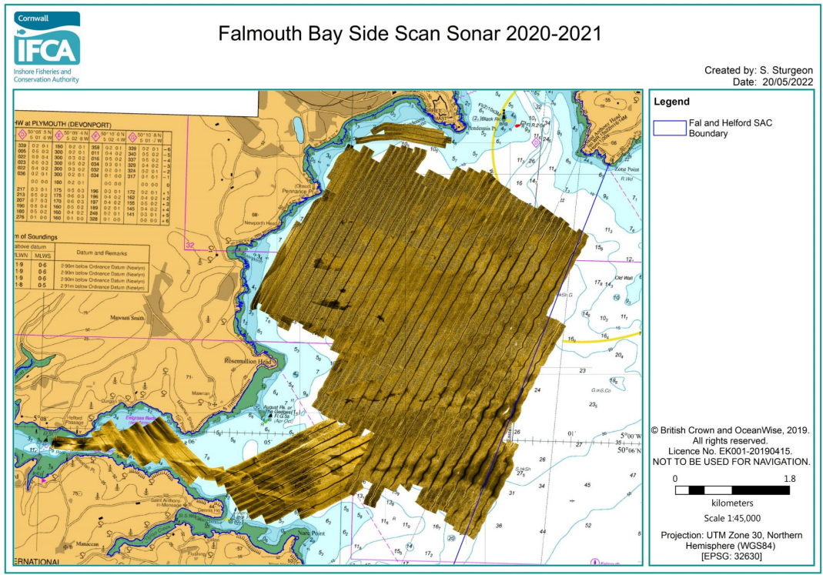Figure 4. Side Scan Sonar carried out by CIFCA during 2021/2 in Falmouth Bay (from Jenkins et al. 2023)

**References**

Bunker, F. St P.D. (1992) Survey and monitoring in the Roseland Voluntary Marine Conservation Area. Report to the National Rivers Authority, January 1993

Dewey, S. & Wilson, J. (2014). Fal and Helford SAC maerl drop-down video and dive survey 2013. A report to Natural England by Seastar Survey Ltd., 89 pages. <https://publications.naturalengland.org.uk/file/6285497528745984>

Doggett, M. and Northen, K.O. 2024. 2023 Fal, Helford and St Austell Bay maerl habitat surveys. [NECR625]. Natural England. Publication in progress, but will be made available for the proposed survey in 2025.

Doggett, M. and Northen, K.O. 2025. 2024 Fal, Helford and St Austell Bay maerl habitat surveys. [NECRXXX]. Natural England. Publication in progress, but will be made available for the proposed survey in 2025.

ENVISION MARINE LTD. 2024. Falmouth Bay to St Austell Bay SPA Maerl Mapping Project. Report No. 20240328 [NECR589]. A report for Natural England by Envision Marine Ltd. Available [publications.naturalengland.org.uk](https://publications.naturalengland.org.uk/publication/5561639456473088) Accessed 17/07/2025

ENVISION MARINE LTD. 2025. Falmouth Bay to St Austell Bay SPA Maerl Mapping Project. Report No. 20240328 [NECR626]. A report for Natural England by Envision Marine Ltd. Publication in progress, but will be made available for the proposed survey in 2025.

Jenkin, A., Naylor, H., Trundle, C., Street, K and Mathews, R. 2017. Manacles MCZ Drop Down Video Survey. Cornwall Inshore Fisheries and Conservation Authority (Cornwall IFCA), Hayle. Available at [Manacles-SSS-and-DDV-2016.pdf](https://secure.toolkitfiles.co.uk/clients/17099/sitedata/Research_Reports/Manacles-SSS-and-DDV-2016.pdf)

Jenkin, A., Street, K., Matthews, R., Trundle, C. and Naylor H. (2016a). Verifying acoustic signals for habitat classification within St. Austell Bay, Veryan Bay and Gerrans Bay. Annex 9. Cornwall Inshore Fisheries and Conservation Authority (Cornwall IFCA), Hayle. Available at: <https://secure.toolkitfiles.co.uk/clients/17099/sitedata/Research_Reports/StAustellGerransVeryanDDVSSS2016-ANNEX-9.pdf>

Jenkin, A., Street, K., Matthews, R., Trundle, C. and Naylor H. (2016b). Verifying acoustic signals for habitat classification within St. Austell Bay, Veryan Bay and Gerrans Bay. Annex 10. Cornwall Inshore Fisheries and Conservation Authority (Cornwall IFCA), Hayle. Available at: <https://secure.toolkitfiles.co.uk/clients/17099/sitedata/Research_Reports/StAustellGerransVeryanDDVSSS2016-ANNEX-10.pdf>

Jenkin, A., Street, K., Matthews, R., Trundle, C. and Naylor H. (2016c). Verifying acoustic signals for habitat classification within St.Austell Bay, Veryan Bay and Gerrans Bay. Annex 11. Cornwall Inshore Fisheries and Conservation Authority (Cornwall IFCA), Hayle. Available at: <https://secure.toolkitfiles.co.uk/clients/17099/sitedata/Research_Reports/StAustellGerransVeryanDDVSSS2016-ANNEX-11.pdf>

Jenkin, A., Street, K., Matthews, R., Trundle, C. and Naylor H. (2016d). Verifying acoustic signals for habitat classification within St. Austell Bay, Veryan Bay and Gerrans Bay. 2016 Summary Report. Cornwall Inshore Fisheries and Conservation Authority (Cornwall IFCA), Hayle. <https://secure.toolkitfiles.co.uk/clients/17099/sitedata/Research_Reports/StAustellGerransVeryanDDVSSS2016.pdf>

Jenkin, A., Trundle, C., Sturgeon, S., Daniels, C. and Street, K. (2023). Fal and Helford Drop Down Video Maerl Habitat Survey Report. Cornwall Inshore Fisheries and Conservation Authority (Cornwall IFCA), Hayle (Accessed 07/06/2023 <https://secure.toolkitfiles.co.uk/clients/17099/sitedata/Research_Reports/22F-H-DDV-Maerl-SurveyFINAL.pdf>)

Jenkin, A., Trundle, C., Sturgeon, S., Daniels, C., and Street, K. (2023). Fal and Helford Drop Down Video Maerl Habitat Field Report. Cornwall Inshore Fisheries and Conservation Authority (Cornwall IFCA), Hayle. (Accessed 07/06/2023 <https://secure.toolkitfiles.co.uk/clients/17099/sitedata/Research_Reports/22F-H-DDV-Maerl-FieldReport-FINAL.pdf>)

Jenkin, A., Trundle, C. and Sturgeon, S. 2023. St.Austell Bay Drop Down Video Habitat Distribution Survey Field Report. Cornwall Inshore Fisheries and Conservation Authority (Cornwall IFCA), Hayle.

Jenkins, T., Axelsson, M., Gall, A., Ratcliffe, F., Ellis, C., and Stevens, J. (2025). Population genomics, polyploidy, climate resilience and the microbiota of two habitat-building coralline algae. 10.21203/rs.3.rs-7035383/v1.

Laing, C. 2023. Carbon accounting and nature recovery options for blue carbon ecosystems in the Fal & Helford estuary, Cornwall. Found at [94d8b9614ee04f3e63d0c626a59a4f76_NEIRF_2041_Maerl_Kelp_Saltmarsh_FalHelford_report_(1).pdf (ehq-production-europe.s3.eu-west-1.amazonaws.com)](https://ehq-production-europe.s3.eu-west-1.amazonaws.com/cec3564082b970c047765a77317a46648b8de13e/original/1704983120/94d8b9614ee04f3e63d0c626a59a4f76_NEIRF_2041_Maerl_Kelp_Saltmarsh_FalHelford_report_%281%29.pdf?X-Amz-Algorithm=AWS4-HMAC-SHA256&X-Amz-Credential=AKIA4KKNQAKICO37GBEP%2F20240430%2Feu-west-1%2Fs3%2Faws4_request&X-Amz-Date=20240430T103436Z&X-Amz-Expires=300&X-Amz-SignedHeaders=host&X-Amz-Signature=4b0b9be943c97fc55206a14bb9338ed1d46951ccc5e27942fae69fe656e77f39) on 30/04/2024

Seasearch (2023). Seasearch Marine Surveys in England. Occurrence dataset <https://doi.org/10.15468/kywx6m> accessed via GBIF.org on 2023-06-14.

Sturgeon S., Trundle, C., and Jenkin, A. 2021. Side Scan Sonar survey of Falmouth Bay within the Fal and Helford Special Area of Conservation Field Report. Cornwall Inshore Fisheries and Conservation Authority (Cornwall IFCA), Hayle. Accessed [21-FalmouthBay-SSS-Field.pdf](https://secure.toolkitfiles.co.uk/clients/17099/sitedata/Research_Reports/21-FalmouthBay-SSS-Field.pdf)

## 2. Aims & Objectives

2.1 **Aims**

Natural England are seeking potential contractors to conduct an acoustic and drop-down video (DDV) survey during Autumn and Winter 2025 to fill current data gaps by collecting high quality data (using the methods from Envision Marine Ltd 2023 and 2024) on the distribution, extent and community composition of maerl habitat within beds within the Fal and Helford SAC and Manacles MCZ. As part of this project, the newly collected data will be combined with data from previous surveys carried out by Envision Ltd (2023 & 2024) and CIFCA (2023) to enable the distribution, extent and condition of subtidal maerl communities of the Falmouth Bay to St Austell Bay SPA, which overlaps the Fal and Helford SAC, and Manacles MCZ, to be reported on. The information gathered must be of sufficient quality to provide a robust baseline from which to measure future change according to methodologies outlined in JNCC common standards.

Please cost for two survey options:

**Option 1**: Both primary and secondary surveys areas

* Area within Fal and Helford SAC (figure 1a and 1b) and additional area within the Manacles MCZ (figure 1c).

**Option 2**: Just primary survey area

* Area within Fal and Helford SAC (figure 1a and 1b, except for the area in Falmouth Bay covered by the side scan carried out by CIFCA in 2021 as this data can be used by the supplier – gaps only to be completed).

Please note that the side-scan component of the survey will not need to be repeated in the part of Falmouth Bay carried out by CIFCA in 2021 (see Figure 4) as the 2021 SSS data can be used by the supplier. Only the gaps around the 2021 SSS in Falmouth Bay and Helford to be costed for with SSS. The required SSS to be undertaken in the Fal and Helford SAC is approximately 21km2, and for the Manacles MCZ the area is approximated at 0.85km2.

The survey design for this tender should achieve the following aims:

* Acquire high quality data on extent and distribution of maerl based on the principles and methodologies from the Common Standards Monitoring guidance and Marine Monitoring Handbook and where appropriate, protocols used during the 2023/4 survey (See appendix 1, and Jenkins et al. 2023b and 2023c)
* Combine previous data (CIFCA side scan from Falmouth Bay from 2021) and newly collected data to create predictive maps for maerl in the Fal and Helford SAC and Manacles MCZ in order to expand the current baseline to fill spatial evidence gaps across all the known maerl beds on the south coast of Cornwall.

In brief, Natural England are seeking potential contractors to pay particular attention to survey design so that quantitatively robust data is acquired which will permit rigorous spatial and temporal analysis and support robust condition assessments.

2.2 Objectives

Undertake a cost-effective survey which will contribute towards building an established baseline for the site, which should be assessed against the relevant attributes of maerl beds:

* **Extent and distribution**
* **Distribution: presence and spatial distribution of biological communities**
* Extent of supporting habitat
* Structure: non-native species and pathogens
* Structure: population abundance

For details on these attributes please refer to the [Conservation Advice package for the Fal and Helford SAC](https://designatedsites.naturalengland.org.uk/Marine/MarineSiteDetail.aspx?SiteCode=UK0013112&SiteName=fal%20and%20helford&SiteNameDisplay=Fal%20and%20Helford%20SAC&countyCode=&responsiblePerson=&SeaArea=&IFCAArea=&NumMarineSeasonality=&HasCA=1) and [Manacles MCZ Feature Condition.](https://designatedsites.naturalengland.org.uk/Marine/MarineFeatureConditionDirect.aspx?SiteCode=UKMCZ0018&SiteName=manacles&SiteNameDisplay=The%20Manacles%20MCZ&countyCode=&responsiblePerson=&SeaArea=&IFCAArea=&NumMarineSeasonality=1)

Specific objectives for this project are as follows:

1. Collect new high-quality data on extent and distribution of maerl using acoustic and DDV methods within areas of the Fal and Helford SAC and The Manacles MCZ for which no recent, similar data exists based on the principles and methodologies from the Common Standards Monitoring guidance, Marine Monitoring Handbook and previous surveys.
2. Ground truth acoustic data collected previously in 2021 by CIFCA in Falmouth Bay using drop-video survey methods.
3. Assess the extent and distribution of maerl habitats (maerl biotopes and other habitats containing live/dead maerl) through imagery analysis following the scheme for DDV analysis Epibiota Remote Monitoring from Digital Imagery: Operational Guidelines’ in the NMBAQC system. Additionally, quantify the percentage cover of live and dead maerl.
4. Analyse raw video/stills, review and report on the percentage cover of live and dead subtidal maerl from up to 10 ROV transects on St Mawes Bank (raw/unprocessed stills/video data to be provided by Natural England no later than 20/01/2026). Seasearch dives during Spring/Summer 2025 have reported large amounts of algae smothering the maerl at St Mawes bank. Natural England would like to understand what impact this smothering may have had on the underlying maerl bed which has been reported at 100% live coverage in previous surveys.
5. Combine previous data and newly collected data to expand the current baseline and fill spatial evidence gaps to create a robust baseline from which to measure future change. Create predictive feature maps for maerl in the Fal and Helford SAC and Manacles MCZ with an indication of the level of confidence in the mapping.
6. Produce a report indicating the condition of maerl beds in the Falmouth to St Austell Bay SPA.
7. Utilise the Natural England Maerl categorisation system, where possible (Axelsson et al, 2023)

Under this specification the successful Contractor(s) must:

* In agreement with Natural England, develop and implement a survey plan to collect data suitable for undertaking quantitative spatial and temporal analysis of the maerl feature.
* Add to an existing reference collection of site-specific habitats and maerl types
* During the course of fieldwork and video analysis, any observations of INNS (as detailed in section 6) and/or anthropogenic influences, potentially impacting the maerl feature should be recorded.
* Produce a concise field report detailing full methodology within one month of the survey completion, to be followed up by a full report as detailed in section 9.
* Provide a final comprehensive report which analyses, interprets and presents the findings in light of the overarching objectives above.
* Provide all data to the relevant standards including GI (MEDIN metadata) and uploaded to Marine Recorder Online (see section 9.3).

**3. Methods**

3.1 Survey Strategy

This survey should be planned in accordance with the methods detailed in the [CSM guidance](https://jncc.gov.uk/our-work/common-standards-monitoring-guidance/), [JNCC Marine Monitoring Handbook (Davies et al., 2001)](https://data.jncc.gov.uk/data/ed51e7cc-3ef2-4d4f-bd3c-3d82ba87ad95/marine-monitoring-handbook.pdf) and the CCW Handbook for Marine Intertidal Phase I Survey and Mapping (Wyn et al., 2000).

The parameters to be monitored are;

* Extent of maerl bed habitat
* Distribution of maerl bed habitat
* Percentage cover of live and dead maerl

Natural England invite potential contractors to propose a survey strategy which targets areas of the Falmouth and Helford SAC and Manacles MCZ which were not surveyed in the Envision Marine Ltd 2024 and Jenkin et al 2023 surveys, in addition to ground truthing acoustic data from Falmouth Bay. Please note that depths within the SAC will need to be considered for acoustic survey work. Upon award for contract, data from previous surveys, including lessons learnt and recommendations, will be shared with the contractor. A drop-down video sampling programme should be created and provided to Natural England for review prior to survey work being undertaken.

3.2 Data analysis

* Complete analysis of still images and video segments from the DDV following the methods and model from Envision Marine Ltd 2023 and 2024, and NMBAQCS guidelines Epibiota Remote Monitoring from Digital Imagery: Interpretation Guidelines (nmbaqcs.org) with a minimum 10% quality assurance of video and image data. Please also provide a separate quote for analysis per hour of video and number of images.
* For each still, video, and habitat section, record the percentage cover of dead and live maerl and record categorisation attributes, according to the MEDIN guidelines for drop-down video surveys. Particular focus should be made on the percentage cover of live and dead maerl, and where possible, classification using the maerl categorisation scale (Axelsson, 2023). The categorisation paper is in draft format, but should be used for this purpose (Axelsson, 2023).
* Image analysis should aim to include the monitored parameters listed above (Section 3.1).
* Note boundaries between maerl and non-maerl habitats. Provide a simple description of non-maerl habitats (these are not the focus of the survey and do not require full analysis).
* Further interpretation of the data that comes out of the image analysis, including classification of the maerl areas following the maerl categorisation scheme, relating results to the acoustic data to produce a habitat map
* Additional stills and video data obtained from up to 10 ROV transects on St Mawes Bank (within the Fal and Helford SAC) will be provided by Natural England no later than 20/01/2026. This will need to be analysed for maerl distribution (% cover of live/dead maerl).

3.3 **Survey window**

Survey work under the contract should be scheduled to be completed by the end of **30/11/2025**, however potential contractors should provide contingency dates should the planned survey be affected e.g. by weather downtime.

Contractors must clearly state their availability and capability to carry both this single contract and any other projects they may consider bidding for in combination within the given timescales.

## 4. Pre-survey Deskwork

Before the survey is carried out the contractor will discuss any pre-survey work with Esther Hughes, Natural England, including:

1. Clarification of roles, responsibilities and expectations

2. Review existing information provided by Natural England.

3. Ways of working and close collaboration with NE.

Before the survey is carried out the contractor will discuss any pre-survey work with the Project Officer. This should include checking site information, prioritising survey areas within the survey sites, and identifying sources of relevant information.

## 5. Site Access

Contractors will need to obtain permission from seabed owners, Port Authorities, or leaseholders for survey work as necessary (including Falmouth Harbour Commission, St Mawes Harbour Authority, Port of Truro, Falmouth Docks, Crown Estate, Duchy of Cornwall).

Each member of the survey team must carry a letter from Natural England to confirm that they are doing this work on the behalf of Natural England. Survey work will not be able to begin until access permissions have been obtained.

## 6. Invasive Non-Native Species

Invasive non-native species (INNS) are considered to be one of the top five pressures directly driving biodiversity loss globally. Prevention is the key focus, particularly in marine environments.

The contractor must collect georeferenced photographs of INNS observed on site, record these on Marine Recorder, report to the Natural England Project Officer, and include within the survey report. Any species currently listed as ‘alert’ species should be flagged immediately to the GB Non-Native Species Secretariat and with the Natural England Project Officer. More information and guidance including ID guides can be found at www.nonnativespecies.org.

## 7. H & S Requirements

All risk assessments need to be seen and signed off by the Nominated Officer (ideally when presented with the project plan), as part of the contract management process. Risk assessments need to be provided by the contractor. If surveys will be done out of season, the risks around reduced daylight and poor weather etc. need to be highlighted.

## 8. Weather Downtime & Contingency

Weather downtime should be defined as those periods during operations where the influence of weather conditions results in a halt to any monitoring due to the impact on data quality and/or operational safety. To ensure the safety of the Contractor and integrity of the project, good, clear, documented communications with (Joshua Crane) is essential. Natural England requires that the contract be assigned through an all-inclusive single price agreed at the outset of the project. Any permission to accrue weather downtime costs given must be in writing or by email from (Joshua Crane) to the Contractor. Any charges for weather downtime where no evidence of prior approval exists will not be approved and will not be reimbursed. Approved weather downtime maybe charged to Natural England at an Operational Weather Downtime Rate, as agreed in the contract.

Survey windows should be allocated in accordance with the best tides available. If weather forecasts predict weather conditions with the potential to result in extended (>1 day) impacts on data quality and/or operational safety, up to 48 hrs prior to mobilising, then Natural England will not pay weather downtime unless expressly agreed in writing. In the event of uncertainty or other unforeseen events that impact upon the ability of the contractor to undertake the survey according to the planned schedule, the Natural England Project Officer should be contacted at the earliest opportunity, and surveys rescheduled. It is the responsibility of the contractor to contact Natural England in the event that impending poor weather is putting the survey at risk.

Natural England does not envisage paying for downtime or contingency time for intertidal survey contracts, but in the event of unforeseeable weather events, a maximum of 1 day may be paid.

In the event of uncertainty or other unforeseen events that impact upon the ability of the contractor to undertake the survey, the Natural England Nominated Officer should be contacted immediately.

## Outputs

Natural England expects robust and appropriate spatial analysis (where relevant) to be completed, and the results presented and discussed.

The results should be compared to previous surveys and other relevant papers (including appropriate statistical/spatial analysis). Any observed changes should be set into context using other existing information.

Review and report on additional data from up to 10 ROV transects on St Mawes Bank (data to be provided by Natural England no later than 20/01/2026. Analyse for % cover of live and dead maerl and add comments into the discussion within the report. We are concerned about increased algal overgrowth which has been reported by Seasearch divers during Spring 2025 – please see [Conservationists 'shocked' by coral bed deterioration in Cornwall - BBC News.](https://www.bbc.co.uk/news/articles/cp92nxp2gdxo) The ROV survey will be carried out during the winter to increase the likelihood of good imagery of the maerl bed once the algae has died back.

## 9 Outputs – Products and Timescales

This contract shall be managed on behalf of the Authority by Esther Hughes, Higher Officer ([esther.hughes@naturalengland.org.uk](mailto:esther.hughes@naturalengland.org.uk)).

The project outputs will follow the objectives set out in this tender (Section 3) and refer to available guidance for writing Natural England Technical publications.

Draft reports should be provided in electronic MS Office Word *.DOCX format for comment. A template and guidance exists for writing Natural England commissioned reports and should be followed and can be found here: [Natural England Commissioned Report writing guidance](https://publications.naturalengland.org.uk/publication/5790636781600768). All reports should retain a clear suggested citation stating that it is a ‘Report to Natural England’.

9.1 Survey report deliverable

Brief report to outline the survey delivered should include the following components:

* Survey narrative
* List dates, tidal conditions (spring/neap) including range etc, timeline of events and actions including number of stations/transects achieved during each tide.
* Provide detailed survey protocols for each survey component including guidance and/or standards applied and parameters/analytes measured/sampled. Provide all relevant Standard Operating Protocols used within an Appendix.
* Provide a list of all target sampling stations and associated position data highlighting which have been achieved and reasoning for any missed. If target stations were moved, provide reasoning for the move.
* Provide a map of all sampling stations/transects achieved.
* Describe any access or protocol issues encountered that may have undermined the coverage or quality of the data (e.g. access issues etc).

9.2 Technical report deliverable

All detailed reports should include the following components:

Introduction:

* Overview of the MPA/study area/target features, map of study area and overview of relevant historical surveys/studies/data
* Aims and objectives of the project, including specific attributes that have been monitored and reported together with their individual targets. Any additional objectives that are not directly associated with attribute targets e.g. recording presence and abundance of specific Invasive Non-Native Species (INNS) etc.

Methods:

* Describe the sampling strategy including maps to support the description. It should be clear which survey components will meet the specific monitoring objectives (i.e. which attributes will be measured using each strategy component).
* Describe how data from previous surveys will be incorporated with new data into the spatial analysis.
* All analytical methods employed should be listed, hypothesis stated together with the purpose/intention of employing individual analytical methods.
* All quality assurance measures should be detailed e.g. NMBAQCS Own Sample component participation, re-analysis of 10% of images by second operator to determine operator variability, ISO management systems compliance etc.

Results:

* Describe the extent and distribution of maerl, supported by maps
* Describe the percentage cover of live/ dead maerl, supported by maps
* Describe the spatial and temporal variability of macroalgae cover, supported by maps.
* Explore/describe spatial variability in monitored attributes and the potential for any variability observed to be anthropogenically induced.

Anthropogenic impacts and FOCI/SOCI/INNS:

* Detail any observations and/or occurrences in the data of Features of Conservation Interest (FOCI) (e.g. biogenic reef), Species of Conservation Interest (SOCI) and Invasive Non-Native Species (INNS)
* Support with maps of extent and/or distribution where relevant
* List any indicators of potential anthropogenic influences such as litter, opportunistic macroalgae, fishing, mooring/anchor scarring etc.

Discussion:

* Observed changes and/or spatial variability in the context of natural change
* Detail any limitations experiences in the survey or the analysis/interpretation of the data e.g. different methods used between years limiting temporal comparison. Describe and explain any differences planned monitoring effort and the monitoring that is achieved.
* Recommendations for alteration in survey strategy for future surveys

Conclusion:

* Summarise the technical findings in light of the attributes being monitored for the maerl feature.

9.3 Data Outputs

Data must be interpreted, analysed and presented in light of the overarching hypotheses stated above.

9.3.1 Natural England Data Standards

Contractors should pay particular consideration to the data and GIS required formats for information compatibility including MEDIN metadata and data standards as well as Marine Recorder Online provision:

* All sample data (grab sample analyses, video/still photography analyses, diver survey species, PSA analysis and biotope lists etc) needs to be entered into [Marine Recorder Online](https://www.marine-recorder.org.uk/) and any import spreadsheets to be delivered with the final reports. Natural England will arrange system logins to Marine Recorder Online for the winning contractors to use in this contract. Guidance ‘Marine Recorder Guidance for Contractors’ will be provided to the winning contractor.
* All GIS datasets need to be provided in ESRI ArcGIS format compatible with ArcMap 10.7 and have attached metadata.
* All GIS files containing habitat data for each individual survey need to be produced to the [EMODnet Seabed Habitats data exchange format](https://emodnet.ec.europa.eu/sites/emodnet.ec.europa.eu/files/public/ESH_DataExchangeFormats_v4_1.pdf), to the most detailed EUNIS habitat level possible. Marine Habitat Classification for Britain and Ireland ([MHCBI](https://mhc.jncc.gov.uk/)) data should be added to the ORIG_HAB column. The Global Unique Identifier (GUI) provided by Natural England for each survey will be used, and as much information as possible (e.g. survey name, originally assigned feature/habitat name etc.) from the original dataset, as well as any documentation provided (where available) should be included in the resulting datasets to maintain a useful audit trail. Where GUI references are identical, the datasets should be combined and treated as a single survey record. As specified in the E[MODnet Submission Process](https://emodnet.ec.europa.eu/sites/emodnet.ec.europa.eu/files/public/Seabed%20Habitats/EMODnet_Guide_for_submitting_seabed_habitat_maps_V3.pdf), data files must be provided as ESRI Shapefiles using geographic coordinates (lat/long) and the WGS84 datum. If the datasets supplied are in other projections, transformation using the appropriate petroleum (EPSG) transformation should be carried out as part of the data formatting procedure.
* If not included in the GIS data layers listed above all sampling locations, vessels tracks, and links to data obtained should also be included as a single GI layer.
* A MESH data confidence assessment for each habitat map should be calculated and provided in a ‘[MESH confidence scoresheet](https://view.officeapps.live.com/op/view.aspx?src=https%3A%2F%2Femodnet.ec.europa.eu%2Fsites%2Femodnet.ec.europa.eu%2Ffiles%2Fpublic%2Fstep4_template_confidenceassessmentscoresheet.xlsx&wdOrigin=BROWSELINK)’ excel file. The confidence assessment process is described in the [EMODnet Submission Process](https://emodnet.ec.europa.eu/sites/emodnet.ec.europa.eu/files/public/Seabed%20Habitats/EMODnet_Guide_for_submitting_seabed_habitat_maps_V3.pdf).
* Accompanying metadata for the data set must meet the [MEDIN metadata discovery standard](https://medin.org.uk/data-standards/medin-discovery-metadata-standard). Metadata derived as part of this project must be submitted to Natural England in an XML file which Natural England will archive through Data Archive Centres (DACs). Guidance ‘MEDIN Guidance for Contractors’ will be provided to the winning contractor. · Data should be supplied in spreadsheet format using the [MEDIN data guidelines](https://medin.org.uk/data-standards/medin-data-guidelines) applicable to the survey methods used.
* High quality imagery which has been selected to form part of the image reference collection for the survey need to be labelled appropriately, including the habitat/species which is represented. These should be provided as a separate folder on the storage device to the standard survey imagery.
* All data products and electronic files must be appropriately named so they sufficiently describe the contents and are not purely a numerical value. All products should be named appropriately so that they can be clearly linked to the report/project.
* Any species lists submitted will be compliant with current taxonomic names and synonyms (e.g. MSBIAS http://www.marinespecies.org/msbias/, World Register of Marine Species (WoRMS)).

## 10. Timeline for project delivery

|  |  |
| --- | --- |
| Event | Date |
| Start-up meeting | 08/09/2025 - 12/09/2025 |
| Collection of survey data by contractor | 12/09/2025 - 30/11/2025 |
| Post-survey discussion | 12/09/2025 - 31/01/2026 |
| Data and reporting interim meeting (optional) | By 18/12/2025 |
| Natural England to send ROV data from 10 transects at St Mawes Bank for review and reporting | By 20/01/2026 |
| Draft final report and associated products to be provided by contractor to Natural England | 31/01/2026 |
| Final report, maps and output to be delivered | 27/02/2026 |

Any delays to this timetable should be discussed with the Natural England Project Officer and delays not outside the control of the contractor will be penalised.

**11. Other**

In support of this contract NE will provide the winning supplier with:

* Project support from dedicated Project Officer
* Opportunity to feedback and discuss progress and the project
* Supporting GIS datasets (if required) under licence for use in this contract:
  + Base map data from Ordnance Survey
  + Aerial photography from Next Perspectives
  + S-57 vector data from the UK Hydrographic Office (in ArcGIS format)*
  + Raster charts from Oceanwise*

*(Not to be used for Navigation)

Please see the following site for information on how to obtain access to the GI datasets listed above: <https://www.gov.uk/how-to-access-natural-englands-maps-and-data>

The intellectual property rights and copyright for all products (including photographs) will lie with Natural England. All data will be made available by Natural England under the Open Government Licence at the end of the project via data.gov.uk and the MEDIN Data Archiving Centres.

## 12. References

Allen, C., Axelsson, M., Dewey, S. & Wilson, J. (2014). Fal and Helford SAC maerl drop-down video and dive survey 2013. A report to Natural England by Seastar Survey Ltd., 89 pages. <https://publications.naturalengland.org.uk/file/6285497528745984>

Axelsson, M., Bamber, R., Dewey S., Duke, S. and Hollies, R. (2008) Falmouth Cruise Project EIA - Marine Ecological Survey

Birkett, D.A. and Dring, M.J. (1998) Maerl: An overview of dynamics and sensitivity characteristics for conservation management of marine SACs.

Bunker, F. St P.D. 1992 Survey and monitoring in the Roseland Voluntary Marine Conservation Area. Report to the National Rivers Authority, January 1993

Cook, K.J. (2000) Report of the Coral Cay Conservation Sub-Aqua Club survey of the Fal estuary, August 1999.

Davies, J. and Sotheran, I. (1995) Mapping the distribution of benthic biotopes in Falmouth Bay and the lower Fal Ruan Estuary

Davies, J., Baxter, J., Bradley, M., Connor, D., Khan, J., Murray, E., Sanderson, W., Turnbull, C. & Vincent, M., (2001). Marine Monitoring Handbook, 405 pp, ISBN 1 85716 550 0. Available online at: <http://jncc.defra.gov.uk/page-2430>

Dipper, F. (1981) Sublittoral Survey of the Scilly Isles and South Cornwall

Doggett, M. and Northen, K.O. 2024. 2023 Fal, Helford and St Austell Bay maerl habitat surveys. [NECRXXX]. Natural England. Unpublished, but will be made available for the July 2024 survey.

Dyer, M. and Worsfold, T. (1998) Comparative Maerl Surveys in Falmouth Bay.

ENVISION MARINE LTD. 2024. Falmouth Bay to St Austell Bay SPA Maerl Mapping Project. Report No. 20240328 [NECR589]. A report for Natural England by Envision Marine Ltd. Available [publications.naturalengland.org.uk](https://publications.naturalengland.org.uk/publication/5561639456473088) Accessed 17/07/2025

ENVISION MARINE LTD. 2025. Falmouth Bay to St Austell Bay SPA Maerl Mapping Project. Report No. 20240328 [NECR626]. A report for Natural England by Envision Marine Ltd. Publication in progress, but will be made available for the proposed survey in 2025.

ERCCIS (2012) Biotope mapping of Helford using Remote Operated Vehicle (ROV)

Farnham, W.F. and Bishop, G.M. (1984) Survey of the Fal Estuary, Cornwall

Hoskin, M.G. (2014). A Marine ecological investigation of the seabed of St Mawes Harbour, Cornwall

Howell, B.R., (1968) Survey of the St. Mawes (Vilt) Bank of the Fal Estuary

Howson, C., Bunker, F., and Mercer, T. (2004) Fal and Helford European Marine Site Sublittoral Monitoring 2002

Jenkin, A., Street, K., Matthews, R., Trundle, C. and Naylor H. (2016). Verifying acoustic signals for habitat classification within St. Austell Bay, Veryan Bay and Gerrans Bay. Annex 9. Cornwall Inshore Fisheries and Conservation Authority (Cornwall IFCA), Hayle. Available at: <https://secure.toolkitfiles.co.uk/clients/17099/sitedata/Research_Reports/StAustellGerransVeryanDDVSSS2016-ANNEX-9.pdf>

Jenkin, A., Street, K., Matthews, R., Trundle, C. and Naylor H. (2016). Verifying acoustic signals for habitat classification within St.Austell Bay, Veryan Bay and Gerrans Bay. Annex 10. Cornwall Inshore Fisheries and Conservation Authority (Cornwall IFCA), Hayle. Available at: <https://secure.toolkitfiles.co.uk/clients/17099/sitedata/Research_Reports/StAustellGerransVeryanDDVSSS2016-ANNEX-10.pdf>

Jenkin, A., Street, K., Matthews, R., Trundle, C. and Naylor H. (2016). Verifying acoustic signals for habitat classification within St.Austell Bay, Veryan Bay and Gerrans Bay. Annex 11. Cornwall Inshore Fisheries and Conservation Authority (Cornwall IFCA), Hayle. Available at: <https://secure.toolkitfiles.co.uk/clients/17099/sitedata/Research_Reports/StAustellGerransVeryanDDVSSS2016-ANNEX-11.pdf>

Jenkin, A., Street, K., Matthews, R., Trundle, C. and Naylor H. (2016). Verifying acoustic signals for habitat classification within St. Austell Bay, Veryan Bay and Gerrans Bay. 2016 Summary Report. Cornwall Inshore Fisheries and Conservation Authority (Cornwall IFCA), Hayle. <https://secure.toolkitfiles.co.uk/clients/17099/sitedata/Research_Reports/StAustellGerransVeryanDDVSSS2016.pdf>

Jenkin, A., Trundle, C., Sturgeon, S., Daniels, C., and Street, K. (2023a). Fal and Helford Drop Down Video Maerl Habitat Field Report. Cornwall Inshore Fisheries and Conservation Authority (Cornwall IFCA), Hayle. (Accessed 07/06/2023 <https://secure.toolkitfiles.co.uk/clients/17099/sitedata/Research_Reports/22F-H-DDV-Maerl-FieldReport-FINAL.pdf>)

Jenkin, A., Sturgeon S. and Trundle, C. (2023b). Side Scan Sonar Survey of St Austell Bay Survey Report. Cornwall Inshore Fisheries and Conservation Authority (Cornwall IFCA), Hayle.

Jenkin, A., Trundle, C. and Sturgeon, S. (2023c). St.Austell Bay Drop Down Video Habitat Distribution Survey Field Report. Cornwall Inshore Fisheries and Conservation Authority (Cornwall IFCA), Hayle.

JNCC (2004). Common Standards Monitoring Guidance for Marine, Version August 2004, ISSN 1743-8160. Available online at: <http://jncc.defra.gov.uk/page-2236>

Metocean Consultancy Ltd. (1990) Fal and Helford Environmental Overview

Moore, J.J., Smith, J. and Northen, K.O. (1999) Inlets in the western English Channel: area summaries - Helford River.

Moore, J.J., Smith, J., Dalkin, M., Hill, T. and Northen, K. (1999) Inlets in the western English Channel: area summaries - Carrick Roads and the River Fal.

Natural England (2009). Condition assessment summary for the Lower Fal & Helford Intertidal SSSI. Published on-line at: [SSSI detail (naturalengland.org.uk)](https://designatedsites.naturalengland.org.uk/SiteDetail.aspx?SiteCode=S2000174&SiteName=lower%20fal&countyCode=&responsiblePerson=&SeaArea=&IFCAArea=)

Perrins, J., Bunker, F. and Bishop, G. (1995) A comparison of the maerl beds of the Fal estuary between 1982 and 1992.

Rostron, D. (1985) Surveys of Harbours, Rias and Estuaries in Southern Britain, Falmouth. Volume 1.

Rostron, D. (1987) Surveys of Harbours, Rias and Estuaries in Southern Britain, The Helford River. Volume 1.

Royal Haskoning (2004) Marine Ecological Survey of the Fal Estuary: Effects of Maerl Extraction.

Royal Haskoning (2004) Monitoring survey of the Fal estuary: Effects of maerl extraction.

Ruiz-Frau, A., Rees, E.I.S., Hinz, H. and Kaiser, M.J. (2007) Falmouth Bay Maerl community benthic survey

Sheehan, E.V., Cousens, S. and Attrill, M.J. (2012) The location and extent of live and dead maerl beds in Falmouth Harbour, Southwest UK

Solly, N.S. & Knowles, H. (2009) Maerl surface area coverage in Fal & Helford SAC

Sturgeon S., Trundle, C., and Jenkin, A. 2021. Side Scan Sonar survey of Falmouth Bay within the Fal and Helford Special Area of Conservation Field Report. Cornwall Inshore Fisheries and Conservation Authority (Cornwall IFCA), Hayle. Accessed [21-FalmouthBay-SSS-Field.pdf](https://secure.toolkitfiles.co.uk/clients/17099/sitedata/Research_Reports/21-FalmouthBay-SSS-Field.pdf)

Sutton, A. and Tompsett, P.E. (2000) Helford River Survey: Eelgrass (Zostera spp.) Project 1995-1998

13. Payment

The Authority will raise purchase orders to cover the cost of the services and will issue to the awarded supplier following contract award. Upon completion of the first field report, the first of three staged payments for this contract will be released (payments 2 and 3 to be arranged at project start up meeting). Final payment will be issued upon completion of the final report.

The Authority’s preference is for all invoices to be sent electronically, quoting a valid Purchase Order number. Please invoice Natural England at least two staged payments at regular intervals between the start and end of contract, and after certain project milestones have been completed (to be arranged at project start up meeting).

It is anticipated that this contract will be awarded for a period of 6 months to end no later than 28th February 2026. Prices will remain fixed for the duration of the contract award period. We may at our sole discretion extend this contract to include related or further work. Any extension shall be agreed in writing in advance of any work commencing and may be subject to further competition.

Evaluation Methodology

We will award this contract in line with the most advantageous tender (MAT). See award criteria:

Technical – 70%

Commercial – 30%

**Evaluation criteria**

Evaluation weightings are 70% technical and 30% commercial, the winning tenderer will be the highest scoring combined score.

|  |  |  |  |  |
| --- | --- | --- | --- | --- |
| Award Criteria | Weighting (%) | Evaluation Topic & Weighting | Sub-Criteria | Weighted Question |
| Technical | 70% | Service / Product Proposal | Quality of acoustic and DDV survey methodology. | 1 Question  Q1 (30% of technical score available) Please supply a detailed proposed methodology. |
| Quality of proposal for report content, data analysis and quality assurance | 3 Questions  Q1.1 (15% of technical score available) What approach will be taken to analyse and report on this data, including inclusion of recent datasets?  Q1.2 (15% of technical score available) Provide detail on which image analysis methodology is proposed, including approach to following methods used in the previous maerl mapping of the SPA.  Q1.3 (15%) What approach will be taken to ensure recognised and accepted standards are utilised/undertaken during the entirety of the project? |
| Staff experience | 1 Question  Q2 (10% of technical score available).  In the form of CV’s, detail personnel proposed to be involved in the project. Include experience gained and training in side-scan sonar, drop-down video, image analysis and other relevant skills. Previous ID experience of maerl bed communities required. |
|  |  |  | Project management and timescales | 1 Question  Q3: (10% of technical score available) Please supply a detailed proposed schedule of work. Include timescales you will be able to execute and deliver the fieldwork (acoustic and DDV) and timeline for project delivery. |
|  |  |  | Health and Safety | 1 Question  Q4: (5% of technical score available) Please provide proposed plan for management of health and safety. |
| Commercial | 30% | Whole life cost of the proposed Contract | Commercial Model | 1 Question  Q5 (100% of commercial score available) Provide a detailed breakdown of the whole life cost of the proposed contract (exclusive of VAT).  Please include breakdown for each survey area: Falmouth Bay and the Helford (figure 1a), Carrick Roads (South of Turnaware Point within the SAC – figure 1b) and Manacles MCZ (figure 1c). |

Technical (70%)

Technical evaluations will be based on responses to specific questions covering key criteria which are outlined below. Scores for questions will be based on the following:

|  |  |  |
| --- | --- | --- |
| Description | Score | Definition |
| Very good | 100 | Addresses all the Authority’s requirements with all the relevant supporting information set out in the RFQ. There are no weaknesses and therefore the tender response gives the Authority complete confidence that all the requirements will be met to a high standard. |
| Good | 70 | Addresses all the Authority’s requirements with all the relevant supporting information set out in the RFQ. The response contains minor weaknesses and therefore the tender response gives the Authority confidence that all the requirements will be met to a good standard. |
| Moderate | 50 | Addresses most of the requirements with most of the relevant supporting information set out in the RFQ. The response contains moderate weaknesses and therefore the tender response gives the Authority confidence that most of the requirements will be met to a suitable standard. |
| Weak | 20 | Substantially addresses the requirements but not all and provides supporting information that is of limited or no relevance or a methodology containing significant weaknesses and therefore raises concerns for the Authority that the requirements may not all be met. |
| Unacceptable | 0 | No response or provides a response that gives the Authority no confidence that the requirement will be met. |

Technical evaluation is assessed using the evaluation topics and sub-criteria stated in the Evaluation Criteria section above.

Separate submissions for each technical question should be provided and will be evaluated in isolation. Tenderers should provide answers that meet the criteria of each technical question.

|  |  |
| --- | --- |
| Proposal | Detailed Evaluation Criteria |
| Q1 Please supply a detailed proposed methodology.  Weighting 30% of technical score.  Minimum score: 50  Responses should not exceed four sides of A4, and use Arial font, size 11 | Your response should:  1) Demonstrate a clear understanding of the nature of the requirements.  2) Be a clear, practical, achievable, and cost-effective methodology to deliver these requirements.  3) Have information in sufficient detail to allow a full appraisal of the suitability of the approach to deliver for the project.  4) Planning/pre-survey desk work/start up meeting: Provide a breakdown to include preparation of Project Plan, Risk Assessment and any start-up meetings with NE)  5) Data analysis, GIS and reporting (Provide breakdown to include field report, review of data (MEDIN compliant) and photos/videos, GIS and mapping, Marine Recorder entry) |

|  |  |
| --- | --- |
| Proposal | Detailed Evaluation Criteria |
| Q1.1 What approach will be taken to analyse and report on this data, including inclusion of recent datasets?  Q1.2 Provide detail on which image analysis methodology is proposed, including approach to following methods used in the previous maerl mapping of the SPA.  Q1.3 What approach will be taken to ensure recognised and accepted standards are utilised/undertaken during the entirety of the project?  Responses to each question should not exceed five sides of A4 in total, and use Arial font, size 11.  Weighting 45% (15% + 15% + 15%) of technical score.  Minimum score: 50 | Your response should:  1) Demonstrate a clear understanding of the nature of the requirements.  2) Be a clear, practical, achievable, and cost-effective methodology to deliver these requirements.  3) Have information in sufficient detail to allow a full appraisal of the suitability of the approach to deliver for the project.  4) Include a schedule of works with timelines to show how you will execute these works.  Specifically, for Q1.3:  1) Demonstrate the use of Common Standards Monitoring, NMBAQCS guidelines Epibiota Remote Monitoring from Digital Imagery followed.  2) MESH guidelines to be followed  3) Creation of MEDIN compliant metadata  Outputs in the formats listed in this document, including resulting dataset entered into Marine Recorder Online database. |

|  |  |
| --- | --- |
| Key Personnel | Detailed Evaluation Criteria |
| Q2. In the form of CV’s, detail personnel proposed to be involved in the project. Include experience gained and training in side-scan sonar, drop-down video, image analysis and other relevant skills. Previous ID experience of maerl bed communities required.  Weighting 10% of technical score  Minimum score: 70  Responses should not exceed ten sides of A4, and use Arial font, size 11. | Key personnel involved in survey and analysis with demonstrable experience and/or training in relevant topics. |
| Q3. Please supply a detailed proposed schedule of work. Include timescales you will be able to execute and deliver the fieldwork (acoustic and DDV) and timeline for project delivery.  Weighting 10% of technical score  Minimum score: 70  Responses should not exceed four sides of A4, and use Arial font, size 11. | Project management and timescales |
| Q4. Please provide proposed plan for management of health and safety.  Weighting 5% of technical score  Minimum score: 70  Responses should not exceed one sides of A4, and use Arial font, size 11. | Include management of health and safety |

Please detail any assumptions made during pricing.

Commercial (30%)

The Contract is to be awarded as a fixed price which will be paid according to the completion of the deliverables stated in the Specification of Requirements.

Suppliers are required to submit a total cost to provide the deliverables stated in the Specification of Requirements. In addition to this the Commercial Response template must be completed to provide a breakdown of the whole life costs against each deliverable and objective/key personnel used in the delivery of this requirement.

**Calculation Method**

The method for calculating the weighted scores is as follows:

* Commercial

Score = (Lowest Quotation Price / Supplier’s Quotation Price) x 30% (Maximum available marks)

* Technical

Score = (Bidder’s Total Technical Score / Highest Technical Score) x 70% (Maximum available marks)

The total score (weighted) (TWS) is then calculated by adding the total weighted commercial score (WC) to the total weighted technical score (WT): WC + WT = TWS.

Once all evaluators have completed their individual evaluations and provided their final scores, an average score will be calculated which will be multiplied by the selected weighting to give a weighted score representing the views of all evaluators.

Information to be returned

Please note, the following information requested must be provided. Incomplete tender submissions may be discounted.

Please complete and return the following information:

* completed Commercial Response template
* separate response submission for each technical question (in accordance with the response instructions)
* complete AI question [ ''Do you use Artificial Intelligence (AI) or machine learning tools, including large language models within your quote submission or service delivery processes.?''] response which will not be scored, is to be returned within technical response
* completed Mandatory Requirements (Annex 1)
* completed Acceptance of Terms and Conditions (Annex 2)

Award

Once the evaluation of the Response(s) is complete all suppliers will be notified of the outcome via email.   
The successful supplier will be issued the contract, incorporating their Response, for signature. The Authority will then counter sign.

Annex 1 Mandatory Requirements

Part 1 Potential Supplier Information

Please answer the following self-declaration questions in full and include this Annex in your quotation response.

Part 1.1 Potential Supplier Information:

|  |  |  |
| --- | --- | --- |
| Question no. | Question | Response |
| 1.1(a) | Full name of the potential supplier submitting the information |  |
| 1.1(b) | Registered office address (if applicable) |  |
| 1.1(c) | Company registration number (if applicable) |  |
| 1.1(d) | Charity registration number (if applicable) |  |
| 1.1(e) | Head office DUNS number (if applicable) |  |
| 1.1(f) | Registered VAT number |  |
| 1.1(g) | Are you a Small, Medium or Micro Enterprise (SME)? | (Yes / No) |

Note: See EU definition of SME <https://ec.europa.eu/growth/smes/business-friendly-environment/sme-definition_en>

Part 1.2 Contact details and declaration

By submitting a quotation to this RFQ I declare that to the best of my knowledge the answers submitted and information contained in this document are correct and accurate.

I declare that, upon request and without delay you will provide the certificates or documentary evidence referred to in this document.

I understand that the information will be used in the selection process to assess my organisation’s suitability to be invited to participate further in this procurement.

I understand that the authority may reject this submission in its entirety if there is a failure to answer all the relevant questions fully, or if false/misleading information or content is provided in any section.

I am aware of the consequences of serious misrepresentation.

|  |  |  |
| --- | --- | --- |
| Question no. | Question | Response |
| 1.2(a) | Contact name |  |
| 1.2(b) | Name of organisation |  |
| 1.2(c) | Role in organisation |  |
| 1.2(d) | Phone number |  |
| 1.2(e) | E-mail address |  |
| 1.2(f) | Postal address |  |
| 1.2(g) | Signature (electronic is acceptable) |  |
| 1.2(h) | Date |  |

Part 2 Exclusion Grounds

Part 2.1 Grounds for mandatory exclusion

|  |  |  |
| --- | --- | --- |
| Question no. | Question | Response |
| 2.1(a) | Please indicate if, within the past five years you, your organisation or any other person who has powers of representation, decision or control in the organisation been convicted anywhere in the world of any of the offences within the summary below. | |
|  | Participation in a criminal organisation. | (Yes / No)  If yes please provide details at 2.1 (b) |
|  | Corruption. | ((Yes / No)  If yes please provide details at 2.1 (b) |
|  | Fraud. | (Yes / No)  If yes please provide details at 2.1 (b) |
|  | Terrorist offences or offences linked to terrorist activities | (Yes / No)  If yes please provide details at 2.1 (b) |
|  | Money laundering or terrorist financing | (Yes / No)  If yes please provide details at 2.1 (b) |
|  | Child labour and other forms of trafficking in human beings | (Yes / No)  If yes please provide details at 2.1 (b) |
| 2.1(b) | If you have answered yes to question 2.1(a), please provide further details.  Date of conviction, specify which of the grounds listed the conviction was for, and the reasons for conviction.  Identity of who has been convicted  If the relevant documentation is available electronically please provide the web address, issuing authority, precise reference of the documents. |  |
| 2.1 (c) | If you have answered Yes to any of the points above have measures been taken to demonstrate the reliability of the organisation despite the existence of a relevant ground for exclusion? (i.e. Self-Cleaning) | (Yes / No) |
| 2.1(d) | Has it been established, for your organisation by a judicial or administrative decision having final and binding effect in accordance with the legal provisions of any part of the United Kingdom or the legal provisions of the country in which the organisation is established (if outside the UK), that the organisation is in breach of obligations related to the payment of tax or social security contributions? | (Yes / No) |
| 2.1(e) | If you have answered yes to question 2.3(a), please provide further details. Please also confirm you have paid or have entered into a binding arrangement with a view to paying, the outstanding sum including where applicable any accrued interest and/or fines. |  |

Part 2.2 Grounds for discretionary exclusion

|  |  |  |
| --- | --- | --- |
| Question no. | Question | Response |
| 2.2(a) | The detailed grounds for discretionary exclusion of an organisation are set out on this [webpage](https://www.gov.uk/government/uploads/system/uploads/attachment_data/file/551130/List_of_Mandatory_and_Discretionary_Exclusions.pdf), which should be referred to before completing these questions.  Please indicate if, within the past three years, anywhere in the world any of the following situations have applied to you, your organisation or any other person who has powers of representation, decision or control in the organisation | |
| 2.2(b) | Breach of environmental obligations? | (Yes / No)  If yes please provide details at 2.2 (f) |
| 2.2(c) | Breach of social obligations? | (Yes / No)  If yes please provide details at 2.2 (f) |
| 2.2(d) | Breach of labour law obligations? | (Yes / No)  If yes please provide details at 2.2 (f) |
| 2.2(e) | Shown significant or persistent deficiencies in the performance of a substantive requirement under a prior public contract, a prior contract with a contracting entity, or a prior concession contract, which led to early termination of that prior contract, damages or other comparable sanctions? | (Yes / No)  If yes please provide details at 2.2 (f) |
| 2.2 (f) | If you have answered Yes to any of the above, explain what measures been taken to demonstrate the reliability of the organisation despite the existence of a relevant ground for exclusion? (Self Cleaning) |  |

Annex 2 Acceptance of Terms and Conditions

I/We accept in full the terms and conditions appended to this Request for Quote document.

Company ____________________________________________________

Signature ____________________________________________________

Print Name ____________________________________________________

Position ____________________________________________________

Date ____________________________________________________

Appendix 1 – Drop Down Video Survey Methodology (from 2023/4 CIFCA survey; Jenkin et al 2023c)

**Survey methodology**

Video and digital still imagery was acquired using a STR SeaSpyder drop camera system (see appendix 2 of Jenkin et al 2023). The survey was carried out in line with Mapping European Seabed Habitats (MESH) recommended operating guidelines for underwater video and photographic imaging techniques (MESH, 2008).

The tows were planned at 200 m with a still image every 10 m at a speed of 0.5 knots aiming for 10 to 15 minutes per tow. Planned survey sites were loaded into Hypack Max Version 2022 for navigation purposes with 10 10 m radius rings around each site with the aim of having one still image at each ring. Target parameters were set in Hypack so that each time a target was created, a 10 m radius ring would be added. This was useful if the tide or wind moved the vessel off course so that still images were still taken at a regular interval.

Prior to the deployment of the SeaSpyder for each tow, the video text overlay was checked and adjusted to display the survey name and tow number (e.g. “Cornwall IFCA 22/04/2024 St.Austell Bay_DDV_11_T1”) and the GPS, heading and depth info was checked to ensure that it was updating correctly. The .jpeg file name prefix was checked and adjusted to display the survey name, tow number, date, time (UTC) and automatic image number (e.g. “CIFCA_NE_STA_11_T1_20240422__09_32_29__0050.JPG”). The SeaSpyder camera was deployed through the A-Frame at the stern of Tiger Lily and lashed securely to the starboard side of the vessel between tows.

The video was set to record once the camera was just above the seabed. Com Port A was set to log to record all positional information from the Hemisphere V500 GNSS (Lat/ Long WGS84) for the entire tow. A target was created in Hypack to indicate the start of line (SOL); this was repeated at the end of line (EOL). The SeaSpyder was ‘flown’ with the frame legs just above the seabed for the tow. The camera frame was landed on the seabed every 10 m for a still image to be captured. Image separation varied slightly to ensure that the stills taken were of good quality (e.g. taken when the camera was focused on the seabed and the lens unobstructed) this sometimes led to a delay. Immediately upon having captured a still image a target was created in Hypack. Field notes were recorded for each target in Hypack such as image number, speed over ground and real-time observations of substrate and taxa (comma delimited) when possible.

For vessel and equipment specifications see Appendix 1 and Appendix 2 (Jenkin et al 2023).

**Data handling**

Hypack targets were used in data processing to obtain the exact time of each still image and the Easytrak Alpha USBL GPS log was used to obtain the exact location of each still image. All position information was recorded in the Lat/Long WGS84 projection and taken from a single GPS (USBL GPS antenna). GPS targets were recorded using the USBL GPS antenna set up on the wheelhouse roof of Tiger Lily. Hypack was set up to log a vessel position recorded every second and the Com Port A file was recording the USBL position from the camera for the duration of each tow. Hypack targets were extracted as a .txt file format and opened in Microsoft Excel (comma delimited). The Hypack ‘logging’ function was left running both survey days which outputs as a .RAW file. This data was opened with Microsoft Excel and cut to only include relevant strings of data such as date, time, position and depth. The data has not been extracted per tow but is available if required. Com Port A data was logged for the duration of each tow and saved in a .txt file format to the Topside PC.

Still images from the SeaSpyder camera were initially stored on the internal computer (sub-surface), then on completion of each tow the still images were transferred to the SeaSpyder topside control unit using FileZilla and filed by site number. Video files were captured to the SeaSpyder topside unit data drive (D:/). The stills and video files were transferred from the topside unit to a WD Passport for transport and storage at the end of each survey day. The log sheets were worked on from the network and saved regularly throughout the day.

**Quality Assessment**

Quality assessment of the still images was carried out post-survey with each still image being assessed in terms of quality with categories good, acceptable or poor in the daily logs as follows;

Good: Clear, camera on seabed and sediment type and fauna distinguishable

Acceptable: Can make out the sediment type and what fauna are present but not the best quality

Poor: Can’t make out the sediment type or what fauna is present

The position data for each tow were transferred to MapInfo Professional Version 17.0.2 and points were created to show the position of each still image and SOL/ EOL positions.

