­­­­­­­­­­­­­­­­

**Specification: Architectural Services RIBA Stages 0-2 - Feasibility Work to Refurbish and Refit Workshop, Improve and Expand Yard Facilities, Improve and Expand Storage Facilities and Provide Staff Welfare and Office Facilities**

**Summary:**

Corsham Town Council wishes to appoint an experienced architectural practice to undertake some initial development/feasibility work (RIBA Stages 0-2) to improve the Council’s grounds team facilities in Corsham town centre. The Town Council wants to refurbish and improve the grounds team’s workshop, expand and improve the works yard, construct new storage facilities in the yard and provide new welfare facilities and office space at the rear of Arnold House, Corsham.

**Background:**

The Town Council’s grounds team has a wide range of responsibilities including:

* Maintenance of eleven play areas, a skatepark, a BMX track, an outdoor gym and a parkour facility.
* Management of dozens of public open spaces including parks, woodlands, wildflower meadows and ponds.
* Management of three cemeteries.
* Maintenance of six allotment sites.
* Litter picking in public spaces and servicing public litter bins and recycling bins.
* Organising/facilitating public events in the town centre such as the Christmas lights switch on and street fairs.

The team’s responsibilities have grown in recent years as Wiltshire Council has looked to devolve management of a number of its sites to the Town Council. The team has expanded from 3.5 full time equivalent (FTE) staff to 5 FTE staff to cope with these additional demands. Moreover, Wiltshire Council’s Service Delegation and Asset Transfer policy is likely to mean that the Town Council will take on additional duties such as grounds maintenance for most/all Wiltshire Council land in the parish and providing street scene services throughout the parish in the next few years.

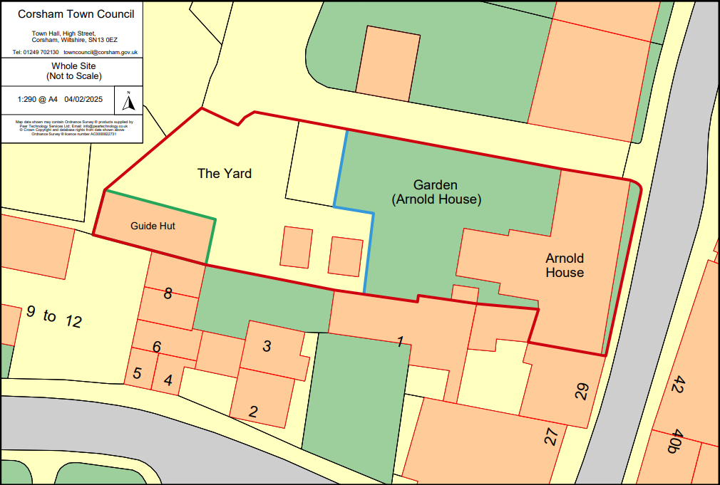

The grounds team is based in two buildings on the High Street: Arnold House (31 High Street) contains a small mess room and the Guide Hut (a timber framed building to the rear of Arnold House) functions as a workshop and store. The team also has a small yard in the curtilage of the Guide Hut. The Town Council has long recognised that these facilities are no longer fit for purpose – the workshop is tired-looking, dimly lit and not set out efficiently. The yard and workshop are cramped and more space is needed to accommodate additional staff and equipment. Furthermore, a condition survey of the Guide Hut carried out by Hextalls Surveyors in April 2022 identified a number of defects. The Town Council had been planning to sell Arnold House and the Guide Hut and had been pursuing a project to construct a new workshop in an out of town location. This project had got quite advanced (to the technical design stage – RIBA Stage 4). However, the Council decided not to proceed with it once a detailed cost plan had been worked up (£944,710).

Following this decision, the Town Council thought again about how to provide proper/suitable facilities for its grounds team and thinks there is scope to redevelop and expand the existing facilities. Moreover, it is felt that this could be achieved at significantly lower cost than constructing a new workshop and that it could be delivered in stages (which would make funding the project through the precept much easier). As such, Corsham Town Council wishes to undertake some scoping work (essentially RIBA Stages 0-2) to determine whether this is something that should be pursued.

The site does have some constraints: Arnold House is a Grade 2 listed building and both the Guide Hut and Arnold House are in a conservation area – so any redevelopment will need to be sensitive to the location and meet the requirements of Wiltshire Council’s planning department/conservation officer. The site is also limited in space. However, we feel that there may be scope to move the Arnold House/Guide Hut yard boundary and so gain extra yard space. As such the Town Council is keen to employ an architectural practice with experience of working with listed buildings and in conservation areas to see if it would be a feasible/suitable project to pursue.

Overall, we would like to:

* Deliver a well-ordered workspace that allows the grounds team to perform their functions in an efficient, organised manner.
* Expand the workspace to accommodate an expanded workforce and new responsibilities.
* Provide modern welfare and office facilities to accommodate the grounds team.
* Achieve good levels of energy efficiency and contribute towards the Council’s aim of achieving net-zero by 2030.

**What we’d like to Deliver:**

Guide Hut:

Address the defects identified in the 2022 Building Survey Report including:

* Undertake a complete overhaul of the roof – Strip and reclad the roof, install insulation and new felt lining, treat timbers against woodworm and provide some means of ventilation.
* External walls – Minor repointing to ground level rubble stone walls and replace any rendered panels that have previously been repaired/replaced with cement, with lime.
* External joinery, windows and doors – Repair elements of the timber frame using a skilled historic timber specialist, replace the drip between the ground and first floor, seal joints with lime mortar to prevent water ingress, treat any signs of woodworm infestation and repair/replace the window frame and sill on lefthand elevation.
* Internal walls – Replace any plasterboard panels (first floor), OSB boards, foam and any other crude patching repairs with lime mortar and replace any render that has come away. Consider insulation within the wall structure.
* Internal joinery – Treat any signs of woodworm infestation and replace any joinery that requires replacement.
* Ceilings – Replace chipboard, plasterboard, foam, Artex and any other materials used in patching repairs with lime mortar.
* Windows – Check all window frames and repair/replace any damage (the first floor window on the lefthand elevation certainly requires a complete overhaul), improve draft sealing where required and replace any cracked panes.
* Doors – Replace front door(s) and refurbish first floor door to the external staircase.
* Internal decoration – A significant improvement in the quality of surface finishes and fittings and redecorate using appropriate materials for workspace.
* Services – Install an appropriate (for its use) and energy efficient heating system.

Equip the ground floor for use as a workshop by:

* Improving the internal lighting.
* Creating two separate workbench areas (one to the left and one to the right of the entrance).
* Install an airline to each workbench.
* Improve ventilation in the working area (to aid tasks such as painting and varnishing).
* Install modern intruder and fire alarm systems.
* Creating a battery charging area (much of the team’s equipment is now battery powered).
* Re-fit the first floor entirely for storage with access via the external steps.
* Consider removing the internal stairs, if building regulations allow. If not, then consider some measure to make them less hazardous (presently, they are very steep and cramped).

Yard:

In general, we’d like to:

* Enlarge the yard by moving the fence/boundary with the Arnold House garden back towards Arnold House.
* Surface the yard with a durable, hard-wearing material that enables staff to keep the yard tidy/smart and allows good drainage e.g. permeable block paving or self-binding gravel.
* Construct a new single-storey storage building in the yard (probably close to where the current storage sheds are located). The new building should feature a green roof, internal lighting, frost-proof heating and be fitted out to store equipment.
* Consider whether it would be possible to construct a better access, direct from the long-stay car park.

Within the yard, we’d like to provide the following:

* Compost heaps x3 (made from robust durable materials).
* Covered road grit/salt storage area.
* Storage for low value items (Heras fencing, stakes, cones etc).
* Storage for heavy items such as paving slabs.
* Temporary storage for a skip (frequently replaced by Hills).
* Area for a bowser/trailer or removeable tank for a new vehicle.
* Area for a rainwater tank (capturing rainwater from the Guide Hut).
* Parking for 5no. work vehicles in marked bays, including EV charging for two vehicles.
* Parking for temporary/hired vehicles/equipment such as a telehandler, ride-on mower, street sweeper.
* Create a new chemical store in the yard near the Guide Hut. Secure, well contained, shelving, fit for purpose.

Arnold House:

In general, we would like to split the ground floor of Arnold House into two specific areas: we’d like to use the front (the original part of the building) to house the Tourist Information Centre (TIC) and the rear (the extension) to house mess facilities and office/planning facilities for our grounds team. As such, we would like to modernise the electrics and have electric meters that split the TIC and grounds team use. We would need to provide the TIC with new kitchen facilities, probably in the far lefthand side of the building. We would also like to install a new heating system using an air-source or ground-source heating pump and carry out works to improve the thermal efficiency of the building, including the installation of secondary glazing (the Town Council recently employed Mitchell & Dickinson to install secondary glazing at the Town Hall and are very happy with their Cozyglazing system).

At the rear of the building (the grounds team area) we would like:

* Refit and redecorate the mess room to provide suitable welfare facilities for the grounds team.
* Re-fit the food bank room for use as a grounds team office/planning room. This would include a complete redecoration using materials appropriate for the listed building and its proposed use and providing desks, lockers noticeboards and maps on walls, Wi-fi etc.
* Provide drying room and shower facilities.
* Provide adequate toilet facilities at the rear of the building, possibly making use of the two lean-to blocks (we would like to look at waterless urinals and/or rainwater flushing if possible).
* Provide a cupboard for muddy boots (potentially the small outside shed near Flat 2 entrance).

At the front of the building (TIC) we would like:

* To redecorate using materials appropriate for the listed building and its’ use as a TIC.
* Address any outstanding defects highlighted in the 2022 Building Survey Report.
* Provide the TIC with kitchen facilities at the left-hand side of the building.

**Site Visits:**

Prospective companies are strongly encouraged to undertake a site visit before submitting a tender. Please contact James Whittleton (Head of Technical Services) to arrange a time/date: [jwhittleton@corsham.gov.uk](mailto:jwhittleton@corsham.gov.uk) 07879 256215.

**Tenders:**

Corsham Town Council wishes to appoint a contractor to undertake some initial development/feasibility work, in order for the Town Council to determine whether it would be possible/suitable to take the project through to delivery. As such, we think it would be suitable to take the project through to the end of RIBA Stage 2 – Concept Design stage. At this point, the Town Council would expect to have a good understanding of:

* What would be possible from a design point of view and if it would meet the needs of our grounds team.
* What planning or building control constraints might be present. We would expect the contractor to take advantage of Wiltshire Council’s pre-application advice service in order to ascertain what is permissible at this site.
* Cost plan/estimate of how much it would cost to deliver.

We would like tenders to include the following:

* A quote for architectural and principal designer services for RIBA stages 0-2, with a fee breakdown by stage.

Quotes are to be based on a traditional form of procurement and should be inclusive of all fees, but exclusive of VAT.

Fees should be based on an estimated contract value of £500,000.

The Town Council would also like tenderers to submit the following additional information:

* Please provide details of three recent projects that might demonstrate your skills and ability to deliver projects dealing with similar issues (listed buildings, working within constraints) of a similar size and complexity – preferably completed in the last five years (maximum 200 words per example). Provide contact details, so that we can take up references for these projects.
* Please provide details of how the project would be resourced within your organisation (maximum 300 words).
* Please describe your practice’s approach to the design and delivery of sustainable (preferably carbon neutral) design (maximum 300 words).
* Please provide hour rates and day rates charged for members of your team who would be working on the proposal.

**Submission of Tenders:**

Tenders should be sent via email to [dmartin@corsham.gov.uk](mailto:dmartin@corsham.gov.uk) and [kgilby@corsham.gov.uk](mailto:kgilby@corsham.gov.uk) with “Tender – Guide Hut/Arnold House” in the title bar.

Alternatively, tenders may be sent by post or delivered by hand in an envelope clearly labelled “Tender – Guide Hut / Arnold House”, addressed to:

David Martin – Chief Executive

Corsham Town Hall

High Street

Corsham

Wiltshire, SN13 0EZ

Tenders should be received no later than **12.00 noon on Friday 9th May 2025.**

**Interviews:**

Following receipt of tenders, Corsham Town Council will invite up to three companies to attend an interview.

We would like these interviews to take place c.3 weeks following the submission of tenders.

**Evaluation:**

The Town Council will assess tenders on a 60:40 quality:cost basis.

**Evaluation Criteria:**

|  |  |  |  |
| --- | --- | --- | --- |
|  | Overall Weighting | Category | Category Weighting |
| Price | 40% | Cost/Competitiveness | 40% |
| Quality | 60% | Environment – commitment/ability to achieve excellent environmental performance | 20% |
|  |  | Technical – capability & resources | 15% |
|  |  | Service Delivery – flexibility, communication, reaction to problems, innovation and added value | 15% |
|  |  | Quality – customer care, quality of service, continuous improvement | 10% |