

TERMINAL EAST EXTENSION 2025

Expression of Interest Notice

General

NIAL is issuing this Expression of Interest in connection with the advertisement placed in the Finder a Tender service (FTS) and using the ‘Competitive Flexible Procedure’ in accordance with the Procurement Act 2023.

NIAL is seeking to appoint a suitably qualified and competent Contractor to deliver the Terminal East Extension, Newcastle International Airport.

During the procurement process negotiations between NIAL and Applicants/Tenderers on fundamental aspects of their offer, such as price are not permissible.

Compliance Check

The project is to be procured using a Design and Build tender process comprising of three stages:

Expression of Interest / Pre-Qualification Questionnaire

First Stage Tender Submission

Second Stage Competitive Package Tendering

NIAL will conduct compliance checks following receipt of the Expressions of Interest. Submissions which are substantially incomplete, or which are non-compliant with the requirements set out in this Expression of Interest may be rejected.

Following initial selection process comprising of the Expressions of Interest / PQQ, the first stage process will commence. Invitations to tender will be issued to a maximum of 5 applicants who the contracting authority consider have submitted the optimum submissions and demonstrated they are the most capable of fulfilling the contract.

Expression of Interest / Pre-Qualification Questionnaire (PQQ)

The Expression of Interest / PQQ stage compliance check will comprise of assessing responses to the criteria outlined in the ‘Supplier Expressions of Interest Questionnaire’ which are set out below in an abbreviated form:

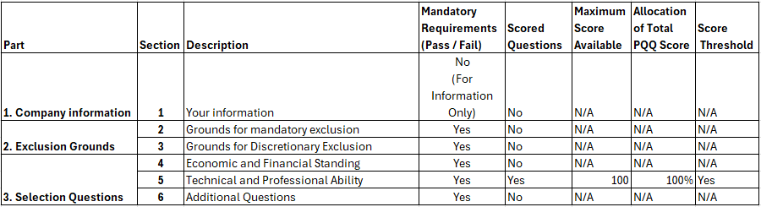

Failure to meet the mandatory requirements and achieve ‘Pass’ classification will result in the Applicants not being considered further and their Bid rejected.

The completed Expression of Interest Questionnaire is to be submitted electronically for the attention of Neil McIntyre, nm@newcastleinternational.co.uk no later than the deadline outlined above.

The Tender documents are made available electronically on the NIAL portal access to which can be obtained by contacting Neil McIntyre, nm@newcastleinternational.co.uk .

