Enquiries to: Richard Clayfield

E-mail: Richard.Clayfield@wales.nhs.uk

Telephone: +44 1639509411

4th July 2025

Digital Devices Ltd

Unit 16 Park Royal Metro Centre

Ealing

London

NW10 7PA

UNITED KINGDOM.

Dear Sir,

**ACCEPTANCE OF CONTRACT –**

**CONTRACT:** **TENDER FOR THE PURCHASE OF MOTOROLA G75 BUSINESS EDITION MOBILE PHONES**

**PERIOD: One Off Purchase x 300 Mobile Phones**

**CONTRACT NUMBER:** **SBU-MIN-59393**

I am pleased to confirm that we are now in a position to accept your offer as previously detailed.

All delivery notes and invoices must state the relevant Purchase Order Number, any invoices without a valid Purchase Order will be rejected in line with the All Wales No PO No Pay Policy.

Invoices and statements should be sent direct to NWSSP Accounts Payable via email address [NWSSP_PSU_P2P@wales.nhs.uk](mailto:NWSSP_PSU_P2P@wales.nhs.uk).

The contract reference number above must be quoted on all future correspondence.

I have attached a copy of all finalised contractual documents for your acceptance, I would be grateful if you could please sign below where indicated and return one copy together with the schedule(s) by **9th July 2025**.

Yours faithfully,

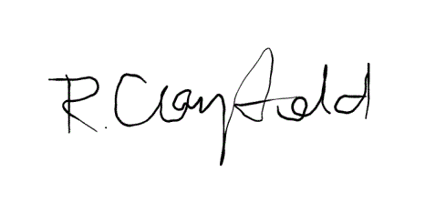pp

**KEIR WARNER**

Head of Procurement

**ACCEPTANCE OF CONTRACT**

I/We hereby acknowledge the receipt of the acceptance for the Supply of Motorola G75 Business Edition Mobile Phones detailed in the Contract documents, and I/We undertake to supply strictly in accordance with Contract documents attached which contain the following;

* NHS Shared Business Services Framework SBS10514 T&C
* Contract award letter
* Contract Schedule.

|  |  |
| --- | --- |
| **SIGNED** |  |
|  |  |
| **NAME IN BLOCK LETTERS** | **KASH JAVED** |
|  |  |
| **PER PRO** | **Project Manager** |
|  | **04-07-25** |
| **DATE** |  |