

Tender

Bishop Otter Campus:

Minor works contract for provision of 2 No. accessible rooms in Chilgrove

The University of Chichester

**Appendix 03**

Copyright © 2022 by The University of Chichester. All rights reserved. This document is supplied purely for the purpose of assisting suppliers to respond to this procurement, no part of this document may be reproduced or transmitted in any form, by any means (electronic, photocopying, recording or otherwise) for any other purpose

|  |  |  |
| --- | --- | --- |
| University of Chichester  College Lane Chichester West Sussex  PO19 6PE | Telephone: Date: Revision: Email | 01243 816000  15/01/2025  1.0 [Tenders@chi.ac.uk](mailto:Tenders@chi.ac.uk) |

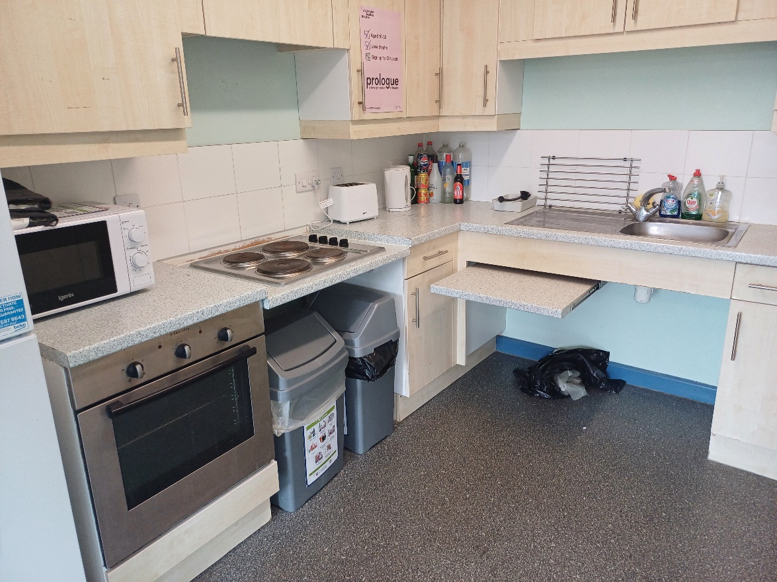

**Picture 1:** Overview(cooker hob ,Worktop)

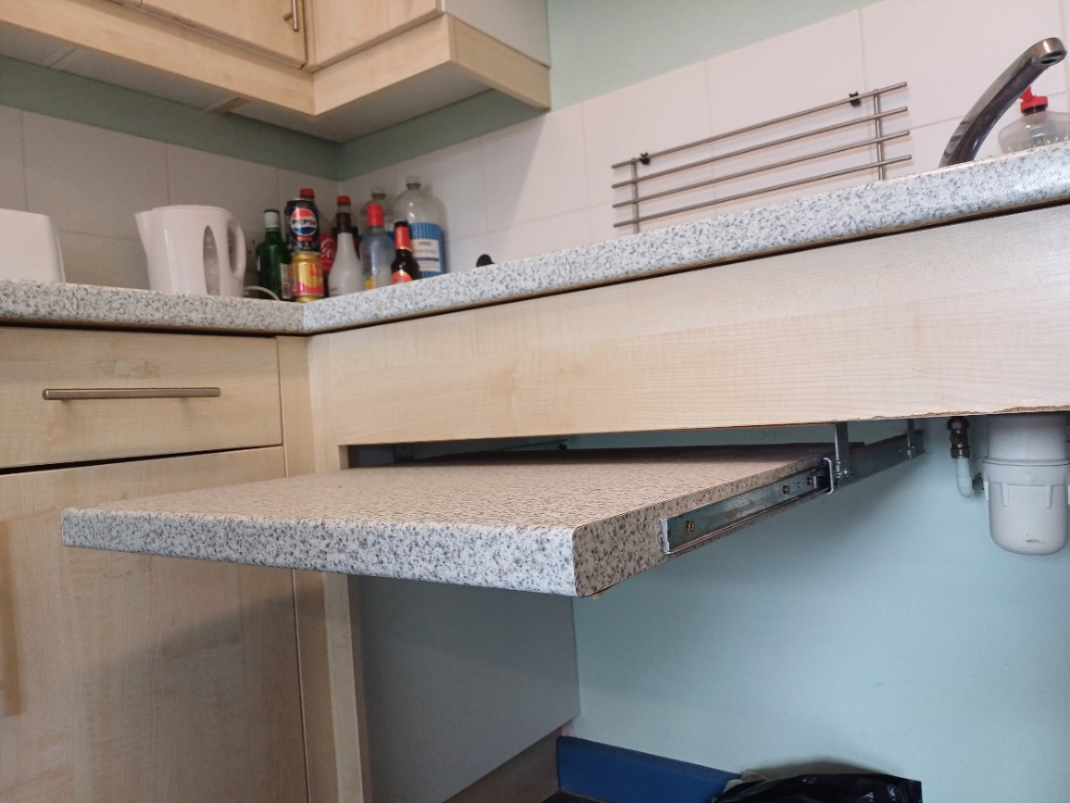

**Picture 2:** Retractable worktop with sliding rail

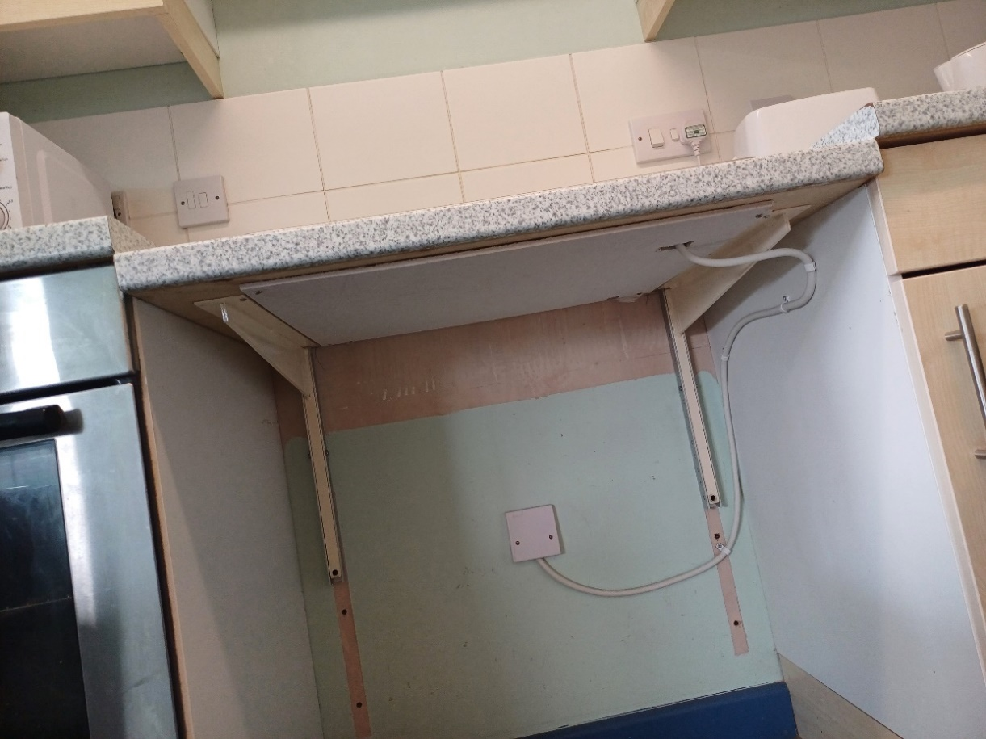

**Picture 3:** Cooker hob (With adjustable Brackets)

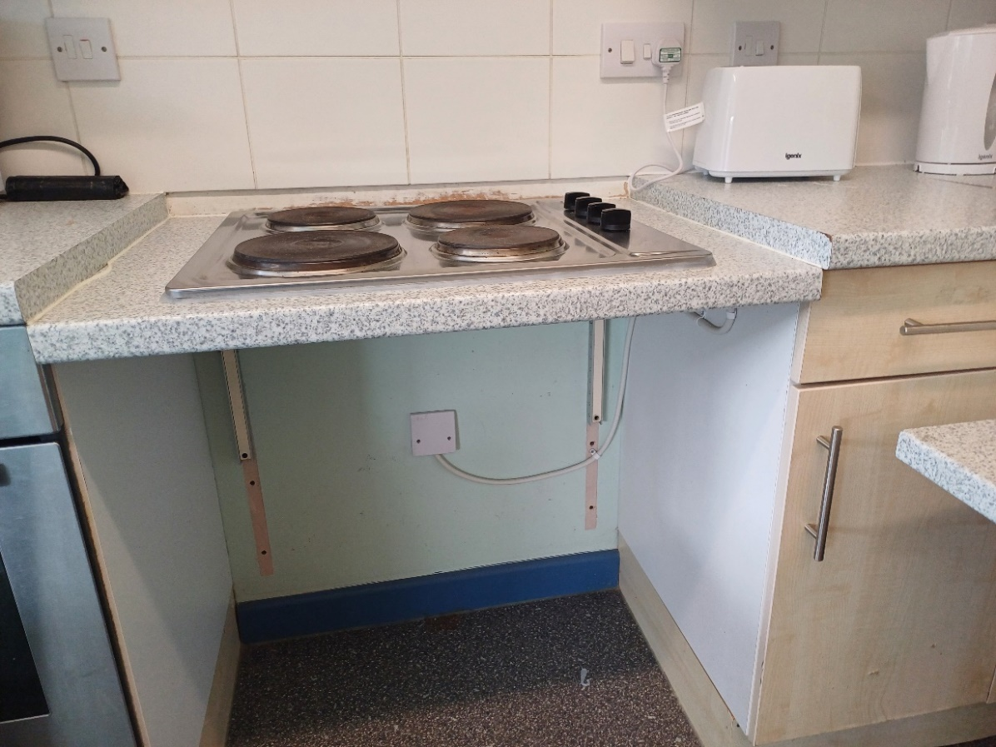

**Picture 4:** Cooker hob ,Hight to be agreed as suitable for people with wheelchair

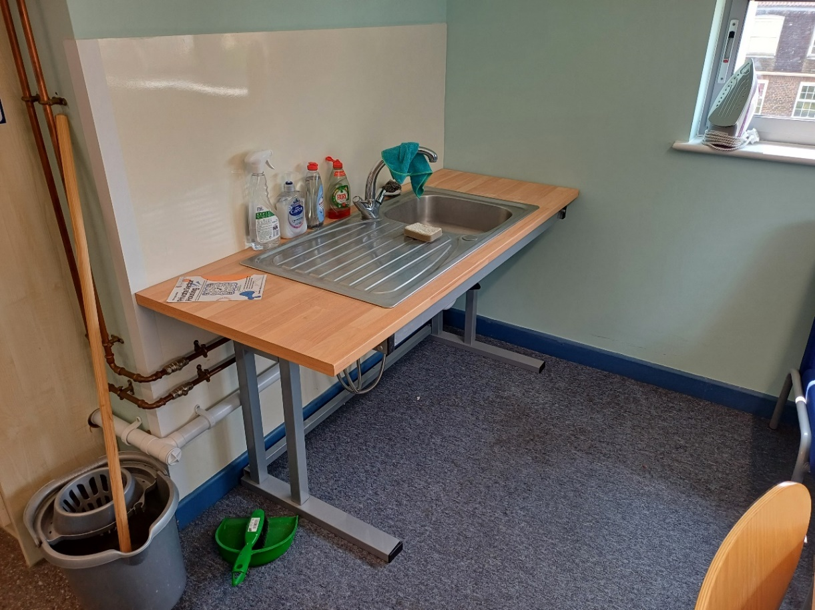

**Picture 5:** Adjustable height desk with sink installed

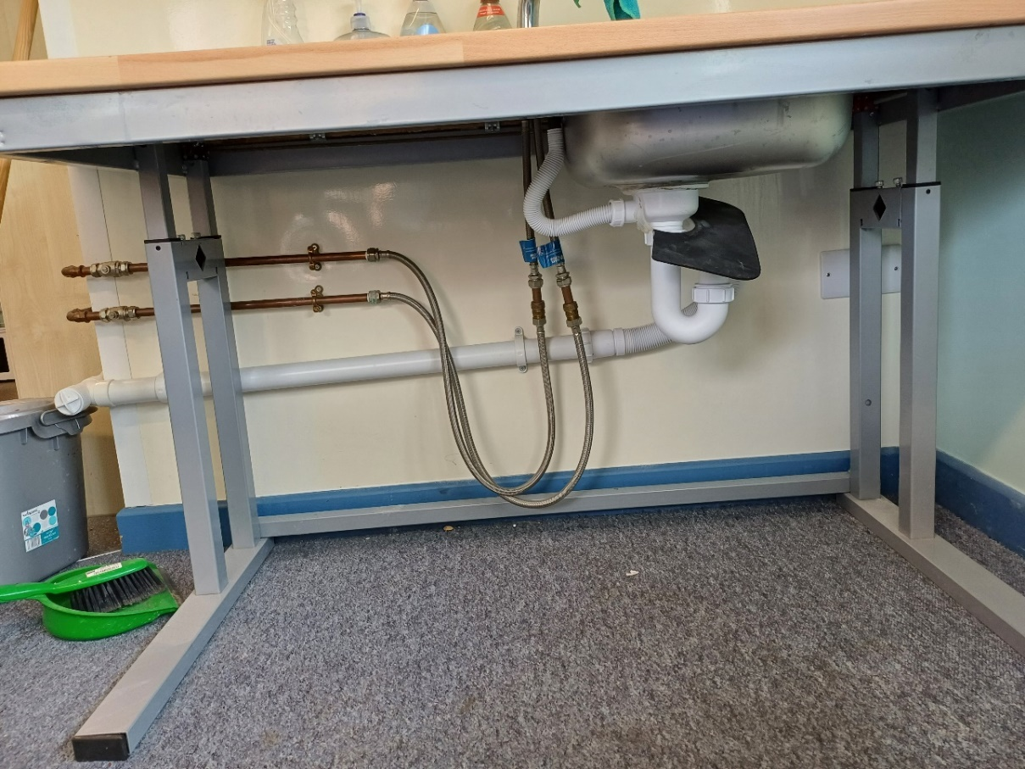

**Picture 6:** Flexible connections (Installed underneath).

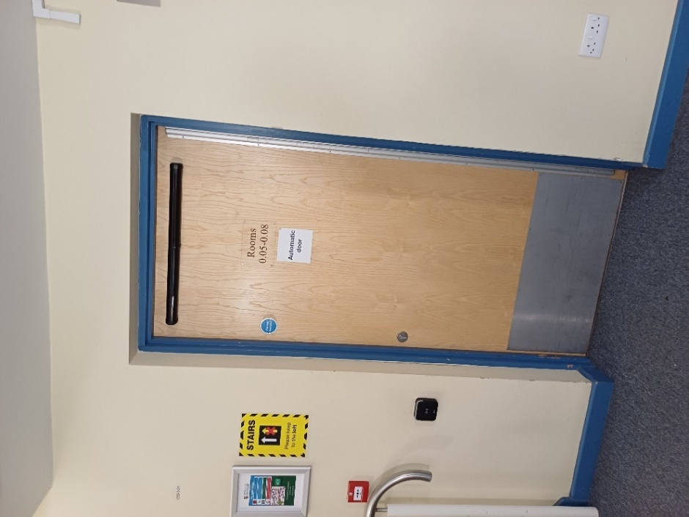

**Picture 7:** Door for flat entrance (900mm wide opening minimum), Automatic opening

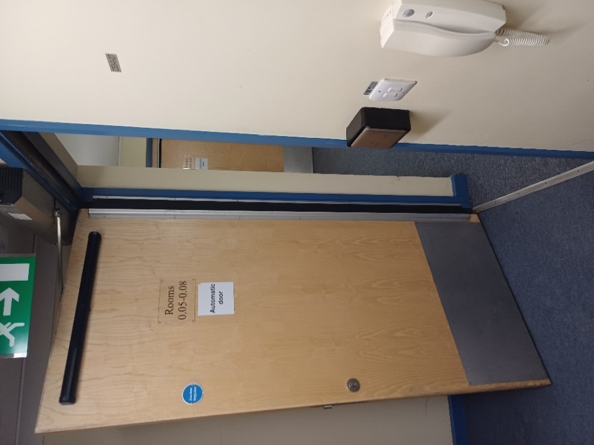

**Picture 8:** Door with automatic push button opening