PLANNED PROCUREMENT NOTICE

Procedure
Is this procurement under a special regime?
Select all that apply.
Concession (Main procurement category must be services or works.) ☐
Defence and security ☐
Light touch (Main procurement category must be services.) ☐
Utilities ☐
or

No special regime ☒

What is the main procurement category?
Select the main type if more than one applies.
Goods ☐
Services ☐
Works ☒
An additional procurement category with a lower threshold is included (optional) ☐
If so, then the lower threshold applies. For example, if goods are included in a contract mainly for works.

What is the procedure type?
For threshold amounts, refer to Schedule 1 of the Procurement Act 2023 at https://www.legislation.gov.uk/ukpga/2023/54/schedule/1
Open procedure (above threshold) ☒
Competitive flexible procedure (above threshold) ☐
Including if a dynamic market is being used above threshold.
Below threshold ☐

Scope

Procurement title
Leivers Court, Arnold, Planned Procurement Notice

Procurement reference (optional)

Procurement description

The required goods, services or works, including the amount and how they must be supplied.

You have 10,000 characters available.
Background
The existing building and associated infrastructure on site are owned by Nottinghamshire County Council and was previously used as a residential care home for older people, which has been vacant and unused since 2019 (ref: Planning Permission 82/1063). The existing building is now deemed unfit for purpose, and it is proposed to demolish the existing care home to make way for a mix of supported living accommodation for young people and affordable rented family housing.

Proposal
This proposal will bring a longstanding derelict brownfield site back into use for public betterment for much needed housing.

The scheme will improve the current brownfield area with 30 new, affordable homes that meet the housing needs of the local populace, tenures and housing types detailed below:

- 24x 1B2P flats for supported housing with associated facilities (2x to be used for office space and communal facilities)
- 6x 2B4P houses for affordable rent
- 2x 3B5P houses for affordable rent

The 22 flats form part of a specialist care and support contract between NCHA and Nottinghamshire County Council and will provide supported housing for the Homelessness and Supported Accommodation Joint Working Protocol for young people aged 16-21 and Care Experienced young people up to the age of 25.

The scheme has very strong support from the Local Authority, Gedling Borough Council have noted a demonstrated need for housing within Gedling for families. The homes will be let through Gedling homes search service addressing the local need.

This scheme will:

- Help improve the site as a sustainable place, replacing an empty, depleting building, with young person’s scheme and family houses.
- Grow the economy, with direct and indirect jobs and apprenticeships provided both during the build process, but also in the running of the supported accommodation.
- Provide new homes on a Brownfield site.
- Reduce inequality by providing quality homes for residents in need- for the flats we are proposing an all-electric solution to reduce standing charge and hence cost of living for the residents.
- Improve health outcomes for vulnerable residents – providing safe, secure, and supported housing with lower running costs.
- Deliver high energy performance units (target EPC A/B) helping to reduce carbon emissions, as detailed below:

Energy: In line with NCHA’s corporate strategy, we are aspiring to achieve an EPC A rating for the houses utilising air source heat pumps. We are aspiring to achieve an EPC B rating for the supported housing flats, and are actively exploring the scheme being fully electric, utilising modern methods of heating and the installation of PV’s to help reduce financial pressures of energy for our customers.
Biodiversity: This scheme is not subject to BNG requirements as the planning application was made before February 2024. Perimeter trees are being retained and a landscaping scheme proposed to make the courtyard a good area for service users to socialize. The presence of a bat in the existing building has been surveyed, we have been advised this will be covered by a Bat Mitigation Clasp license.

Flooding: There is no recorded flood risk in the local area.
Local Authority Area: Gedling Borough Council

Programme

Milestone | Proposed programme date
Exchange of contract | June 2025
Full Planning permission | February 25 (with officer recommendation for approval and subject to a Section 106 agreement. Reference: 2022/0867PRE)
Funding agreed (if relevant) | Homes England (Strategic Partnership Funded)
Start on site | Demolition works of existing building to take place before 31st March 2026
Practical completion | September 2027

Site
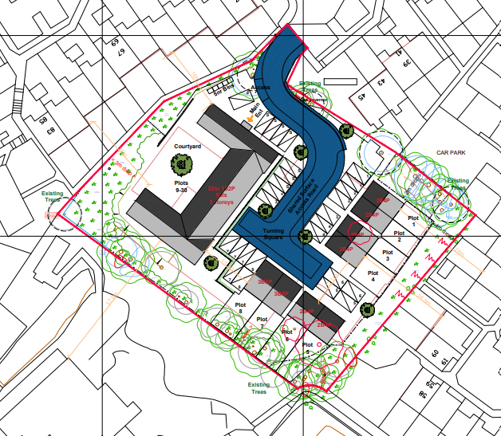

The successful tenderer will be expected to enter into a JCT 2024 Design and Build contract with demonstratable experience in delivering complex building projects and sustainable technology.

Is a framework being established?

Yes ☐

No ☒

Is the procurement divided into lots?

Yes ☐
No ☒

Participation
Small and medium-sized enterprises (SMEs) ☐
Fewer than 250 staff, and either turnover less than £44 million or balance sheet total less than £38 million.
Voluntary, community and social enterprises (VCSEs) ☐
Non-governmental organisation that is value-driven and principally reinvests its surpluses to further social, environmental or cultural objectives.

Total value (estimated)

Maximum value including all possible extensions and options. For a framework, the sum of the values of all contracts awarded under it, or under the same open framework scheme. For example, 200000 or 417709.28.

Excluding VAT

Required if a contracting authority is central government.

Including VAT

Currency

Award criteria

Describe the criteria that will be used to decide who will be awarded the contract after tenders have been submitted. If these criteria will be refined later, describe how in the 'Competitive flexible procedure description' on the 'Procedure' page.
This tender will be awarded on a 70% price, 30% quality split and assessed against a 0-5 scoring matrix provided by NCHA in the tender documents.

Documents
Associated tender documents (optional)
Documents that supplement the tender notice may be provided, but all required information must still be included in the tender notice itself.

Description (optional)

Technical specifications to be met (optional)
Web address For example, https://www.example.com/abc123/specification.pdf.

Description (optional)

Submission

Publication date of tender notice (estimated) 12:00 (noon) on 04/08/2025
Enquiry deadline (optional) (For suppliers to ask clarification questions) 12:00 (noon) on 08/09/2025
Tender submission deadline 12:00 (noon) on 15/09/2025

May tenders be submitted electronically?

Yes ☒
No ☐

Submission address and any special instructions
Must include a website if tenders may be submitted electronically. For example, https://www.example.com/. Include further information about the electronic auction if one will be used.

An electronic auction will be used (optional) ☐

