Novation Agreement

Novation Agreement

Name of party 1

Physical address

Postal address

Phone number

Email address

Signature

NHS Hertfordshire and West Essex ICB

Outgoing Party

Charter House, Parkway, Welwyn Garden City, Herts, AL8 6JL

Charter House, Parkway, Welwyn Garden City, Herts, AL8 6JL

07385 398951

[a.shah23@nhs.net](mailto:a.shah23@nhs.net)

(who warrant that they are duly

authorised to sign)

For and on behalf of Party

Phil Turnock

Name of signatory

Title of signatory

Date of signature

Managing Director

9th July 2024

Name of party 2

Physical address

Postal address

Phone number

Email address

Signature

East and North Hertfordshire NHS Trust

Incoming Party

ENHT Cory Mill Lane Stevenage

SG1 4AB

01438314333

Ollie.morely@nhs.net

_

(who warrant that they are duly

authorised to sign)

For and on behalf of Party

Name of signatory

Title of signatory

Date of signature

Name of party 3

Physical address

Postal address

Phone number

Email address

Signature

NTT United Kingdom Limited

Continuing Party

1 King William Street, London, EC4N 7AR

As above

N/A

[uki.legal@global.ntt](mailto:uki.legal@global.ntt)

_

_______________________

(who warrant that they are duly

authorised to sign)

For and on behalf of Party

Steve Brown

Name of signatory

Title of signatory

Date of signature

CFO

By signing above, each party acknowledges that it has carefully read and fully understood this agreement and agrees to be bound

by the terms of this agreement. If an electronic signature has been used to sign this agreement (whatever form the electronic

signature takes) each party agrees that this method of signature is as conclusive of their intention to be bound by this agreement as

if signed by each party's manuscript signature.

Confidential - Recipients Only

Page 1 of 4

©

NTT DATA, Inc. NTT United Kingdom Limited Ltd. is an affiliate of the NTT DATA, Inc. Group.

East and North Hertfordshire NHS Trust

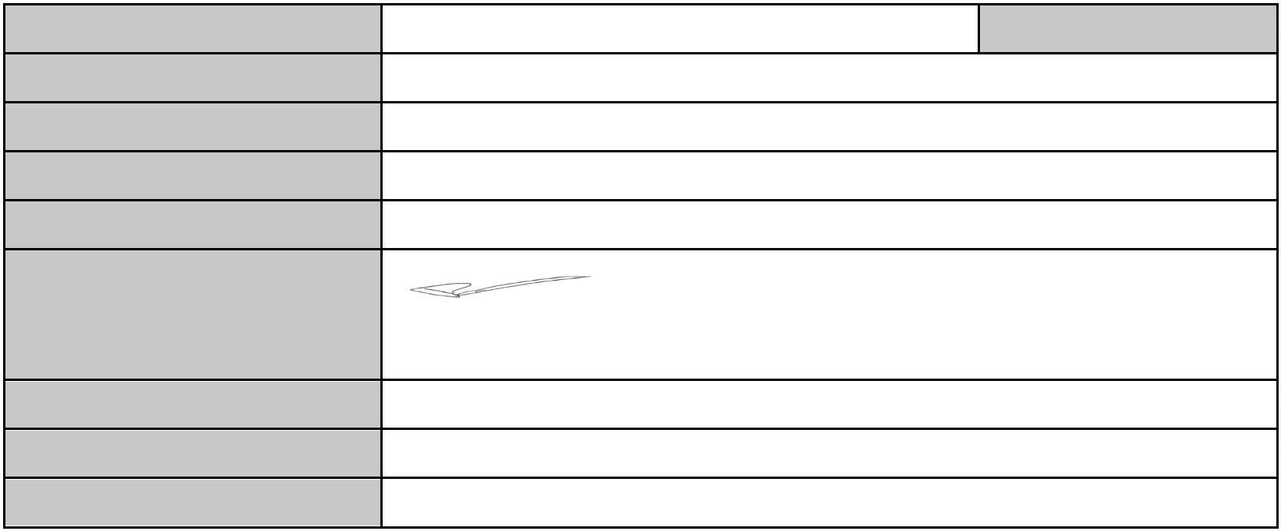

Ollie Morley, Deputy CIO

09/08/2024

Novation Agreement

1

Background:

1

1

.1

.2

The Outgoing Party and the Continuing Party are parties to the Contract.

They agree to novate the Contract to the Incoming Party on the terms contained in this Novation.

2

Definitions and Interpretation

2

.1

Defined terms

In this Novation:

(a)

“Contract” means the current Order Form (Appendix 1) Framework Agreement (REF: 000976) entered into between the Outgoing Party and the Continuing Party dated 17th November 2022 and includes all related documents;

(b)

(c)

"Effective Date" means 01/05/2024, the effective date of this Novation despite the date of

signature; and

“Novation” means this written Novation Agreement concluded between the Outgoing Party, the

Incoming Party and the Continuing Party.

2

.2

Interpretation

In this Novation:

(a)

(b)

(c)

the Outgoing Party, the Incoming Party, and the Continuing Party are referred to collectively as the

parties’ and each individually as a ‘party’.

‘

clause headings are for convenience only and will not impact the interpretation or meaning of any

terms.

unless the context otherwise requires, words in the singular will include the plural and words in the

plural include the singular.

(d)

(e)

a reference to the word ‘include’ or ‘including’ is to be without limitation.

a person includes a natural person, corporate or unincorporated body (whether or not having separate

legal personality) and that person’s legal and personal representatives, successors and permitted

assigns.

(f)

a reference to a statute or statutory provision is a reference to it as it is in force for the time being,

taking account of any amendment or modification, and includes any subordinate legislation made under

it.

(g)

any obligation on a person not to do something includes an obligation not to agree or allow that thing to

be done.

(h)

(i)

the term ‘or’ will be interpreted as ‘and/or’ unless otherwise indicated, and

all attachments of the Contract form part of the Novation.

3

Novation

3

.1

Novation

In consideration of the Outgoing Party procuring the Incoming Party to accept the Outgoing Party's rights and

obligations under the Contract, the Continuing Party agreeing to release the Outgoing Party from its

obligations under the Contract and the Incoming Party agreeing to take on the rights and obligations of the

Outgoing Party under the Contract, with effect on and from the Effective Date, the parties agree to novate the

Contract so that each of the following is the case:

(a)

the Incoming Party replaces the Outgoing Party under the Contract as if it is an original party to the

Contract; and

(b)

a reference in the Contract to the Outgoing Party must be read as a reference to the Incoming Party.

3

3

.2

.3

Assumption of rights and obligations

With effect from the Effective Date, the Incoming Party:

(a)

(b)

is bound by, and must comply with the Contract; and

obtains the rights and assumes the obligations of the Outgoing Party under the Contract.

Obligations and liabilities

The Incoming Party is not liable for any obligations or liabilities of the Outgoing Party under the Novation

which accrued or arose before the Effective Date. From the Effective Date, the Continuing Party must comply

with the Contract on the basis that the Incoming Party has replaced the Outgoing Party under it in accordance

with this Novation.

Confidential - Recipients Only

Page 2 of 4

©

NTT DATA, Inc. NTT United Kingdom Limited Ltd. is an affiliate of the NTT DATA, Inc. Group.



Novation Agreement

3

3

.4

.5

Release by Continuing Party

The Continuing Party releases the Outgoing Party from any obligation or liability under or in respect of the

Contract excluding any liability or obligation which arose under or in respect of the Contract before the

Effective Date.

Release by Outgoing Party

The Outgoing Party releases the Continuing Party from any obligation or liability under or in respect of the

Contract excluding any liability or obligation which arose under or in respect of the Contract before the

Effective Date.

4

Consideration

4.1

5

Costs

5

.1

The parties will each pay their own costs and expenses (including legal fees) incurred in connection with the

negotiation, preparation and execution of this Novation or (as appropriate) any amendments to the Contract.

6

General

6

6

.1

Governing Law

This Novation and any Dispute (defined below) or claim arising out of or in connection with it will be governed

by, and construed in accordance with, the laws of England and Wales and subject to the exclusive jurisdiction

of the courts of England.

.2

Dispute Resolution

(a)

If a dispute arises out of or in connection with this Novation (‘Dispute’), the parties will first attempt to

resolve it through good faith negotiation as set out below, provided nothing in this clause prevents a

party from seeking interim or provisional relief concerning a Dispute, including a temporary restraining

order or preliminary injunction.

(b)

A party may initiate Dispute negotiations by delivering to the other party a written notice describing the

Dispute in sufficient detail, together with relevant supporting documents. Within 14 days of receipt of

such notice (or such other time period agreed by the parties in writing), two representatives from each

party, including at least one senior executive from each (the ‘Committee’), will conduct a meeting to

negotiate the Dispute in good faith. The Committee will determine its own procedures and any decision

of the Committee will be binding on the parties. If the Committee is unable to resolve the Dispute within

1

4 days of their initial meeting, then either party may start, as applicable, the legal or alternative

dispute resolution proceedings pursuant to clause 6.1 above.

6

.3

Notices

Any notice required in connection with this Novation must be in writing and will be deemed given when (a)

delivered in person at the notice recipient physical address or via email to the notice recipient email address,

(b) received by mail (postage prepaid, registered or certified mail, return receipt requested) at the notice

recipient physical address, or (c) received by an internationally recognized courier service (proof of delivery

received by the noticing party) at the notice recipient physical address.

6

6

.4

.5

Amendment

Except where a party expressly reserves the right to amend or update any descriptions or materials

incorporated or otherwise referenced in this Novation, no variation to this Novation will be effective unless it is

in writing and duly signed by the parties.

No Waiver

No failure or delay by a party to exercise any right or remedy provided under this Novation or by law will

constitute a waiver of that or any other right or remedy, nor will it preclude or restrict any further exercise of

that or any other right or remedy. No single or partial exercise of any right or remedy will prevent or restrict

the further exercise of that or any other right or remedy.

Confidential - Recipients Only

Page 3 of 4

©

NTT DATA, Inc. NTT United Kingdom Limited Ltd. is an affiliate of the NTT DATA, Inc. Group.



There will be no consideration payable by any party for this Novation.

Novation Agreement

6

6

.6

.7

No Third-Party Rights

No one other than the parties to this Novation have any rights under or in connection with this Novation.

Severability

If any provision (or part thereof) of this Novation is or becomes invalid, illegal, or unenforceable, it will be

deemed modified to the minimum extent necessary to make it valid, legal, and enforceable. If such

modification is not possible, the relevant provision (or part thereof) will be deemed deleted and the Novation

will be carried out as nearly as possible in accordance with its original terms and intent. Modification or

deletion of any provision (or part thereof) under this clause will not affect the validity and enforceability of the

rest of the Novation.

6

6

.8

.9

Entire Agreement

This Novation constitutes the entire agreement between the parties and supersedes and extinguishes all

previous drafts, agreements, arrangements, communications, and understandings between them, whether

written or oral. No representation, undertaking or promise will be taken to have been given or to be implied

from anything said or written in communications between the parties prior to the Effective Date, except as set

out in the Contract.

Counterparts

This Novation may be executed in any number of counterparts, each of which will constitute an original, but

which together constitute one agreement.

Confidential - Recipients Only

Page 4 of 4

©

NTT DATA, Inc. NTT United Kingdom Limited Ltd. is an affiliate of the NTT DATA, Inc. Group.

