**Yate Outdoor Sports Complex**

**All Weather Pitch & Track Floodlights**

**Specification**

**Site Address –** Yate Outdoor Sport Complex, Broad Lane, Yate, Bristol, BS37 7LB

Supply and installation of the full lighting system including removal of all existing floodlights at the All Weather Pitch & Athletics Track, replacement with new.

The system is required to meet England Hockey and England Athletics Specification.

* Class I hockey - maintained average illumination level of 500 Lux
* Class II athletics - maintained average illuminance of 200 lux

All works associated with the mechanical and electrical installation to include;

* Removal and disposal of Mast 4 (M4) on the All Weather Pitch
* Replacement of M4 - To supply and installation of 15m HL250E base hinged mast complete with concrete foundation and foundation kits identified in a structural survey report.
* Mast 20 (M20) requires an overlap pot adaptor. The current bracket must be removed, and the mounting plate cut and prepared in accordance with the specifications.
* General repainting and corrosion protection measures to all masts.
* 52no LED luminaires, new brackets and drivers.
* Removal and disposal of the existing HID floodlights.
* On completion a satisfactory electrical test and light check to confirm Lux Levels.
* A minimum 5 year parts and labour warranty.
* Risk Assessments & Method Statements to be included.

All Weather Pitch Floodlights (M1 – M8) and Mast 4 replacement to be completed first and preferably by the 1st September 2025. If works are carried out during September, then the engineers are to phase floodlight works so that only one floodlight column at a time shall be out of commission to ensure the sporting complex is still able to use the remaining floodlights for training.

Athletics Track Floodlights (M9 – M20) to be completed by 30th September with engineers to phase floodlight works so that only one floodlight column at a time shall be out of commission to ensure the sporting complex is still able to use the remaining floodlights for training.

The successful tender will be required to enter a JCT Design and Build form of contract with the client: Yate Town Council.

Retention percentage 5% reducing to 2.5% on practical completion

Valuations will be monthly. Should the works be completed in less than a month, payment will be made on receipt of invoice. 30 day payment terms.

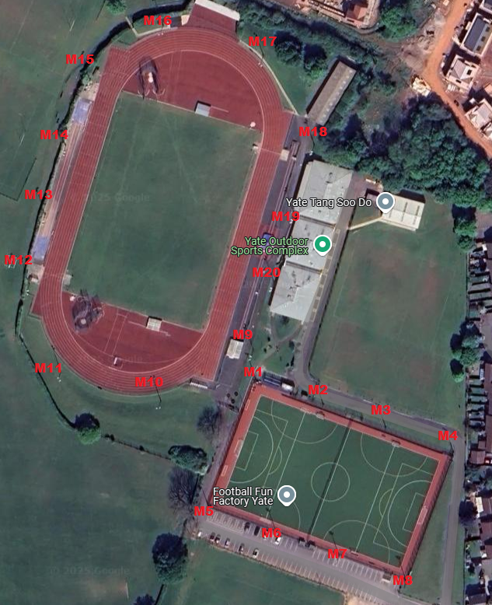

Yate Town Council, Poole Court, Poole Court Drive, Yate, South Gloucestershire, BS37 5PP

Tel: 01454 866506