Add NE Logo

**Standard Contract for Goods and/or Services - Order Form**

|  |  |  |
| --- | --- | --- |
| 1. **Purchase Order Number** | To be confirmed when Purchase Order is raised | |
| 1. **Customer** | Natural England | |
| 1. **Contractor(s)** | [**Insert** *Contractor’s name, registered address (if registered), and registration number (if registered)* | |
| 1. **Defra Group Members** | The following Defra Group members will receive the benefit of the Deliverables:  Natural England | |
| 1. **The Agreement** | This Order is part of the Agreement and is subject to the terms and conditions referenced at Appendix 1 and shall come into effect on the Start Date.  Unless the context otherwise requires, capitalised expressions used in this Order have the same meanings as in the terms and conditions.  The following documents are incorporated into the Agreement. If there is any conflict, the following order of precedence applies (in descending order):   1. this Order; 2. the terms and conditions at Appendix 1; and 3. the remaining Appendices (if any) in equal order of precedence. | |
| 1. **Deliverables** | **Applicable Deliverables** | **Goods Only:**  **Services Only:**  **Good and Services:** |
| **Goods** | None |
| **Services** | The requirement is to undertake the required timber repairs to the roof structure of the South Range as in the Schedule of Works and Repair Specification Drawings, and to reinstate the existing set-aside roof covering, as set out in Appendix 2 – Specification / Description.  To be performed at South Range, Paston Great Barn, Bacton Road, Paston, Norfolk, NR28 9TZ.  Date(s) of Delivery: *[****Insert date(s) or the period of Delivery****]* |
| 1. **Start Date** | *[****Insert*** *Day Month Year]* | |
| 1. **Expiry Date** | *[****Insert*** *Day Month Year]* | |
| 1. **Charges** | The Charges for the Goods and/or Services shall be as set out in Appendix 3 – Charges. The Charges are fixed for the duration of the Agreement. | |
| 1. **Payment** | Payments will be made in pounds by BACS transfer using the details provided by the supplier on submission of a compliant invoice. | |
| 1. **Contractor’s Liability Cap (Clause 13.2.1)** | A sum equal to £5,000,000. | |
| 1. **Customer’s Authorised Representative(s)** | For general liaison your contact will continue to be  Steve Hall- for contract management  Higher Officer- Historic Environment, National Nature Reserves Operations  Steve.hall@naturalengland.org.uk  or, in their absence,  Howard Jones- for day to day supervision of contract  Broads NNRs Senior Reserves Manager  Howard.jones@naturalengland.org.uk | |
| 1. **Contractor’s Authorised Representative** | For general liaison your contact will continue to be  [**Insert *contract manager name and contact details***]  or, in their absence,  [**Insert *secondary name and contact details***]. | |
| 1. **Optional Intellectual Property Rights (“IPR”) Clauses** | The Customer has chosen Option B (Default Option) in respect of intellectual property rights provisions for the Agreement as set out in the terms and conditions.  Default Option- Option B: Customer ownership of all New IPR with limited Contractor rights to all New IPR in order to deliver the Agreement. | |
| 1. **Progress Meetings and Progress Reports** | * The Contractor shall attend progress meetings with the Customer:   Initial site meeting.  Additionally, as required by project officer.  Site meeting on completion of works.   * The Contractor shall provide the Customer with progress reports:   Weekly.  Additionally, as required by project officer. | |
| 1. **Address for notices** | |  |  | | --- | --- | | **Customer:** | **Contractor:** | | Natural England Mail Hub  Natural England  Foss House  Kings Pool  1-2 Peasholme Green  YORK  YO1 7PX  Attention: Steve Hall  Email: Steve.hall@naturalengland.org.uk | [**insert *name and address of Contractor*]**  Attention: **[insert *title***]  Email: [**insert *email address***] | |  | | |
| 1. **Key Personnel of the Contractor** | |  |  |  | | --- | --- | --- | | **Key Personnel Role:** | **Key Personnel Name:** | **Contact Details:** | |  |  |  | | ***List names of any Contractor Key Personnel required to deliver the Agreement, and their contact details*** | | | |  |  |  | | |
| 1. **Procedures and Policies** | For the purposes of the Agreement:  All relevant policies and procedures have been outlined in the Guided Buying Request for Quotation document. | |
| 1. **Special Terms** | N/A | |
| 1. **Additional Insurance** | N/A | |
| 1. **Further Data Protection Provisions** | The further data protection provisions contained within Annex 4 of the terms and conditions are applicable to this Agreement where indicated below:  **Yes:**  **No:** | |

***[Guidance note: Please note that typically the Contractor should sign first and return the copy to the Customer to sign]***

|  |  |
| --- | --- |
| Signed for and on behalf of the **Customer** | Signed for and on behalf of the **Contractor** |
| Name:  [**Insert** name]  [**Insert** job title] | Name:  [**Insert** name]  [**Insert** job title] |
| Date: | Date: |
| Signature: | Signature: |

**Appendix 1: Terms and Conditions**

The Customer’s Standard Good & Services Terms and Conditions which can be located on the [Natural England Website](https://eur05.safelinks.protection.outlook.com/?url=https%3A%2F%2Fwww.gov.uk%2Fgovernment%2Forganisations%2Fnatural-england%2Fabout%2Fprocurement&data=05%7C01%7Cdaniel.lavender%40dlapiper.com%7Ce61b389c5e15470f278e08dbcc060e37%7Ce855e7acc54640d299f7a100522010f9%7C1%7C0%7C638328098969691096%7CUnknown%7CTWFpbGZsb3d8eyJWIjoiMC4wLjAwMDAiLCJQIjoiV2luMzIiLCJBTiI6Ik1haWwiLCJXVCI6Mn0%3D%7C3000%7C%7C%7C&sdata=ymInFtzabvMF3T9or361i03D%2B4kyuzgt8T5CzJeS7Gc%3D&reserved=0) and which are called ‘Standard Goods & Services Terms and Conditions’

**Appendix 2: Specification/Description**

**Specification of Requirements**

1. **Background to Natural England**

The Authority is Natural England. The Authority’s priorities are to secure a healthy natural environment; a sustainable, low-carbon economy; a thriving farming sector and a sustainable, healthy and secure food supply. Further information about the Authority can be found at: [Natural England](http://www.naturalengland.org.uk/).

1. **Paston Great Barn National Nature Reserve (NNR)**

Paston Great Barn is a 16th century thatched agricultural barn with associated outbuildings in north-east Norfolk, United Kingdom, located in the small hamlet of Paston. It is one of the best preserved thatched great barns left in England, and also supports the only known breeding colony of Barbastelle bats *Barbastella barbastellus* found in a building in the United Kingdom.

Location: Bacton Road, Paston, Norfolk, NR28 9TZ.

NGR: TG 32193 34544.

W3W: slanting.resolved.dorm.

Figure 1: Paston Great Barn National Nature Reserve.

It is built from coursed Quaternary flint and chert pebbles and cobbles, with brick and Lincolnshire Limestone ashlar dressings to the corners, openings and buttresses. There are several brick and flint barns connected to the Great Barn which have either pan tiled or thatched roofs. The Great Barn itself is both a designated Scheduled Ancient Monument and a Grade II* listed building and the adjoining outbuildings form part of the curtilage of the Great Barn listed building.

Paston Great Barn supports an exceptional assemblage of bat species and represents one of the few known maternity roosts of Barbastelle bat *Barbastella barbastellus* in the UK (as well as the only confirmed barbastelle maternity roost in a building in the UK). In total, 7 species are known to have used the buildings: Barbastelle, Brown Long-eared, Common Pipistrelle, Soprano Pipistrelle, Nathusius’ Pipistrelle and Natterer’s. In addition, a further two species have been recorded from around the buildings: Noctule and Daubenton’s. As a result, Paston Great Barn is designated as a Site of Special Scientific Interest (SSSI), National Nature Reserve (NNR) and a Special Area of Conservation (SAC). The barn itself is closed to the public to minimise disturbance to the bats, but other access is provided.

The year-round high sensitivity for bats makes managing the conservation of the building fabric very challenging, and although undertaking works in winter reduces the disturbance to bats it does not eliminate it, particularly as the bats are often located within the features requiring repair, such as the crevices within door lintels and headings. Additionally, the winter is not necessarily the best time to undertake some repairs, particularly those involving the use of lime mortar.

The South Range is an open fronted barn located separately from the Great Barn, and is a single-storey, detached structure to the southern boundary of the Paston Great Barn complex. It is a long, narrow range, which is largely open fronted on its northern side with walls of brick and flint to the remainder. To the western end, there is a loft with a timber floor (accessed via steps from the open fronted section) which is enclosed in solid walls. The roof is hip ended of shallow pitch, covered in clay pantiles.

Figure 2: Location of South Range Barn at Paston Great Barn National Nature Reserve.

1. **Scope**

A condition survey of Paston Great Barn and outbuildings undertaken by *Nicholas Warns Architects* for Natural England has identified structural faults relating to the roof of this building. The roof of the South Range Barn has a depression about mid-length where the structure below has failed. The connection between the truss and wall plate has broken and the wall plate has spread outwards and the truss has fallen down. The roof is relying on the short connection joints of the wall plate to prevent further spreading and collapse. Internally, the truss has disconnected from the wall-plate and fallen down, the wall-plate has been pushed outwards by the falling roof slope and the support post has moved and twisted.

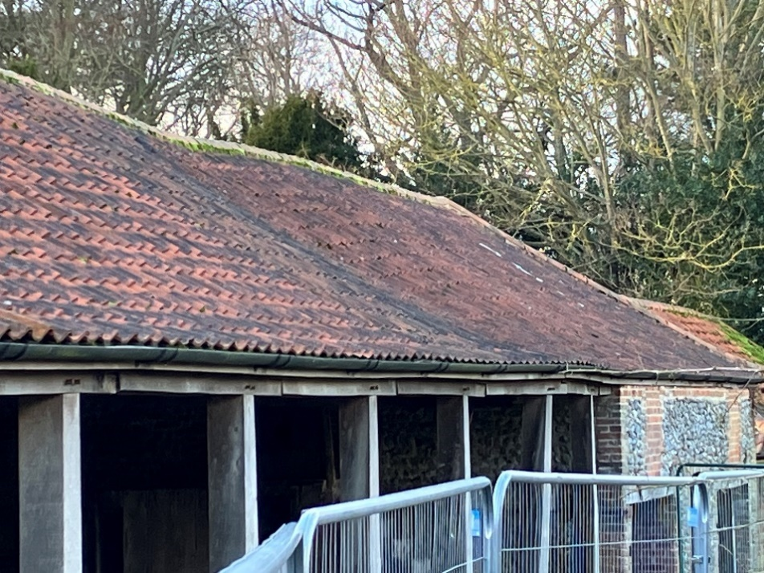

Figure 3: The South Range, looking West, showing subsidence to roof (Photo: ©Natural England/ Howard Jones).

The section of roof with the failed truss has been propped and stabilised to prevent further damage and the roof tiles have been removed from the two associated bays to reduce the roof loading and a temporary covering employed. Additionally, the public footpath adjacent to the South Range Barn has been temporarily rerouted.

Figure 4: Temporary stabilisation and roof covering, and exclusion of public footpath from the South Range (Photo: Natural England/ Howard Jones).

A structural assessment of the roof and associated timbers has been undertaken by *Conisbee Structural Engineers*, and Conisbee have identified and specified the necessary timber repairs to rectify the faults with the roof, including other trusses showing timber decay, reinforcing other truss ends and strengthening the bressummer beam connections.

1. **Requirement.**

**The requirement is to undertake the required timber repairs to the roof structure of the South Range as in the Schedule of Works and Repair Specification Drawings, and to reinstate the existing set-aside roof covering.**

The following documents are appended this RFQ:

1. South Range Structural Condition Report (*Conisbee*).
2. Repair Drawings and Specifications (Zip File- 7 no. drawings) (*Conisbee*).
3. Construction Hazard Assessment Structural Design (Designer Risk Assessment) (*Conisbee*).
4. Schedule of Works (*Conisbee/ Daniel Connal*).
5. Paston Great Barn NNR Site Risk Assessment.
6. Paston Great Barn NNR Hazard Map.

The required works are summarised in Table 1 for reference only, and costs and tendering should be based on the appended Schedule of Works and Repair Specification Drawings.

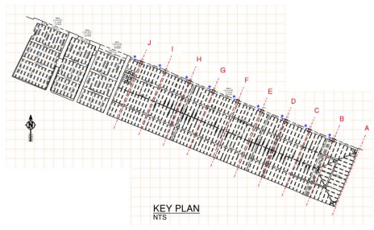

Figure 5: Plan of South Range roof showing roof truss locations and identification (© Conisbee/ Survey Solutions).

|  |
| --- |
| **Table 1: Summary of Works. Refer** **to Schedule of Works and Repair Specification Drawings for full and complete details.** |
| **Surveys / Investigations / General Works** |
| Further timber decay investigations (attendance of specialist carpenter with hand tools to identify extent/ further areas of timber decay) to determine the extent of repair/ section replacement to Truss I post base, Truss F and Truss J. |
|  |
| Remove temporary roof sheeting / battens ready to receive new work. |
|  |
| Remove previous timber repairs (incl. strapping and fixings) and make good following new repair works |
|  |
| Remove any loose materials from work area and set aside. |
|  |
| Design, supply and install temporary works (incl. all propping, bracings, struts etc) and maintain for the duration of repair. |
|  |
| **Timber Repairs** |
|  |
| Truss I Repair |
|  |
| Truss I Post Base Repair |
|  |
| Truss F Lower Chord Repair |
|  |
| Truss J Southern Top Chord Repair |
|  |
| Northern End Truss Repairs (Trusses A, C- H, J) |
|  |
| Northern End Truss B Repair |
|  |
| Bressummer Beam Connection Repairs (9 no.) |
|  |
| **Surveys / Investigations / General Works** |
|  |
| Felt and battens to section of exposed roof structure; refix previously set-aside pantiles (new pantiles if required are to match existing) |
|  |
| Reinstate gutter to match existing |
|  |

The Local Planning Authority is North Norfolk District Council, whose Conservation, Design & Landscape Team have confirmed that listed building consent will not be required in this instance, and these stabilisation works can proceed without further recourse to the Local Planning Authority.

A licenced bat worker will be appointed by Natural England who will undertake a watching brief of the repair works as and when appropriate. Any instructions given by the bat worker to the contractor must be followed. If the contractor or employees/ sub-contractors of the contractor encounter any bats whilst working the Broads NNRs Senior Reserves Manager should be immediately advised. The work must not proceed until further instruction is received.

1. **Outputs**

The contractor will be required to:

1. Secure and sign the area from pedestrians
2. Carry out any CDM requirements.
3. Carry out the described works.
4. A project report will be required detailing the works carried out with photographic evidence.
5. **Materials, labour and equipment**

All labour, materials and equipment to be provided/ arranged by the contractor, except for the existing set-aside roof tiles.

The Works include the design and construction of Temporary Works:

* The contractor is responsible for the design, supply and installation of temporary works (incl. all propping, bracings, struts etc) and to maintain for the duration of repair.
* The contractor is responsible for the provision of scaffolding as required through a suitable and appropriate sub- contractor.

The contractor is responsible for arranging further timber decay investigations (attendance of specialist carpenter with hand tools to identify extent/ further areas of timber decay) to determine the extent of repair/ section replacement to Truss I post base, Truss F and Truss J.

1. **Health and Safety**

All work is to be carried out with full regard to the safety of the workforce and any visitors to the work site. Contractors must ensure through a written Risk Assessment & Method Statement (RAMS) that all safety measures are taken to safeguard their employees and the general public in terms of equipment, clothing, PPE, site supervision and safe working practices. The RAMS must take into account individual work locations, the nature of the work, and individual site hazards. Full details of measures to remove or reduce hazards and risks posed by working at height should be included, including height above ground level, methods and equipment to be used, any PPE or fall restraint equipment to be used and expected duration of working at height.

The risk assessment should be produced with reference to the following:

1. *Conisbee* Construction Hazard Assessment Structural Design (Designer Risk Assessment).
2. Paston Great Barn NNR Site Risk Assessment.
3. Paston Great Barn NNR Hazard Map.
4. The temporary repairs to the existing structures. The original specification for the temporary repairs is provided at Annex 3.

**The RAMS must be completed and agreed with Natural England before work starts.**

All construction contractors engaged by Natural England should hold either a valid Safety Schemes In Procurement (SSIP) certification in the correct trade and scope, or ISO 45001 (Occupational Health and Safety Management) accreditationthrough a UKAS accredited certification organisation. Any contractors who do not hold SSIP/ ISO 45001 accreditation should be able to demonstrate a H&S system to the equivalent of SSIP certification and must complete a Natural England Contractor Competence Questionnaire. A copy of this is at Annex 4.

**CDM Roles**

Client: Natural England

Contractor/ Principal Contractor: The Contractor

Principal Designer: To be appointed by Natural England

If the works are likely to exceed 30 days the Project Officer must be informed so that HSE can be notified.

1. **Environmental and Site Management**
2. Protect the site, the works and the general environment (including the atmosphere, land, streams and waterways) against pollution.
3. Prevent nuisance from smoke, dust, rubbish, vermin and other causes.
4. Report immediately any suspected Asbestos containing materials discovered during execution of the works. Do not disturb and agree methods for safe removal or encapsulation.
5. Prevent personal injury or death and damage to the Works or other property from fire. Smoking on-site: Not permitted.
6. Where instructed to remove material affected by fungal/ insect attack from the building, minimize the risk of infecting other parts of the building.
7. Minimize production and prevent accumulation of waste. Keep the site and works clean and tidy. Clean out voids and cavities in the construction before closing.
8. Prevent the introduction or spread of species (e.g. plants or animals) that may adversely affect the site and/ or the Works economically, environmentally or ecologically.
9. Maintain roads and footpaths within and adjacent to the site and keep clear of mud and debris.
10. Prevent over compaction of existing topsoil and subsoil in those areas which may be damaged by construction traffic, parking of vehicles, temporary site accommodation or storage of materials and which will require reinstatement prior to completion of the Works.
11. Preserve and prevent damage to retained trees/ shrubs/ grass areas.
12. Prevent damage to existing buildings, fences, gates, walls, roads, paved areas and other site features, which are to remain in position during execution of the Works.
13. Prevent damage to existing work, structures or other property during the course of the work.
14. Prevent the trespass of workpeople and take precautions to prevent damage to adjoining property.
15. Check proposed methods of work for effects on adjacent structures inside and outside the site boundary.

**Appendix 3: Charges**

To be confirmed on Contract Award.

**Appendix 4: Processing Personal Data**

|  |  |
| --- | --- |
|  |  |
| **[XXXX]** |
| **Contract:** |
| **Date:** | **[XXXX]** |
| **Description of authorised processing** | **Details** |
| Identity of Controller and Processor for each category of Personal Data |  |
| Subject matter of the processing |  |
| Duration of the processing |  |
| Nature and purposes of the processing |  |
| Type of Personal Data |  |
| Categories of Data Subject |  |
| Plan for return and destruction of the data once the processing is complete UNLESS requirement under law to preserve that type of data |  |
| Locations at which the Contractor and/or its subcontractors process Personal Data under this Agreement |  |
| Protective Measures that the Contractor and, where applicable, its subcontractors have implemented to protect Personal Data processed under this Agreement against a breach of security (insofar as that breach of security relates to data) or a Personal Data Breach |  |