**Ham Street Woods NNR Emergency Plan 2025**

**Injury to member of Public**

If needing to move patient from far in the reserve an Ambulance should ideally attend site in 4x4 vehicle if available – Use Ride network (hazard map).

2WD Ambulance cannot access the reserve unless using the limited surfaced tracks (see hazard map) but can park at the 2 main entrance gates at.

1. Bourne Lane, Hamstreet, TN26 2HH.

What3words – ///profited.parsnips.barefoot

TR 004 338

1. Gill Lane Entrance, Gill lane, TN26 2PG.

What3words - ///Exhaling.snored.articulated

TR 014 345

Being woodland only small areas are easily accessible for helicopter landings, these being the larger glades and the wider rides. The surrounding farmland to the woods is mainly pasture and arable so is possible to land outside of the reserve.

**Wildfire**

The reserve is made up of extensive woodland with small areas of bracken and grass glades and rides which can get very dry in summer.

Water supply – The southern boundary of the woods is alongside Hamstreet village so access to mains water.

2 major streams run through the reserve and 4 ponds (see hazard map)

Fire vehicles unless 4wd are unable to access any of the reserve, unless using the limited hard tracks (see hazard map).

**Missing / Vulnerable Persons**

Ham Street Woods is a very well used site and people use most of the site. in the case of a missing person Please contact police in first instance who will liaise with the relevant parties. Reserve staff may be able to help with access & co-ordination of search if required.

**Unexploded ordnance and military use**

The woods have been used for military training so ordnance is a possibility. Although yet to be found. Please call Police on 101 if discover a suspicious object.

There are WW2 bunkers in the woods which may represent a hazard. The known one is found at TR 013 340

**Electricity Pylons**

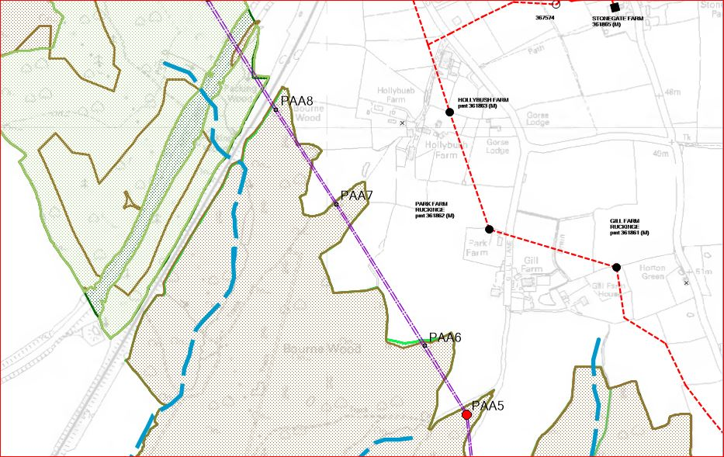

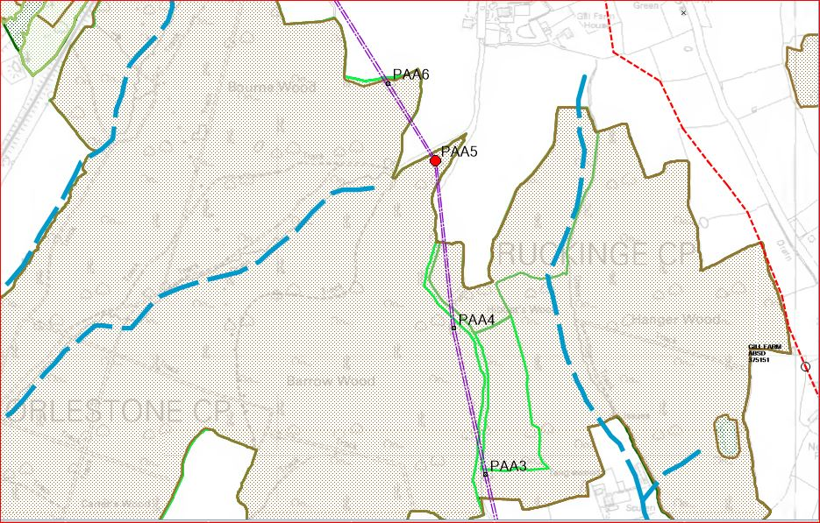

**Mobile phone reception is patchy on the reserve. If absent move to another area.**

**Emergency Numbers**

* Call 999 for emergency services – and advise on best access routes to incident.
* Report Incidents to Natural England Enquiries 0300 060 6000 – this will direct to “Duty Officer” outside office hours.

**Key NE Contacts**

NE Reserve Manager – Piers Griffin – 07881 037704

NE Senior Reserve Manager – Robin Hanson – 07342 088534

NE NNR Group Coordinator – Rob Carver – 07709 855702

NE Area Manager Sussex and Kent – Jim Seymour – 07721 759286

**Other Contacts**

Network Rail – Emergency Helpline 24 hours – 03457 11 41 41

UKPN (UK Power Network) – 0800 31 63 105 or 105.

Openreach – 0800 023 2023 (option 1)

Environment Agency – Emergency incident hotline – 0800 80 70 60 (24 hour)

Environment Agency – Flood line – 0345 988 1188

NHS Direct - 111

**Nearest Defibrillator.**

1. Hamstreet Sports Pavilion, Marsh Road, Hamstreet, Nr Ashford, TN26 2HJ.

///window.defeated.roosters

TR 002 333

1. Hamstreet Victory Hall, Ruckinge Road, Hamstreet, TN26 2NJ

///clockwork.certainly.billiard

**Nearest A&E.**

Just off Junction 10 of the M20.

William Harvey Hospital Accident and Emergency unit. Kennigton Road, Ashford, Kent,

Post Code - TN24 0LZ.

What3words - ///blast.risk.nets

TR 042 421

**Fire Station.**

Ashford Fire Station, Henwood, Henwood Industrial Estate, Ashford, TN24 8DH.

What3words - ///level.shots.chop

TR 016 429

There are smaller stations in

* New Romney, Church Road, TN28 8EX.
* Aldington, Lympe Road, TN25 7DJ
* Tenterden, Ashford Road, TN30 6BT.

**Police Station.**

Ashford Police Station, Tufton Street, Ashford, TN23 1BT (101 / 999)

What3words - ///snaps.muddy.hogs

TR 010 426

