**Ham Street Woods National Nature Reserve Track Surfacing 2025**

Ham Street Woods National Nature Reserve is located in Kent Near Ashford (Map 1 below). It is a Site of Special Scientific Interest (SSSI) due to its woodland flora, Invertebrate and breeding bird populations.

**Location: Ham Street Woods NNR, Bourne Lane, Hamstreet, Nr Ashford, Kent** **TN26 2HH.**

**Map 1 – Hamstreet Village and NNR Location.**



Specification of Requirements

*See separate plan - Track Surfacing 2025*

Bridleway Track

The main arterial bridleway track in Ham Street Woods NNR is well-used by walkers, horse riders and bikers, as well as forestry vehicles. Last year the track was resurfaced but due to adverse ground conditions affecting the clay substrate at the time of these works, the lower 400m section now requires a further dressing of 50mm compacted MOT Primary Type 1 to a width of 3m to bring it up to standard.

Linking Tracks

In addition to the above tracks adjoining the bridleway totalling 300m x 3m need surfacing to provide a choice of easy access circular routes for visitors that discourages access and disturbance across the wider woodland.

The specification for these additional works is as follows:

1. Cut back and clear overhanging vegetation to a total width of 5m. Debris to be mulched and larger material stacked within wooded areas alongside the track.
2. Scrape back soil / surface material to a width of 3m to create clean level ground into which MOT Primary Type 1 can be keyed. Infill any hollows with Type 1. All arisings to be scattered off the rides within the woodland.
3. Lay down a semi-permeable geotextile membrane (3m) to stop any loss of stone in the clay over the winter months, before laying with Type 1 aggregate.
4. Cover with an average of 150mm MOT Primary Type 1 aggregate to a width of 3m. This will vary throughout the site due to dips and hollows in the tracks.
5. Compact with vibrating roller to give a cambered surface.
6. Camber to follow the topography to enable the track to self-drain where possible.
7. Recontour ditches and install new culverts as necessary to ease drainage. Repair existing culvert side wall (to be discussed on site visit).

Tenders should be broken down to show the three separate costs of 1) the vegetation clearance, 2) 425m top-up dressing and 3) 300m of full specification track surfacing.

All works are to be completed by the end of August. This is to avoid the risk of the tracks becoming waterlogged in the autumn, making the clay soil very difficult to work with.

Further information

See the supporting documents, particularly ‘Ham Street Woods NNR Track Surfacing Brief 2025’ for background, location, access, maps and photographs.

Mandatory Site Visit

A site visit is a compulsory requirement prior to tendering. This will ensure a robust and consistent specification and accurate quotes, and provides an opportunity to discuss site access, plant/material storage, visitor management etc. Please contact Rob Carver on 07469 036829 or [rob.carver@naturalengland.org.uk](mailto:rob.carver@naturalengland.org.uk) to book and confirm arrangements.

Contractor site visits: 10am at Bourne Lane car park (**TN26 2HH)** on 15th or 17th July 2025

**Photos of Reserve entrance and Bridleway**

**Main entrance and parking at Bourne Lane.**

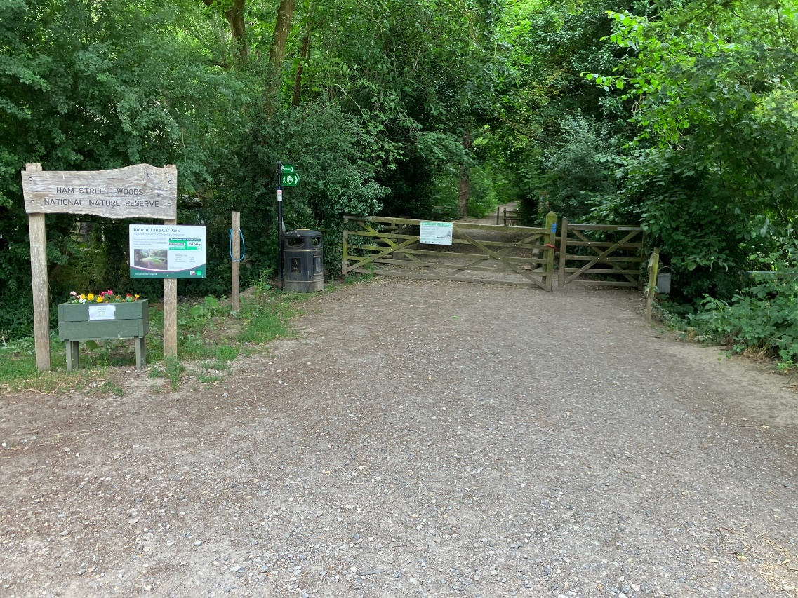

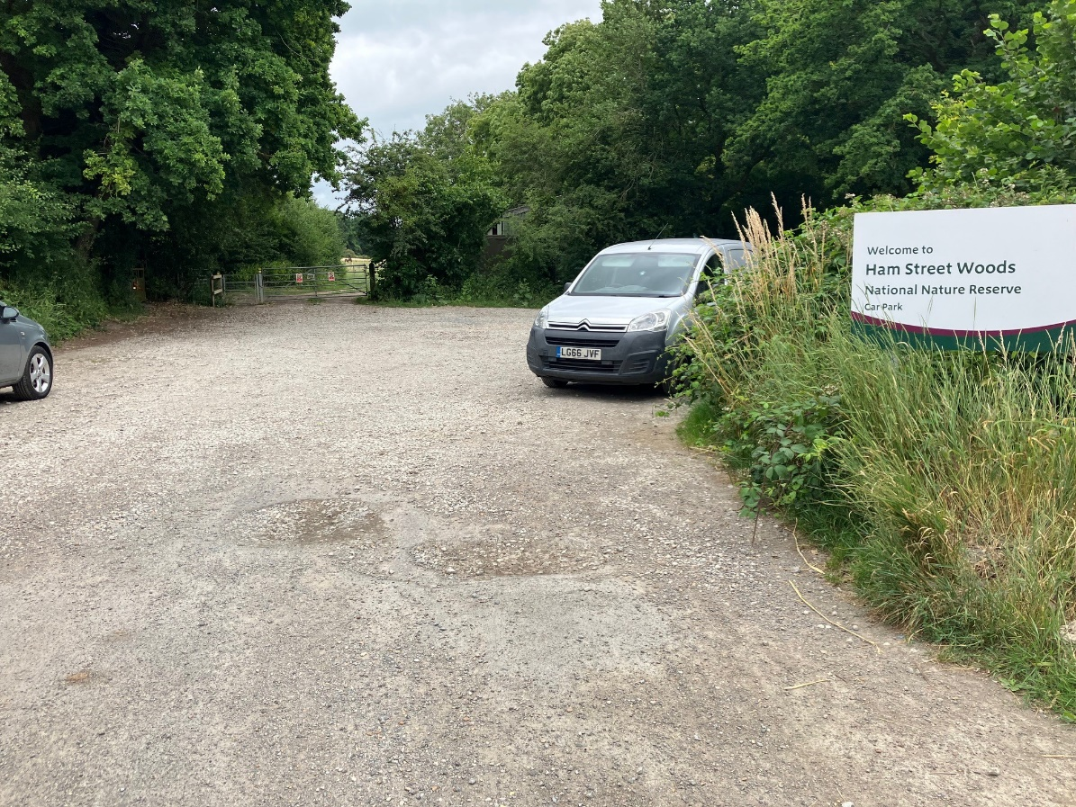

**Bridleway Photos before and after surfacing in 2024**

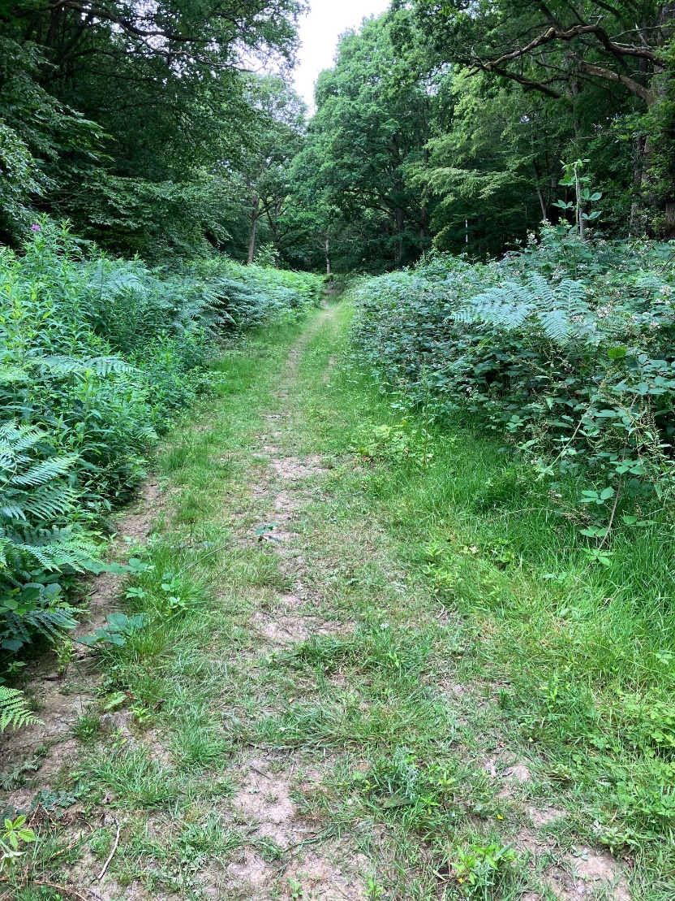

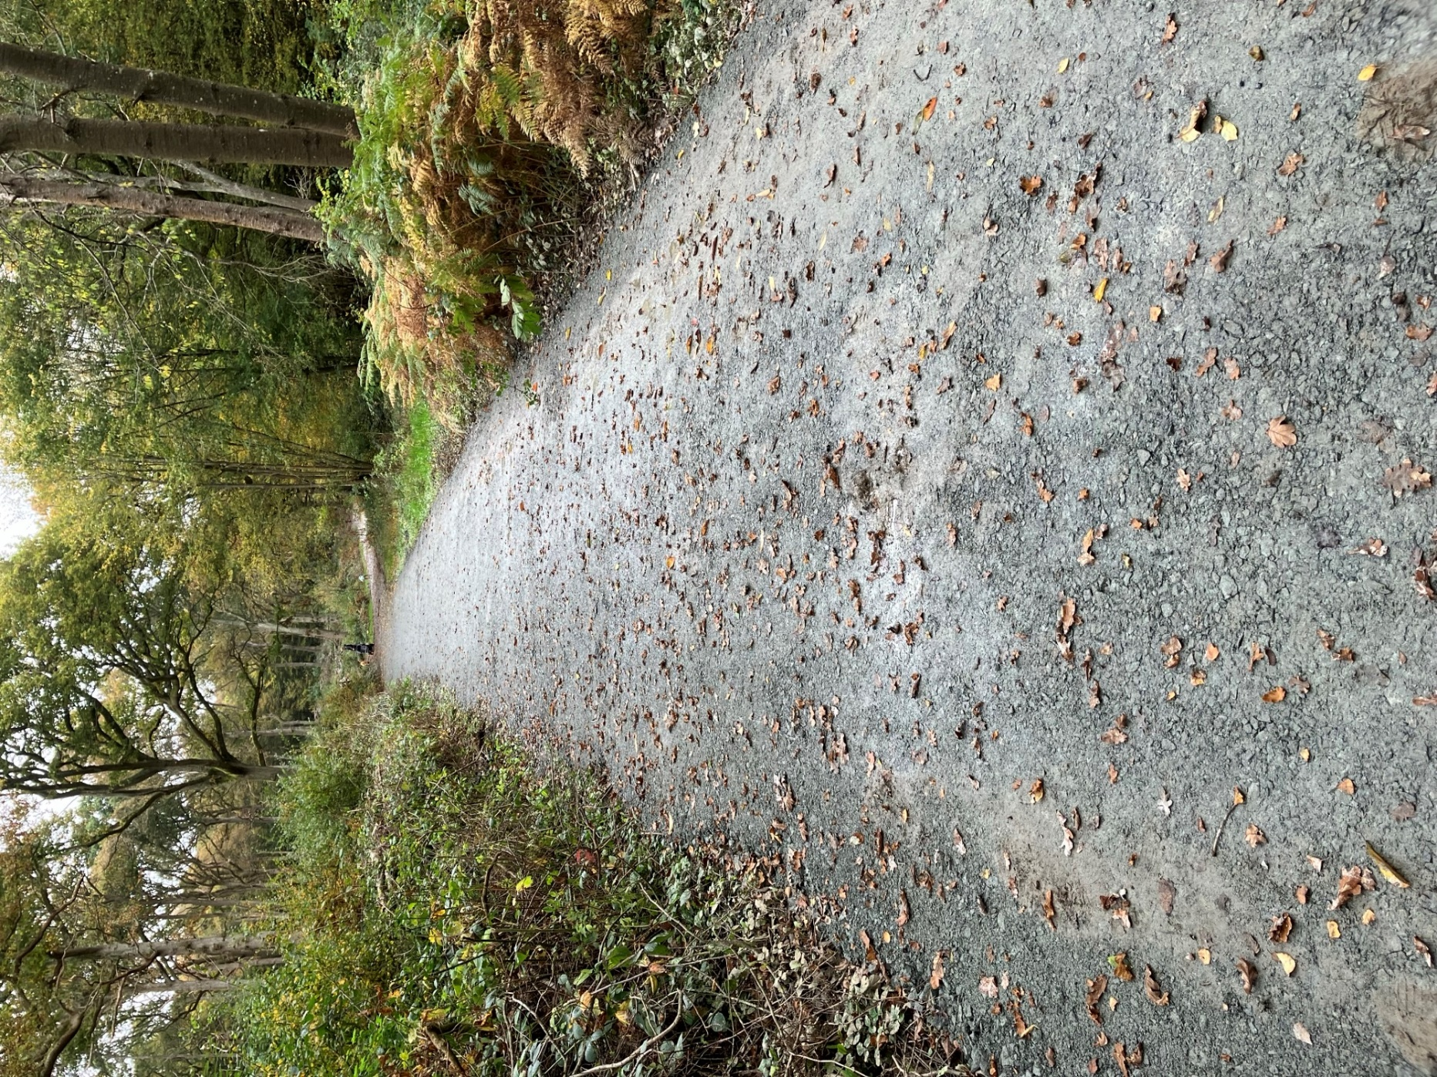

**General track photos**

