Urban Habitat Mapping Clarifications.
Answers to question received by 25th June 2025

Box 1 – Questions relevant to both Urban Habitat Mapping Amendments and Review and Urban Habitat Mapping – Expansion Requests for Quote.
Question | Answer
It was observed that the Contract locations (Pg-2 of 7) is specified as UK - United Kingdom.  To clarify project constraints, please confirm if there are any restrictions on performing this work outside of United Kingdom. Can you please confirm if this work can be performed offshore? | The work for both contracts can be carried out offshore, however;  Companies will need to be registered in the UK.  Proposals involving the offshore processing of data will need to explain the approach that will be taken to ensuring data security to protect the data.  For reference, all non-open data will be provided by Natural England via a secure link and finished products will be required to be sent via upload to a provided secure link once it is ready to deliver. Data security arrangements during the period of processing should be explained.

Box 2 – Questions relevant to the Urban Habitat Mapping – Amendments and Review Request for Quote only.
Question | Answer
Process and Timeline for Agreeing the Final Method (Task 1)  The RFQ indicates that Task 1 is expected to be completed within four weeks of contract start. Could you please clarify:  - Does this four-week period include the time required for review and sign-off by Natural England?  - Is Task 1 intended primarily as a rewrite of the existing User Guide based on feedback and annexes, without full testing of the revised method on real data at this stage?  - If so, is there scope for further revision of the method following its application and testing in later Tasks?  - Is there a defined list of technical specifications to follow in amending the guide, or should we extract this from the documents provided (Annexes 2–5 and the previous technical review report)? | We aim for task 1 to be completed within 4 weeks of the formal start of contract (when work can begin). However, whilst it is envisaged that this task should be relatively straight forward, flexibility will be given if unforeseen complexities are encountered.  Task is intended to take the original guidance developed at the end of Phase 1 (annex 2) of the mapping and update based on a few subsequent amendments made during phases 2 and 3 (annexes 3 and 4) and incorporate some changes that emerged from the stakeholder review exercise (annex 5). No testing is required.  Subsequent to the completion of task 1, if any further amendments were identified as desirable, these would be noted for future reference only.  Task 1 is intended purely to amend the original “User Guide” (annex 2) by incorporating the changes provided in annexes 3 to 5. No testing will be undertaken but each APGB date tile will require a Confusion Matrix to establish accuracies.
The RFQ notes that "No Naturalness or Combined Factor Naturalness maps will be required and this part of the method should be ignored." As the existing guide (e.g. Annex 2) includes the Naturalness component throughout:  - Should references to Naturalness be excluded from the amended guide and documentation produced under Task 1?  - Or should they be retained unchanged, even if not used in the current project outputs? | The Naturalness component of the method is subject to separate review processes and should be entirely ignored. The outputs from task 1 should not include any Naturalness methodology or components.
Potential Delay in Access to OS MasterMap Data  Will there be any allowance or flexibility in project timelines if there are delays in receiving required data (such as OSMM)? | Previous projects have experienced delays in data compilation regarding OS Mastermap data (the use if which will also require NE to provide a Contractor License to access. Allowance will be made in the eventuality that delay in accessing the data is incurred.
Milestone Date Check  Could you please confirm the project completion date, there appears to be a mismatch in project end dates:  - Section 2 of the RFQ lists the Task 1 due date as 27th February 2026.  - Annex 1 states that the project is anticipated to complete by 30th January 2026. | The date in Annex 1 is an error. The intended completion date for the work is 27th February 2026.
Based on our understanding of the requirement, all the areas should be reprocessed and amended as per the Annex 7 - Digitising Standards for Urban Habitat Mapping, General Digitizing Guidelines.  UHM Datasets outputs are Pixel-based polygons (deliverables). These can be aligned with OSMM geometry by adjusting or removing excess vertices, resulting in simplified polygons with minimal vertices.  Outputs based on this approach would likely incur significant processing effort to align the extracted vector with OSMM data.  Please advise if this will be required and what would be the allowed minimum tolerance between UHM dataset and OSMM feature that needs to be considered for alignment. | The pixel-based polygons are fine and can remain in this format:  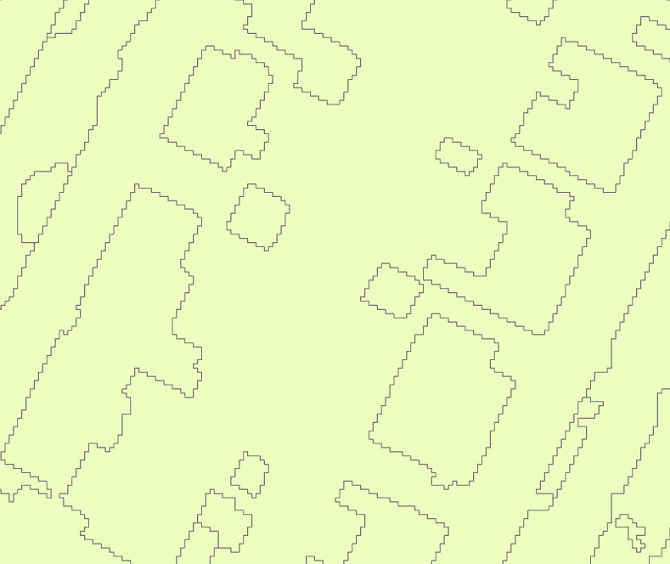  Data should be supplied by 10km x 10km grid squares and cover the extent of the UHM Boundary Extent provided.  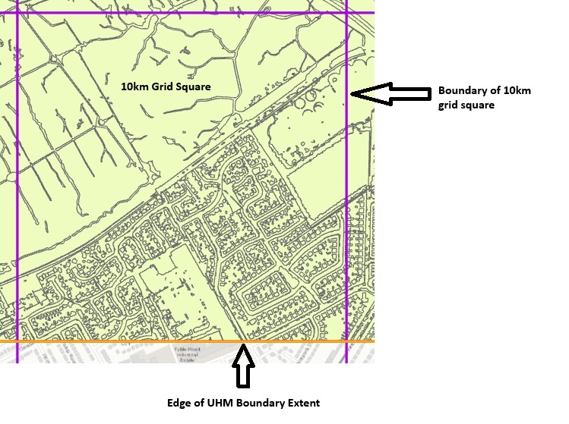  They should align with the neighbouring grid square, and be clipped to the OS grid square:  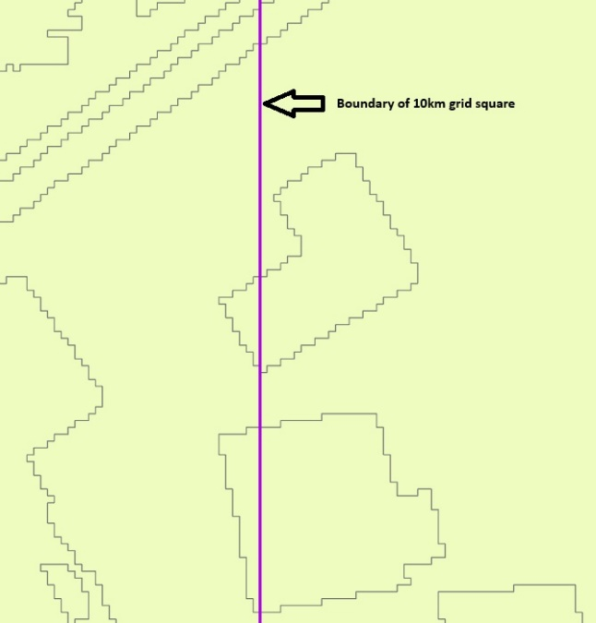  Where the UHM data meets the extent of the UHM Boundary, it should be clipped to the UHM Boundary Extent:  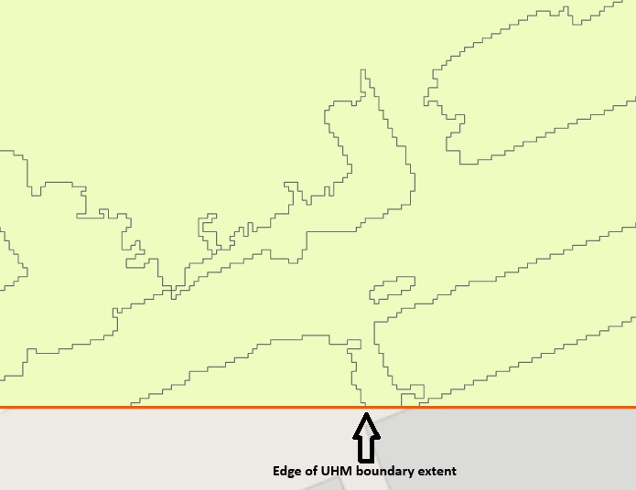
It is stated in Annex 7, sections 5. Data outputs, that UHM data should be supplied to OS in 10km grid square for the project area. However, it is stated in Annex 1, the Outputs section, that the Broad and Detailed Habitat Classification Map deliverables should be split into 5 × 5 km tiles that aligned with the OS National Grid. Could you please confirm the correct tile size to be followed for the deliverables? | All outputs should be in 10 x 10 km grid squares. Reference to 5 x 5 is an error.  Grid data can be downloaded from here: https://github.com/OrdnanceSurvey/OS-British-National-Grids
Please advise if the source data such as Date blocks, Aerial photographs, LiDAR, or DTM/DSM will be received as part of inputs for processing Pilot areas and also Phase-1, 2 & 3 project areas? | The Natural England Data Services team will arrange data access and manage licence approvals, allowing use on NE’s behalf. Contractors should not source restricted data directly.  Natural England Data Services will provide access to the APGB website and the latest aerial photographs. Contractors will need to sign a licence to use this.  The LIDAR/DTM/DSM data is available under Open Government License and can be accessed from here: https://environment.data.gov.uk/survey  The reference to Date Blocks refers to dates provided for the APGB and the LIDAR data tiles and these should be recorded as used.

Box 3 – Questions relevant to the Urban Habitat Mapping – Expansion Request for Quote only.
Question | Answer
Use of the Final Method and Potential Reprocessing  As noted in the RFQ, this project will apply the “final” amended method being developed under the related "England Urban Habitat Mapping – Technical Amendments and Revisions” project. If the final method/guide is updated following Task 1 of that sister project (e.g. due to testing or feedback), would this trigger any need to revisit or reprocess data delivered under this contract, as it was based on the earlier method? Or should we assume that any such risk is minimal, based on the expectation that the method will only be subject to minor modifications? | Once the “final” method is delivered as an output from Task 1 of the Technical amendments and Review project, this will be the method employed through the contract.  It is not impossible that a few modifications emerge as desirable during both projects subsequent to Task 1 delivery. Any such modifications should be noted as desirable for the future but not incorporated into the work at this stage unless they turn out to be essential.  These arrangements would be confirmed with the Project Management Group.
Dependencies and Project Timeline Flexibility  As this project is reliant on receiving the updated method from the sister contract, would flexibility be allowed in the delivery schedule if there are any delays in its availability beyond the estimated 4-week period, in terms of deadlines? | The delivery of the updated method will be essential to start work on the Expansion contract and flexibility will be given in the event of any delay incurred in its finalisation.
Milestones and Payment Schedule  We also wanted to confirm the milestone payment percentages. As currently stated:  - Task 1a is listed as 70%  - Task 1b as 20%  - Task 2 as 20%  - Task 3 as 10% | The percentage listed for task 1a is in error and should read 50% (unless task 1b is not progressed in which case it would be 70%).

