Request for Quotation

Bewick and Beanley Moors SSSI Amphibian Survey

18/03/2025

Request for Quotation
Bewick and Beanley Moors SSSI Amphibian Survey
You are invited to submit a quotation for the requirement described in the specification, Section 2.
Please confirm by email, receipt of these documents and whether you intend to submit a quote or not.
Your response should be returned to the following email address by:
Email: anna.docherty@naturalengland.org.uk
Date: 31/03/2025
Time: 17:00
Ensure you include the name of the quotation and ‘Final Submission’ in the subject field to make it clear that it is your response.
Contact Details and Timetable
Anna Docherty will be your contact for any questions linked to the content of the quote or the process. Please submit any clarification questions via email and note that, unless commercially sensitive, both the question and the response will be circulated to all tenderers.

Action | Date
Date of issue of RFQ | 18/03/25 at 17:00
Deadline for clarifications questions | 28/03/2025 at 09:00
Deadline for receipt of Quotation | 31/03/2025 at 17:00
Intended date of Contract Award | 04/04/2025
Intended Contract Start Date | 07/04/2025
Intended Delivery Date / Contract Duration | 07/04/2025 - 23/03/2025

Section 1: General Information
Glossary
Unless the context otherwise requires, the following words and expressions used within this Request for Quotation shall have the following meanings (to be interpreted in the singular or plural as the context requires):
“Authority” | means Natural England who is the Contracting Authority.
“Contract” | means the contract to be entered into by the Authority and the successful supplier.
“Response” | means the information submitted by a supplier in response to the RFQ.
“RFQ” | means this Request for Quotation and all related documents published by the Authority and made available to suppliers.

Conditions applying to the RFQ
You should examine your Response and related documents ensuring it is complete and in accordance with the stated instructions prior to submission.
Your Response must contain sufficient information to enable the Authority to evaluate it fairly and effectively. You should ensure that you have prepared your Response fully and accurately and that prices quoted are arithmetically correct for the units stated.
By submitting a Response, you, the supplier, are deemed to accept the terms and conditions provided in the RFQ. Confirmation of this is required in Annex 2.
Failure to comply with the instructions set out in the RFQ may result in the supplier’s exclusion from this quotation process.
Acceptance of Quotations
By issuing this RFQ the Authority does not bind itself to accept any quotation and reserves the right not to award a contract to any supplier who submits a quotation.
Costs
The Authority will not reimburse you for any costs and expenses which you incur preparing and submitting your quotation, even if the Authority amends or terminates the procurement process.
Self-Declaration and Mandatory Requirements
The RFQ includes a self-declaration response (Annex 1) which covers basic information about the supplier, as well as any grounds for exclusion. If you do not comply with them, your quotation will not be evaluated.
Any mandatory requirements will be set out in Section 2, Specification of Requirements and, if you do not comply with them, your quotation will not be evaluated.
Clarifications
Any request for clarification regarding the RFQ and supporting documentation must be submitted via email no later than the deadline for clarifications set out in the Timetable. The Authority shall be under no obligation to respond to queries raised after the clarification deadline.
The Authority will respond to all reasonable clarifications as soon as possible but cannot guarantee a minimum response time. The Authority will publish all clarifications and its responses to all suppliers via email unless deemed commercially sensitive.
If a supplier believes that a request for clarification is commercially sensitive, it should clearly state this when submitting the clarification request. However, if the Authority considers either that:
- the clarification and response are not commercially sensitive; and
- all suppliers may benefit from its disclosure,

then the Authority will notify the supplier (via email), and the supplier will have an opportunity to withdraw the request for clarification by sending a further message requesting the withdrawal of the clarification request. If not withdrawn by the supplier within 2 working days of the Authority’s notification, the Authority may publish the clarification request and its response to all suppliers and the Authority shall not be liable to the supplier for any consequences of such publication.
The Authority reserves the right to seek clarification of any aspect of a quotation and/or provide additional information during the evaluation phase to carry out a fair evaluation. Where the Authority seeks clarification on any aspect of the quotation, the supplier must respond within the timeframe requested by the Authority.
Amendments
The Authority may amend the RFQ at any time prior to the deadline for receipt. If it amends the RFQ the Authority will notify you via email.
Suppliers may modify their quotation prior to the deadline for Responses. No Responses may be modified after the deadline for Responses.
Suppliers may withdraw their quotations at any time by submitting a notice via the email to the named contact.
Conditions of Contract
The Authority’s
- Low Value Terms & Conditions (used for purchases under £10k)
- Standard Good and Services Terms & Conditions (used for purchases under £50k)
can be located on the
Natural England Website
and will be applicable to any contract awarded as a result of this quotation process. The Authority will not accept any changes to these terms and conditions proposed by a supplier.
Suppliers should note that the quotation provided by the successful bidder will form part of the Contract.
Prices
Prices must be submitted in £ sterling, exclusive of VAT.
Disclosure
All Central Government Departments, their Executive Agencies and Non Departmental Public Bodies are subject to control and reporting within Government. In particular, they report to the Cabinet Office and HM Treasury for all expenditure. Further the Cabinet Office has a cross-Government role delivering overall Government policy on public procurement, including ensuring value for money and related aspects of good procurement practice. For these purposes, the Authority may disclose within Government any details contained in your quotation. The information will not be disclosed outside Government during the procurement.
In addition, the Authority is subject to the Freedom of Information Act 2000 and the Environmental Information Regulations 2004, which provide a public right of access to information held by public bodies. In accordance with these two statutes, the Authority may be required to disclose information contained in your quotation to any person who submits a request for information pursuant to those statutes.
Further to the Government’s transparency agenda, all UK Government organisations must advertise on Find a Tender Service (FTS) in accordance with the following publication thresholds:
- Central Contracting Authority’s: £12,000
- Sub Central Contracting Authority’s and NHS Trusts: £30,000
For the purpose of this RFQ the Authority is classified as a 'Central Contracting Authority' with a publication threshold of £12,000 inclusive of VAT.
If this opportunity is advertised via FTS, we are obliged to publish details of the awarded contract.
A copy of the contract must also be published with confidential information redacted.
By submitting a Response, you consent to these terms as part of the procurement.
Disclaimers
Whilst the information in this RFQ and any supporting information referred to herein or provided to you by the Authority have been prepared in good faith the Authority does not warrant that this information is comprehensive or that it has been independently verified.
The Authority does not:
- make any representation or warranty (express or implied) as to the accuracy, reasonableness or completeness of the RFQ;
- accept any liability for the information contained in the RFQ or for the fairness, accuracy or completeness of that information; or
- accept any liability for any loss or damage (other than in respect of fraudulent misrepresentation or any other liability which cannot lawfully be excluded) arising as a result of reliance on such information or any subsequent communication.
Any supplier considering entering into contractual relationships with the Authority following receipt of the RFQ should make its own investigations and independent assessment of the Authority and its requirements for the goods and/or services and should seek its own professional financial and legal advice.
Information Security requirements
The Government Security Classification Policy (GSCP) sets out the administrative system used by HM Government (HMG) to protect information and data assets appropriately against prevalent threats through the use of ‘classification tiers’. HMG uses three classification tiers; OFFICIAL, SECRET and TOP SECRET. Each tier provides a set of recommended baseline behaviours and a set of protective controls, which are proportionate to the threat profile for that tier AND the potential impact of a compromise, accidental loss or incorrect disclosure of information held within that tier.

Tenderers and suppliers must ensure that appropriate protective security controls are in place to comply with the GSCP and manage the information shared and received as part of this tender exercise.
A full suite of guidance documents is available on GOV.UK, with specific guidance for tenderers and suppliers set out in Guidance 1.6 - Contractors and Contracting Authorities.docx (publishing.service.gov.uk).
Use of Artificial Intelligence
The Authority expects suppliers to declare where they have used AI software in the creation of Tender responses or intend to use AI software in the performance of the contract. How any AI software was, or will be, used should be to be declared within the technical submission part of the tender. We may require you to answer specific question/s on this topic, particularly where the Authority expects that usage is highly likely or clearly relates to the contract requirements.
Suppliers must follow any guidelines or regulations related to AI use and declarations as indicated in the PPN 2/24 Improving Transparency of AI use in Procurement.
Any information, instructions, or data provided by the Authority to suppliers as part of this tender, the requirements, or contract should not be directly inserted into Generative AI software (such as Gemini, ChatGPT, or CoPilot) without prior permission, unless this information is clearly published in the public domain.
Use of any Authority confidential tender information for training AI software is prohibited. it is advised that Defra’s data or instructions, or anything marked as confidential should not be directly inserted into AIs. For example, putting Authority’s instruction email into Gemini, ChatGPT, or CoPilot is not recommended.
If you intend to use AI to provide goods or services to the Authority, then you are required to complete a declaration which is simply answering the question stated within the 'Information to be returned’. The answer to this question will not be used in scoring your quote.
Protection of Personal Data
In order to comply with the General Data Protection Regulations 2018 the supplier must agree to the following:
You must only process any personal data in strict accordance with instructions from the Authority.
- You must ensure that all the personal data that we disclose to you or you collect on our behalf under this agreement are kept confidential.
- You must take reasonable steps to ensure the reliability of employees who have access to personal data.
- Only employees who may be required to assist in meeting the obligations under this agreement may have access to the personal data.
- Any disclosure of personal data must be made in confidence and extend only so far as that which is specifically necessary for the purposes of this agreement.
- You must ensure that there are appropriate security measures in place to safeguard against any unauthorised access or unlawful processing or accidental loss, destruction or damage or disclosure of the personal data.
- On termination of this agreement, for whatever reason, the personal data must be returned to us promptly and safely, together with all copies in your possession or control.
General Data Protection Regulations 2018
For the purposes of the Regulations the Authority is the data processor.
The personal information that we have asked you provide on individuals (data subjects) that will be working for you on this contract will be used in compiling the tender list and in assessing your offer. If you are unsuccessful the information will be held and destroyed within two years of the award of contracts. If you are awarded a contract it will be retained for the duration of the contract and destroyed within seven years of the contract’s expiry.
We may monitor the performance of the individuals during the execution of the contract, and the results of our monitoring, together with the information that you have provided, will be used in determining what work is allocated under the contract, and in any renewal of the contract or in the award of future contracts of a similar nature. The information will not be disclosed to anyone outside the Authority without the consent of the data subject, unless the Authority is required by law to make such disclosures.
Equality, Diversity & Inclusion (EDI)
The Client is striving to create a diverse and inclusive working environment where every individual has equality of opportunity to progress and to apply their unique insights to making the UK a great place for living. The Service Provider is expected to respect this commitment in all dealings with Natural England staff and service users.
Suppliers are expected to;
- support Defra group to achieve its Public Sector Equality Duty as defined by the Equality Act 2010, and to support delivery of Defra group’s Equality & Diversity Strategy.
- meet the standards set out in the Government’s Supplier Code of Conduct
- work with Defra group to ensure equality, diversity and inclusion impacts are addressed (positive and negative) in the goods, services and works we procure, barriers are removed and opportunities realised.
Sustainable Procurement
Addressing global sustainability impacts and realising additional community benefits within commercial activity is core to Defra group’s approach, working with its supply chain is key to achieving sustainable outcomes. In addition to supporting Defra group to meet its outcomes we look to understand and reduce negative sustainability impacts associated with our commercial activity and realise benefits.
The Client encourages its suppliers to share these values, work to address negative impacts and realise opportunities, measure performance and success.
Suppliers are expected to have an understanding of the Sustainable Development Goals, the interconnections between them and the relevance to the Goods, Services and works procured on the Client’s behalf
Conflicts of Interest
The concept of a conflict of interest includes but is not limited to any situation where an Involved Person or Relevant Body has directly or indirectly, a financial, economic or other personal interest which might be perceived to compromise their impartiality and independence in the context of the procurement procedure and/or affect the integrity of the contract award.
We expect suppliers to mitigate appropriately against any real or perceived conflict of interest through their work with government. A supplier with a position of influence gained through a contract should not use that position to unfairly disadvantage any other supplier or reduce the potential for future competition
Where the supplier is aware of any circumstances giving rise to a conflict of interest or has any indication that a conflict of interest exists or may arise you should inform the Authority of this as soon as possible (whether before or after they have submitted a quotation). Tenderers should remain alert to the possibility of conflicts of interest arising at all stages of the procurement and should update the Authority if any new circumstances or information arises, or there are any changes to information already provided to the Authority. Failure to do so, and/or to properly manage any conflicts of interest may result in a quotation being rejected.
Provided that it has been carried out in an open, fair and transparent manner, routine pre-market engagement carried out by the Authority should not represent a conflict of interest for the supplier.

Section 2: The Invitation
Specification of Requirements

Background to Natural England
We were established by an Act of Parliament in 2006. Our purpose is to help conserve, enhance and manage the natural environment for the benefit of present and future generations, thereby contributing to sustainable development.
Our vision is ‘Thriving Nature for people and planet’.
We aim to achieve this through our mission ‘Building partnerships for Nature’s recovery’.

Project Title: Bewick and Beanley Moors SSSI Amphibian Survey

Background to the specific work area relevant to this purchase
The aim of this contract is:
Undertake an amphibian survey to assess the current state of the amphibian assemblage using a combination of torch survey, netting, visual survey methods.
Determination of the area and quality of the core habitats.
Undertake proxy assemblage monitoring assessments of each sample point (please see section 3.4 for further information).
Provide a habitat description and its condition, suggesting where current management is working and where it is not, why might that be.
The results will allow Natural England to undertake a Common Standards Monitoring (CSM). (JNCC, 2008) assessment of the condition of amphibian assemblages at the site and help with advising on future management to conserve the species.
The surveys should be undertaken between April – June.
Please see Annex 3 for site location.

Requirement
Please provide a full method statement of how you plan to carry out the works, considering H&S, biosecurity and methodology as indicated below.
Health and Safety/ Known Hazards & Risks
Risks associated with field-based work need to be considered. The Health and Safety at Work Act 1974 is to be fully complied with at all times.
Please provide a clear and structured proposal to demonstrate your intended approach to health and safety on this project and how you ensure the requirements of legislation are met. You do not need to submit a site-specific risk assessment with your tender response, if successful you will be expected to do so before commencing any work.
If any incidents occur on site, these should be reported to the Project Officer within 3 working days.
Your quotation for the work should be accompanied by the following Health and Safety documentation required by Natural England:
- Risk assessment: this must take the hazards identified above into account including working around water/use of a boat.
- Valid certificates (if appropriate) to be made available on request:
- Employers Liability Compulsory Insurance
- Public Liability Insurance – provide description of level taken out.
- Professional Indemnity Insurance – provide description of level taken out.
Work shall not commence without Natural England being in possession of appropriate documentation and an agreed safe method of working.

Biosecurity
- Please follow biosecurity measures as noted in the following: Microsoft Word - Advice note 4 - Amphibian Disease Precautions, A Guide for UK Fieldworkers

- Handle amphibians only when necessary.
- If handling amphibians, or if contact with pond water is necessary, wear powder-free disposable vinyl gloves which you rinse before contact with the amphibians. Use vinyl rather than latex or nitrile because the latter two may be harmful to amphibians.
- Use a fresh pair of gloves for each site1 visited. For higher risk activities, it may be appropriate to change gloves between handling individual amphibians, even within the same site (see below).
- Disinfect survey equipment or containers used to hold amphibians between each site1 visited (see disinfection procedures below).
- If entering the water, footwear should be washed and disinfected (see disinfection procedures below) immediately after the site visit. If you do not enter the water, there is no need to disinfect footwear unless visiting a high risk site (see guidance on specific activities below).
- Wash all clothing on a 40oC cycle with biological detergent, after exposure to amphibians or pond water. If visiting several sites bring a change of clothes. Use a lower temperature wash if care instructions indicate this may be harmful to your clothing, and take additional precautions such as washing twice or spraying with disinfectant before next use.
- Do not release amphibians anywhere except at the place of capture.
- If travelling by vehicle, park on hard standing (rather than vegetated areas) and walk to the pond.
- Treat dead or sick amphibians as a high infection risk and do not handle unless necessary.

Field Work and Detailed Methodology
Amphibian Assemblage (Common frog, Common toad, Smooth newt, Palmate newt, Great crested newt*).
* Although this site was notified for its assemblage of amphibians, it is considered one of the most important sites in Northumberland for the great crested newt, a UK BAP species. Therefore measures of condition for amphibian assemblages have been combined with those for great crested newts where not duplicated. (Source: Amphibian guidance 18/02/04).
- Prior to sampling please ensure necessary licences are in place.
- Please see table 1 for methodology detail.
- All sampling points must be clearly mapped.
- All sampling points must have a brief written description of them to describe how the sampling point relates to the habitat requirement of the assemblage being assessed.
- Photographs must be taken of each sampling point.
- Record as much information as possible including the location of important or rare species and the locations of all sampling points.
- Map the approximate locations, with estimated size, of all areas of the SSSI that contain suitable habitat for each of the surveyed assemblages. Please also comment on the habitat quality.
- Record the date, start and finish times, observer name and weather conditions for each survey visit.
- General notes on the site should also be made and photographs should be taken.
- Please ensure the site unit is noted when commenting on management/making recommendations. Whilst Natural England are following the method of Whole Feature Assessment, unit-based feedback enables us to provide detailed feedback to landowners.
- See Annex 5 for example recording form.

Table 1.
Variable | Measurement | Method
Adults | Visual assessment | Assess by torch survey, netting, visual assessment as appropriate for species present in/around breeding ponds. Assess 3 years in every 6 years.  3-5 visits for each assessment year, depending on species. Survey dates depend on site location and species, likely  to be mid-Feb - March for common frogs and common toads, March-April for newts, May-June for Pool frog and Natterjack toad. Day or night visits depending on species. See scoring table at the bottom of this form. Qualifying score: 4+ species and minimum score of 10, or 5 if adjacent to existing SSSI.
Juveniles, tadpoles and  spawn | Visual assessment | Species spawning time is same as row above  Visual or netting. February – September. 2-3 visits per year, depending on species present. Assess 3 years in every 6.  Present in all or sample breeding ponds at least once every 4 years. (i.e. acceptable for eggs to be absent from individual ponds 3 years out of 4; fail if any breeding pond lacks eggs for 4 years)
Presence of ponds (permanent and  temporary) | Visual assessment | Record number of ponds present. Record once every 3 years. Any time of year.  No net loss of any of the eight ponds present at designation (Annex 4.)
Pond persistence | Visual assessment | Record approximate depth of water in identified breeding ponds between mid-May and mid-June for sites supporting frogs or toads) or mid-July to mid-August (for sites supporting newts).  All ponds should be permanent excluding  Record once every 3 years.
Pond shading by  scrub/trees | % cover | Extent and orientation of pond margin solidly shaded by scrub/trees directly overhanging or adjacent to margin (not floating or emergent macrophytes).  Assess April to June. Record once every 3 years.  Shade should only be counted if relatively solid  (and therefore likely to cause lower light levels and lower water temperatures). Maximum shade <30-40%
Terrestrial habitat extent | Visual assessment | Determine area by walking site and comparing with map or aerial photo; most semi-natural habitats within 500m of breeding pond to be included. Assess presence of fragmentation. Any time of year. Record once every 3 years. Fragmentation refers to significant barriers to movement such as walls, buildings, and not, for instance, footpaths or tracks.
Terrestrial refuge habitat- structure and quality | Visual assessment | At any time of year. Record once every 3 years.  Ensure suitable for species i.e. mixed grassland/ scrub/ woodland mosaic suitable for most species. Most species will use rock/log/vegetation piles in which to hibernate/find refuge under.
Mandatory attribute applicable to sites with good or exceptional great  crested newt populations:  Fish and wildfowl | Visual assessment | March-September. Record once every 3 years. 1 visit per year required. Look for fish and stocked wildfowl, or evidence of their presence: characteristic disturbance at water surface  for fish, high turbidity, nests, droppings at pond margin, major loss of aquatic macrophytes, presence of algal blooms, heavily grazed grasses on bank. Numbers required to fail target:  • Fish: any number of individuals  (need only to determine  presence).  • Wildfowl: > 4 pairs/ha of open water.
Mandatory attribute  applicable to sites with  exceptional populations of one or more newt  species: Aquatic macrophyte  cover | Visual assessment | Visual assessment between May and mid-September. Record once every 3 years. 1 visit per year required. “Good” defined as:  • 25% - 100% of margin covered  by marginal and emergent  species, and  • 25% - 75% of pond bottom/  midwater/ surface covered by  submerged or floating species.

Access to land
Natural England will initially obtain landowner/manager permission in advance of the surveys and provide approximate timings of site visits. Land manager contact details will be provided at the start of the contract by Natural England. The contractor will then liaise directly with landowners and occupiers to arrange specific dates and times for access. Permissions must be obtained at least 48 hours prior to monitoring. Any refusals or other issues should be notified to the Natural England project officer within 3 working days.

Sustainability
Natural England protects and improves the environment and is committed to reducing the sustainability impacts of its activities directly and through its supply chains. We expect the Contractor to share this commitment and adopt a sound, proactive sustainable approach in keeping with the 25 yr environmental plan/our commitments compliant with all applicable legislation. This includes understanding and reducing direct and indirect sustainability impacts and realising opportunities, including but not restricted to; resilience to climate change, reducing greenhouse gas emissions, water use and quality, biosecurity, resource efficiency and waste, reducing the risk of pollution, biodiversity, modern slavery and equality, diversity & inclusion, negative community impacts.
As a delivery partner, the successful contractor is expected to pursue sustainability in their operations, thereby ensuring the Contracting Authority is not contracting with a supplier whose operational outputs run contrary to the Contracting Authority’s objectives. The successful contractor will need to approach the project with a focus on the entire life cycle of the project.

Please provide details of your company’s sustainability policy/procedures. Companies who are located closer to the survey sites will score higher (see Evaluation Criteria below).

Outputs and Contract Management
A written survey report (word and pdf) will include:
- Introduction, including summary of site details and a simple site map.
- Amphibian species population (see methodology above) and assemblage score.
- Method(s) used
- Time spent and date
- Results:
  - Species listing (all species including those in the assemblage and others recorded) in an Excel spreadsheet, annotated with any relevant information included e.g. conservation status.
  - Grid refs and maps for each sampling area.
  - Brief summary of species of conservation value, with a map of key areas;
  - NVC type, if known to the contractor.
  - Habitat information, including size and quality, with clear and concise recommendations for management to benefit the assemblage/ species.
  - Completed Proxy assemblage form with any comments

- The assessor’s professional opinion of the site for the assemblages (both target and non-target ones), e.g. structure of the site, any negative indicators and a view on site condition.
- The assessor’s professional opinion on any potential climate change impacts on the species/assemblage (see climate change section below)
- A summary of the pressures found on the site (see pressures section below)
- The assessor’s review on the Monitoring Specification (this will be provided at the inception meeting)
- Completion of a feature form, this is a summary of the report and will be provided upon contract award.
- Digital photographs should be included, either embedded within the report or as an appendix (if many photos are used, leading to large file sizes, e.g., >20Mb, consider placing the photos in an appendix, as a separate file).
- References

GPS data formats
It is important to be able to geolocate the survey effort so that geospatial cross-referencing with other data sources can take place.
An Excel spreadsheet should be included showing the ten-figure x:y co-ordinates of the sample locations. This spreadsheet must only contain binomials in the main species column; if more detailed trinomial, sub-specific, or sens lat, sens strictu ascriptions are required then these should be in an “other name” column.
A template will be provided upon award of contract to input excel data. Please see an example in annex 2.
Once agreed with Natural England, a map showing the sampling areas should be provided as part of the contract outputs. Indicative mapped routes can be provided as part of the tender process, but it is at the discretion of the contractor.
Climate change impacts
Please provide a description of the current and future impacts of climate change on the site’s amphibian features and associated relevant habitat(s). Using professional judgement please infer how climate based future alterations, such as potential range shifts of amphibians, may influence the site and its amphibian feature(s). Suggesting any potential management mitigations or changes in designation that may be appropriate based on projections.
'Pressures' data collection
‘Pressures’ are observations of land management or other factors at a site that have the potential to impact on the condition of designated features. These are recorded as part of monitoring surveys and used to inform Natural England’s engagement with land managers. A list of potential pressures to be assessed will be supplied on contract award. Ideally, these should be recorded using ArcGIS Field Maps - Natural England can provide shapefiles for this purpose. Pressures recorded should be flagged and summarised in the final report according to the following template:
Broad Pressure | Detailed Pressure | Date Identified | Risk to Condition (H/M/L) | Pressure Status (Active/Potential) | Comments

Further guidance will be provided upon contract award.
Monitoring Specification
The contractor should provide interpretation of the accuracy, appropriateness and quality of the information and targets as set out in the Monitoring Specification Documents. These comments should detail whether the current document provides sufficient information to accurately monitor the feature(s) which this contract covers. Where amendments or additions are required, these should be described in sufficient detail for staff to update the documents.
Maps
Provide maps showing the location of each target assemblages corresponding habitat.
Provide separate x:y grid references in an excel spreadsheet and provide locations in a GIS file compatible with ArcMap.
Provide maps showing the location of any survey areas in the report and in a GIS file compatible with ArcMap.
A copy of maps should be provided in jpg or pdf format and as GIS layers, in or compatible with ESRI ArcGIS format. Information and guidance on requesting baseline digital geographical data from Natural England can be found on our website at Geographical Information for contractors and partners.
If you are unable to provide GIS layers, please advise in your tender.

Reference | Deliverable | Responsible Party | Date of completion
 | Date of issue of RFQ | Natural England | XX
 | Deadline for receipt of Quotation | Contractor | 31/03/2025
 | Intended date of Contract Award | Natural England | 04/04/2025
 | Intended date of inception meeting | Natural England | 07/04/2025
 | Intended Contract Start Date | Contractor | 07/04/2025
 | Contract Duration | Contractor | 23/03/2026
 | Draft report to be submitted to project officer | Contractor | 23/02/2026
 | Draft report to be submitted to contractor with Natural England comments | Natural England | 09/03/2026
 | Final report submission date | Contractor | 24/03/2026

Payment
The Authority will raise purchase orders to cover the cost of the services and will issue to the awarded supplier following contract award.
The Authority’s preference is for all invoices to be sent electronically, quoting a valid Purchase Order number after all the work has been completed.
It is anticipated that this contract will be awarded for a period of 12 months to end no later than 23/03/2026. Prices will remain fixed for the duration of the contract award period. We may at our sole discretion extend this contract to include related or further work. Any extension shall be agreed in writing in advance of any work commencing and may be subject to further competition.
Evaluation Methodology
The contract will be awarded to the tender which best fits the profile of requirements. This will be assessed by the Project Officer in consultation with relevant colleagues using the evaluation criteria detailed below.
As part of the evaluation process a quality threshold will be placed on each scoring criterion identified below. If your tender falls below the threshold then your bid will not be considered.
Your tender should include the following information and supporting evidence.
We will award this contract in line with the most advantageous tender (MAT). See award criteria:
Technical – 50%
Commercial – 50%

Evaluation criteria
Evaluation weightings are 50% technical and 50% commercial, the winning tenderer will be the highest scoring combined score.

Evaluation Criteria | Weighting  (%) | Threshold score out of 10 | Tender Information
TECHINICAL  Technical expertise and experience –  Please provide details of your experience in undertaking:  Amphibian surveys using the methods outlined in this specification.  Please provide details of your experience in:  Amphibian surveys generally.  Analysis, presentation and reporting of data generated from surveys. | 20 | 8 | Previous contracts for undertaking Amphibian surveys for site evaluations and Site Condition Monitoring on SSSI sites.  Qualifications, technical merit and experience of key staff engaged on the contract e.g. CVs, previous amphibian survey / contracts, technical qualifications. Particular reference should be made to experience of amphibian surveying of the previously mentioned target habitat/assemblage.
TECHINICAL  Fit with Specification and methodology –  Availability:  Please provide full details as requested under Tender Information.  Capability for full delivery of expectation:  Please provide full details as requested under Tender Information. | 15 | 7 | Include details of availability given the timescales page 1/2 and a proposed outline schedule or timetable of works.  Include details of capability for field survey work with a clear rationale for the estimated number of days for field work. Please include details of how the survey area will be covered and how the visits will be organised in terms of personnel and timescales.
TECHINICAL  Project and risk management, and resources allocated –  Please provide full details as requested under Tender Information | 10 | 6 | Details of organisational and project management skills to deliver all aspects of the requirement in full, including GDPR. This must include an assessment of the risks to project delivery and mitigation (including contingency in the event of delays). Confirmation you are able to meet the required deadlines.
TECHINICAL  Sustainability | 5 | N/A | Company sustainability policy/procedures.  Distance from the SSSIs, local suppliers will score more highly.
COMMERCIAL  Financial (value for money) | 50 | No threshold | Include all costs and VAT clearly itemised.

Technical (50%)
Technical evaluations will be based on responses to specific questions covering key criteria which are outlined below. Scores for questions will be based on the following:
Description | Score | Definition
Very good | 100 | Addresses all the Authority’s requirements with all the relevant supporting information set out in the RFQ. There are no weaknesses and therefore the tender response gives the Authority complete confidence that all the requirements will be met to a high standard.
Good | 70 | Addresses all the Authority’s requirements with all the relevant supporting information set out in the RFQ. The response contains minor weaknesses and therefore the tender response gives the Authority confidence that all the requirements will be met to a good standard.
Moderate | 50 | Addresses most of the requirements with most of the relevant supporting information set out in the RFQ. The response contains moderate weaknesses and therefore the tender response gives the Authority confidence that most of the requirements will be met to a suitable standard.
Weak | 20 | Substantially addresses the requirements but not all and provides supporting information that is of limited or no relevance or a methodology containing significant weaknesses and therefore raises concerns for the Authority that the requirements may not all be met.
Unacceptable | 0 | No response or provides a response that gives the Authority no confidence that the requirement will be met.

Technical evaluation is assessed using the evaluation topics and sub-criteria stated in the Evaluation Criteria section above.
Separate submissions for each technical question should be provided and will be evaluated in isolation. Tenderers should provide answers that meet the criteria of each technical question.

Commercial (50%)
The Contract is to be awarded as a ‘fixed rate’ which will be paid according to the completion of the deliverables stated in the Specification of Requirements.
Suppliers are required to submit a total cost to provide the deliverables stated in the Specification of Requirements. In addition to this the Commercial Response template must be completed to provide a breakdown of the whole life costs against each deliverable used in the delivery of this requirement.
Calculation Method
The method for calculating the individual weighted scores is as follows:
- Commercial
Score = (Lowest Quotation Price / Supplier’s Quotation Price ) x [50%] (Maximum available marks)
- Technical
Score = (Bidder’s Total Technical Score / Highest Technical Score) x [50%] (Maximum available marks)
The total score (weighted) (TWS) is then calculated by adding the total weighted commercial score (WC) to the total weighted technical score (WT): WC + WT = TWS.
Once all evaluators have completed their individual evaluations and provided their final scores, an average score will be calculated which will be multiplied by the selected weighting to give a weighted score representing the views of all evaluators.
Information to be returned
Please note, the following information requested must be provided. Incomplete tender submissions may be discounted.
Please complete and return the following information:
- completed Commercial Response template
- separate response submission for each technical question (in accordance with the response instructions)
- complete AI question [ ''Do you use Artificial Intelligence (AI) or machine learning tools, including large language models within your quote submission or service delivery processes.?''] response which will not be scored, is to be returned within technical response
- completed Mandatory Requirements (Annex 1)
- completed Acceptance of Terms and Conditions (Annex 2)
Award
Once the evaluation of the Response(s) is complete suppliers will be notified of the outcome via email.
The successful supplier will be issued the contract via a Purchase Order.

Annex 1 Mandatory Requirements
Part 1 Potential Supplier Information
Please answer the following self-declaration questions in full and include this Annex in your quotation response.
Part 1.1 Potential Supplier Information:
Question no. | Question | Response
1.1(a) | Full name of the potential supplier submitting the information
1.1(b) | Registered office address (if applicable)
1.1(c) | Company registration number (if applicable)
1.1(d) | Charity registration number (if applicable)
1.1(e) | Head office DUNS number (if applicable)
1.1(f) | Registered VAT number
1.1(g) | Are you a Small, Medium or Micro Enterprise (SME)? | (Yes / No)
Note: See EU definition of SME https://ec.europa.eu/growth/smes/business-friendly-environment/sme-definition_en
Part 1.2 Contact details and declaration
By submitting a quotation to this RFQ I declare that to the best of my knowledge the answers submitted and information contained in this document are correct and accurate.
I declare that, upon request and without delay you will provide the certificates or documentary evidence referred to in this document.
I understand that the information will be used in the selection process to assess my organisation’s suitability to be invited to participate further in this procurement.
I understand that the authority may reject this submission in its entirety if there is a failure to answer all the relevant questions fully, or if false/misleading information or content is provided in any section.
I am aware of the consequences of serious misrepresentation.

Question no. | Question | Response
1.2(a) | Contact name
1.2(b) | Name of organisation
1.2(c) | Role in organisation
1.2(d) | Phone number
1.2(e) | E-mail address
1.2(f) | Postal address
1.2(g) | Signature (electronic is acceptable)
1.2(h) | Date

Part 2 Exclusion Grounds
Part 2.1 Grounds for mandatory exclusion, including being on the Government Debarment List.
Question no. | Question | Response
2.1(a) | Please indicate if, within the past five years you, your organisation or any other person who has powers of representation, decision or control in the organisation been convicted anywhere in the world of any of the offences within the summary below.
 | Participation in a criminal organisation. | (Yes / No)  If yes please provide details at 2.1 (b)
 | Corruption. | ((Yes / No)  If yes please provide details at 2.1 (b)
 | Fraud. | (Yes / No)  If yes please provide details at 2.1 (b)
 | Terrorist offences or offences linked to terrorist activities | (Yes / No)  If yes please provide details at 2.1 (b)
 | Money laundering or terrorist financing | (Yes / No)  If yes please provide details at 2.1 (b)
 | Child labour and other forms of trafficking in human beings | (Yes / No)  If yes please provide details at 2.1 (b)
2.1(b) | If you have answered yes to question 2.1(a), please provide further details.  Date of conviction, specify which of the grounds listed the conviction was for, and the reasons for conviction.  Identity of who has been convicted  If the relevant documentation is available electronically please provide the web address, issuing authority, precise reference of the documents.
2.1 (c) | If you have answered Yes to any of the points above have measures been taken to demonstrate the reliability of the organisation despite the existence of a relevant ground for exclusion? (i.e. Self-Cleaning) | (Yes / No)
2.1(d) | Has it been established, for your organisation by a judicial or administrative decision having final and binding effect in accordance with the legal provisions of any part of the United Kingdom or the legal provisions of the country in which the organisation is established (if outside the UK), that the organisation is in breach of obligations related to the payment of tax or social security contributions? | (Yes / No)
2.1(e) | If you have answered yes to question 2.3(a), please provide further details. Please also confirm you have paid or have entered into a binding arrangement with a view to paying, the outstanding sum including where applicable any accrued interest and/or fines.

Part 2.2 Grounds for discretionary exclusion
Question no. | Question | Response
2.2(a) | The detailed grounds for discretionary exclusion of an organisation are set out on this webpage, which should be referred to before completing these questions.  Please indicate if, within the past three years, anywhere in the world any of the following situations have applied to you, your organisation or any other person who has powers of representation, decision or control in the organisation
2.2(b) | Breach of environmental obligations? | (Yes / No)  If yes please provide details at 2.2 (f)
2.2(c) | Breach of social obligations? | (Yes / No)  If yes please provide details at 2.2 (f)
2.2(d) | Breach of labour law obligations? | (Yes / No)  If yes please provide details at 2.2 (f)
2.2(e) | Shown significant or persistent deficiencies in the performance of a substantive requirement under a prior public contract, a prior contract with a contracting entity, or a prior concession contract, which led to early termination of that prior contract, damages or other comparable sanctions? | (Yes / No)  If yes please provide details at 2.2 (f)
2.2 (f) | If you have answered Yes to any of the above, explain what measures been taken to demonstrate the reliability of the organisation despite the existence of a relevant ground for exclusion? (Self Cleaning)

Annex 2 Acceptance of Terms and Conditions
I/We accept in full the terms and conditions appended to this Request for Quote document.
Company ____________________________________________________
Signature ____________________________________________________
Print Name ____________________________________________________
Position ____________________________________________________
Date ____________________________________________________

Annex 3: Bewick and Beanley Moors Site map.
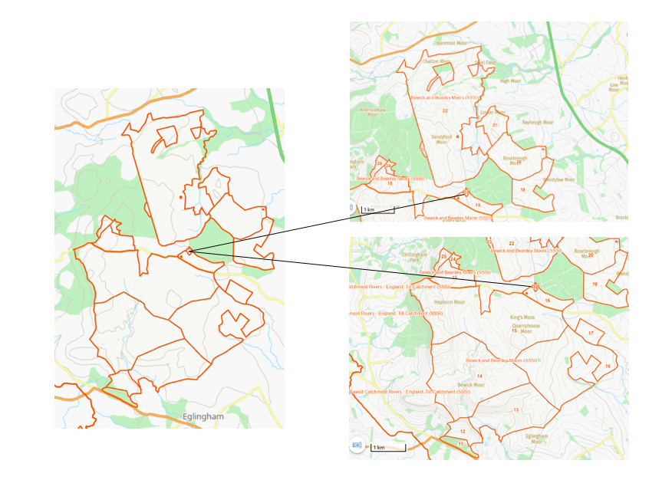

Annex 4. Location of Quarryhouse Ponds within Bewick and Beanley Moors SSSI:
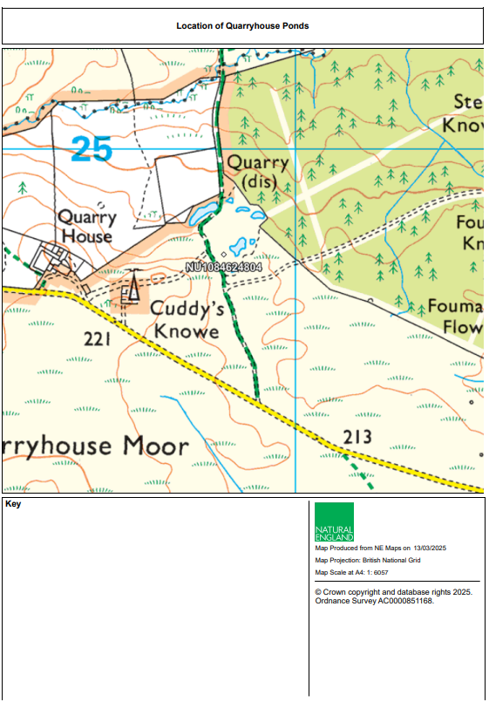

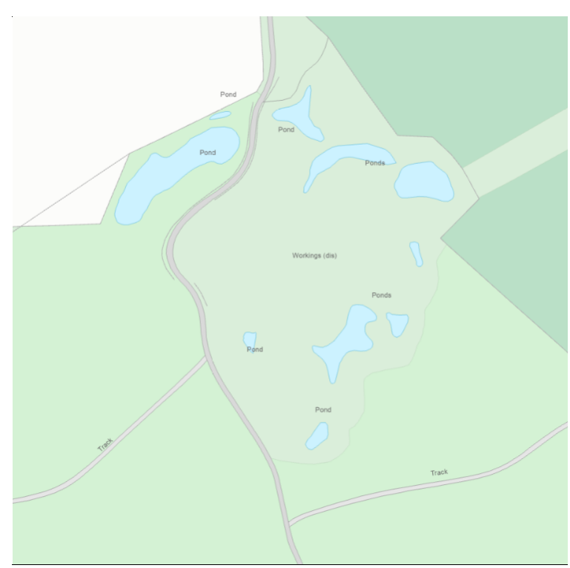

Annex 5: Example data collection form

SSSI Feature Assessment Form – Herpetofauna assessment form

Name of SSSI
SSSI reportable feature being assessed |  | Amphibian assemblage
Date of assessment
Assessed by
Brief description: This form is to record variables that are required by Amphibians, in order to assess the suitability of the site for this assemblage of species. It is intended that this form is tailored to include all suitable habitats that occur on the SSSI. All variables are to be measured across the SSSI as a whole. Details on criteria for SSSI selection based on outstanding amphibian assemblage are in Section 5.1 (Bernhard et al., 2022).
Herpetofauna proxy assessment – Amphibian assemblage
Variable | Measurement |  | Method (please add site specific text from FCT) | Summary | Pass/Fail
Adults | Visual assessment |  | Assess by torch survey, netting, visual assessment as appropriate for species present in/around breeding ponds. Assess 3 years in every 6 years.  3-5 visits for each assessment year, depending on species. Survey dates depend on site location and species, likely  to be mid-Feb - March for common frogs and common toads, March-April for newts, May-June for Pool frog and Natterjack toad. Day or night visits depending on species. See scoring table at the bottom of this form. Qualifying score: 4+ species and minimum score of 10, or 5 if adjacent to existing SSSI.
Juveniles, tadpoles and  spawn | Visual assessment |  | 2-3 visits per year, depending on species present. Assess 3 years in every 6. Species spawning time is same as row above
Presence of ponds (permanent and  temporary) | Visual assessment |  | Record number of ponds present. Record once every 3 years. Any time of year.
Pond persistence | Visual assessment |  | Record approximate depth of water in identified breeding ponds between May-August. All ponds should be permanent excluding Natterjack toad ponds which should be ephemeral, drying up by late August but not before July. Record once every  3 years. Natterjack pools should remain shallow throughout (<70cm depth) with shallow edges (<10cm) for tadpole basking
Pond shading by  scrub/trees | % cover |  | Extent and  orientation of pond margin solidly shaded by scrub/trees directly overhanging or adjacent to margin (not floating or emergent macrophytes). Assess April to June. Record once every 3 years. Shade should only be counted if relatively solid  (and therefore likely to cause lower light levels and lower water temperatures). Maximum shade <30-40%
Terrestrial habitat extent | Visual assessment |  | Determine area by walking site and comparing with map or aerial photo; most semi-natural habitats within 500m of breeding pond to be included. Assess  presence of fragmentation. Any time of year. Record once every 3 years. Fragmentation refers to significant barriers to movement such as walls, buildings, and not, for instance, footpaths or tracks.
Terrestrial refuge habitat- structure and quality | Visual assessment |  | At any time of year. Record once every 3 years.  Ensure suitable for species i.e. mixed grassland/ scrub/ woodland mosaic suitable for most species, and for natterjack toads; a mosaic of open/bare ground/low sward should be 70%+ of immediate terrestrial habitat surrounding ponds, and this should be connected to further extent of 50%+ open/bare ground/low sward in wider habitat mosaic. Most species will use rock/log/vegetation piles in which to hibernate/find refuge under. Natterjack toads, in addition, will often burrow underground in open sand banks.
Mandatory attribute applicable to sites with good or exceptional great  crested newt populations:  Fish and wildfowl | Visual assessment |  | March-September. Record once every 3 years. 1 visit per year required. Look for fish and stocked wildfowl, or evidence of their presence: characteristic disturbance at water surface  for fish, high turbidity, nests, droppings at pond margin, major loss of aquatic macrophytes, presence of algal blooms, heavily grazed grasses on bank. Numbers required to fail target:  • Fish: any number of individuals  (need only to determine  presence).  • Wildfowl: > 4 pairs/ha of open water.
Mandatory attribute  applicable to sites with  exceptional populations of one or more newt  species: Aquatic macrophyte  cover | Visual assessment |  | Visual assessment between May and mid-September. Record once every 3 years. 1 visit per year required. “Good” defined as:  • 25% - 100% of margin covered  by marginal and emergent  species, and  • 25% - 75% of pond bottom/  midwater/ surface covered by  submerged or floating species.

Guidance within: Bernhard, T., Driver, D., Dyer, S., Edgar, P., Ellis, M., Foster, J., Howe, E., McKinnell, J., and Raynor, R. (2022). Guidelines for the Selection of Biological SSSIs. Part 2: Detailed Guidelines for Habitats and Species Groups. Chapter 18. Reptiles and Amphibians. Joint Nature Conservation Committee, Peterborough. Guidelines for the Selection of Biological SSSIs. Part 2: Detailed Guidelines for Habitats and Species Groups: Chapter 18 Reptiles and Amphibians (jncc.gov.uk).
For any specific queries, please contact Tim Bernhard, Senior Amphibian and Reptile Specialist (tim.bernhard@naturalengland.org) or Tim Baker, Species Specialist (tim.baker@naturalengland.org).

Scoring table (Bernhard et al., 2022):
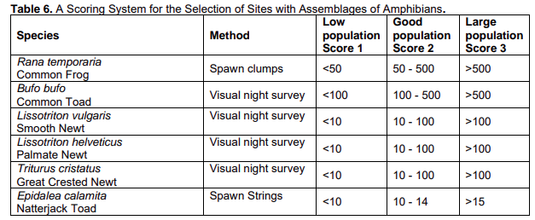

Please provide site photographs as evidence for the decision for each variable

Provide detailed map of site, NVC map as well as satellite/OS

Notes

