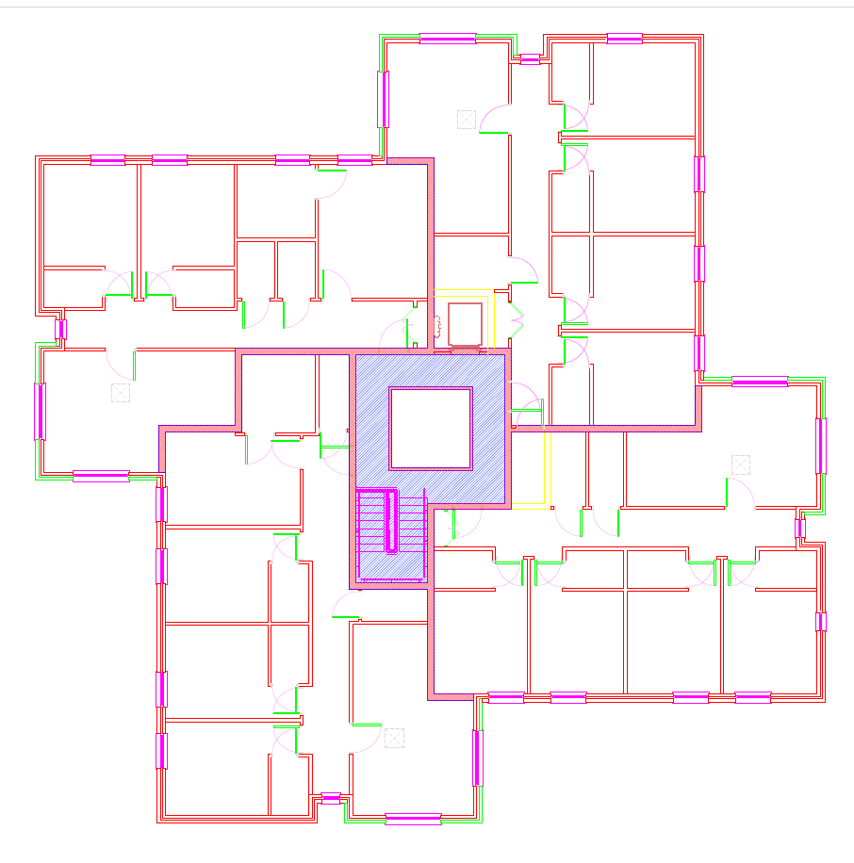
Amberley Hall: proposed cable route through loft space and fire barriers above fire separating walls (shaded) to connect PV panels to inverter unit
(Note: Chilgrove plan is handed)
Riser route: either by means of installing new cable riser (here) through hot water cylinder plant rooms or by means of existing cabling direct from main board to distribution board on top floor next to suggested inverter location
Suggested inverter location – second floor electrical cupboard
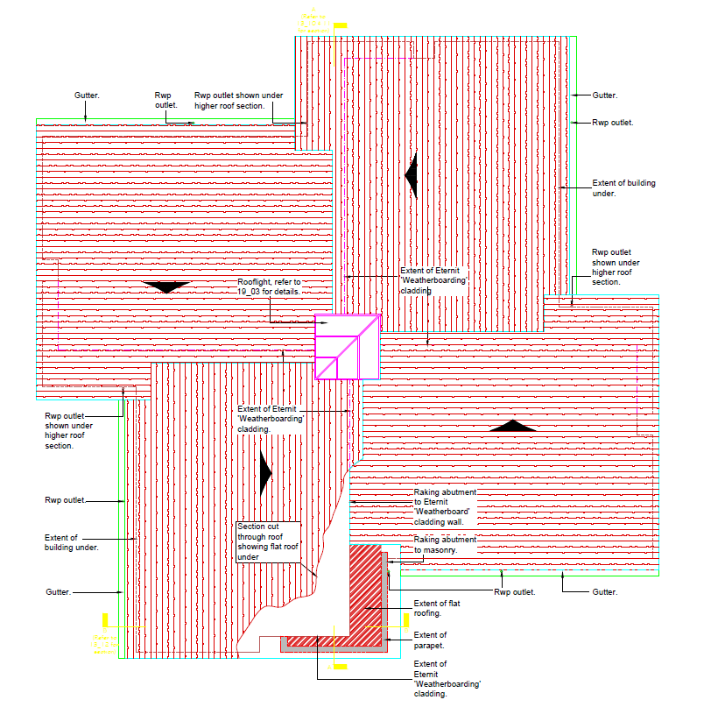
Suggested cable routes: relative to roof slopes (Amberley)
Note: Chilgrove is handed
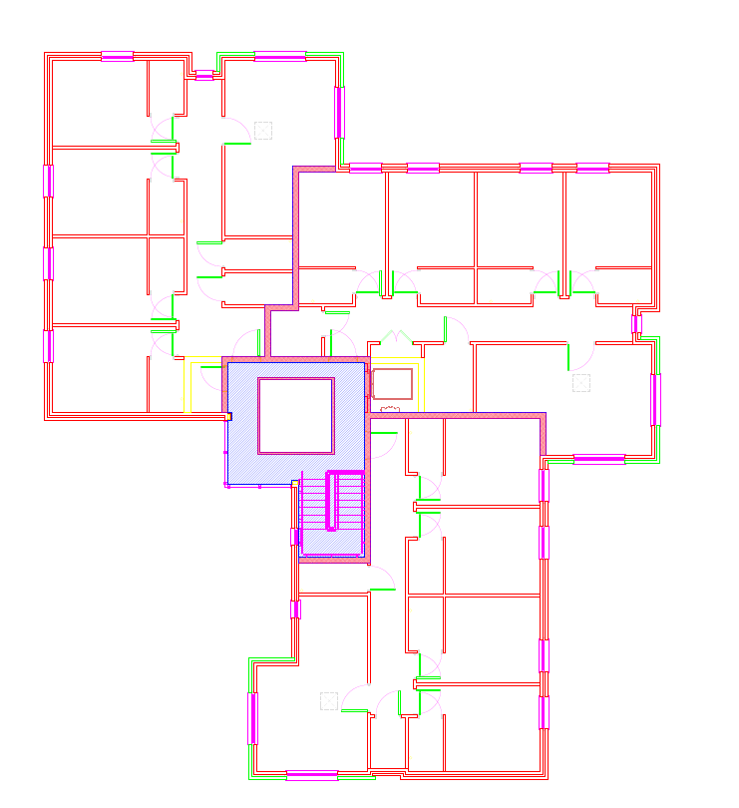
Harting Hall: suggested cable route through loft space and fire barriers above fire separating walls (shaded) to connect PV panels to inverter unit.
Suggested inverter location – top floor electrical cupboard
Riser route: either by use of existing cabling from main board to existing distribution board on top floor (next to suggested inverter location) or via new cable riser through electrical riser cupboards and lift motor room
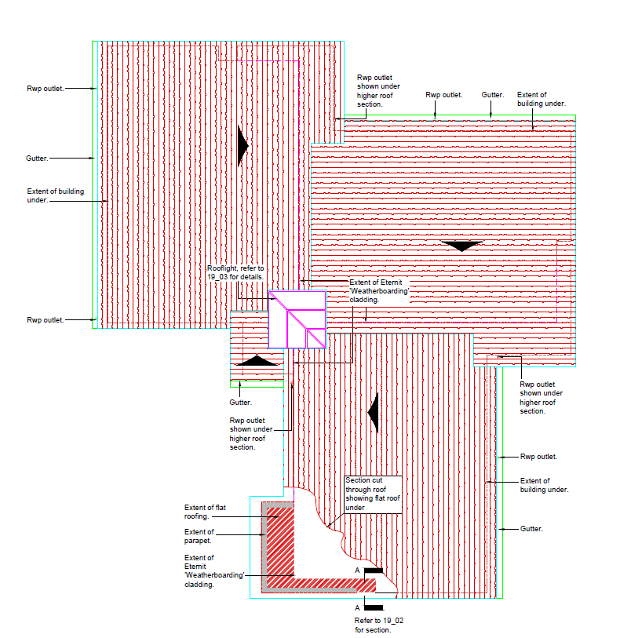
Suggested cable routes: relative to roof slopes (Harting)

