**On Being fish-friendly of the 400d Solar Tube pump by Aqua Delta**

Concerning the question of the extent of fish friendliness of the tube pump the following can be said.

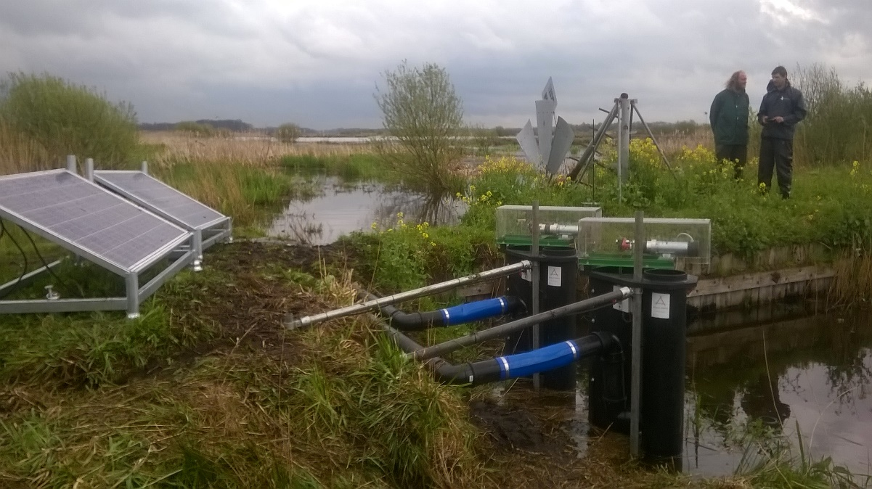

*Two T400d pumps for inundation of wetlands for Natuur Monumenten*

This pump is a piston pump with a relatively big piston with a low frequency of movement. By reasoning the potential path of fish through the pump and looking at the problem they might meet when fish are going through the following parts of the pump:

1. Inlet valve. This valve is made out of two components, the valve seat and the valve membrane. The valve seat is a non-moving part made out of PE plastic. The holes for the water to pass all have rounded edges (at least R2) and the size of them are ring segment shape of about 50 x 30mm and circle segment shape of about 40 x 40mm. The flow speed dosn’t exceed 3.5 m/s at peak but the flow curve is sinus shaped and has an average speed of less than 1m/s.

The membrane is made of 5mm thick silicon rubber and if a fish would get stuck it would not be in between hard parts. So the fish should be able to pass unscathed. The max press on the valve membrane would be the lift plus 5% so at a 1,5m lift it would be 0,16 bar.

1. The cross over and pump chamber. The fish would be passing here and the pressure varies from 0 – 0,16 bar (1,6m water column) at a rate of 30-40 times per second. So the fish have to endure a pressure variation of 0,16 bar each second. This would compare to a fish being hunted up from 1,6m depth to the surface in 1 second. The flow speeds don’t exceed 2m/s peak in the pump chamber and cross over tube. The piston is moving up and down by about 160mm each stroke but there are no parts there for a fish to get hurt because parts are rounded and no water is passing for fish to be pulled in/through.
2. Outlet valve. This valve is identical to the inlet valve.
3. Outlet pipe/open air vessel. No sharp corners here and flow speeds are not exceeding 2m/s

Some other factors which have to be taken in to consideration are:

1. The valves do make some slight clapping noise when closing so this probably will scare the fish away from the pump. In general fish are not attracted to objects creating some noise under water.
2. Small chance of fish being pulled in by surprise. This is because the pump works directly on the sun. So in the morning the pump will start –up gradually and will slow down during clouds passing the sun, but also in that case not start up fast. In my experience in seeing fish being pulled in by pumps, have been with types that start up suddenly. Small fish hiding are being pumped up only with the first strokes of the pump.
3. Only operates during daylight hours, so no pumping occurs at night.

In discussion with users of the pump for nature conservation the opinion is that this pump is by reason fish friendly.

