# Kings Sedgemoor installation of 2 Solar Pumps, Panels and associated works – Specifications of Requirements

Increasing temperatures and extended periods of drought have impacted ditch water levels within the Kings Sedgemoor Raised Water Level Area (RWLA). Low water levels within the summer months are causing ditches to dry out and impact ditch species, increasing oxidisation rates of peat and carbon release from drying fields. Animal welfare issues also occur as dry ditches no-longer provide water or act as wet fences, so animals move between fields and get stuck in the ditch bottom. Ground water/ditch water levels of 10cm below mean field height throughout the year are ideal for a functioning RWLA.

The RSPB produced a report recommending the installation of t400d2 solar pumps from **DUTCH** company Aqua Delta to re-wet the Kings Sedgemoor RWLA (see RWLA Solar Irrigation Final Report).

The successfully appointed contractor will:

* Procure and install 2x Aqua Delta t400d2 solar pumps with water flow meter on pump outlet pipes and 12x solar panels sufficient to power the pumps at full capacity.
* Install associated infrastructure to protect the asset and provide suitable conditions for it to operate.
* Reinstate safe access for farm machinery through a redundant gateway over an earth bund.

All works detailed within the Specifications of Requirements shall be delivered by the appointed contractor unless specified otherwise.

## Solar Pump Operation:

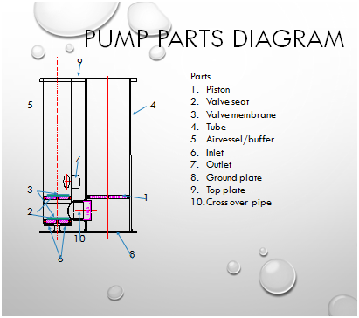

Diagrams showing how the pumps work during intake and outflow.

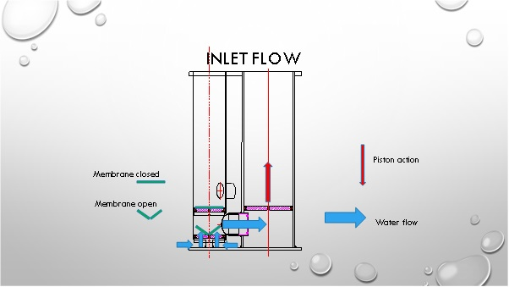

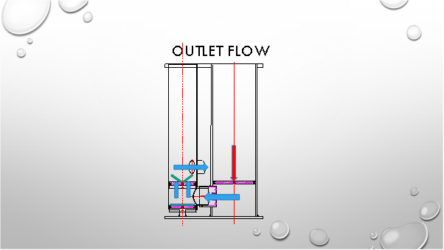

Minimal water level in pumping season

300mm

Pump

Sheet pile

Pipe

motor

The t400d2 requires a minimum 300mm of water in which to operate. Positioning the pump adjacent to the bank will improve access for maintaining the motor and pump, however, the water on the edge of the ditch is much shallower than the middle due to the trapezoid ditch profile. The edge will need to be deepened, but to stop the bank losing integrity, it will need reinforcing with sheet piling.

## Pump volumes

The pump will operate during spring and summer months when groundwater levels are anticipated to be low. They work directly through solar power; in the morning the pump will start up gradually and will slow down when clouds pass the sun. Daily outputs are listed below. Daily abstraction peak for 2x t400d2 solar pumps = 752m³. Pumps will not operate when high ground water levels achieved – when water levels within ditches are at 10cm below mean field height, pumps will be turned off. A requirement of the Environment Agency Abstraction Licence is that abstraction volumes are recorded.

|  |  |  |  |  |
| --- | --- | --- | --- | --- |
| Product Specifications | | | | |
| Average yield per day London | Month | Average hours of sunshine (Met office) | Daily output | |
| t400d | t400d2 |
| March | 3.4 | 119m³ | 190.4m³ |
| April | 5.2 | 182m³ | 291.2m³ |
| May | 6 | 210m³ | 336m³ |
| June | 6 | 210m³ | 336m³ |
| July | 6.7 | 235m³ | 376m³ |
| August | 6.1 | 214m³ | 342.4m³ |
| September | 4.5 | 158m³ | 252.8m³ |
| October | 3.6 | 126m³ | 201.6m³ |

# Location of solar pumps

High Ham Rhyne (HHR) borders the Eastern edge of the Kings Sedgemoor Raised water level area (RWLA). HHR which is connected to the Kings Sedgemoor Drain and the Old River Cary has a continuous supply of water throughout the year. HHR is separated from the RWLA by an earth bund – EKS008, grid reference ST 41700 33249. Two solar pumps will be required to pump water over EKS008 and into the RWLA at High Ham Rhyne (Lot ID 170) to raise the water levels within the system. Further information on the Kings Sedgemoor RWLA is provided in the attached map (see Reduced all_KSMAller_WLMPmaps_Jul10) and on the Somerset Drainage Boards Consortium interactive map [Somerset Drainage Boards Consortium](https://sdbc.maps.arcgis.com/apps/View/index.html?appid=013d8b18f2c7434e92a0802f5ffd541c).

Peat depths of approximately 2.5m are approximated for the working area [England Peat Map (EPM)](https://experience.arcgis.com/experience/2de81f5bd54f48e99771549e0b4746d0/)

# Solar pump layout

Indicative arrangement of the pumps and supporting structures are shown below with descriptions of each of the elements to be installed as part of the works:

* metal sheet piling – the pumps are to be positioned side by side along one ditch bank. As they must not sit in shallow water to remain operational, the channel on the edge of the ditch must be deepened. To preserve the bank integrity, the ditch bank and EKS008 Bund will be reinforced with metal sheet piling pushed into the peat with an excavator, these will then be bolted together to create a structure of minimum size, 4000mm x 2000mm. A survey to look for water vole burrows will be conducted prior to operations by Natural England. If burrows are not evident, the vegetation shall be strimmed to ground level to make the areas unsuitable and ensure they are not used by water voles prior to installation of the piling. If burrows are recorded, a water vole mitigation licence shall be applied for prior to commencement of any works.
* eel screening – 25mm galvanised metal screening will be attached to the ends of the barriers to screen our large detritus. A finer 2mm mesh screen will be applied where the inlet is for the pumps to prevent elvers and eels being sucked into the pumps. Aqua delta is applying for a Fish Friendly Certificate for the t400d2 as the impact these piston pumps have on fish is considered to be negligible (see On Being fishfreindly of the 400d Solar Tube pump by Aqua Delta). If approved by the Environment Agency, this would negate the need for screening.
* floating boom – a floating boom will be positioned across the ditch to reduce the quantity of floating plants, such as duckweed, entering the zone where water will be drawn into the pump inlets. This will reduce the quantities of vegetation which will be drawn through the pump and minimise clogging.
* discharge pipe support – the force at which the pumps will discharge water could be great enough to cause erosion of the ditch bed. A wooden structure will be installed within the channel to focus the discharge to the centre of the ditch; away from the earth bund and ditch banks which may be eroded.
* field gates to be installed on the earth bund to provide access for farm machinery and prevent access to the asset by livestock.

Note – This image shows a pump arrangement with three solar panels – we are proposing two pumps at a single location, each pump with 6 solar panels, 12 in total. Each solar panel is 2000mm length x 1260mm width x 1150mm height when in operating position on metal frame. The solar panels will require a total area of approximately 8x13m = 104m², this will be fenced to protect from cattle damage.

## Outline Method of works

An outline method of works is described below. The successful tender must elaborate on the outline method for a more detailed methodology.

**Working Method:**

* Clear the working area of vegetation prior to construction works.
* Prepare ground as required prior to installation.
* Install sheet piling to sufficient extent and depth.
* Install gates and make improvements to peat bund as required for farm machinery access and to exclude livestock.
* Install Aqua Delta t400d2 pumps within water channel.
* Install pump outlet pipes (with water flow meter) which must pass water over the adjacent peat bund from High Ham Rhyne into an adjacent ditch within the Kings Sedgemoor Raised Water Level Area. Access for farm machinery across this bund must still be feasible following installation.
* Install 12x solar panels capable of powering solar pumps when operating at full capacity.
* Install fencing to protect solar panels from livestock.
* Connect pumps to solar panels.
* Turn on pumps to successfully demonstrate that they are operational.

## Environmental considerations

Works will occur within Kings Sedgemoor SSSI. Natural England assent will be secured by Philip Thorpe. Kings Sedgemoor SSSI is wetland grazing marsh with ditches on peat soils. This protected site was designated for its breeding and wintering wildfowl and waders, ditch vegetation and invertebrates, and species-rich grasslands, therefore special consideration and sympathetic working practices must be employed to safeguard these features and any other protected species that may occur on site during the delivery stage of this project.

Parrett Internal Drainage Board consent PA-002747 has been granted for works.

## Maintenance

Natural England, or tenants of Natural England, shall be responsible for maintenance of the structure for as long as Natural England owns the land.

## Outputs and timescales

The main outputs for this project will be:

1. Procure and install 2x Aqua Delta t400d2 solar pumps with water flow meter on pump outlet pipes, and 12x solar panels sufficient to power the pumps at full capacity.
2. Install associated infrastructure to protect the asset and provide suitable conditions for it to operate.
3. Reinstate safe access for farm machinery through a redundant gateway over a peat bund.

Key timescales:

Project installation start date 1st September 2025

Contract Completed by 31st October 2025

Please note on 06/06/25 Aqua Delta informed Natural England there is a 5 to 6 weeks lead in time for two Aqua Delta t400d2 solar pumps. Completion of an online form is required [Request a quote - Aqua Delta](https://eur03.safelinks.protection.outlook.com/?url=https%3A%2F%2Faqua-delta.nl%2Fofferte%2F&data=05%7C02%7Cphilip.thorpe%40naturalengland.org.uk%7Cf839e758090d447aeeae08dda4d73334%7C770a245002274c6290c74e38537f1102%7C0%7C0%7C638847966360503422%7CUnknown%7CTWFpbGZsb3d8eyJFbXB0eU1hcGkiOnRydWUsIlYiOiIwLjAuMDAwMCIsIlAiOiJXaW4zMiIsIkFOIjoiTWFpbCIsIldUIjoyfQ%3D%3D%7C0%7C%7C%7C&sdata=Ls6gt2F%2BRagq7DbcKxIi0hSVeF6g5H4vB6VS%2BO3DDSg%3D&reserved=0)

Prices will remain fixed for the duration of the contract award period. We may at our sole discretion extend this contract to include related or further work. Any extension shall be agreed in advance of any work commencing and may be subject to further competition.

# Project management

The contractor will appoint a project leader who must have sufficient experience, authority to act on behalf of the contractor and time allocated to manage the project effectively. The contractor’s project leader (CPL) will be responsible for the management and delivery of the project and will act as the liaison point, particularly liaison between members of any consortium, with the Natural England project manager (NEPM).

# Supporting Documentation

The following supporting documentation should be provided:

* + Health & safety Policies/certificates
  + Environment Policies
  + VAT registration number
  + Public Liability Insurance
  + Professional Indemnity Insurance
  + CV’s
  + Past Work
  + Sustainable Procurement Practices

# Sustainability

As a delivery partner, the successful contractor is expected to pursue sustainability in their operations, thereby ensuring Natural England is not contracting with a supplier whose operational outputs run contrary to Natural England’s objectives. The successful contractor will need to approach the project with a focus on the entire life cycle of the project. The successful contractor is likely to be able to provide a copy of their environmental policy and any environmental accreditation schemes such as ISO 14001 or EMAS which they have been awarded or are working towards.

1. **Operational Sustainability -** Explain to Natural England what your organisation is doing to incorporate sustainability within its operations. This may include any details you are able to provide in relation to steps you may be taking to reduce your carbon footprint.
2. **Environmental Management -** Detail what you will do to assess the environmental impact of completing this project and provide mitigations. Examples may include operational measures to reduce emissions and noise impacts, efficient energy use, efficient use of raw materials and minimisation of waste where possible.

# Key Natural England Contact

Project Officer – Philip Thorpe, Senior Adviser - Somerset, Tel – 07979119406

Email – philip.thorpe@naturalengland.org.uk

#### Key Aqua Delta Contacts

|  |  |
| --- | --- |
| [AquaDeltaLogo](https://eur03.safelinks.protection.outlook.com/?url=http%3A%2F%2Fwww.aqua-delta.nl%2F&data=05%7C02%7CPhilip.Thorpe%40naturalengland.org.uk%7Ceed4acbce2b84683399c08dc8533e162%7C770a245002274c6290c74e38537f1102%7C0%7C0%7C638531705132781804%7CUnknown%7CTWFpbGZsb3d8eyJWIjoiMC4wLjAwMDAiLCJQIjoiV2luMzIiLCJBTiI6Ik1haWwiLCJXVCI6Mn0%3D%7C0%7C%7C%7C&sdata=gAvr72b3XqQLWsI52RmfIQI7FBNy4k2UFsglIISLR3I%3D&reserved=0) | **Aart den Breejen | Aqua Delta  Website:**[**www.aqua-delta.nl**](https://eur03.safelinks.protection.outlook.com/?url=http%3A%2F%2Fwww.aqua-delta.nl%2F&data=05%7C02%7CPhilip.Thorpe%40naturalengland.org.uk%7Ceed4acbce2b84683399c08dc8533e162%7C770a245002274c6290c74e38537f1102%7C0%7C0%7C638531705132788511%7CUnknown%7CTWFpbGZsb3d8eyJWIjoiMC4wLjAwMDAiLCJQIjoiV2luMzIiLCJBTiI6Ik1haWwiLCJXVCI6Mn0%3D%7C0%7C%7C%7C&sdata=oQ%2FnK8YBI4uw4krhZQDeXdvL8KlGuonaBYR%2FjogeyF0%3D&reserved=0)[**Telefoon:  +31 6 36 31 56 27**](tel:+31636315627)[**E-mail:  aart@aqua-delta.nl**](mailto:aart@aqua-delta.nl) **Postadres:  Rivierdijk 829ws, 3371 EN Hardinxveld-Giessendam, The Netherlands Werkplaats:  Oosteind 47, 3356 AB Papendrecht, The Netherlands** |
| [AquaDeltaLogo](https://eur03.safelinks.protection.outlook.com/?url=https%3A%2F%2Furl.uk.m.mimecastprotect.com%2Fs%2F5JS8CM838toRZnnfwf5c8btz3%2F&data=05%7C02%7Cphilip.thorpe%40naturalengland.org.uk%7Cf839e758090d447aeeae08dda4d73334%7C770a245002274c6290c74e38537f1102%7C0%7C0%7C638847966360528155%7CUnknown%7CTWFpbGZsb3d8eyJFbXB0eU1hcGkiOnRydWUsIlYiOiIwLjAuMDAwMCIsIlAiOiJXaW4zMiIsIkFOIjoiTWFpbCIsIldUIjoyfQ%3D%3D%7C0%7C%7C%7C&sdata=pvHFm8NH2Ih4vzCrI%2Bmb64mA7mPP3b%2BwRhFEsi%2FSQo8%3D&reserved=0) | **Nathan van Wijngaarden**| Aqua Delta  **Website:**  [www.aqua-delta.nl](https://eur03.safelinks.protection.outlook.com/?url=https%3A%2F%2Furl.uk.m.mimecastprotect.com%2Fs%2F5JS8CM838toRZnnfwf5c8btz3&data=05%7C02%7Cphilip.thorpe%40naturalengland.org.uk%7Cf839e758090d447aeeae08dda4d73334%7C770a245002274c6290c74e38537f1102%7C0%7C0%7C638847966360544661%7CUnknown%7CTWFpbGZsb3d8eyJFbXB0eU1hcGkiOnRydWUsIlYiOiIwLjAuMDAwMCIsIlAiOiJXaW4zMiIsIkFOIjoiTWFpbCIsIldUIjoyfQ%3D%3D%7C0%7C%7C%7C&sdata=6X7J4dfYZVdSstqhsLZxRCfkctKV8qqQKlRVcgNwlvU%3D&reserved=0) [**Telefoon:**  +31 6 34 44 77 28](tel:+31634447728) [**E-mail:**  nathan@aqua-delta.nl](mailto:nathan@aqua-delta.nl) **Postadres:**  Rivierdijk 829ws, 3371 EN Hardinxveld-Giessendam, The Netherlands **Werkplaats:**  Oosteind 47, 3356 AB Papendrecht, The Netherlands |

**Location of works:**

Kings Sedgemoor, off Beer Drove (adjacent to High Ham Rhyne), Aller, Somerset. TA10 0QX.

**What3Words for the solar pump location:**

intrigued.merely.vegetable