11th June 2025

DOG SUPPORT UNIT

DURHAM CONSTABULARY

Dear Marie

RE: SUPPLY TERMS

I am pleased to confirm our terms of continued supply:

# TERMS

1. Anigene Professional Surface Disinfectant Cleaner will be supplied at £+ VAT per case of 2x5 Litre. **Dill and Citrus scented cases please, mixed order of both scents if possible.**

1. The contract will run from 01/08/2025 – 31/07/2028 inclusive.

1. 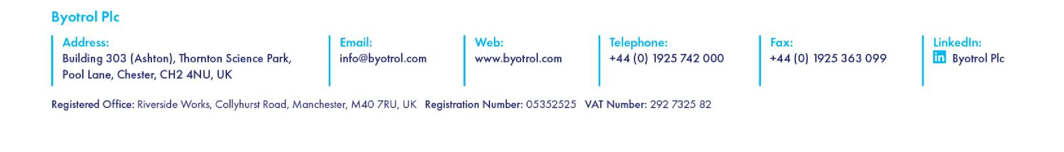Deliveries will be free of charge for orders of - cases or more; less than - cases will be charged at the prevailing rate.

1. During the term of this agreement, Byotrol plc will be the dedicated supplier of disinfection products to Durham Constabulary. In the event that Byotrol plc cannot supply the above item stipulated at clause 1.1 of this agreement, or a near alternative product during the stock outage period, then Durham Constabulary may source an alternative supplier in those circumstances.

1. Orders are to be placed by Durham Constabulary every - months and be for at least -cases (- units)

1. Should Durham Constabulary find alternative premises or start purchasing 1000 Litre containers this agreement will be amended accordingly, subject to a variation of contract which will be issued by Durham Constabulary Procurement Team.

1. Pricing for subsequent contracts will be proposed within 180 to 90 days of the termination date, with a view to negotiating a subsequent contract. The new contract proposal prices will be forwarded to Durham Constabulary Procurement Team for review.

# VISIT

1. Byotrol plc will hold account review meetings upon request

**3. SUPPLY OF ADVISORY NOTICE POSTERS AND STICKERS**

1. Byotrol plc agrees to supply posters, educational pamphlets and other material as required by Durham Constabulary.

**4. FORCE MAJEUR**

1. Neither party will be held accountable for any delay, cost, or inability to fulfil the terms of this agreement from any unseen action, strike, riot, or civil commotion, change in legislation or government action that renders this agreement unworkable.

I would be grateful if you could sign and return a copy of this letter as acceptance of the terms herein.

Yours Sincerely,

Vicky West-Dean, Human Health Key Account Manager, Byotrol

## We hereby accept the terms as outlined above: -

Signature: 

Name: Marie Dale

Position: Head of Procurement

## Date: 16/06/2025