POWER HALL + DECARBONISATION

HISTORIC WORKING MACHINERY
Historic Engine Contractor Scope of Works

ELECTRIC MOTOR DRIVES TO 4 x HISTORIC ENGINES

February 2025

The Science Museum Group seeks a supplier to finalise the design, manufacture, assemble, install, and commission electric drive systems for selected historic working machines (HWMs) in the Power Hall.

This work follows a preliminary audit (Stage 1) that defined the scope of work required. A detailed condition audit and benchmarking process (Stage 2) is currently underway and will run alongside this project.

Project Background

Built in 1855 as the shipping shed for Liverpool Road Station—the world’s first purpose-built passenger railway station—the Power Hall is one of the UK’s most significant industrial heritage galleries. It houses Europe’s largest collection of working steam engines, most of which were manufactured in Manchester.

The Grade II listed Power Hall was closed in 2018 for structural inspections, during which the historic engine collection was carefully covered and protected. Inspections revealed the need for substantial repairs and renovations. In response, the Museum undertook restoration works to address:

- Fabric repair – Restoring the roof, brickwork and doors
- Decarbonisation – Reducing energy use and dependence on fossil fuels, while exploring environmentally sustainable operation for the engines
- Visitor experience – Improving access, refreshing the dated gallery, and restoring as many engines as possible to working condition for public demonstrations.

With the building works nearing completion, the Museum is now focusing on reinstating its historic engine collection to working order. Since 2018, the engines have remained stationary, and the large gas boiler previously used to generate steam has been replaced by a more efficient electric boiler. Additionally, some engines will be adapted to run using electric drives.

The work requires a mechanical electrical engineering contractor to finalise details of the designs, developed in collaboration with our Historic Machinery Consultant, fabricate, install and commission electric motor drive systems for four (4) historic engines. This includes purchasing equipment and materials, fabricating, preassembly in works, delivery to site, installation, adjustment, commissioning, and costed snagging and system optimisation visits to site at 3-months, 6-months and 12-months following commissioning.

Outcomes

This work will achieve the following key outcomes:
- Fabrication of electric motor drives systems and supporting structures for four (4) historic engines in accordance with the specification.
- On-Site Installation, alignment and adjustments required
- Commissioning of the electric drive for safe operation by the Museum technical and operational teams
- Production of 4 x Operation & Maintenance manuals in hard copy and editable, electronic format.

The following supporting documents are included as appendices at the end of this document.

- General Arrangement Drawings for each Electric Motor Drive System, developed by the Historic Machinery Consultant
- Indicative Schedule of Parts for each Electric Motor Drive System developed by the Historic Machinery Consultant
- Latest Asbestos Containing Material (ACM) Surveys for the engines being assessed as part of this work.
- Stage 2 Condition and Benchmarking reports for each engine (where this information is available)

Electric Motor Drive System Design

The electric drives have been designed in collaboration with our Historic Machinery Consultant on the following basis:

- Rotational speed. A reasonable proportion of original service speed to give visitors a reasonable impression of the original appearance.

- Visibility. No attempt has been made to hide equipment, as it is understood some may be required as part of the interpretation of developing energy use.

- Reversibility. Permanent alteration to any historic working machine has been avoided. Friction drives have therefore been used on Buxton, Pender and the Workshop engine. On Firgrove the option of motorising the barring engine or removing it have been discounted as too intrusive, so a separate drive to the rack has been adopted.

- Loadings. Where feasible, drives have been designed to minimise the loads on historic working parts and their bearings. For example, on the workshop engine the drive is below the flywheel to reduce the load on its original plain bearings.

Technical Risks

Over running building work has restricted the access to carry out the detailed Stage 2 Condition Checking and Benchmarking work. Consequently, it is necessary for this Stage of condition checking to run concurrently with this work. This presents the following technical challenges:

- On appointment, the contractor will be responsible for finalising the designs of the Electric Motor Drive Systems for the specified four engines. This is likely to involve at least one pre-works site visit at the outset of the contract to inspect and familiarise themselves with the engines, confirm measurements etc. and engage with our Historic Machinery Consultant to develop the detailed design, resolve any queries etc.

- Each of these engines have plain bearings with sliding not rolling contact. They rely on a film of oil or grease to be retained between the sliding surfaces to reduce friction and prevent wear. When an engine is stationary the lubricant tends to be lost from the bearing and the torque required to re-start it rises significantly. Electric motors do not naturally provide high torque on starting, so, whilst theoretically they are of sufficient size, some modifications and balancing may be required if starting difficulties are encountered.

- Due to Stage 2 Condition checking works running concurrently with these works, there is a likelihood that defects and issues may be discovered that will not have been allowed for in these designs, requiring alterations to the drive equipment and/or HWM’s during design finalisation or after commissioning. For this reason, this package requests follow-up visits for system optimisation, snagging and servicing to be costed for 3-months, 6-months and 12-months after the commissioning date.

- Where steam engines are to be driven by electric power, alternative means of internal lubrication must be provided, and wear-mitigation alterations made. Without these engines running for long periods will wear, so they should not be run until Stages 2 benchmarking and Stage 3 remedials works are completed. This may potentially cause delays to commissioning.

WORK PACKAGES

WP1: Isle of Man Locomotive No. 3 ‘Pender’ (Y1980.12)

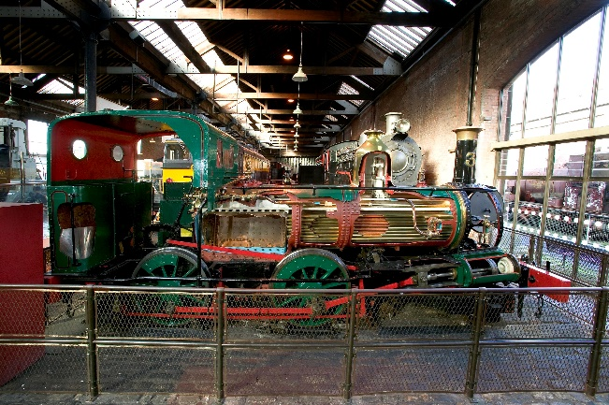

Pender is one of the first batch of locomotives built for the Isle of Man Railway by Beyer, Peacock & Company. It is a visually striking exhibit, offering visitors a classic example of a steam locomotive. One of its most engaging features is the sectioned side, which allows visitors to observe the piston mechanism in operation.
Pender has been operating on electric drive for several years and, therefore, does not require the same level of conversion as other Historic Working Machines (HWMs) in this project. However, the previous roller system supporting the wheelsets resulted in alignment issues, necessitating a redesigned roller arrangement. This revised design depends on the friction levels between the rollers and the worn wheels. Since the exact friction levels cannot be predicted with certainty, reasonable assumptions have been made. If these prove incorrect—resulting in wheel slippage on start-up—further modifications may be required.
A Stage 2 condition assessment has been completed for Pender, and a copy of the report is included as an appendix to this document.

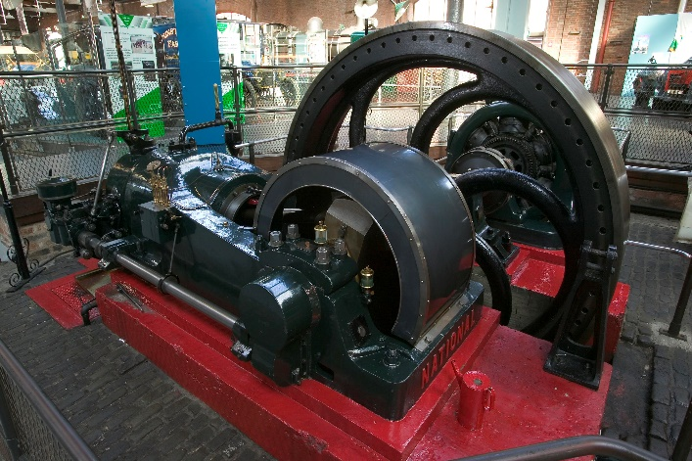

WP2: National Buxton Diesel Engine & Generator Set (Y1983.7)
This engine originally provided power for the Buxton Safety in Mines Research Establishment until the arrival of the National Grid. Even after grid connection, it continued to supply electricity to remote areas of the site that were not connected to the main network.
Technologically, the engine represents a key transition in fuel injection methods, demonstrating the shift from air-blast injection to mechanical pump systems. Previously operating on diesel, this project is part of its conversion to electric drive. This engine previously powered a generator which powers several electric lamps around the machine. Whilst not a critical element of this work package, the museum would be keen to reintroduce this element as part of the electric drive operation of the engine and would welcome suggestions of how to integrate this within the electric drive start-up.
The engine will be driven by friction-wheels held against the flywheels by springs. Contact loads will need adjustment on commissioning, and wheels may need to be changed if slippage occurs. The spring-post of the Buxton Engine will apply a high upward pull of 9,000N on the concrete plinth adjacent the Flywheel.
The engine is mounted on a low concrete plinth, but to facilitate the conversion, a pilot hole drilled in January 2025 revealed that the existing sub-structure was insufficient to support the electric drive installation. As a result, reinforced flooring is being installed to support the upward pull load of 9,000N, equivalent to approximately half a cubic meter of concrete.
Stage 2 condition checking work is in-progress on this engine.

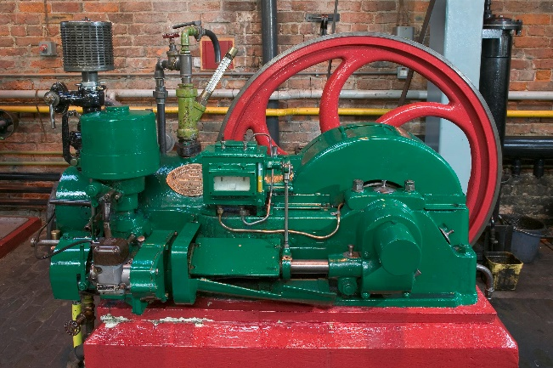
WP3: National Gas ‘Workshop’ Engine (Y1976.22.1)
This engine was mass-produced, and numerous examples still survive. Within the National Gas & Oil Engine Co. B Series range—both Diesel and Gas variants—at least 50 examples exist in the UK, with approximately half in operational condition. Many more examples are preserved worldwide.
During its display at the Museum’s former Grosvenor Street premises (1976–1983), there is a strong possibility that it was operated on electric drive. Its high display value comes from its integration with the lineshafting system and machine tools, providing visitors with a realistic demonstration of its historical use.

The engine is installed on a ground-floor plinth and drives a lineshaft system via a flat belt on the crankshaft pulley. This system powers up to four machine tools:
- A lathe
- A horizontal milling machine
- A pillar drill
- A grinder

A slotting machine is positioned next to the pillar drill, but it is not currently set up for lineshaft operation. The lineshaft system is engaged via a modern electrically operated clutch, while drive to individual machines is controlled by manually shifting belts between the drive pulley and a dummy pulley.

Before mothballing in 2018, this engine operated on Simulated Town Gas. As part of this project, it will be converted to electric drive. Like the Buxton engine, it will be powered by friction wheels held against the flywheels by springs. During commissioning, contact loads will need to be adjusted, and if slippage occurs, the friction wheels may require replacement.

Stage 2 condition checking work is in-progress on this engine.

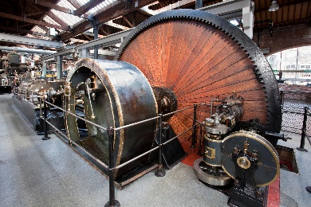

WP4: Firgrove Mill Engine (Y1976.22.1)
Whilst not unique, this engine is an exemplary representation of a typical mill engine from the late 19th to early 20th century, featuring compound expansion. Its historical integrity is enhanced by the inclusion of its original expansion (Corliss) cut-off valve gear and rope drive. This engine plays a crucial role in illustrating Manchester’s steam technology heritage, with its significance rooted in being a common yet essential example of its type.
The engine has been out of operation since June 2017, having previously run on steam and condensate at approximately 80 rpm. Its barring rack is ‘as cast’, meaning the pitch and profile of its teeth may be inconsistent. As a result, rattling or clunking noises may occur after commissioning, potentially requiring remedial work on the rack or a reduction in drive speed.
Access to the underfloor areas of this engine is severely restricted, limiting viable installation points for the drive onto the barring rack. The only practical location is within the flywheel pit, which is just 500mm wide. This constraint may present installation difficulties, potentially requiring modifications to the strut-frame.
Additionally, the main-bearing pump oiler must be removed before motor-drive installation and reinstalled in a new position afterward. However, the exact location and drive method for the oiler cannot be determined until the motor-drive installation is complete.
Stage 2 condition assessment is scheduled for April 21st – May 31st, 2025. To accommodate any findings or necessary design adjustments arising from this assessment, the final completion date for this work package has been set for September 2025.

SCOPE OF WORKS
The contractor will...
- Review all drawings, verifying components specified as ‘contractor-design’ to ensure compliance and correct function.
- Supply, fabricate and finish all components and materials
- Preassembly at their facility
- Deliver to site, install and adjust as required
- Provide temporary guarding where required
- Commission the Electric Motor Drive system
- Supply Operation & Maintenance Manuals for each installation in hard-copy and editable electronic document (.docx) format
- After commissioning, ensure all newly installed work is re-protected against damage or deterioration.

PROJECT DELIVERABLES

In response to these Work Packages, The Contractor must:

- Conduct a Pre-Works Site Survey – Undertake at least one site visit before commencing works to assess access requirements, site conditions, and the scope of work. This visit will support the preparation of detailed Risk Assessments and Method Statements (RAMS) for each historic engine package.

- Finalise Design & Engineering for 4 x Electric Motor Drive Systems - The Contractor is responsible for the final design of the four (4) Electric Motor Drive Systems as detailed in the work packages and supporting documents, ensuring correct level, balancing, alignment, fit, and suitability of all components and fabrications. The Principal Contractor, Historic Machinery Consultant, and internal Museum teams will be available to provide guidance and support throughout the process. Collaboration with these teams is essential to ensure the design aligns with project specifications, conservation requirements, and installation constraints.

- Fabricate Electric Motor Drive Systems & Supporting Structures – Manufacture the electric motor drive systems and structural supports for four (4) historic engines as detailed in the work packages and supporting documents, ensuring full adherence with the Specification and Scope of Works.

- On-Site Installation & Commissioning – Install the four (4) Electric Motor Drive Systems on-site, carrying out all necessary alignments, balancing and adjustments to ensure proper functionality and integration. Systems must be tested and commissioned in full adherence with the Specification and Scope of Works.

- Deliver Operation & Maintenance Manuals – Produce four (4) comprehensive Operation & Maintenance (O&M) manuals in both hard copy and editable electronic format, detailing installation, operation, maintenance, and troubleshooting procedures in line with the Specification and Scope of Works.

- Provide Post-Commissioning Monitoring & Support – Conduct scheduled monitoring, servicing, optimization, and snagging visits at approximately three-month, six-month, and twelve-month intervals following the commissioning date.

GENERAL SPECIFICAITONS

Responsibility for Detailing
The contractor must ensure correct levelling, alignment, and fit of all components, supplying any required packers, shims, and washers etc. as necessary. The fabricator is responsible for ensuring proper fit, compatibility, serviceability and fitness for purpose of all parts. Proprietary parts should be purchase before frame manufacturing to avoid incompatibility. Drawing dimensions must be adjusted as necessary.

Keys and Keyways
Keys and keyways must conform to BS 4235 Part 1: 1972 and must be secured against axial movement.

Fastenings & Fixings
Schedules of components and fastenings are indicative only; the contractor shall determine bolt sizes and spacings to suit the components. Maximum hole clearance for bolts through steelwork is 1mm on diameter. All fastenings and fixings shall be mild-steel, zinc-plated, unless otherwise specified.

Concrete fixings must be installed in dust-free holes for proper resin adhesion. Where required, bolts shall be torqued per BS 7371-1 or manufacturer recommendations, with critical fastenings secured using thread-locking compound or locking washers.

Welding
All welds must be veed out on both sides, using multiple runs for 100% penetration. Distortion should be minimized and corrected as needed, with all spatter prevented or removed. The contractor is responsible for any weld verification. Welds requiring inspection must be tested using MPI, dye penetrant, or ultrasonic methods per BS EN 5817.

Motor Terminal Box Orientation
Terminal boxes must be positioned for easy post-installation access for servicing and maintenance. Cables should be routed to prevent mechanical stress and protected by flexible conduit where necessary. Cable entry points must be sealed against moisture and dust ingress.

Paint Finishes
Motor gearboxes, couplings, bearings, shafts, springs, and fastenings shall remain self-coloured as received. Fabricated steelwork must be cleaned to ST3 standard, primed with a two-pack primer, and finished with 125-micron DFT two-pack polyurethane gloss black. Adhesion and impact resistance tests shall follow ISO 12944.
Commissioning
Temporary guarding must be in place during commissioning. The SIM Technical Services team must fully lubricate each engine before operation. Test the engine, ensuring it rotates freely. The spring pressure on the friction wheel must be adjusted just enough to prevent slipping—excess pressure risks damaging the friction wheel and must be avoided.

Operation and Maintenance Manuals
Upon completion of commissioning, the contractor shall provide the SIM Technical Services Team with a comprehensive digital documentation package containing the following:
- As-built drawings, which may include marked-up construction drawings reflecting any modifications made during installation.
- Technical data sheets and drawings for all proprietary components and assemblies.
- Operating instructions, detailing safety procedures, startup, and shutdown processes.
- Inspection, maintenance, and lubrication guidelines, specifying servicing requirements and intervals.
- Bearing and gearbox lubrication schedules, including recommended lubricants, specifications, and the required frequency for inspection, maintenance, and lubrication.
This package must be submitted in a structured, editable and accessible digital format to ensure ease of reference for ongoing operation and maintenance.
Preferred Suppliers
The following suppliers have been suggested for reference; however, the contractor remains fully responsible for sourcing suitable components that meet the required quality, duty, and compatibility. Any proposed alternatives must be approved in advance by the Historic Machinery Consultant, and the contractor is solely accountable for ensuring the suitability, serviceability, and long-term performance of all equipment used.

The inclusion of supplier details does not constitute an endorsement or guarantee of product availability, pricing, or lead times. It is the contractor’s responsibility to verify that all sourced materials comply with the required specifications, industry standards, and project requirements. Any delays, substitutions, or supply chain issues must be managed by the contractor without impact on project timelines or quality. General enquiry/sales contact details are provided below; however, contacting local branches or specific department representatives may offer a more direct and efficient response.

Motors, Gearboxes, Bearings, and Chain Drives

Eriks UK, Seven Stars Road, Oldbury, B69 4JR
Email: marketing@eriks.co.uk
Tel: 0121 508 6000
Web: www.eriks.co.uk

Fastenings & Fixings (Including nuts, bolts, flanged Nylock nuts, and Nord-Lock washers)

Orbital Fasteners, Olds Approach, Northwood, Watford, WD18 9XT
Tel: 01923 777 777
Email: sales@orbitalfasteners.co.uk
Web: www.orbitalfasteners.co.uk

Friction Wheels

Blickle Castors & Wheels Ltd, 30 Vincent Avenue, Crownhill, Milton Keynes, MK8 0AB
Tel: 01908 560 904
Email: sales@blickle.co.uk
Web: www.blickle.co.uk

Keystone Castors & Wheels, Unit 5, Paul House, Stockport Road, Timperley, WA15 7UQ
Tel: 0161 865 3800
Email: manchester@keystonecastors.com
Web: www.keystonecastors.co.uk
Workmanship
The Historic Working Machines (HWMs) form part of the Science Museum Group’s (SMG) nationally significant collection of working engines. These engines are generally complete and in either potential or actual working order, serving as a central feature of the Power Hall display.

During all on-site works we expect that:
- The highest standards of professionalism and workmanship are required at all times to prevent loss or damage.
- Trainees may be employed for tasks within their proven competence but must be continuously supervised.

Health & Safety/Compliance
All on-site works must comply with the Science Museum Group (SMG) Health & Safety policy and all relevant UK legislation.

This includes, but is not limited to:
- The Health and Safety at Work Act 1974.
- Control of Asbestos Regulations 2012.
- The Construction (Design and Management) Regulations 2015.
- The Provision and Use of Work Equipment Regulations 1998 (PUWER)
- Electricity at Work regulations 1989

The Power Hall is a Grade II listed building, requiring adherence to specific planning, building control, and heritage guidelines. Intrusive works, such as fixings or suspended objects, must be pre-approved by the Museum and/or Historic Machinery Consultant to ensure compliance with heritage protections.

Tools & Equipment
To deliver the specified work packages, the Historic Machinery Contractor must supply all necessary tools, equipment, and materials, including but not limited to:
- Hoists and lifting gear as appropriate, soft slings, lifting eyes, winches etc.
- Access equipment (such as stepladders, ladders, scaffold towers)
- Hand and power tools.
- LED task lighting. No hot lights are permitted.
- Personal Protective Equipment (PPE) including face-fitted industrial P3 masks for use when opening areas containing suspect materials.
The contractor must provide all tools and equipment required for the successful delivery of the work packages, ensuring that all tools:
- Are in good working condition and regularly inspected.
- Meet relevant safety standards and certifications (e.g. CE marking).
- Are suitable for use in heritage environments, with minimal risk of damage to historic components.

On-Site Works
All Risk Assessments, Method Statements, and work plans must be reviewed and approved by the Museum Team(s) and/or Historic Machinery Consultant before work begins. A joint pre-work inspection will confirm the existing condition of the site and Historic Working machinery.

Additional details regarding on-site requirements and responsibilities are outlined below.

Off-Site or Enabling Works
The tender response must clearly identify all foreseeable costs associated with preparatory or enabling works, including but not limited to:
- Preparation of risk assessments and method statements
- Attendance at site meetings and scoping visits
- Collection and delivery of equipment
- Sourcing, Procurement of tools, equipment or components
- Manufacturing of parts, components or elements
These costs should be itemised to ensure transparency and completeness in the tender submission.

CONTRACTOR SUPPORT & SITE REQUIREMENTS

Asbestos Containing Materials (ACMs)

The most recent Asbestos Containing Material (ACM) surveys for the Historic Working Machines (HWMs) are provided in the appendices of this document.

All works must comply with the Science Museum Group (SMG) Policy on the management of ACMs. During these specific work packages, the contractor should anticipate working alongside ACM survey and remedial contractors appointed by the project. The Museum will coordinate work sequencing to minimise disruption and ensure safe working conditions.

To mitigate the risk that additional costs may arise due to delays caused by ACM discoveries, the tender response must include:

- A specified day rate per technician, including related costs such as travel and accommodation.
- A commitment to exploring all reasonable alternatives (e.g., redeployment to other tasks, adjusted working hours) in collaboration with the Museum before suspending works to minimise downtime and costs.

If suspected ACMs are discovered during work, all activity in the affected area must cease immediately, and the area must be secured. The Museum Technical Team, Museum ACM Manager and Contractor Manager must be notified, and no further work may proceed until clearance is granted.

Communication & Coordination

Prior to the project start date, the contractor must attend a pre-works meeting with the Museum Team and/or the Historic Machinery Consultant. This meeting will ensure all parties are aligned on the project scope, schedule, and expectations.

A nominated member of the Museum staff will act as the Contractor Manager and serve as the primary point of contact for the contractor throughout the works. Whilst working on-site the contractor can also expect daily interactions with the site’s technical team and frequent collaboration with the Historic Machinery Consultant. The contractor should be aware that other contractor-led exhibition fit-out works may be taking place simultaneously within the site, and close coordination will be essential to minimise disruptions and ensure smooth progress.

Additionally, other areas of the Museum will remain open to the public between 10:00 and 17:00. Contractors must avoid public areas during these hours and use designated staff routes to access the site and ensure that all site access doors/gates are securely locked after use.

Any safety, security, or wellbeing concerns should be reported immediately to the Contractor Manager for prompt resolution.

Site Access & Security

During on-site works, the Power Hall will operate as an active construction site under the management of the Science Museum Group (SMG). Standard main-contractor attendances—including road access, general lighting, power, and water—will be provided. Reasonable access will be maintained throughout delivery, installation, and commissioning, with designated access routes in place to accommodate HGV movements and facilitate the transportation of materials within the building to each Historic Working Machine (HWM).

All staff attending the site must complete a site safety induction before commencing any works. Access to the site is available from 07:30 am, and specific access times will be agreed upon with the Contractor Manager at the commencement of works.

The site benefits from 24-hour security and limited on-site parking may be available by prior arrangement with the Contractor Manager. Welfare facilities will be provided, although due to the nature of other works on site, these may be limited. Contractors are encouraged to plan accordingly.

It is essential that all contractors respect site regulations and work collaboratively with the Museum Team to maintain a safe and secure environment.

Technical Support & Facilities provided by SMG
To support the installation and commissioning, where practicable, SMG will ensure:

- The availability of the overhead 9-tonne gantry cranes and clear access to operating chains, enabling efficient handling of heavy materials and components.
- Completion of Stage 2 Benchmarking works and the sharing of information and findings relevant to this project.
- Provision of isolated electrical supplies next to each HWM, along with inverter controls as required.
- Motor connection, commissioning, and inverter parameter adjustments in collaboration with the contractor, Technical Team, and HWM Consultant.
- Cleaning and oiling of engines before commissioning by our Technical Services team.
- Design and installation of any subsequent permanent guards for drives and HWMs upon project completion.
- Fixed Electrical Testing following final commissioning

Emergency Procedures

The contractor must familiarise themselves with the Museum's emergency procedures before commencing any works.

These procedures will be covered during the site safety induction. In the event of an emergency, such as fire, medical incidents, or security threats, contractors must follow the Museum's establish procedures, which include:

Fire Evacuation: Evacuate immediately upon hearing the fire alarm, using the nearest designated escape route, and assemble at the designated assembly point. Do not re-enter the building until authorised to do so.

First Aid: First aid facilities are available on site, and trained first aiders can be contacted via the Contractor Manager or the site’s technical team. Any injuries must be reported immediately to the Contractor Manager.

Incident Reporting: Any emergencies, near misses, or safety concerns must be reported to the Contractor Manager as soon as possible. This includes potential hazards identified during works.

Quality Control & Monitoring

The Contractor Manager or their representative will conduct periodic inspections to ensure compliance with project specifications and health and safety standards. Any deviations or non-compliance must be rectified immediately.

The Contractor is expected to collaborate with the Museum Technical Team and Historic Machinery Consultant, ensuring they are notified of any significant findings or observations.

Defect Identification

Any defects or issues identified during work must be reported to the Museum team immediately and works temporarily stopped until observed by representatives of the Museum technical and conservation teams and/or the Historic Machinery Consultant.

Upon completion of the works, the Museum Technical Team and/or Historic Machinery Consultant will undertake a final inspection to verify that all work meets the required standards, and the object is left in a safe and appropriate condition.

Programme

Milestone | Date
Returns received by Museum
Appointment
Pre-Works Site visit | Agreed on Appointment
Completion of Stage 2 Inspections on National Gas ‘Workshop’  & Buxton Engines | 30th April 2025
Completion of Stage 2 Inspections on Firgrove Mill Engine | 31st May 2025
Off-Site Works | April-July 2025
Exhibition Opening at Science and Industry Museum | June 2025
Delivery, Installation and Commissioning of Work Package 1  (Pender, National Gas ‘Workshop’ Engine & Buxton) | By 30 June 2025
Delivery, Installation and Commissioning of Work Package 2  (Firgrove) | By 31 August 2025
First Service & Optimisation Visit | By 30 September 2025
Second Service & Optimisation Visit | By 31st January 2026
Final Service & Optimisation Visit | By 30th April 2026

*Provisional dates to be discussed and agreed upon appointment. Dates refer to completion of activities unless otherwise stated.

