Digitising Standards for Urban Habitat Mapping (UHM) and Naturalness – May 2025

1. General Digitising Guidelines
1.1 Where a boundary follows an OS MasterMap feature the OS MasterMap feature should be copied so that the habitat feature uses its geometry.
1.2 Where a boundary follows part of an OS MasterMap feature the digital boundary should be snapped along the OS MasterMap feature so that the digitised boundary and OS MasterMap feature both share the same geometry where appropriate.
1.3 Where a boundary does not follow an OS MasterMap feature, such as where the boundary follows a feature on an aerial photograph, scanned and geo-rectified map (maybe field or historical), the digitised boundary should be captured with sufficient nodes that the digitised feature takes on the shape of the feature on the source material at a scale of 1:2500.
1.4 Where a boundary is shared between two polygons the boundaries must share the exact same geometry. There should be no slivers or gaps between polygons with shared boundaries.
1.5 Features should not be "stream" digitised. Stream digitising is the process of manual digitising, of lines or regions, where nodes are automatically placed at preset intervals based upon distance or time.
1.6 Polygons should not contain inappropriate "spikes". In the figure below the digitised field has an inappropriate spike.

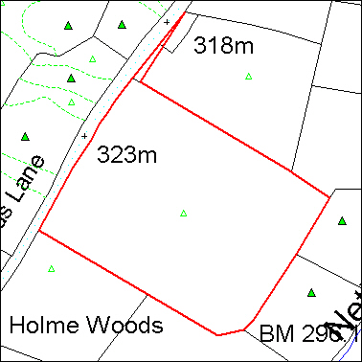
1.7 Polygons must not self-intersect (aka "bowties"). Polygons must not intersect or cross themselves. In the figure below the digitised field has a bowtie caused by a polygon crossing itself.

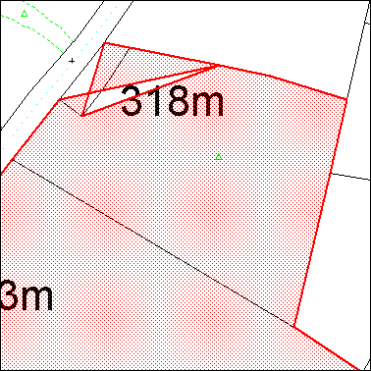

1.8 Holes in polygons (aka “Doughnuts”) should be appropriately "punched". Where there is a hole in a polygon this should be digitised as a hole as shown below.

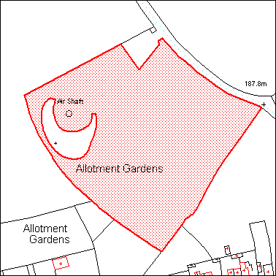

- Urban Habitat Mapping and Naturalness Specific Digitising Guidelines
2.1 All data within the Urban Habitat Mapping and Naturalness datasets should be mapped as polygons.
2.2 No polygons are to be mapped that fall below the defined Minimum Mapping Unit (5m²).
2.3 Urban Habitat Broad Classification Maps and Detailed Habitat Classification Maps for the listed target areas in tiles aligned with the Ordnance Survey National grid and in 5 x 5 Square kilometres tile sizes, link to data here: https://github.com/OrdnanceSurvey/OS-British-National-Grids
2.4 Polygons should not be mapped as multi-part polygons.
2.5 When undertaking work for a specific geographic area such as a county, the digitising should yield 100% coverage of the project area, split into chunks using Ordnance Surveys’ (OS) 20km grid square.
2.6 There must not be any overlaps between parcels. Boundaries must share the same geometry.
2.7 Polygons must not cross roads (as defined with metaling on the OS MasterMap data), currently active railway lines or any watercourses that are mapped as polygons in OS MasterMap. If subdividing an otherwise contiguous area of UHM or Naturalness with a road, railway line or watercourse causes a polygon to fall below the designated MMU then it may be included within the inventory even if below the ascribed MMU.
- Attribute Structure and Content for Urban Habitat Mapping
3.1 Supply the attribute table in the following format for the Broad Habitat Classification Dataset:
Column | Alias | Format
Hab_Code | Broad Habitat Code | Text (255)
Hab_Type | Broad Habitat Description | Text (255)

3.2 Use the following spelling for the attributes. Do not use any symbols or punctuation marks, such as commas(,), hyphens (-) or apostrophes (‘):
Hab_Code | Hab_Type
A | Grasslands
B | Woodlands
C | Scrubs
D | Wetlands
E | Impervious and Non Vegetated
F | Private Gardens
G | Formal Planting
H | Recreational Landscapes
I | Coastal
J | Agricultural Land
K | Uplands Habitats
L | Habitat Mosaics and Heath

3.3 Supply the attribute table in the following format for the Detailed Habitat Classification Dataset:
Column | Alias | Format
Hab_Code | Detailed Habitat Code | Text (255)
Hab_Type | Detailed Habitat Description | Text (255)

3.4 Use the following spelling for the attributes. Do not use any symbols or punctuation marks, such as commas(,), hyphens (-) or apostrophes (‘):
Hab_Code | Hab_Type
A1 | Amenity Grassland
A2 | Undifferentiated Grassland
B1 | Broadleaved Mixed and Yew Woodland
B2 | Conifer Dominated Woodland
B3 | Small Woods
B4 | Isolated and Scattered Trees
C1 | Scrubs
D1 | Open Water
D2 | Vegetated Wetland
E1 | Sealed Surfaces and Buildings
E2 | Vegetated Building Surfaces and Green Roofs
E3 | Bareground
F1 | Non Vegetated Gardens
F2 | Vegetated Gardens
F3 | Garden Trees
F4 | Garden Scrubs
G2 | Allotments
H1 | Park Amenity Grassland
H2 | Park Undifferentiated Grassland
H3 | Park Woodland and Canopy
H4 | Park Scrubs
H5 | Park Small Woods
H6 | Park Trees
I1 | Coastal Sand
I2 | Coastal Dunes
I3 | Coastal Shingle Loose and Bare Rocks
I4 | Coastal Mud
I5 | Coastal Saltmarshes
I6 | Coastal Cliffs and Slopes
J1 | Vegetated Fields
J2 | Ploughed Fields
K1 | Upland Habitats

- Attribute Structure and Content for Naturalness Mapping

5. Data Outputs
5.1 Any data created must be supplied to Natural England either as ESRI Shapefiles or ESRI File Geodatabases.
5.2 Data should be supplied by OS 10km grid square for the entirety of the project area. Link to OS Grid Square Data here: https://github.com/OrdnanceSurvey/OS-British-National-Grids
5.3 Make sure that both the spatial and attribute data have been quality checked before submission.
5.4 The geometry of the data must be checked and corrected before submission. Within ESRI ArcGIS this can be accomplished using the “Check Geometry” and the “Repair Geometry” tools.
5.5 Data can be sent to Natural England via a transfer site, such as Quatrix.
5.6 When supplying the final submission, please also complete and supply the metadata template.

