**MS8257**

**Urban tree canopy, green spaces and   
built environment data analysis and reporting 2022**

**Report 3: Local government area - Adelaide City Council**

**February 2023**

**Urban Habitat and Naturalness Mapping**

**Phase 2 analysis and reporting 2024**

LiverpoolCityRegionandWarrington, Greater London and

West Yorkshire Area

Technical Report

May 2024

Contents

**1. Challenges we faced in the processes and solutions 3**

**1.1. eCognition issues and Potential fixes 3**

1.1.1. eCogntion server time out issue 3

**1.2. Inputs Processing issues and Potential fixes 4**

1.2.1. Data processing extent and input priority 4

1.2.2. CIR image-Double color data process 6

**1.3. Ruleset processing issues and potential fixes 7**

1.3.1. Grassland wrong prediction in Agriculture 7

1.3.2. Small gaps in the AOIs 9

1.3.3. Misclassification of Coastal mud as bare ground 10

1.3.4. Woodland classification through thematic layer using DSM & DTM input process 12

## Challenges we faced in the processes and solutions

In the Urban Habitat Classification, we encountered three different types of challenges, which are listed below along with the solutions.

* eCognition issues and Potential fixes
* Inputs Processing issues and Potential fixes
* Ruleset processing issues and potential fixes

## eCognition issues and Potential fixes

The data submitting in the eCognition server we have face some challenges and resolve the issue and we summarized as below.

### eCogntion server time out issue

We processed the larger date block of Liverpool (Liverpool_20230520) in the eCognition server, but multiple tiles were failed due to the ***server time-***out issue. As a solution to fix the issue, we increased the ***Virtual memory*** in the server that is having the eCognition server software.

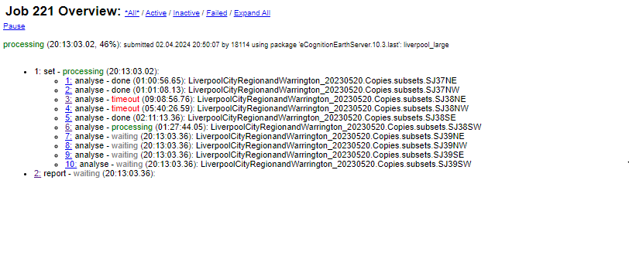

***Figure 01: Job timeout in eCognition server***

**Log file for timeout job:**

|  |
| --- |
|  |

***Figure 02: Log file for timeout job in a eCognition server***

## Inputs Processing issues and Potential fixes

In the Input data process execution, we faced some challenges and the solution is below

### Data processing extent and input priority

We received various forms of elevation data, including LAZ, DSM, and DTM. In certain date blocks, we had to utilize different elevation datasets based on availability. To address this issue, we employed LIDAR data whenever it was available for the entire date block and utilized DSM/DTM when LIDAR data was partially available or unavailable. Additionally, we processed the extent of DSM and DTM coverage as a buffered AOI during the usage of DSM and DTM data. (as illustrated in the figure 04).

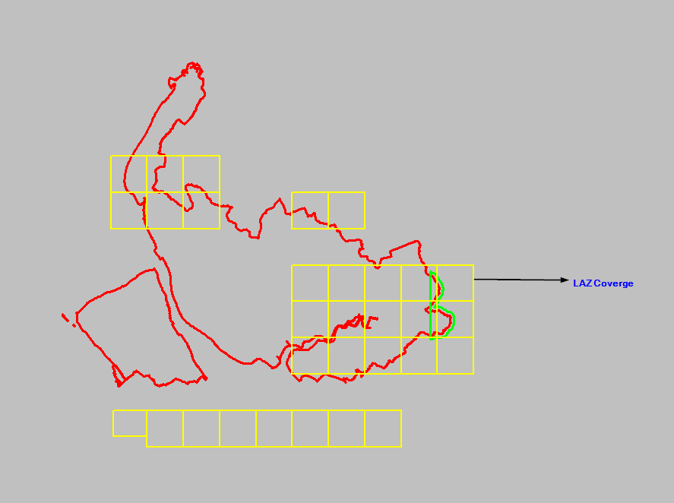

***Figure 03: Partial LAZ data coverage in Liverpool area***

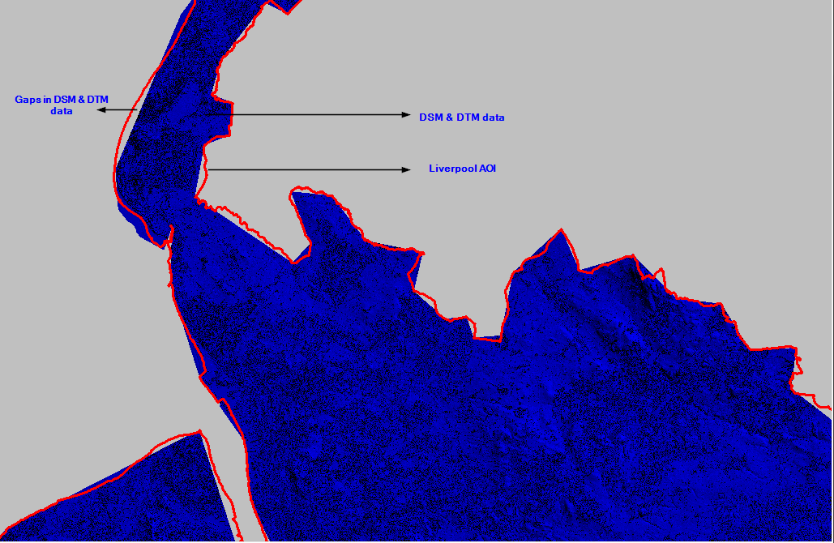

***Figure 04: Extent of DSM & DTM coverage of the Liverpool area***

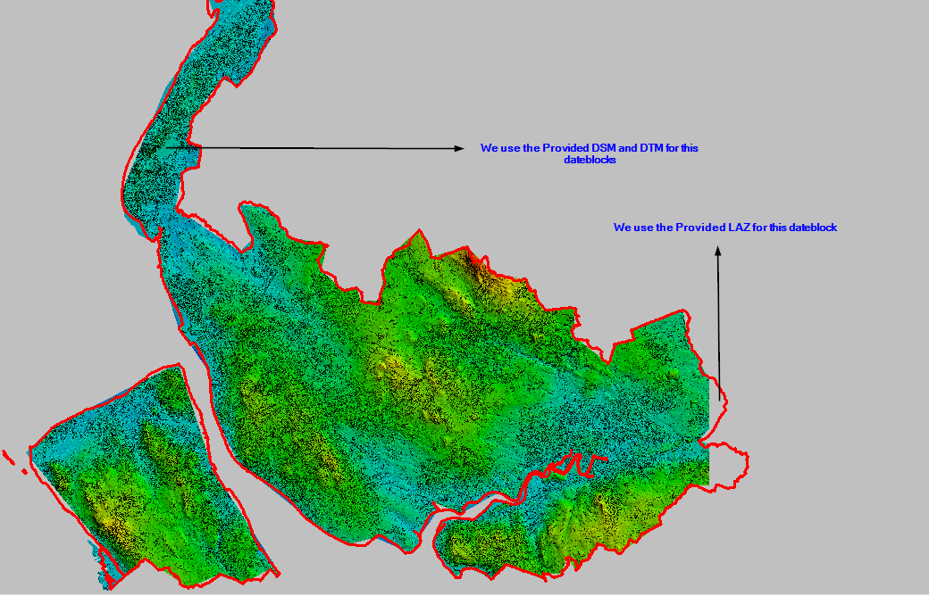

***Figure 05: Process of LAZ and DSM&DTM coverage using in Urban Habitat classification***

### CIR image-Double colour data process

We have noticed that there are different band combinations available in some date blocks within the Greater London and West Yorkshire LGAs. Below are screenshots of the different band combinations from affected date blocks.

|  |
| --- |
|  |

***Figure 06: Different colour CIR occurs in one date block in Greater London_20210423***

|  |
| --- |
|  |

***Figure 07: Different colour CIR occurs in one date block in Greater London_20210531***

**Method for processing date block:**

We processed two different band combinations separately and fine-tuned two different classification rulesets. Those rulesets were executed for the images with appropriate band combinations within a date block.

## Ruleset processing issues and potential fixes

In the classification ruleset execution, we faced some challenges in the Grassland and the solution below

### Grassland wrong prediction in Agriculture

We captured and quality checked 100 grassland sample polygons (A1 and A2 features) as training samples within the DTM and DSM coverage. However, we have noticed some inaccuracy in the grassland class.

As a solution for improving accuracy, a new rule has been added for the ‘Agricultural land’ class in the classification ruleset based on query clarification.

|  |  |  |
| --- | --- | --- |
| **Rule** | **Parameters** | **Condition** |
| Find enclosed by class | J1, J2 | Enclosed by J1 and J2 and less than 500 sq. m |

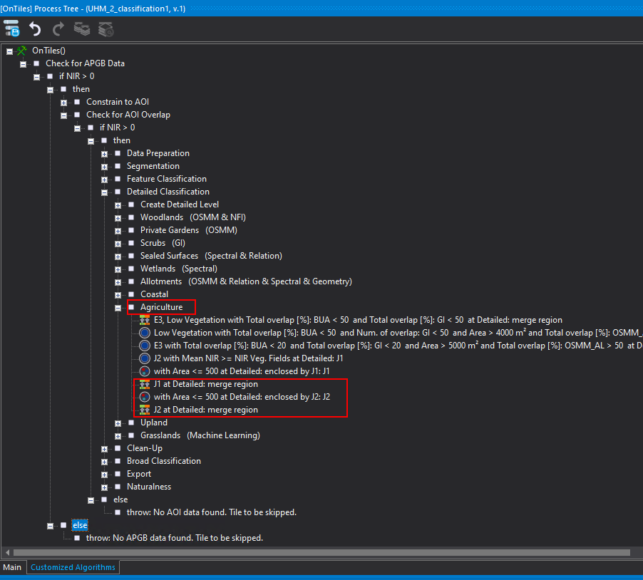

***Figure 08: Agriculture data enclose in the Classification ruleset.***

|  |  |
| --- | --- |
|  |  |

***Figure 09: Grassland samples captured in one date block.***

Below are the incorrect results from the grassland prediction.

|  |  |
| --- | --- |
| **Raw Image** | **Grassland prediction output** |
|  |  |
|  |  |

### Small gaps in the AOIs

In the output extraction, we noticed that the geodatabase (gdb) data contain small gaps (Figure 10). To resolve this issue, a new rule has been added for the 'enclose AOI’ rule under the ‘Constrain to AOI’ part in the classification ruleset, as shown in Figure 11.

|  |  |  |
| --- | --- | --- |
| **Rule** | **Parameters** | **Condition** |
| Find enclosed by class | AOI, unclassified | Enclosed by AOI-Class and less than 50 sqm |

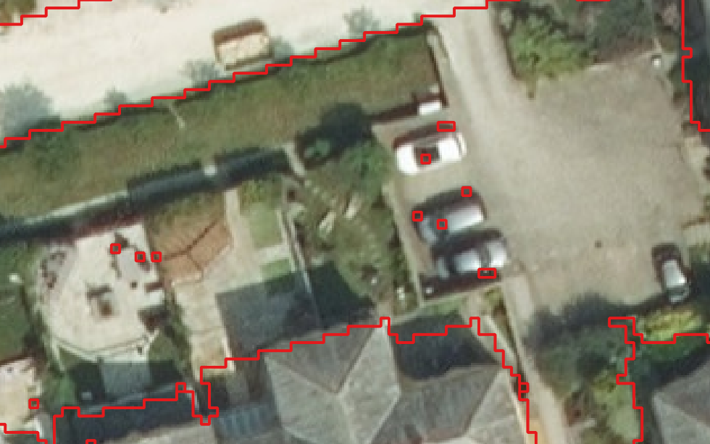

***Figure 10: Small gaps in the output Vector file***

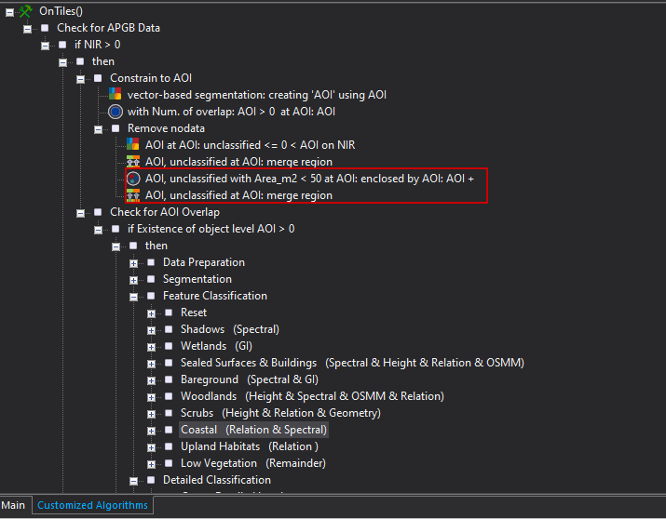

***Figure 11: Additional rules added to fix the small gaps.***

### Misclassification of Coastal mud as bare ground

The Liverpool LGA date block 20220810 is not covered by the related reference from the thematic layer OSMM_Mud data in the coastal area. Consequently, the feature has been incorrectly classified as Bare Ground instead of the Coastal Mud class. So we fine-tuned the classification ruleset to predict the coastal area correctly.

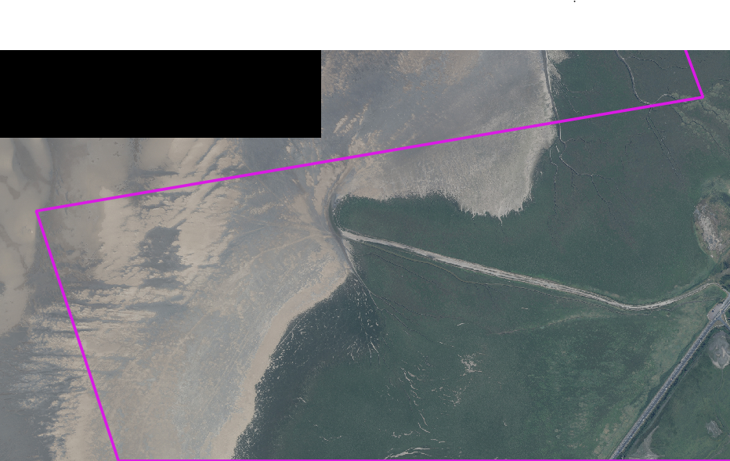

***Figure 12: Coastal area in the processed date block***

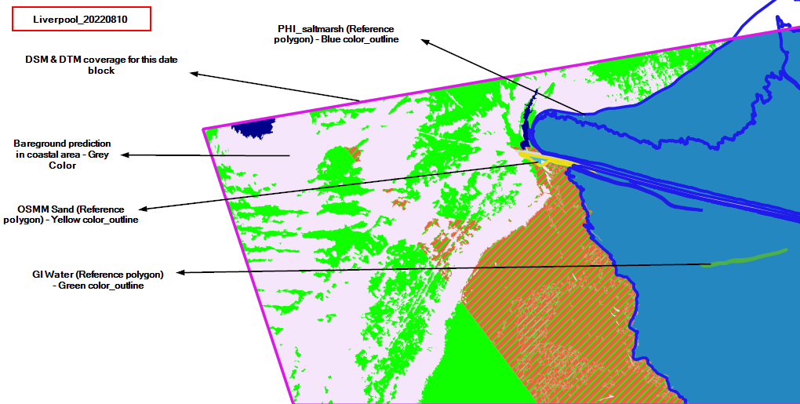

***Figure 13: The Classification output process after classification***

### Woodland classification through thematic layer using DSM & DTM input process.

We observed that the details of the LAZ data contain correct information, while the provided DSM exhibits some abnormal heights (Figure 15). Consequently, the Canopy Height Model (CHM) displays lower height values in wooded areas. To address this issue, we have added a new rule to use woodland data as a reference in a classification ruleset and explained below.

|  |  |  |
| --- | --- | --- |
| **Rule** | **Parameters** | **Condition** |
| Total overlap by Thematic layer | AOI, Shadows | Total and Maximum overlap covered greater than 50 |

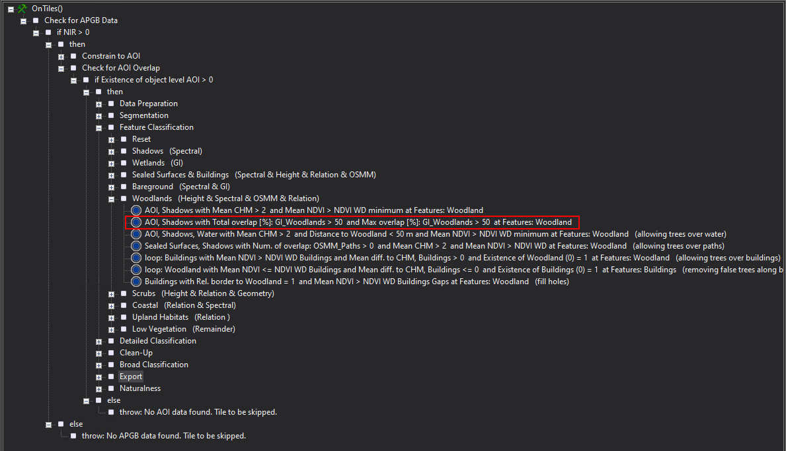

***Figure 14: The newly added Woodland rule highlighted in Classification ruleset.***

**Raw image and DSM Height values**

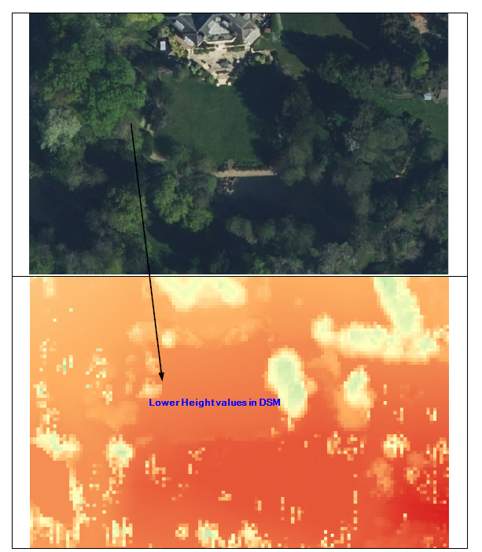

***Figure 15: The DSM-Height values in represented in the tree areas.***