## Digitising Standards for Urban Habitat Mapping (UHM) and Naturalness – May 2025

**1. General Digitising Guidelines**

1.1          Where a boundary follows an OS MasterMap feature the OS MasterMap feature should be copied so that the habitat feature uses its geometry.

1.2          Where a boundary follows part of an OS MasterMap feature the digital boundary should be snapped along the OS MasterMap feature so that the digitised boundary and OS MasterMap feature both share the same geometry where appropriate.

1.3          Where a boundary does not follow an OS MasterMap feature, such as where the boundary follows a feature on an aerial photograph, scanned and geo-rectified map (maybe field or historical), the digitised boundary should be captured with sufficient nodes that the digitised feature takes on the shape of the feature on the source material at a scale of 1:2500.

1.4          Where a boundary is shared between two polygons the boundaries must share the exact same geometry.  There should be no slivers or gaps between polygons with shared boundaries.

1.5          Features should not be "stream" digitised.  Stream digitising is the process of manual digitising, of lines or regions, where nodes are automatically placed at preset intervals based upon distance or time.

1.6          Polygons should not contain inappropriate "spikes". In the figure below the digitised field has an inappropriate spike.

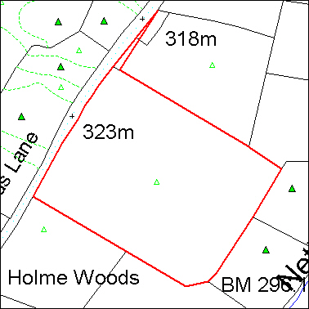

1.7          Polygons must not self-intersect (aka "bowties"). Polygons must not intersect or cross themselves. In the figure below the digitised field has a bowtie caused by a polygon crossing itself.

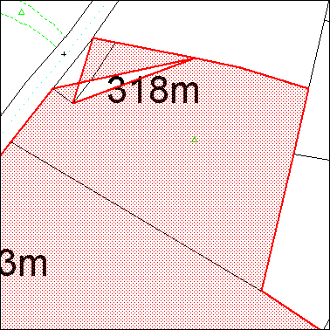

1.8          Holes in polygons (aka “Doughnuts”) should be appropriately "punched".  Where there is a hole in a polygon this should be digitised as a hole as shown below.

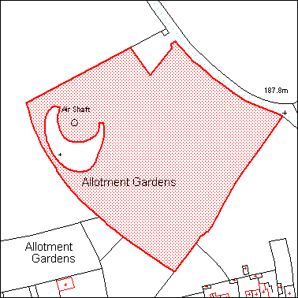

1. **Urban Habitat Mapping and Naturalness Specific Digitising Guidelines**

2.1          All data within the Urban Habitat Mapping and Naturalnessdatasets should be mapped as polygons.

2.2          No polygons are to be mapped that fall below the defined Minimum Mapping Unit (5m²).

2.3          Urban Habitat Broad Classification Maps and Detailed Habitat Classification Maps for the listed target areas in tiles aligned with the Ordnance Survey National grid and in 5 x 5 Square kilometres tile sizes, link to data here: <https://github.com/OrdnanceSurvey/OS-British-National-Grids>

2.4          Polygons should not be mapped as multi-part polygons.

2.5          When undertaking work for a specific geographic area such as a county, the digitising should yield 100% coverage of the project area, split into chunks using Ordnance Surveys’ (OS) 20km grid square.

2.6          There must not be any overlaps between parcels. Boundaries must share the same geometry.

2.7          Polygons must not cross roads (as defined with metaling on the OS MasterMap data), currently active railway lines or any watercourses that are mapped as polygons in OS MasterMap. If subdividing an otherwise contiguous area of UHM or Naturalness with a road, railway line or watercourse causes a polygon to fall below the designated MMU then it may be included within the inventory even if below the ascribed MMU.

1. **Attribute Structure and Content for Urban Habitat Mapping**

3.1 Supply the attribute table in the following format for the Broad Habitat Classification Dataset:

|  |  |  |
| --- | --- | --- |
| **Column** | **Alias** | **Format** |
| Hab_Code | Broad Habitat Code | Text (255) |
| Hab_Type | Broad Habitat Description | Text (255) |

3.2 Use the following spelling for the attributes. Do not use any symbols or punctuation marks, such as commas(,), hyphens (-) or apostrophes (‘):

|  |  |
| --- | --- |
| **Hab_Code** | **Hab_Type** |
| A | Grasslands |
| B | Woodlands |
| C | Scrubs |
| D | Wetlands |
| E | Impervious and Non Vegetated |
| F | Private Gardens |
| G | Formal Planting |
| H | Recreational Landscapes |
| I | Coastal |
| J | Agricultural Land |
| K | Uplands Habitats |
| L | Habitat Mosaics and Heath |

3.3 Supply the attribute table in the following format for the Detailed Habitat Classification Dataset:

|  |  |  |
| --- | --- | --- |
| **Column** | **Alias** | **Format** |
| Hab_Code | Detailed Habitat Code | Text (255) |
| Hab_Type | Detailed Habitat Description | Text (255) |

3.4 Use the following spelling for the attributes. Do not use any symbols or punctuation marks, such as commas(,), hyphens (-) or apostrophes (‘):

|  |  |
| --- | --- |
| **Hab_Code** | **Hab_Type** |
| A1 | Amenity Grassland |
| A2 | Undifferentiated Grassland |
| B1 | Broadleaved Mixed and Yew Woodland |
| B2 | Conifer Dominated Woodland |
| B3 | Small Woods |
| B4 | Isolated and Scattered Trees |
| C1 | Scrubs |
| D1 | Open Water |
| D2 | Vegetated Wetland |
| E1 | Sealed Surfaces and Buildings |
| E2 | Vegetated Building Surfaces and Green Roofs |
| E3 | Bareground |
| F1 | Non Vegetated Gardens |
| F2 | Vegetated Gardens |
| F3 | Garden Trees |
| F4 | Garden Scrubs |
| G2 | Allotments |
| H1 | Park Amenity Grassland |
| H2 | Park Undifferentiated Grassland |
| H3 | Park Woodland and Canopy |
| H4 | Park Scrubs |
| H5 | Park Small Woods |
| H6 | Park Trees |
| I1 | Coastal Sand |
| I2 | Coastal Dunes |
| I3 | Coastal Shingle Loose and Bare Rocks |
| I4 | Coastal Mud |
| I5 | Coastal Saltmarshes |
| I6 | Coastal Cliffs and Slopes |
| J1 | Vegetated Fields |
| J2 | Ploughed Fields |
| K1 | Upland Habitats |

1. **Attribute Structure and Content for Naturalness Mapping**

5**. Data Outputs**

5.1          Any data created must be supplied to Natural England either as ESRI Shapefiles or ESRI File Geodatabases.

5.2 Data should be supplied by OS 10km grid square for the entirety of the project area. Link to OS Grid Square Data here: <https://github.com/OrdnanceSurvey/OS-British-National-Grids>

5.3          Make sure that both the spatial and attribute data have been quality checked before submission.

5.4          The geometry of the data must be checked and corrected before submission. Within ESRI ArcGIS this can be accomplished using the “Check Geometry” and the “Repair Geometry” tools.

5.5          Data can be sent to Natural England via a transfer site, such as Quatrix.

5.6          When supplying the final submission, please also complete and supply the metadata template.