Urban Habitat Mapping.
Method Summary Statement.

What is Urban Habitat and Naturalness Mapping.

Urban Habitat and Naturalness Maps are being developed for the main urban conurbations of England. The development of the maps is supported by the Natural Capital and Ecosystems Assessment Programme and they are intended to support planning, strategy development and targeting of resources for urban nature recovery as part of the suite of England Green Infrastructure Framework headline standards.

Natural Capital and Ecosystem Assessment Programme - GOV.UK (www.gov.uk)

England Green Infrastructure Standards.

Home (naturalengland.org.uk)

Overview.

History of Development.

Overall approach.

Classification System.

Data inputs and assembly. What each data source is used for.

Data processing.

Accuracy assessment.

Outputs.

Urban Habitat Maps are created using an Earth Observation based approach blending a variety of source data to create maps of the spatial location and extents of a system of Broad and Detailed Urban Habitat Classes.

The data sources used are;

- Green Infrastructure and Blue Infrastructure (Open Government Licence)

- Aerial Photography for Great Britain (Public Sector End User Licence)

- Ordnance Survey British National Grid (Open Government Licence)

- Ordnance Survey Master Map (Public Sector End User Licence)

- National Forest Inventory (Open Government Licence)

- Environment Agency National LiDAR Programme (Open Government Licence)

- OS Open Built-Up Areas (Open Government Licence)

- Priority Habitat Inventory (Open Government Licence)

- Moorland Line (Open Government Licence)

History of its development.

Methodological development for Urban Habitat and Naturalness Mapping was conducted during 2021/22 and focussed on the Pilot Cities of Plymouth, Cambridge and City of Manchester.

Following successful piloting, a second phase of work was undertaken during 2022/23 that further developed the methodology and then developed approaches to upscaling its application to large city conurbations. This phase resulted in the creation of Urban Habitat and Naturalness Maps for Tyneside, Greater Manchester and Greater Birmingham using an amended approach that was more streamlined and more applicable to desk based application for large scale urban areas.

Work is ongoing with the original Pilot Cities to explore the utilisation of the Urban Habitat and Naturalness data in a variety of planning and strategy development contents to explore its usefulness and limitations.

Further work is planned in 2023/24 for roll out of the new method to a second phase mapping of more urban conurbations in England.

Purpose and use.

Urban Habitat and Naturalness Mapping data is intended to improve our understanding of;

- The constituency of the urban ecosystem (Urban Habitats).

- It’s quality using “Naturalness” as a proxy.

- Urban species distribution and diversity (planned expansion of the data).

- Change in these parameters of the Urban Ecosystem in England over time.

Overall approach.

The overall approach to undertaking the process of developing Urban Habitat and Naturalness maps is set out below.

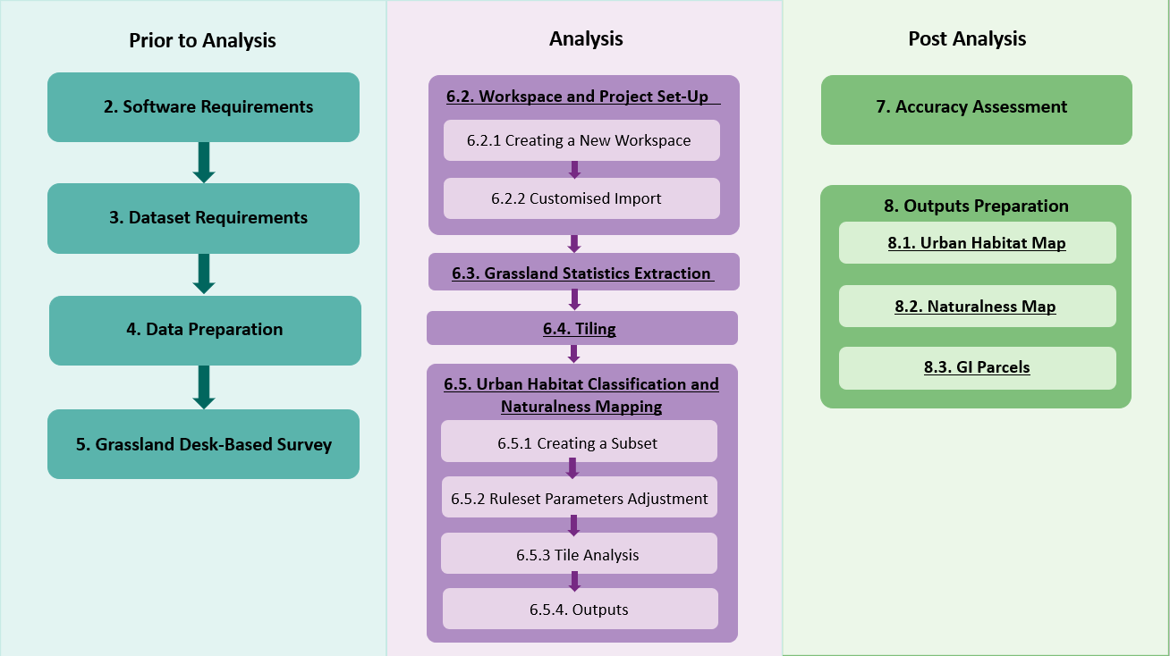

Classification systems.

Urban Habitat Classification System.

The system of Broad and Detailed Habitat Classes are;

Broad Key | Broad Class Name | Detailed Key | Detailed Class Name
A | Grasslands | A1 | Amenity Grassland
A | Grasslands | A2 | Undifferentiated Grassland
B | Woodlands | B1 | Broadleaved, Mixed and Yew Woodland
B | Woodlands | B2 | Conifer-Dominated Woodland
B | Woodlands | B3 | Isolated and Scattered Trees
C | Rough, Abandoned and Derelict Land | C1 | Habitat Mosaics (These have proved to uncertain to map to date).
C | Rough, Abandoned and Derelict Land | C2 | Scrubs
D | Wetlands | D1 | Open Water
D | Wetlands | D2 | Vegetated Wetland
E | Impervious and Non-Vegetated | E1 | Sealed Surfaces and Buildings
E | Impervious and Non-Vegetated | E2 | Vegetated Building Surfaces and Green Roofs
E | Impervious and Non-Vegetated | E3 | Bareground
F | Private Gardens | F1 | Non-Vegetated Gardens
F | Private Gardens | F2 | Vegetated Gardens
F | Private Gardens | F3 | Garden Trees
F | Private Gardens | F4 | Garden Scrubs
G | Formal Planting | G2 | Allotments
H | Parklands | H1 | Park Amenity Grassland
H | Parklands | H2 | Park Undifferentiated Grassland
H | Parklands | H3 | Park Wood Pasture
H | Parklands | H4 | Park Scrubs
I | Coastal | I1 | Coastal Sand
I | Coastal | I2 | Coastal Dunes
I | Coastal | I3 | Coastal Shingle, Loose and Bare Rocks
I | Coastal | I4 | Coastal Mud
I | Coastal | I5 | Coastal Saltmarshes
I | Coastal | I6 | Coastal Cliffs and Slopes
J | Agricultural Land | J1 | Vegetated Fields
J | Agricultural Land | J2 | Ploughed Fields
K | Upland Habitats | K1 | Upland Habitats

Contexts. Urban Habitat Maps are generated with a minimum pixel level of 5 square metres. All the urban area is mapped (including buildings and man made surfaces) and the mapping specifically separates and highlights habitat classes that occur within two key contexts of specific interest – Private Gardens Space and Parklands (predominantly Accessible Green Infrastructure spaces).

Accuracy. Certainties are identified using “confusion matrixes” to identify overall and specific levels of accuracy.

The Earth Observation approach employed to generate Urban Habitat Maps uses digitised aerial imagery as a core data source. The accuracies of the resultant maps are affected by the capture date of the aerial imagery and each “aerial tile” has its own specific “Confusion Matrix”.

An example Confusion Matrix is given below. Actual accuracy rates vary by habitat class and date tile. This matrix is purely illustrative of the approach.

The table shows where classification samples agree between initial output (Producer) and accuracy check (user) and where they do not, and which habitat class confusions have occurred.

An overall accuracy is also calculated.

Classification | A | B | C | D | E | F | G | H | J
A | 25 | 0 | 1 | 0 | 11 | 1 | 0 | 0 | 2
B | 0 | 42 | 1 | 0 | 1 | 0 | 0 | 0 | 0
C | 2 | 0 | 15 | 0 | 2 | 0 | 0 | 1 | 0
D | 0 | 0 | 0 | 26 | 0 | 0 | 0 | 0 | 0
E | 0 | 0 | 0 | 0 | 52 | 0 | 0 | 1 | 4
F | 0 | 0 | 0 | 0 | 0 | 78 | 0 | 0 | 0
G | 0 | 0 | 0 | 0 | 0 | 0 | 20 | 0 | 0
H | 0 | 0 | 0 | 0 | 6 | 1 | 0 | 71 | 0
J | 1 | 0 | 0 | 0 | 0 | 0 | 0 | 0 | 30
Total samples | 28 | 42 | 17 | 26 | 72 | 80 | 20 | 73 | 36
Producer accuracy | 89 | 100 | 88 | 100 | 90 | 100 | 100 | 90 | 97
User accuracy | 63 | 95 | 75 | 100 | 90 | 100 | 100 | 90 | 96
Overall accuracy. | 91

As a result of the inherent identification confusions resulting in variable accuracy levels, the resultant Urban Habitat Maps must be considered as “probability maps”.

Sample Broad and Detailed Urban Habitat Maps.

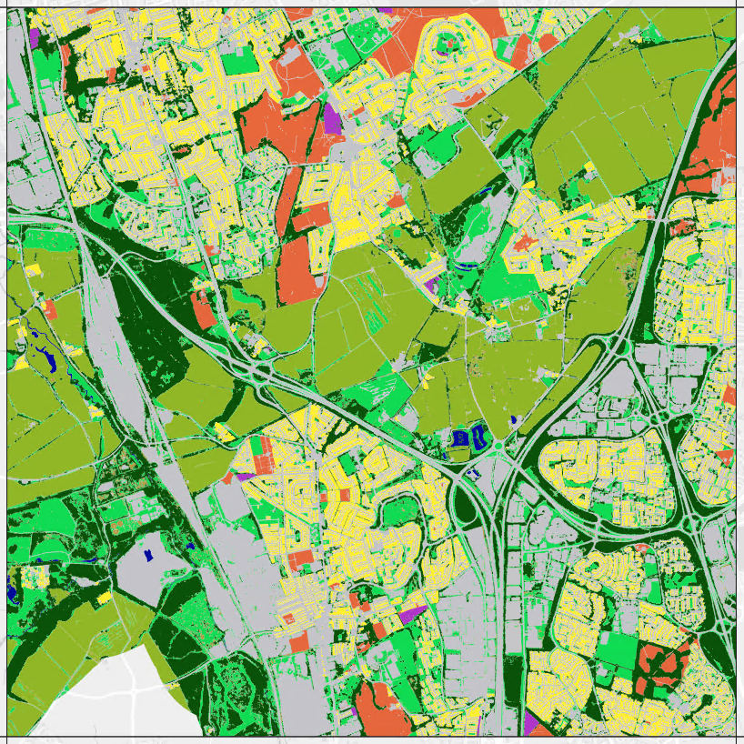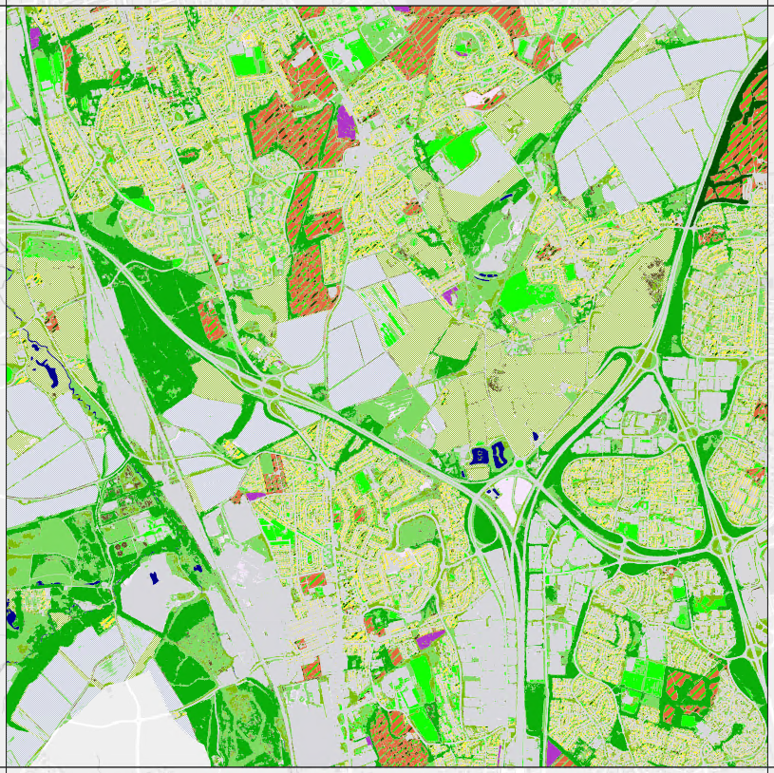

© Natural England 2022, reproduced with the permission of Natural England.
Contains, or is derived from, information supplied by Ordnance Survey. © Crown copyright and database rights 2022. Ordnance Survey 100022021. EA Lidar. APGB Licensed Data: ‘© Getmapping Plc and Bluesky International Limited 2022.

