

MS8257
Urban tree canopy, green spaces and
built environment data analysis and reporting 2022

Report 3: Local government area - Adelaide City Council
February 2023

Urban Habitat and Naturalness Mapping
Phase 03 analysis and reporting 2024

Coventry, Dartford and Gravesham, East Midlands (Nottingham, Derby, Leicester), Sheffield and Rotherham, Stoke and Newcastle under Lyme and
TeessideArea
Technical Report
November2024

Contents
1. Challenges we faced in the processes and solutions 3
1.1. Inputs Processing issues and Potential fixes 3
1.1.1. Input Dataset processing and input priority 3
1.1.2. Data processing of OSMM input dataset 5
1.1.3. Removal of "Access Land" from Green Infrastructure Typology for Parklands 6
1.2. Ruleset processing issues and potential fixes 7
1.2.1. Misclassification in SheffieldRotherham_20210412-Dateblock Due to Data Year Discrepancy 7
1.2.2. Misclassification of Agriculture as Sealed surfaces 9
1.2.3. Misclassification of Sealed surfaces as Grasslands 11

Challenges we faced in the processes and solutions
In the Urban Habitat Classification, we encountered two different types of challenges, which are listed below along with the solutions.

- Inputs Processing issues and Potential fixes
- Ruleset processing issues and potential fixes

Inputs Processing issues and Potential fixes
In the Input data process execution, we faced some challenges and the solution is below

Input Dataset processing and input priority
We received various forms of elevation data, including LAZ, DSM, and DTM, from different years. For example, the Coventry date block includes datasets from 2021 and 2018 (as illustrated in Figures 01, 02, and 03). In certain date blocks, we had to use LiDAR datasets from different years based on availability. To address this, we prioritized using the most recent LiDAR data available for the entire date block. When LiDAR data was partially available or unavailable, we merged datasets from different years and evaluated whether the changes were minimal. If minimal changes were observed, we proceeded with those datasets.

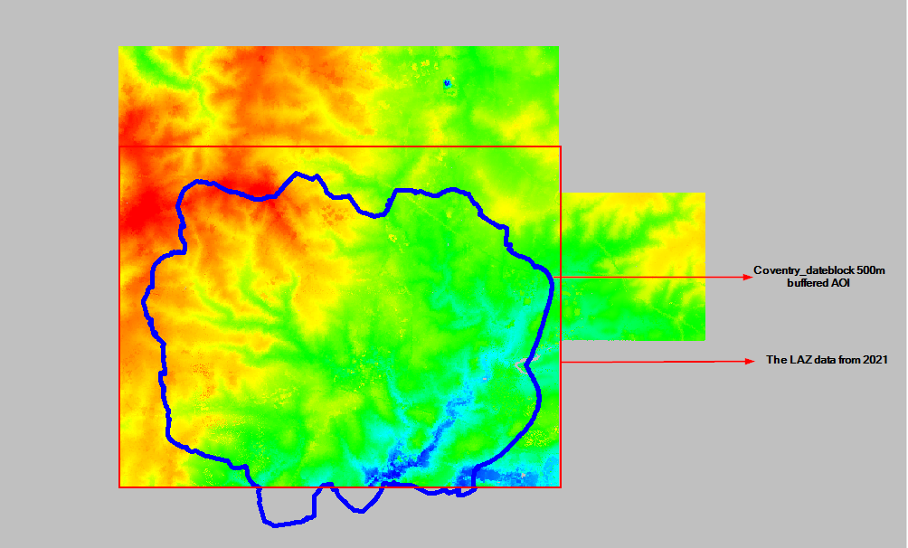

Figure 01: LAZ data coverage for 2021 in the Coventry area

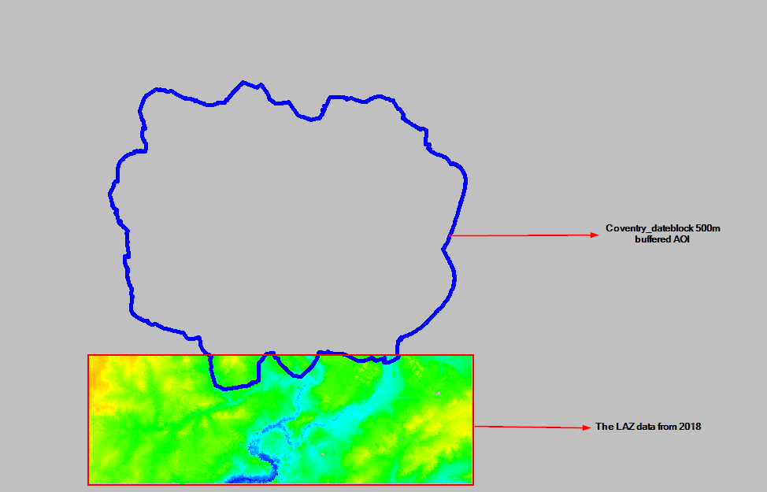

Figure 02: LAZ data coverage for 2018 in the Coventry area

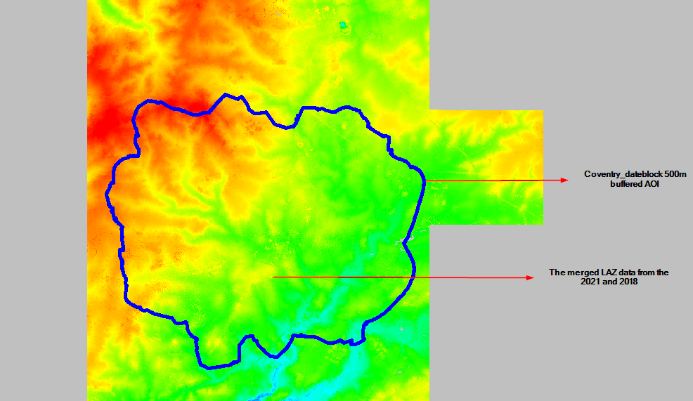

Figure 03: Process of Merged LAZ data for 2021 & 2018

Data processing of OSMM input dataset
We have received the most recent OSMM data from Phase 02 processing and have clipped it for the Phase 03 LGAs. Following confirmation from Natural England, the OSMM data was used for subsequent processing, as illustrated in Figure 04 below

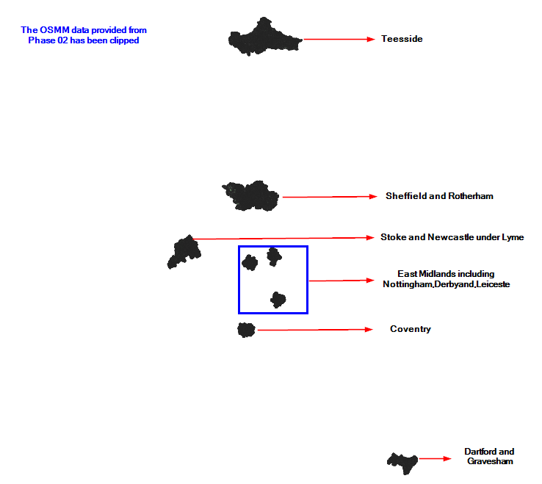
Figure 04: Process of Clipped OSMM data from the Phase02

Removal of "Access Land" from Green Infrastructure Typology for Parklands
Natural England has proposed a significant change to the identification of 'Parklands'. Specifically, they recommend removing 'Access Land' from the list of Green Infrastructure typology classes that contribute to the broad Parklands classification. This change will also impact the detailed habitat classes within the Parklands category. Consequently, we have removed 'Access Land' from the Green Infrastructure and proceeded with the subsequent processes, as illustrated in Figure 06.

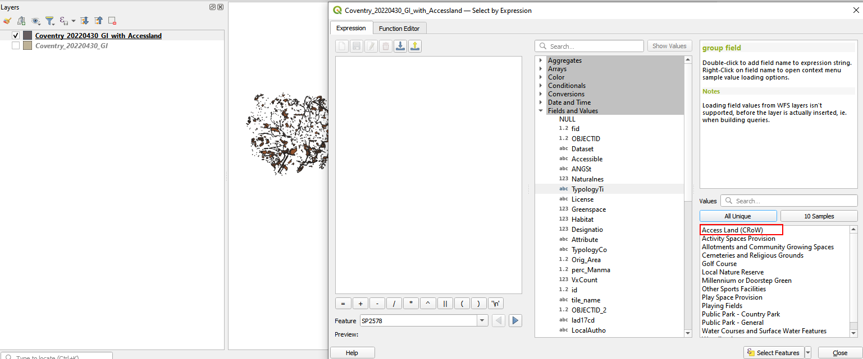

Figure 05: Before the Removal of "Access Land" from Green Infrastructure Typology for Parklands

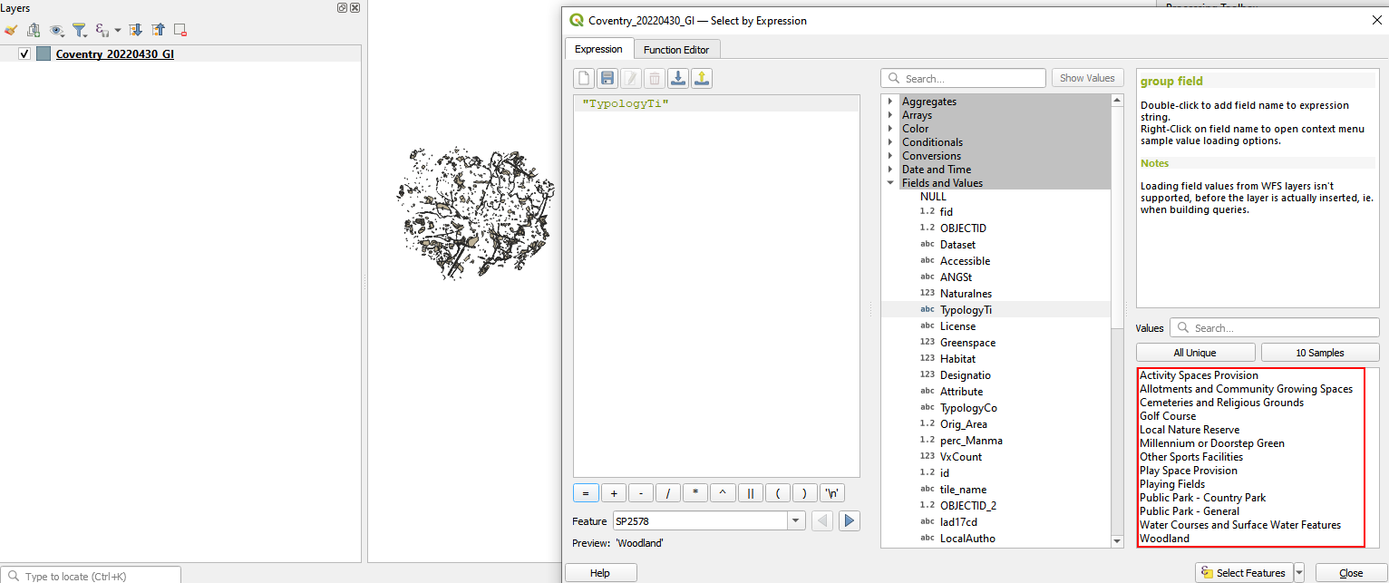

Figure 06: Removal of "Access Land" from Green Infrastructure Typology for Parklands

Ruleset processing issues and potential fixes
In the classification ruleset execution, we faced some challenges and the solution below

Misclassification in SheffieldRotherham_20210412-Date block due to Data Year Discrepancy
We have noticed some misclassification in the SK58NW - 5K tile date block, where the input datasets span various years. We processed the OSMM data for this date block from 2022/2023, as it is the most updated dataset (figure 08). The APGB image and LAS data are both from 2021, which may explain the misclassification issues as illustrated in Figure 09.

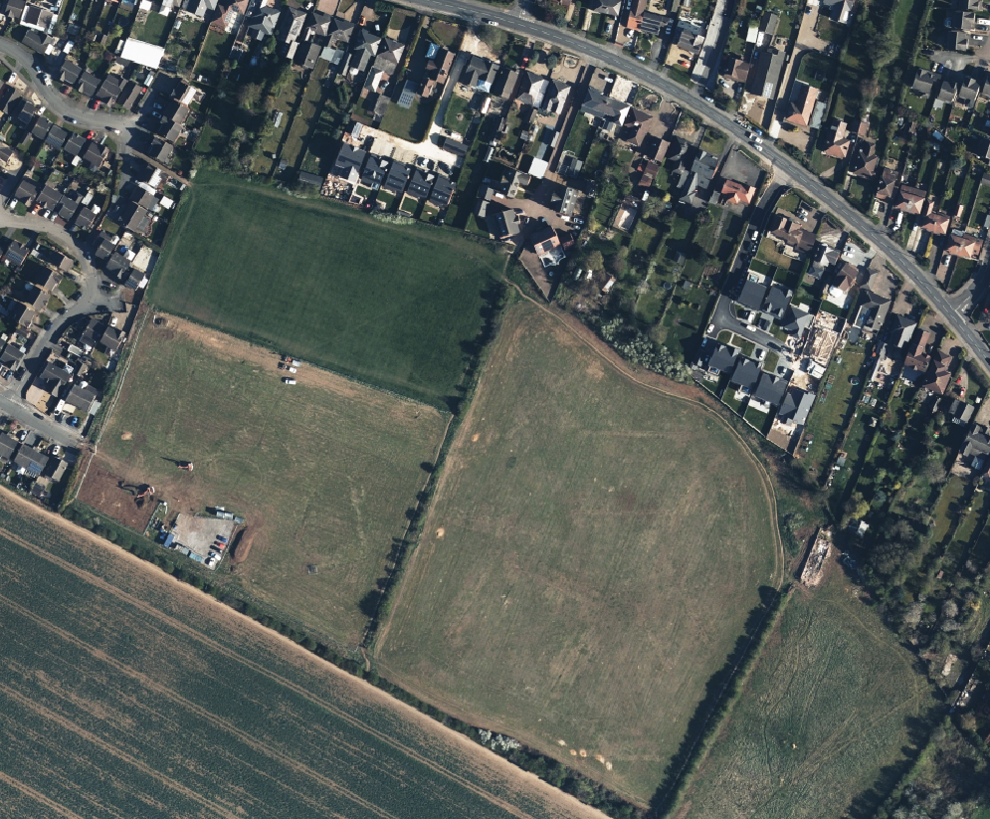

Figure 07: Raw image in the Sheffield and Rotherham_20210412_APGB_RGB date block
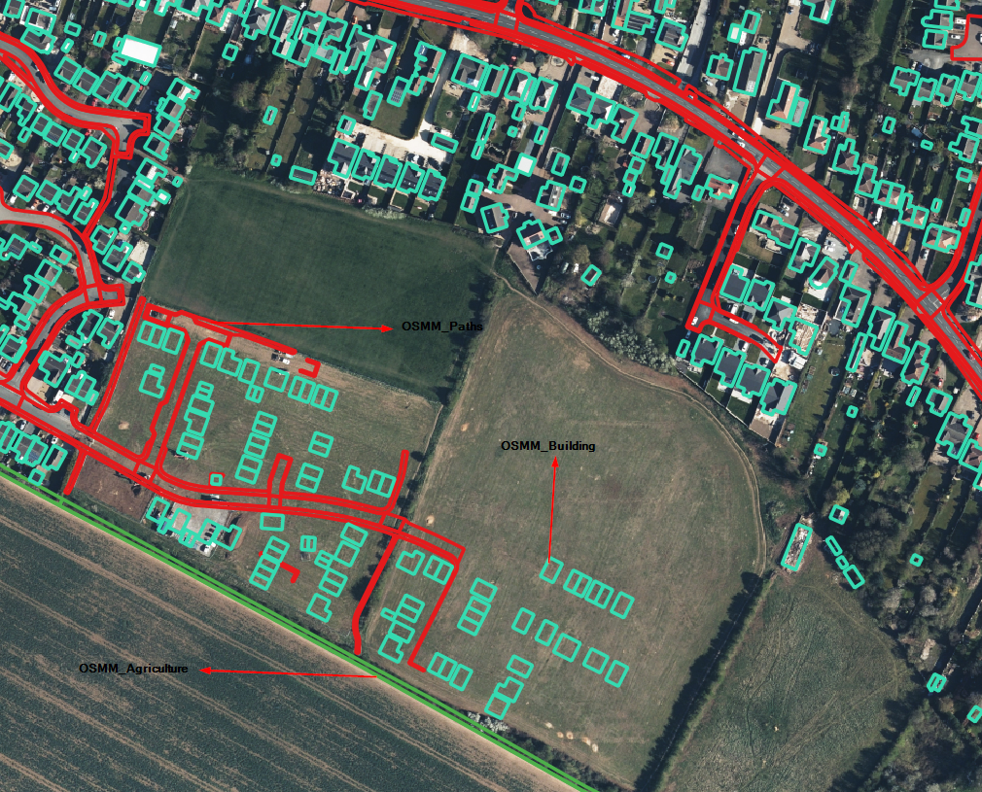

Figure 08: OSMM dataset with a RGB image of the Sheffield and Rotherham_20210412_APGB_RGB date block

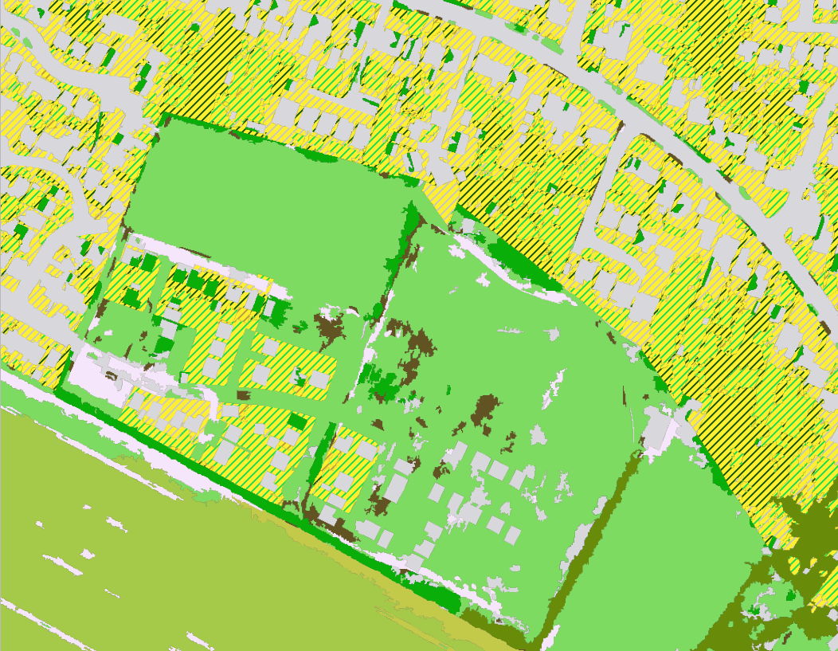

Figure 09: Detailed classification data in the Sheffield and Rotherham_20210412 date block

Misclassification of Agriculture as Sealed surfaces
We processed the Stoke and Newcastle-under-Lyme 20210530 date block classification and noticed some issues with the detailed classification, where agriculture was misclassified as sealed surfaces, as shown in the screenshot below (figure 11). To resolve this, we added a rule to the agriculture classification ruleset, as shown in Table 01 (figure 12). The issue was successfully resolved for this date block, as illustrated in the screenshot below (figure 13).
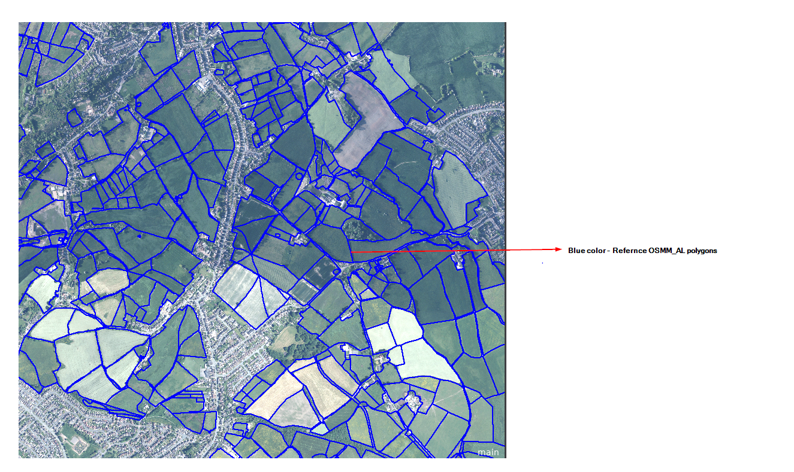
Figure 10: Raw image in the Stoke and Newcastle-under-Lyme 20210530_APGB_RGB date block

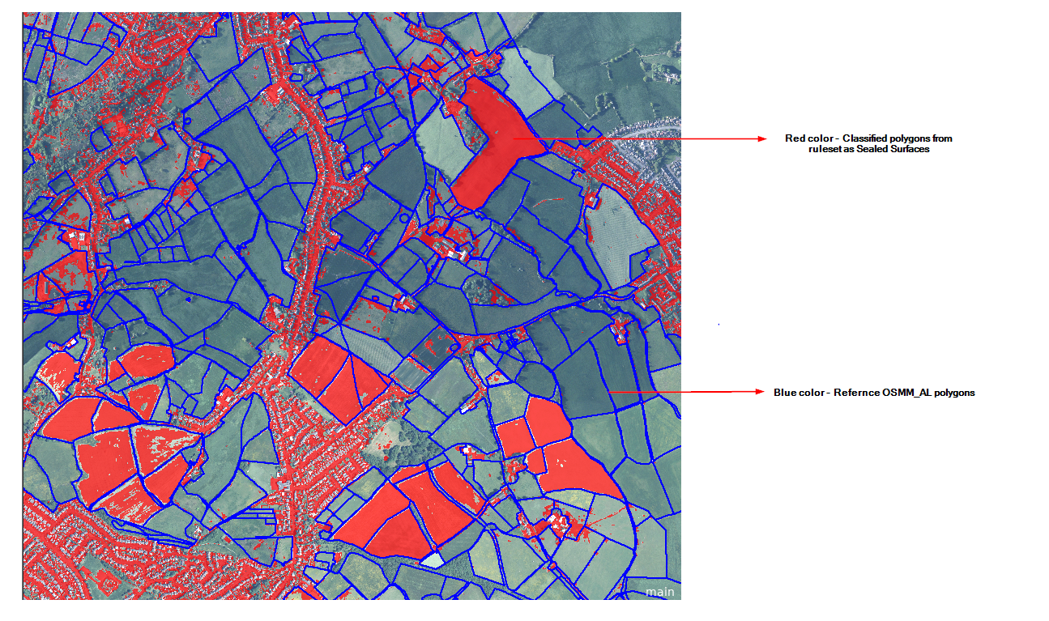

Figure 11: Misclassification of Agriculture as sealed surfaces in the Stoke and Newcastle-under-Lyme 20210530 date block
Table 01:

Rule | Parameters | Condition
Assign class | E, E1, E2 and Sealed Surfaces | Total Overlap with OSMM_AL moved to J2

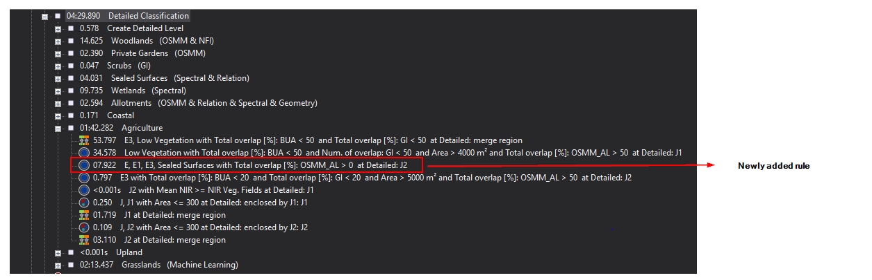

Figure 12: Additional rules added to fix the agriculture classification.

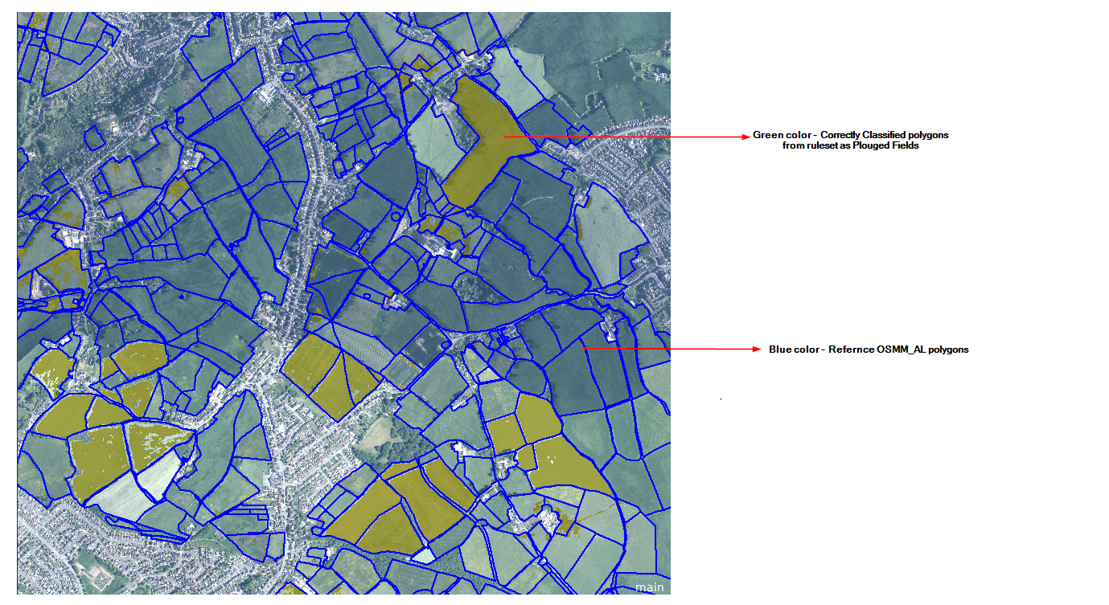

Figure 13: The correct classification of Agriculture classes.

Misclassification of Sealed surfaces as Grasslands

We noticed some misclassification issues in Sheffield and Rotherham_20210419. Sealed surfaces were misclassified as Grassland (A1 & A2) classes, as illustrated in the screenshots (figure 15) below. Since we are using the same provided ruleset, we cannot modify any rules (figure 16). Although we fine-tuned the values, it did not resolve the issue. This is because the shadow-segmented values do not match the parameters for sealed surfaces, leading to their classification as low vegetation, which is then predicted as grassland based on the Grassland CSV values.

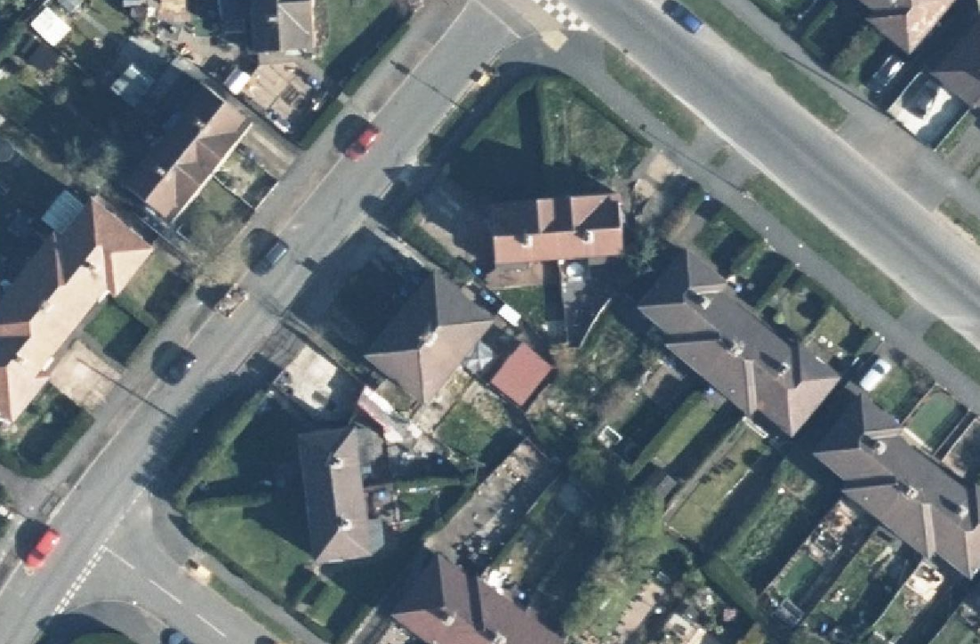

Figure 14: Raw image in the Sheffield and Rotherham_20210419 APGB_RGB date block

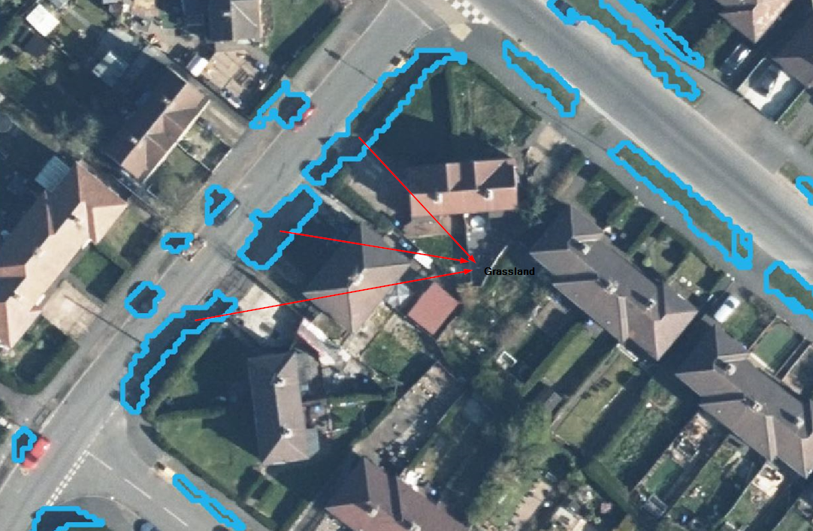

Figure 15: Misclassification of Sealed surfaces as Grassland in the Sheffield and Rotherham_20210419 date block

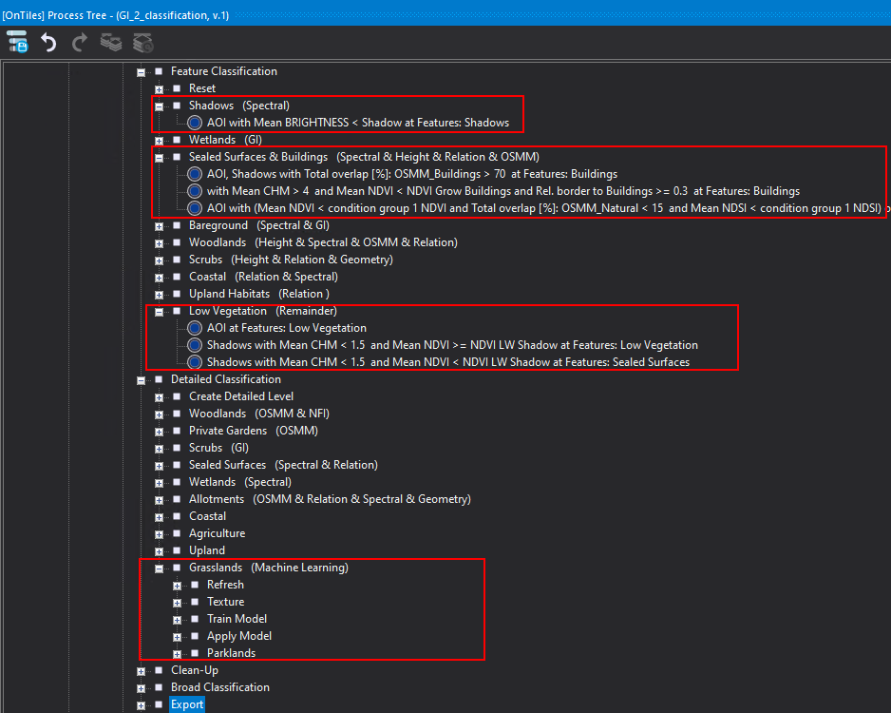

Figure 16: The Classification ruleset used for processing

