Guide to applying for Appliances Tender opportunity

Link to Flooring tender: https://procontract.due-north.com/Supplier/Advert/View?advertId=06039308-fc41-f011-8136-005056b64545&fromProjectDashboard=False&fromRfxSummary=False&selectWorkgroup=False&fromAdvertEvent=False&fromActivityDashboard=False
- To start, select Find opportunities from the home screen.
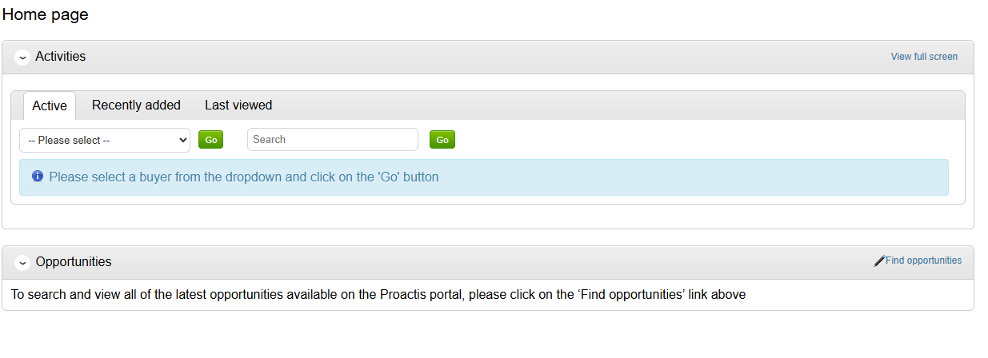
- When searching opportunities, narrow your search to “Organisation: Futures Housing Group” using the drop down on the left. This will bring up the appliances tender. Click the blue title and it will open.
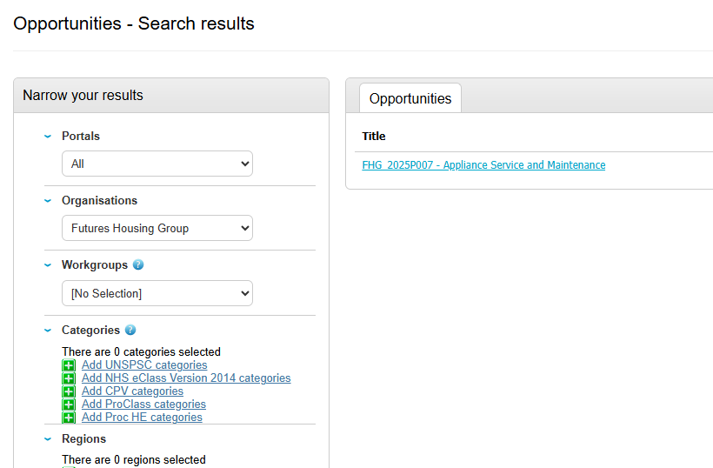

- The details for the tender will open, you should click the green button “Register interest in this opportunity”.
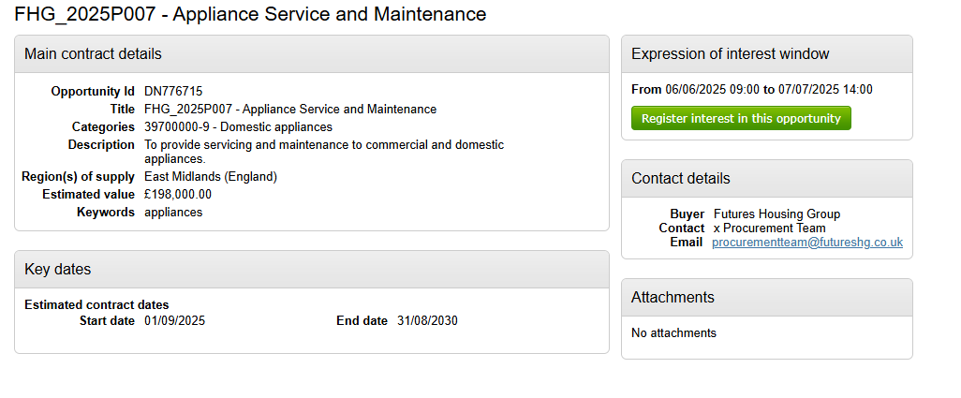

- A screen will pop up with some further information – to view the ITT and start your bid, you should click the “click here” link highlighted below:
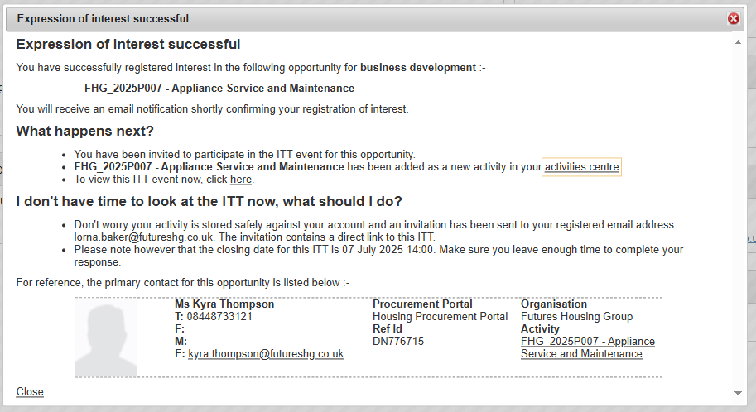
- To start your bid, you should click the green button “Start my response”
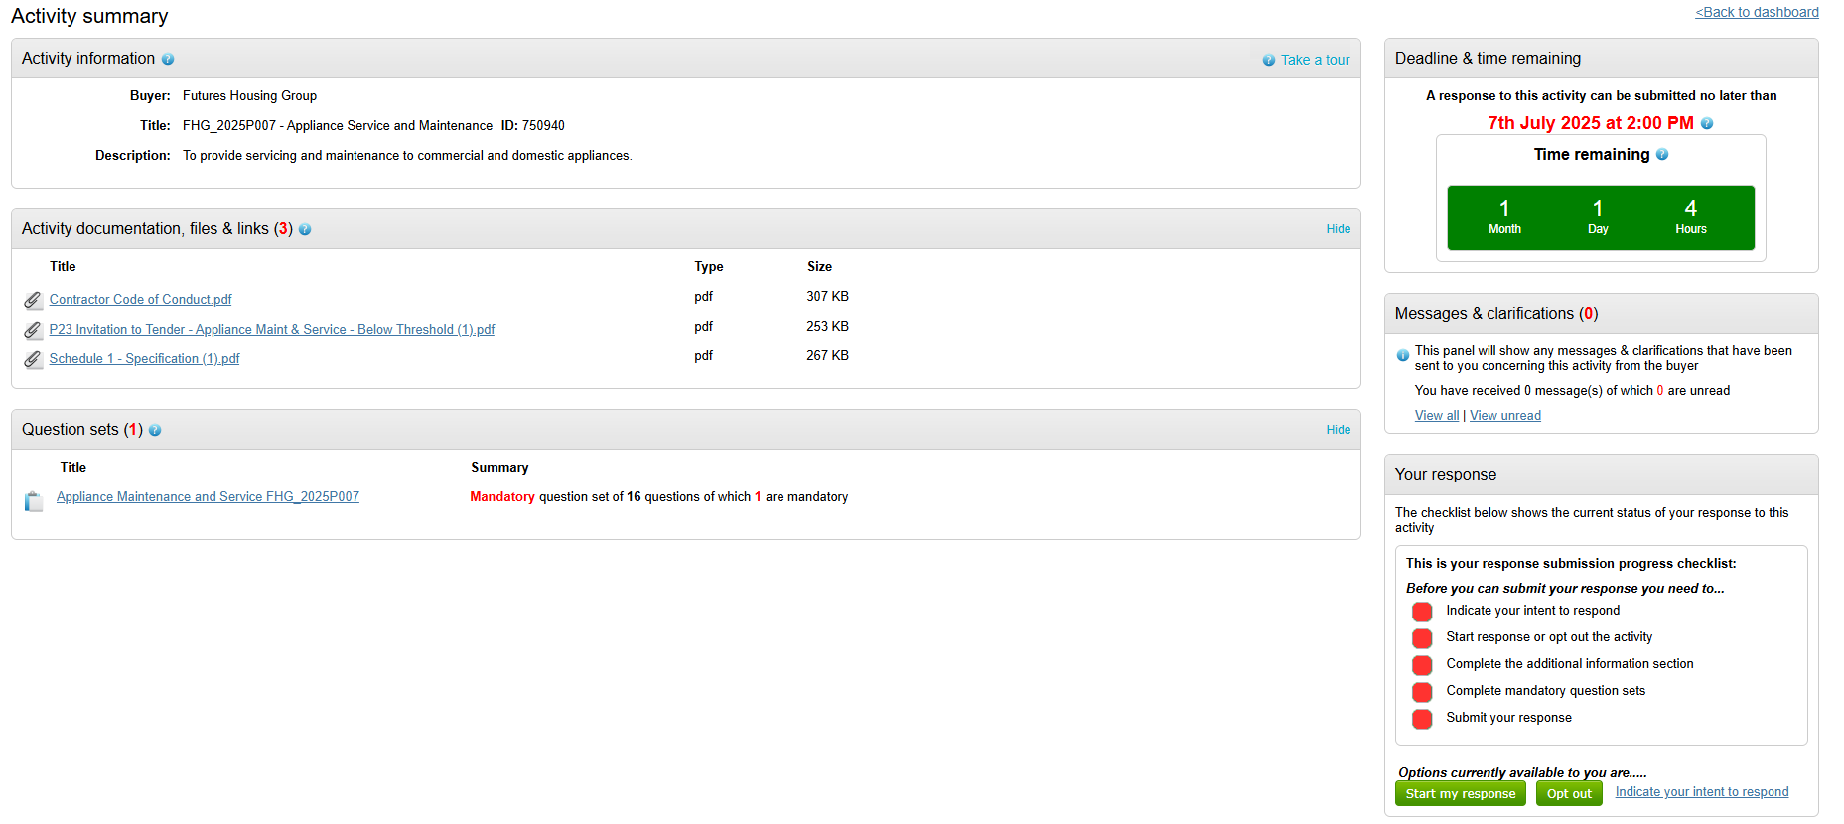
- Finally, click edit under the question set to answer the evaluation questions.
