PRENTON RUFC
Single storey extension and refurbishment work to Prenton RUFC
PRE-CONSTRUCTION INFORMATION PACK

REVISION TRACKER
Issue | Date | Author | Revision Notes | Comment(s)
1.0 | 30/04/2024 | Darren Campbell | First Issue- Draft for Client Review
2.0 | 04/05/2024 | Darren Campbell | Ecology update and Designers Risk Assessment
3.0

Table of Contents
PROJECT OVERVIEW 6
PROGRAMME 7
CONSTRUCTION PHASE PLAN 7
PROJECT ROLES 8
CLIENT 8
QUANTITY SURVEYOR/CONTRACT ADMINISTRATOR 8
PRINCIPAL DESIGNER 8
PRINCIPLE CONTRACTOR 8
DESIGNER (STRUCTURAL) 8
DESIGNER (ARCHITECT) 8
DESIGNER (DRAINAGE) 8
DESIGNER (M&E SERVICES) 8
LOCAL AUTHORITY 8
SITE LOCATION 10
EXISTING RECORDS 10
SITE REQUIREMENTS 11
WELFARE FACILITIES DURING CONSTRUCTION 11
SAFETY OF GLAZING AND TRANSPARENT SURFACES 11
DESIGN COMPLIANCE AND BUILDING REGULATIONS 11
EQUALITY AND INCLUSIVE DESIGN 11
SITE REQUIREMENTS OVERVIEW 11
WASTE MANAGEMENT 12
ENVIRONMENTAL PROTECTION ACT 1990 12
MANAGEMENT OF CONSTRUCTION SITE WASTE 12
HAZARDOUS WASTE REGULATIONS 2005 (AS AMENDED) 12
WASTE (ENGLAND AND WALES) REGULATIONS 2011 13
CDM 2015 CONSTRUCTION SITE MANAGEMENT 13
SUMMARY OF PROJECT WASTE MANAGEMENT REQUIREMENTS 13
PROJECT DOCUMENTS 14
MANAGEMENT OF HEALTH & SAFETY 14
ARRANGEMENTS FOR PLANNING AND MANAGING CONSTRUCTION WORK 14
DUTY HOLDER RESPONSIBILITIES AND PROJECT COORDINATION 14
PRE-START AND PROGRESS MEETINGS 15
CONSTRUCTION PHASE PLAN (CPP) 15
CONTRACTOR RISK MANAGEMENT AND CONTRACTUAL ACCEPTANCE 16
PROJECT RESOURCES 16
CLIENT’S HEALTH AND SAFETY OBJECTIVES 16
COMMUNICATION DURING CONSTRUCTION 16
SECURITY OF THE SITE 17
WELFARE PROVISIONS (CONSTRUCTION) 17
MANAGING CONSTRUCTION HEALTH & SAFETY 17
SITE TRANSPORT ARRANGEMENTS 17
CLIENT’S SITE RULES FOR CONTRACTORS 18
EMERGENCY PROCEDURES 19
ACCIDENT AND INCIDENT REPORTING 19
UNAUTHORISED AREAS 20
CONFINED SPACES 20
PARKING RESTRICTIONS 20
PROJECT ENVIRONMENTAL IMPACT 20
BOUNDARIES AND ACCESS INCLUDING TEMPORARY ACCESS 20
ADJACENT LAND USES 20
EXISTING STORAGE OF HAZARDOUS MATERIALS 20
EXISTING SERVICES 21
GROUND CONDITIONS AND CONTAMINATED LAND 21
INFORMATION ABOUT EXISTING STRUCTURES 21
ASBESTOS 21
HEALTH RISKS FROM CLIENT’S ACTIVITIES 22
MANUAL HANDLING 22
ENVIRONMENTAL ISSUES 22
ECOLOGY 22
DESIGNERS RISK ASSESSMENT 23
SIGNIFICANT DESIGN ASSUMPTIONS 23
DESIGN CO-ORDINATION 23
SIGNIFICANT RISKS IDENTIFIED DURING DESIGN 23
CLOSE PROXIMITY TO SURROUNDING AND OCCUPIED ADJACENT BUILDINGS 24
MATERIALS REQUIRING PARTICULAR PRECAUTIONS 24
PROJECT COMPLETION AND HANDOVER 24
HEALTH AND SAFETY FILE 24
O&M MANUAL 25
PRESENTATION OF O&M MANUAL 26
TRAINING OF CLIENT’S STAFF 26
SPARE PARTS 26
TOOLS 27
APPENDIX 1 F10 NOTIFICATION 28
APPENDIX 2 DESIGNERS RISK ASSESSMENT 29
APPENDIX 3 ARCHITECTURAL DRAWING LIST 30
APPENDIX 4 STRUCTURAL DRAWING LIST 31
APPENDIX 5 M&E DRAWING LIST 32

PROJECT OVERVIEW

The proposed extension & remodelling works are proposed to provide an enlarged clubhouse, new changing rooms/showers, changing rooms for future use, welfare facilities and ancillary store rooms.

The site is currently occupied by Prenton RUFC which is fully operational. The site is made up from a series of single storey structures which have been added to the main clubhouse building over the past several years. All buildings are single storey in height. There is currently vehicular parking to the north side of the site and there are various hard and soft landscaped amenity areas surrounding the building.

The current Rugby club is in need of renovation to bring the facilities in-line with qualities that would be expected of such a facility today. The proposed development will provide excellent facilities for the club and will have a dramatic impact on improving the quality of the facilities for members, staff, and also the public.

A full specification of works is to be confirmed between the Client and Principal Contractor. Specification and scope of works to be issued as part of the Principal Contractor tender pack.
Notes:
The Principal Contractor must ensure that all scaffolding and temporary works are planned, erected, inspected, and maintained in full compliance with the Work at Height Regulations 2005, NASC guidance (such as TG20:21 for scaffolding), and relevant temporary works procedures, including those outlined in BS 5975. All such works must be managed by competent personnel and coordinated as part of the wider site safety plan.
All Contractors must refer to all tender documents, preliminaries, building specifications, drawings, all surveys and reports, existing asbestos register and any existing site specific information included within the tender package. Other relevant surveys, reports, drawings and H&S file information not included in the pack can be viewed by liaison and arrangement with the Client and Principal Designer- contact details included in this document and the project directory within the tender pack.
All contractors are advised to undertake a visit to the site for the purpose of undertaking their own surveys and hazard identification. Utilise all necessary pre-construction information.

PROGRAMME

The planned construction phase is estimated to commence at the end of May 2025 with practical completion expected in December 2025. Finalised dates to be documented once confirmed.
The Principal Designer shall submit the F10 notification to HSE prior to the construction phase. Further details to be included within this PCI pack.

CONSTRUCTION PHASE PLAN

The Principal Contractor shall provide a sufficiently developed construction phase plan to the Principal Designer for review prior to the start of the construction phase. This pre-construction information pack, along with other relevant pre-construction documentation are to be issued to the Principal Contractor for consideration. Please see Construction Phase Plan section of this document for further information.
The construction phase plan must meet the requirements of Regulation 12 of CDM 2015 and must set out the arrangements for securing health and safety for the period during which construction work in a project is carried out. These arrangements include site rules and any specific measures put in place to where work involves one or more of the particular risks listed in Schedule 3 (regulation 12(2)).
The content of the construction phase plan should as a minimum follow the legal guidance in Appendix 3 of the Legal Guidance on the Construction (Design and Management) Regulations 2015 (L153).
Work must not begin on site until the Principal Designer has notified the Client (in writing) that the Construction phase plan has been suitably and sufficiently developed to enable safe working to commence and that suitable welfare facilities have been provided and will be maintained on site for the duration of the project. On receipt, the Client will notify the Principal Contractor in writing that they may start work on site.

PROJECT ROLES

CLIENT
Client representative: Gareth Knapman
Prenton RUFC
E-mail: knappo@hotmail.com
Phone: 07912944751

QUANTITY SURVEYOR/CONTRACT ADMINISTRATOR
Tony Campbell
The Builder’s QS
Email: tony@tpqs.co.uk
Phone: 07714007677

PRINCIPAL DESIGNER
Darren Campbell
DPC Consultants Ltd (DPC Safety)
Email: darren@dpcsafety.co.uk
Phone: 07871321462

PRINCIPLE CONTRACTOR
TBC

DESIGNER (STRUCTURAL)
Alex Fairhurst
AJF Engineering
E-mail: alex@ajfengineering.co.uk
Telephone: 0151 374 0545

DESIGNER (ARCHITECT)
Michael McCugh
Evolve Architects
Email: mmchugh@evolve-architects.co.uk
Mob: 07947 941 523

DESIGNER (DRAINAGE)
Lisulo Sitali
AJF Engineering
E-mail: sulo@ajfengineering.co.uk
Telephone: 0151 374 0545

DESIGNER (M&E SERVICES)
Colin Finlay
Progressive Services Design Ltd (PSD)
E-mail: colin@psdltd.co.uk
Telephone: 0151 647 0857

LOCAL AUTHORITY
Wirral Council
PO Box 290
Brighton Street
Wallasey
CH27 9FQ

SITE LOCATION

Prenton RUFC, Prenton Dell Road, Prenton, Birkenhead, Wirral, CH43 3BS

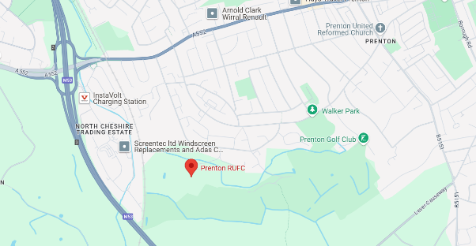

​Prenton Rugby Club is located on Prenton Dell Road in Prenton, Wirral, CH43 3BS. The club is situated less than two minutes from Junction 3 of the M53 motorway, providing easy access to the site.
The surrounding area of Prenton is a residential area, within close proximity to Birkenhead, featuring a mix of housing styles and local amenities. The club itself serves as a community hub, hosting various events and activities beyond rugby, including community meetings and social gatherings
The site is completely secluded once accessed via Prenton Dell Road, with an isolated location and significant parking/storage space.
Contractors’ vehicles and delivery vehicles should not park on the main access road to the site as this is quite narrow in places and serves as the only means of access and egress to the site.

Local residential streets, including Prenton Dell Road must be kept clear at all times and Contractors are advised to give priority to residents where possible when accessing the site.

EXISTING RECORDS
TBC other than project specific documentation provided as part of this PCI and issued within the Principal Contractor tender pack.

SITE REQUIREMENTS

WELFARE FACILITIES DURING CONSTRUCTION
Under Regulation 13(4) of CDM 2015, the principal contractor must ensure that appropriate welfare facilities are provided from the start and maintained throughout the construction phase. These facilities must meet the minimum standards outlined in Schedule 2 of CDM 2015, which include:
- Sanitary conveniences (toilets) that are suitable and sufficient in number
- Washing facilities (with hot and cold or warm running water)
- Drinking water
- Facilities for rest and eating
- Changing rooms and lockers (where required)

These obligations reflect and compliment Regulation 20 of the Workplace (Health, Safety and Welfare) Regulations 1992 (WHSWR), which also requires employers to provide readily accessible and adequate toilet and washing facilities within workplaces, including provisions for persons with disabilities.

SAFETY OF GLAZING AND TRANSPARENT SURFACES
Regulation 14 of WHSWR 1992 applies to workplaces and requires that any window, transparent door, or translucent wall or partition in areas where persons are likely to be present must:
- Be constructed of a safety material to reduce risk of shattering
- Be protected against breakage if not made of safety glass (e.g. by barriers or films)
- Be clearly marked or made apparent to prevent accidental collision

During the design and construction phase, designers under Regulation 9 of CDM 2015 must eliminate foreseeable risks, including risks associated with transparent elements. This obligation applies whether the glazing is temporary (used during the construction phase) or permanent (as part of the finished facility).

DESIGN COMPLIANCE AND BUILDING REGULATIONS
All permanent works, fixtures, and fittings must be designed and constructed in accordance with the Building Regulations 2010 (as amended), which set minimum standards for health, safety, accessibility, and energy performance in buildings.
The designer’s duties under Regulation 9 of CDM 2015 include ensuring that their designs comply with all relevant statutory requirements and do not introduce avoidable risks to workers or end users.

EQUALITY AND INCLUSIVE DESIGN
The Equality Act 2010 legally requires reasonable adjustments to be made to ensure that premises (including workplaces and sports facilities) are accessible to people with disabilities. In construction, this obligation typically applies to:
- The final design and layout of the refurbished premises (e.g. accessible WCs, entrances, and circulation routes)
- Opportunities to upgrade facilities during refurbishment (e.g. replacing narrow doors, improving signage or contrast for visual impairment)

SITE REQUIREMENTS OVERVIEW
During the construction phase, the legal focus is on compliance with CDM 2015, especially Schedule 2 welfare requirements. Once works are complete, WHSWR 1992 and the Equality Act 2010 guide ongoing workplace compliance and inclusive access. The project must also meet Building Regulations 2010 and be designed in a way that actively reduces foreseeable risks under CDM designer duties.

WASTE MANAGEMENT

Effective waste management is a critical component of responsible construction practice. For this project, the handling, storage, removal and disposal of waste materials must comply with UK environmental legislation and be managed to reduce environmental impacts where practicable.

ENVIRONMENTAL PROTECTION ACT 1990
Under Section 34 of the Environmental Protection Act 1990, all parties in the construction project (client, principal contractor, sub-contractors) have a Duty of Care to ensure that all waste is:
- Handled and stored safely and securely
- Described accurately and completely
- Only transferred to authorised persons (e.g. registered waste carriers)
- Accompanied by appropriate documentation, including Waste Transfer Notes (WTNs) for non-hazardous waste and Hazardous Waste Consignment Notes (HWCNs) for hazardous waste

MANAGEMENT OF CONSTRUCTION SITE WASTE
The Principal Contractor must have suitable arrangements in place to manage and dispose of site waste. These processes should be proportionate to the project size and scope. While Site Waste Management Plans are no longer a legal requirement in England (as of 2013), they remain best practice. This methodology includes documenting the following:
- Types and estimated quantities of waste to be produced
- Measures for waste minimisation and segregation
- Storage arrangements (e.g. skips, containment units)
- Waste carrier and disposal site details
- Record of waste movements
Although not legally required, the Principal Contractor is advised to manage waste to a similar standard as noted above.

HAZARDOUS WASTE REGULATIONS 2005 (AS AMENDED)
Although the majority of Asbestos Containing Materials (ACMs) identified within the pre-construction phase shall be removed from the building prior to the commencement of the construction phase, the project shall manage this element of works separately to the main construction phase. Ensuring any dangerous ACMs are removed or made safe prior to intrusive demolition & construction work. Within this pre-commencement element of works, the following requirements of the Hazardous Waste Regulations shall apply:
- Proper classification and segregation of hazardous waste
- Use of consignment notes for all movements
- Transfer only to licensed hazardous waste facilities
- Appropriate PPE, training, and controls to prevent harm to people and the environment
Contractors must be able to demonstrate correct identification and safe disposal of any hazardous materials encountered during refurbishment. Details of the nominated Licensed Asbestos Removal Contractor shall be noted in this PCI pack once agreed.

WASTE (ENGLAND AND WALES) REGULATIONS 2011
Under these regulations, all waste producers (Principal Contractor and any other Contractors) should utilise the waste hierarchy in order as set out below:
- Prevention
- Preparation for reuse
- Recycling
- Other recovery (e.g. energy recovery)
- Disposal
Contractors and subcontractors must ensure that waste management decisions prioritise reduction and reuse over landfill or incineration. Where applicable, this should be documented within the construction phase documentation.

CDM 2015 CONSTRUCTION SITE MANAGEMENT
Under Regulation 12 and 13 of CDM 2015, the principal contractor must plan and manage construction work in a way that:
- Minimises risks to health and safety from waste handling and storage
- Prevents slips, trips, fire hazards, and environmental contamination
- Ensures the site is kept clean and orderly
- Coordinates contractors and waste disposal teams to prevent unsafe or unscheduled waste accumulation

SUMMARY OF PROJECT WASTE MANAGEMENT REQUIREMENTS
For the Prenton RUFC project, the project must
- Assign clear responsibility to the principal contractor for overseeing all waste activities
- Identify and segregate hazardous and non-hazardous waste
- Maintain proper documentation and compliance with the Duty of Care
- Prevent environmental and safety risks from improper waste storage or removal
- Comply with relevant legislation including:
  - Environmental Protection Act 1990
  - Hazardous Waste Regulations 2005
  - Waste (England and Wales) Regulations 2011
  - Construction (Design and Management) Regulations 2015
  - Environment Act 2021

PROJECT DOCUMENTS

Reference | Type | Title
2025 007 300 000 | Drawing | Proposed Site Plan & Roof Plan (1:200/1:1250)
2025 007 300 001 | Drawing | Existing Floor Plan, Roof Plan, Site Plan &  Elevations (1:100/1:200/1:1250)
2025 007 300 001 | Drawing | Proposed Ground Floor Plan (1:100)
2025 007 300 002 | Drawing | Proposed Elevations (1:100)
2025 007 300 003 | Drawing | Proposed Part Ground Floor Plan  Sheet 1 (1:50)
2025 007 300 004 | Drawing | Proposed Part Ground Floor Plan  Sheet 2 (1:50)
2025 007 300 005 | Drawing | Proposed Part Ground Floor Plan  Sheet 3 (1:50)
2025 007 300 007 | Drawing | Proposed Key Section AA (1:20)
2025 007 300 008 | Drawing | Proposed Key Section BB & CC (1:20)
2025 007 300 009 | Drawing | Proposed Fire Strategy (1:75)
2025 007 300 010 | Drawing | Door & Window Schedule (NTS)
2025 007 300 011 | Drawing | Building Regulations Specification (NTS)
2025 007 300 012 | Drawing | Proposed Ceiling Layouts (1:100)
PRUFCPCI | Document | Pre-Construction Information Pack
PRUFCDRA | Document | Designers Risk Assessment
Fibre Safe WIR5811 | Survey | Asbestos Survey
Bat Survey Rev 01 | Survey | Dawn / Dusk Bat Roost Survey
CW20-447 RPT 001 | Survey | Preliminary Ecological Appraisal Report
25039-AJF-ZZ-ZZ-DR-S-001 | Drawing | Structural Details A1
25039-AJF-ZZ-ZZ-CA-S-001 | Calculations | Structural Calculations
2262-E-61-00-01 | Drawing | Proposed Power, Data, Voice and Fire Alarm Layout
2262-E-63-00-01 | Drawing | Proposed Lighting and Emergency Lighting Layout
2262-M-52-00-01 | Drawing | Proposed Soil and Waste Layout
2262-M-53-00-01 | Drawing | Proposed Hot and Cold Water Services Layout
2262-M-55-00-01 | Drawing | Proposed Air Conditioning Layout
2262-M-57-00-01 | Drawing | Proposed Ventilation Layout
9008/01 | Drawing | Topographic Survey

MANAGEMENT OF HEALTH & SAFETY

ARRANGEMENTS FOR PLANNING AND MANAGING CONSTRUCTION WORK

In accordance with the Construction (Design and Management) Regulations 2015 (CDM 2015), effective planning of construction work is required to ensure health, safety and welfare throughout the duration of the project. This Pre-Construction Information (PCI) document marks the starting point for planning how health, safety and welfare will be managed throughout the project, helping everyone involved understand the risks and responsibilities from the outset.

DUTY HOLDER RESPONSIBILITIES AND PROJECT COORDINATION
The Principal Contractor and Principal Designer have been appointed under Regulations 5 and 11 of CDM 2015 to plan, manage, monitor and coordinate the construction phase and pre-construction phase. They act as key agents representing the Client's interests and serve as primary contacts for all designers and contractors involved.
Under Regulation 4(4), the Client must ensure that sufficient time and resources are allocated and that the Principal Designer and Principal Contractor carry out their duties competently. The Client, via the Principal Designer, must also provide all pre-construction information (PCI) in accordance with Regulation 4(4)(c) and Regulation 11(3), ensuring that relevant health and safety information is made available to all parties before the commencement of work.

PRE-START AND PROGRESS MEETINGS
A pre-start meeting shall be held prior to the commencement of construction work to:
- Review the adequacy and completeness of the Construction Phase Plan (CPP) as required by Regulation 12
- Confirm arrangements for managing identified significant hazards (e.g. work at height, asbestos, live services etc)
- Verify that suitable welfare facilities (in compliance with Schedule 2 of CDM 2015) are installed and maintained
- Establish communication lines, reporting mechanisms, and the responsibilities of each contractor
Regular design team and progress meetings will be scheduled during the project. Details regarding these meetings are to be formalised.

CONSTRUCTION PHASE PLAN (CPP)
The Principal Contractor is legally required under Regulation 12(1) to prepare a Construction Phase Plan before construction work begins. This plan must describe:
- Site rules
- Management arrangements for health and safety
- Measures for controlling the specific risks listed in Schedule 3 of CDM 2015 (e.g. working at height, demolition, exposure to hazardous substances)
The CPP must be submitted to the Principal Designer no later than two weeks prior to the proposed start date. The Principal Designer must confirm in writing to the Client that:
- The CPP is sufficiently developed to allow the construction phase to proceed safely
- Suitable and sufficient welfare facilities are provided in accordance with Regulation 13(4) and Schedule 2
Construction work must not commence until this confirmation has been received by the Client.
As per Appendix 3 of the CDM 2015 Legal Guidance ACoP (L153), the CPP should address:
- Health and safety project goals
- Roles and responsibilities of all parties
- Management of foreseeable risks
- Site induction information
- Procedures for cooperation and coordination
- Emergency planning and first aid arrangements
- Site security and welfare facilities

CONTRACTOR RISK MANAGEMENT AND CONTRACTUAL ACCEPTANCE
All appointed contractors are required under Regulation 15 of CDM 2015 to plan, manage and monitor their own work activities, ensuring they are conducted safely and without risk to health. Upon submitting tender documentation and being appointed, contractors will be deemed to have:
- Accepted the Terms and Conditions of contract, including risk management responsibilities
- Acknowledged their legal duties under CDM 2015 and associated legislation

PROJECT RESOURCES
The Principal Contractor must ensure that the construction phase is properly resourced, planned, and monitored in line with Regulation 13(1)(b). This includes:
- Appointing competent site managers
- Implementing inspection regimes and supervision levels proportionate to the project’s complexity and risk
- Monitoring subcontractor performance and ensuring risk controls are followed on site

CLIENT’S HEALTH AND SAFETY OBJECTIVES
The Client has defined the following health, safety and environmental objectives for the project:
- Delivery of the project on time and within budget
- Adoption of a proactive and preventative safety culture
- Achievement of zero reportable accidents or incidents
- Minimisation of environmental impact in line with best practice and sustainable construction principles

COMMUNICATION DURING CONSTRUCTION
Good communication between the Principal Contractor (PC), Principal Designer (PD) and Client is essential to keep the project safe and on track.
- The PC will lead day-to-day site communication, provide inductions, hold toolbox talks, keeping the Client and PD updated on health and safety matters.
- The PD will remain involved during the construction phase, offering input on design-related risks and ensuring changes are managed safely.
- The Client will receive regular updates and be available to support key decisions or respond to emerging risks.
A pre-start meeting will set out clear lines of communication, and regular site meetings will be held to review progress, share updates and manage risks collaboratively. It is recommended that site meetings or progress meetings are held on a weekly basis.

SECURITY OF THE SITE
The Principal Contractor once appointed is to ensure that the project site is secure and separated from nearby/adjacent boundaries. Unauthorised access to the site, particularly by children, staff or general third parties must be prevented for the duration of the works.
Suitability of the Construction Phase Plan prior to commencement of works will be dependent upon the Principal Contractor demonstrating adequate arrangements for securing the various sites and spaces.

WELFARE PROVISIONS (CONSTRUCTION)
The Principal Contractor is to ensure adequate welfare facilities are available on site from the start of the works until the project has been completed in accordance with Construction (Design Management) Regulations 2015 and schedule 2 of the regulations.
Designated Welfare facilities/Site Compound areas will need to be confirmed prior to any works commencing on site. There are existing welfare facilities within the buildings that may suitable though further discussion/ agreement with the Client will be required to ascertain how suitable these areas are; and if there are any specific restrictions on the site.
Suitability of the Construction Phase Plan prior to commencement of works will be dependent upon the Principal Contractor demonstrating adequate arrangements for Welfare. The Client or Principal Designer are to work with the appointed Principal Contractor to ensure suitable welfare facilities are made available. This includes agreeing drainage/discharge routes and ensuring adequate power, connection and electrical supplies are in place.

MANAGING CONSTRUCTION HEALTH & SAFETY
The Principal Contractor is responsible for regularly monitoring health and safety on site to ensure that all work is carried out safely and in line with the Construction Phase Plan. This includes routine site inspections, audits and compliance checks regarding construction methodology and adherence to RAMS.
Findings will be recorded and reviewed during progress meetings and any issues or unsafe practices will be addressed promptly. The Client and Principal Designer will also take an active role in reviewing performance, especially where design or risk changes occur.
Regular reviews help ensure continuous improvement and support the project's goal of zero reportable incidents. If necessary the Principal Designer shall work with the Principal Contractor to develop accident/incident tracking processes to ensure issues are suitably documented and recurring near misses are recorded and controls implemented to mitigate future incidents.

SITE TRANSPORT ARRANGEMENTS
The Principal Contractor is to ensure they include and maintain a suitable traffic management plan showing as a minimum; details of access/egress traffic routes, signage, segregation of vehicles and pedestrians, speed limits, any restrictions on deliveries or waste collection or storage within their Construction Phase Plan.
Unobstructed Access for fire brigade and other emergency services must be available at all times. This must be documented within the Principal Contractors documentation.
Suitability of the Construction Phase Plan prior to commencement of works will be dependent upon the Principal Contractor demonstrating adequate arrangements for the above.

CLIENT’S SITE RULES FOR CONTRACTORS

  - Specific site rules and procedures are to be issued to the Principal Contractor.

  - The site boundary shall be clearly marked and suitable physical barriers put in place. Adequate signage is to be displayed throughout the site boundary.

  - Hard Hats/Protective Clothing. The site should be designated a hard hat area until such time as a Risk Assessment identifies that this may be relaxed.

  - Smoking on site. Smoking is not permitted within the construction site boundary.

  - Personal Protection - Hard Hats, high visibility clothing and foot protection will be worn as a minimum requirement throughout the duration of the contract. These shall be available for visitors. Personal protective equipment shall be provided for all those who require it.

  - Visitors - will be required to visit the site office throughout the duration of the project. Before entering the site, the Principal Contractor shall advise them of any hazards on the site, whether in the area to be visited or not. Visitors must sign in and out and must receive a CDM site induction from the Principal Contractor on their first visit.

  - No "hot work" - involving blow lamps, welding equipment, soldering irons, etc. may be carried out during the last two hours of the working day. The Principal Contractor shall carry out suitable hot work risk assessments and implement necessary control measures.

  - Stressing the structure - The Principal Contractor shall not overload or over stress any part of the structure. The Principal Designer or Structural Engineer are to be contacted to advise if necessary.

  - Breaching Compartment Walls, Floors or Fire Barriers. Any breaching which could prejudice the safety of personnel and the building must be made good prior to the end of each shift.

  - Plant. All portable equipment not in use shall be isolated and carefully stored. Items of plant not in use shall be rendered safe and isolated.

  - Tidy site. The Principal Contractor shall maintain the site in a tidy condition, especially along pedestrian and vehicular routes.

  - Adjacent property. The Principal Contractor shall take such steps as necessary to protect domestic properties near the site entrance from damage and to prevent his workforce from trespassing on neighbouring sites.

  - Contract Requirements. The Principal Contractor is required to comply with the requirements of the Contract Preliminaries. Any area of conflict between the Pre- Construction Information and the Contract Documents shall be brought to the attention of the Contract Administrator and the Principal Designer.

  - Competence. The Principal Contractor is required to ensure that any Designers responsible for any design within their scope are competent in terms of the Construction (Design & Management) Regulations 2015.

  - Contractors and Self-employed people - It is a requirement under the Construction (Design & Management) Regulations 2015 that the Principal Contractor ensures contractors and self-employed people working on the site are made aware of the relevant portions of the Construction Phase Plan.

  - Induction training is to be provided to all site persons to include the provision of induction sheets.

  - Each work package is to include safety training for operatives.

EMERGENCY PROCEDURES
The Principal Contractor is to devise an adequately detailed Emergency Plan and ensure that it is incorporated within the Construction Phase Plan. The Following elements should be included: -
• Training and Instruction for all operatives and staff
• Induction of Visitors
• Location of Muster points, escape routes and exits
• Instruction of procedures to be followed in an emergency
• Location and identification of Fire equipment
• Special and specific arrangements for evacuation in high risk areas/activities.

The Principal Contractor is to include within the Construction Phase Plan a Site-specific Fire Risk Assessment and relevant Fire Safety Information for the site. The documents should clearly identify fire preventative measures and incorporates the provision of fire fighting equipment, maintenance of escape routes and signage.
The Principal Contractor must ensure unobstructed access for emergency services is maintained throughout the project and that any necessary contacts with external services are arranged, particularly with regards to first aid, emergency medical care and fire & rescue work.
All emergencies must be reported to the Client
Contractors will be expected to provide emergency contact details for their company and employees.
The nearest accident and emergency hospital to this site is;
Arrowe Park Hospital
Arrowe Park Road, Birkenhead, Wirral, CH49 5PE

ACCIDENT AND INCIDENT REPORTING
Contractors must comply with the requirements of the Reporting of Injuries, Diseases and Dangerous Occurrences Regulations 2013 (RIDDOR) - regarding the reporting of accidents. In addition, Contractors must report to the Client:

    - Their own employee or Sub-contractor of RIDDOR reportable injuries.
    - Any accident / incident which results in injury to a visitor of the site.
    - Any accident / incident which causes damage to Clients, neighbours buildings/land.
    - Any unsafe situation which would affect the visitors, neighbours, the public.
    - Any environmental Incident e.g.: Pollution, release of a dangerous substance etc.

UNAUTHORISED AREAS
Site personnel are not permitted to enter grounds or areas of client’s land other than within the defined site perimeter, unless agreed with the client.

CONFINED SPACES
No confined spaces have been identified within the construction scope.

PARKING RESTRICTIONS
Adequate parking spaces are located within the site boundary. Contractors’ vehicles and delivery vehicles should not park on access roads to the site where they could cause danger to the public.
It should be noted that the main entrance route to the site is within residential streets and suitable arrangements are to be used to prevent obstructing these areas.
The Principal Contractor is advised to implement their own investigations regarding nearby public parking facilities and include arrangements within a traffic management plan
Suitability of the Construction Phase Plan prior to commencement of works will be dependent upon the Principal Contractor demonstrating adequate arrangements for the above.

PROJECT ENVIRONMENTAL IMPACT

BOUNDARIES AND ACCESS INCLUDING TEMPORARY ACCESS
For clarity and orientation, reference should be made to the site location drawings supplied with tender documents. The property will be unoccupied throughout the project, with the exception of areas of the clubhouse being opened/utilised towards the end of the project programme. Further details are to be supplied by the client to avoid clashes with simultaneous operations.

ADJACENT LAND USES
The site is located within a private, secluded part of the Prenton RUFC boundary. Minimal direct adjacent land uses are present. The main access road is found within a residential street of Prenton so the Principal Contractor is to include this within their construction documentation.

EXISTING STORAGE OF HAZARDOUS MATERIALS
There are no known hazardous materials stored on the site
Checks should be made to ensure all pipework has been disconnected and purged prior to removal.
The Principal Contractor shall include in the CPP their method of storing hazardous materials.

EXISTING SERVICES
Existing services on site include electricity, water, gas, telecoms and drainage.
Below ground services and drainage information in the Clients possession will be supplied with tender documents.
The PC should undertake surveys of the site prior to tender to establish the presence or absence of overhead services within the site boundary.
Further information on M&E services are to be provided.
The Principal Contractor will be responsible for liaison with service providers regarding isolations, disconnections, capping and purging etc.

GROUND CONDITIONS AND CONTAMINATED LAND
Ground conditions around the footprint of this property are generally level and well made. No ground penetrations are expected to be undertaken on the project other than shallow excavations for new foundations, substructure elements and drainage/services.

INFORMATION ABOUT EXISTING STRUCTURES
All necessary structural details and designs are to be issued to the Principal Contractor within the tender pack.

ASBESTOS
A Refurbishment & Demolition asbestos survey as defined by 'HSG264 Asbestos: The Survey Guide' has been completed and is supplied within the tender pack and PCI documentation.
Refer to asbestos survey – FibreSafe WIR5811.
It is noted that all licensed ACMs will be removed prior to the commencement of the construction phase (Asbestos Insulating Board) located within the boiler room- refer to page 14 of the asbestos survey.
The non-licensed ACMs consisting of textured coating to the ceiling of the cellar are not within the scope of the construction work. However this material should be highlighted within the risk assessments for the work. Refer to page 12 of the asbestos survey.
The non-licensed ACMs consisting of vinyl floor tiles to the boiler room and store room are to be removed prior to the construction phase commencing. Refer to pages 13 and 15 of the asbestos survey.
All asbestos removal work shall be fully documented and carried out in compliance with HSG247. Certificate of reoccupation and asbestos analytical air test certificates are to be provided within the pre-construction information pack following completion of this work.
The Principal Contractor must have an asbestos procedure in place to cover any intrusive or demolition work planned throughout the project. Although every effort has been made to identify all known ACMs within the building, it is good practice to have suitable arrangements in place to manage the discovery or disturbance of suspect ACMs that may be hidden within the building structure.
Important note: All Contractors’ employees must have suitable Asbestos Awareness Training within the past 12 months.

HEALTH RISKS FROM CLIENT’S ACTIVITIES
Asbestos health risks have been identified within the building. All ACMs will have been removed or identified prior to the construction phase commencing.

MANUAL HANDLING
All designers must be able to demonstrate that the principles of prevention of ACOP L153 have been followed with the aim of designing out risk at source. All significant residual risks must be clearly communicated ideally by inclusion on design risk registers and drawings.

ENVIRONMENTAL ISSUES
The Site Waste Management Plan Regulations 2008 were revoked in 2013 and no longer apply however the Client does require Contactors to implement effective and responsible waste management by applying the waste management hierarchy of controls;
- Reduce the amount of waste generated
- Separate/ stream waste types
- Re-use
- Recycle that which cannot be re-used
- That which cannot be re-used or recycled to be disposed of to a licenced transfer station or landfill.

All Waste transfer notes must be retained ON SITE and included in the H&S File as required.

ECOLOGY
A series of ecological assessments have been undertaken at Prenton Rugby Club in support of the proposed refurbishment works. A Preliminary Ecological Appraisal (PEA) identified the site as primarily comprising amenity grassland and existing buildings, with limited ecological value and low suitability for protected species. A follow-up Bat and Bird Survey (July 2022) specifically assessed the potential for roosting bats and nesting birds within the buildings proposed for redevelopment. No evidence of roosting bats or nesting birds was found, and general bat activity in the surrounding area was not associated with the structure.
As a result, no specific ecological mitigation measures are currently required, provided works proceed as planned. However, in line with best practice and legal obligations under the Wildlife and Countryside Act 1981, the Conservation of Habitats and Species Regulations 2017, and CDM 2015 Regulation 11, site operatives must remain vigilant during construction. Should any evidence of nesting birds or bats be discovered, works must stop immediately, and a qualified ecologist should be consulted.
Based the finding of these surveys, the below mitigation measures have been highlighted for the Principal Contractor to take into consideration:
Site Induction & Awareness
Ensure all site operatives are briefed on the ecological constraints identified in the PEA and bat/bird survey. This includes awareness of potential protected species and how to respond if any are encountered.
Habitat Protection
Although habitats on site are of low ecological value, ensure there is no unnecessary damage to boundary vegetation or offsite areas. Protect any retained green space or trees in line with BS 5837 (if applicable).
Construction Programme
While no nesting birds were identified, the construction programme is due to commence within the bird nesting season (March–August). If any active nests are found during this period, works must cease in that area until a qualified ecologist provides clearance.
Unexpected Species Encounters
Should bats, nesting birds or other protected species be encountered during works, cease operations in the immediate area and consult an ecologist immediately.
Waste and Pollution Control
Implement measures to prevent ecological harm from construction-related waste, dust, or runoff in accordance with the Environment Act 2021 and standard site environmental protection measures.
Record Keeping
Keep records of any ecological observations or actions taken on site, including toolbox talks, induction records and any relevant communications.

DESIGNERS RISK ASSESSMENT

SIGNIFICANT DESIGN ASSUMPTIONS
Assumed that all access points will be maintained clear and unobstructed throughout the project.
Assumed that prior to commencement, all asbestos containing materials that are likely to be disturbed/damaged during the works will have been removed and that the asbestos register and management plan is updated and made available to all contractors.
Assumed that lifting plans and methodology will be prepared by a competent appointed person for all lifting operations.
All relevant Temporary Works shall be designed and managed by a suitable competent person, including Temporary Works Coordinator/Supervisor.

DESIGN CO-ORDINATION
Co-ordination of ongoing design work and handling design changes will be through the Client and the Principal Designer. Details on design updates/revisions to be agreed with the Principal Contractor.

SIGNIFICANT RISKS IDENTIFIED DURING DESIGN

See Designers Risk Assessment for more information: PRUFCDRA001
Asbestos
Refer to asbestos survey report with certificate of reoccupation and air test certificates being issued prior to commencing works on site. Asbestos should still be included within Principal Contractor risk management processes due to the age of the building. It is assumed that further asbestos surveys will not be required during the construction phase, however emergency procedures should be developed for the construction phase works.
Structural Loading of Bridge to Access Road
Structural Engineer to provide details on the structural capabilities of the bridge located within the only access road to the site. This information should be made available within all Principal Contractor operations, including the coordination of deliveries and waste to ensure all contractors and suppliers are made aware of the structural limitations of the bridge. It is advised that suitable signage be displayed near the bridge.
Traditional Construction Methods
With the majority of the design incorporating traditional construction techniques to be adopted during refurbishment and extension works, it is noted that these methods have associated health & safety risks, including manual handling, exposure to vibration, noise and dust. Storage of materials and waste may also be incorporated into the risk management of this element of work. The Principal Contractor shall implement suitable risk mitigation measures to eliminate or minimise these risks.

CLOSE PROXIMITY TO SURROUNDING AND OCCUPIED ADJACENT BUILDINGS
There are no immediate adjacent structures or buildings within the site boundary.
Access to the site is made via public roads and residential streets.

MATERIALS REQUIRING PARTICULAR PRECAUTIONS

ACMs
Glazing
Silica dust

PROJECT COMPLETION AND HANDOVER

The Health & Safety File and O&M manuals must clearly identify the relevant information following the completion of the construction phase.

HEALTH AND SAFETY FILE
A hard copy and electronic copy of this information will be required in logical format at the completion of the project. The format must consider the Clients facilities and software to ensure it can be easily used. Once reviewed by the Principal Designer the H&S File will be handed over to the Client. It is advisable that a draft copy in word (etc) format be forwarded to the Principal Designer at least 2 weeks before the end of the project for review before committing to the production of hard and electronic copies.
The health and safety file should contain information needed to allow future construction work, including cleaning, maintenance, alterations, refurbishment and demolition to be carried out safely. The level of detail should allow the likely risks to be identified and addressed by those carrying out the future work:
The Health and Safety File must be developed ‘along the way’ and essentially not left until the end of the project. Milestone dates will be set within the project programmed for the delivery of information.
During the pre-construction phase, the Principal Designer with the project team will develop the health and safety file and issue to the Principal Contractor prior to the construction phase commencing.
All designers, contractors and Principal Contractor will provide information to be included within this file.
The Health and Safety File must be submitted to the Principal Designer at least 2 weeks prior to practical completion for review and comment.
It is anticipated that the Principal Contractor can periodically work with the Principal Designer during the project to ensure adequate documentation is included within the H&S file.
At the end of the construction phase the health and safety file must be passed to the Principal Designer for review and shall be formally handed over to the Client on completion.

O&M MANUAL
The O&M Manual is to be a comprehensive information source and guide for the Client and end users providing a complete understanding of the building and its systems and enabling it to be operated and maintained efficiently and safely.
The Principal Contractor is required to obtain or prepare all the information to be included in the O&M Manual, produce the required number of copies of the O&M’s and submit them to the Principal Designer for delivery to the Client. The O&M Manual is to consist of the following three parts, sub sectioned as appropriate:

Part 1: GENERAL must include:

- A description of the building.
- Details of all consultants and designers.
- Copies of all consents and approvals obtained.
- Drawings showing emergency escape routes, location of emergency and fire fighting systems, services shut-off valves, switches, etc.

Part 2: BUILDING FABRIC must include:
- Design criteria including floor loadings, insulation values and other performance requirements.
- As-built drawings recording details of construction, together with an index.
- Details of all materials, components and equipment including copies of manufacturer’s current literature, C0SHH data sheets and manufacturers’ recommendations for cleaning and maintenance.
- Names, addresses, telephone and fax numbers of all subcontractors, suppliers and manufacturers.
- Copies of all guarantees, warranties and maintenance agreements offered by subcontractors and manufacturers. All guarantees must run from the date of Practical Completion.
- Copies of all test certificates and reports required in the specification

Part 3: BUILDING SERVICES must include:

- A full description of each of the systems installed, written to ensure that the Client’s staff fully understand the scope and facilities provided.
- A description of the mode of operation of all systems.
- Diagrammatic drawings of each system indicating principal items of plant, equipment, valves etc.
- Photos of necessary elements and services.
- Schedules (system by system) of plant, equipment, valves, etc., stating their locations, duties and performance figures. Each item must have a unique number cross- referenced to the record and diagrammatic drawings and schedules.
- The name, address and telephone number of the manufacturer of every item of plant and equipment together with catalogue list numbers.
- Manufacturers’ technical literature for all items of plant and equipment, assembled specifically for the project, excluding irrelevant matter and including detailed drawings, electrical circuit details and operating and maintenance instructions.
- A copy of all Test Certificates (including but not limited to electrical circuit tests, corrosion tests, type tests, works tests, start and commissioning tests) for the installations and plant, equipment, valves, etc., used in the installations.
- A copy of all manufacturers’ guarantees, warranties and maintenance agreements offered by subcontractors and manufacturers.
- Starting up, operating and shutting down instructions for all equipment and systems installed.
- Control sequences for all systems installed.
- Schedules of all fixed and variable equipment settings established during commissioning.
- Procedures for seasonal changeovers.
- Recommendations as to the preventative maintenance frequency and procedures to be adopted to ensure the most efficient operation of the systems.
- Lubrication schedules for all lubricated items.
- A list of normal consumable items.
- A list of recommended spares to be kept in stock by the Client, being those items subject to wear or deterioration and which may involve the Client in extended deliveries when replacements are required at some future date.
- Procedures for fault finding.
- Emergency procedures, including telephone numbers for emergency services.

PRESENTATION OF O&M MANUAL
The O&M Manual is to be issued in hard copy and digital copy upon completion.
A complete draft of the O&M Manual must be submitted not less than 2 weeks before the date of practical completion allowing for amendment of the draft Manual in the light of any comments and resubmits to the Principal Designer. Do not proceed with production of the final copies of the O&M Manual until authorised to do so by the Principal Designer.

Final copies of the O&M Manual: Provide the Principal Designer with relevant copies in print format (including original) and electronic copies (on disc/secure link in editable word, excel and pdf format) not less than 2 weeks before Practical Completion. As-built drawings: Provide 2 copies in print format.

TRAINING OF CLIENT’S STAFF
Before Practical Completion explain and demonstrate to the Client’s maintenance staff the purpose, function and operation of the installations including all items and procedures listed in the O&M Manual. Dates and training demonstrations are to be planned with the Client.

SPARE PARTS
At least 2 weeks before Practical Completion submit to the Client a schedule of spare parts that the Principal Contractor recommends should be obtained and kept in stock by the Client for maintenance of the services installations. State against each item the manufacturer’s current price, including packaging and delivery to site.

TOOLS
At Practical Completion provide relevant sets of tools and portable indicating instruments for the operation and maintenance of all services plant and equipment (except any installed under Nominated Subcontracts) together with suitable means of identifying, storing and securing these tools.

APPENDIX 1 F10 NOTIFICATION

TBC

APPENDIX 2 DESIGNERS RISK ASSESSMENT

See PRUFCDRA001:

APPENDIX 3 ARCHITECTURAL DRAWING LIST

Architectural Drawing issue sheet 02/05/2025
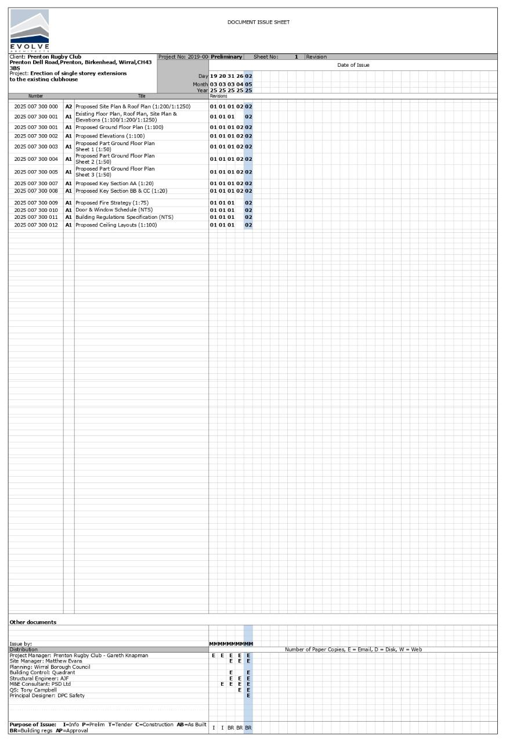

APPENDIX 4 STRUCTURAL DRAWING LIST

Structural Drawing issue sheet 04/04/2025
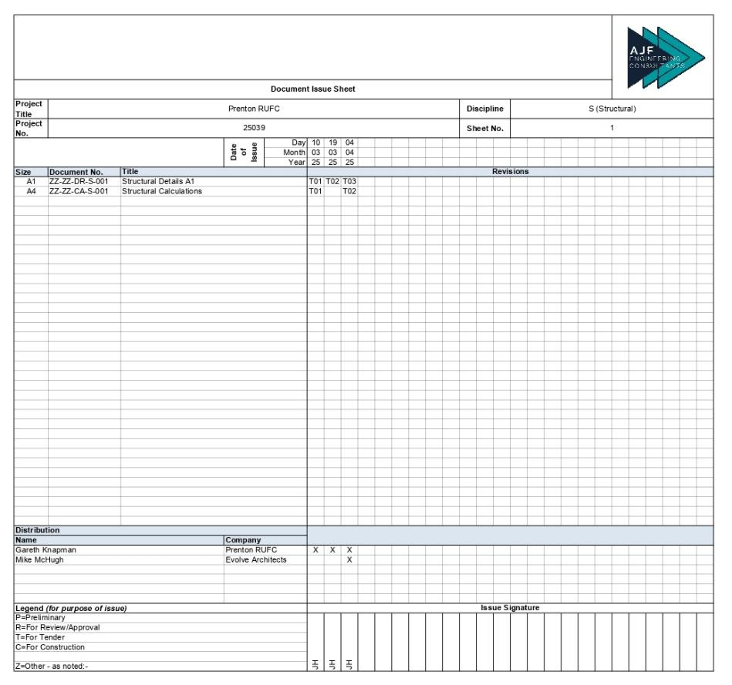

APPENDIX 5 M&E DRAWING LIST

M&E issue sheet 10/04/2025
