**Tender Notice for**

**The Provision of Facilities Capex Projects**

Issue Date: 14/05/2025

Closing Date and Time: 09/06/2025 - 5pm

**NGN Primary Contact:** Elle Flood

[eflood@northerngas.co.uk](mailto:eflood@northerngas.co.uk)

**NGN Secondary Contact:** Joanna Palmer

[jpalmer@northerngas.co.uk](mailto:jpalmer@northerngas.co.uk)

# Contents

Guidance. Please read carefully on how to proceed with event 3

Introduction…………………………………. 4

Northern Gas Networks Geographic Area 5

NGN Core Values 5

Scope of Requirements 6

# Guidance

This Tender Notice is issued by Northern Gas Networks (NGN) and is live until 09/06/2025 until 5pm.

The aim of this Tender Notice is to:

* Ensure we provide bidders with adequate information to determine if they wish to proceed with this tender event.

* Provide NGN with a more detailed understanding of the interest within the market.

The Tender Notice process is the first stage of multistage procurement process.

All interested suppliers must follow the below steps in order to proceed with the conditions of participation and PQQ stages of this procurement event:

Sign up or Sign in to NGNs Tendering Portal – Market Dojo. Follow this link to do so: [sign-up - Market Dojo](https://secure.marketdojo.com/signup)

When you have logged in to your dashboard, you'll need to click the '**Show all or enter invite code**' button under the Event Invitations section, as per below screenshot:

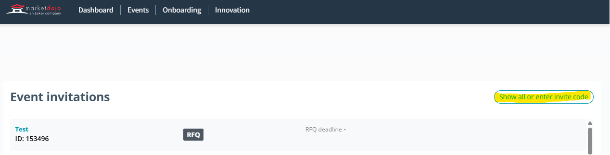

You’ll need to enter this code: **431AC0234C**

It will then notify NGN to approve you onto the tender event. Once approved you will be given access to the event, where you’ll be taken to the Conditions of Participation stage, this stage is a pass/fail and will be locked until after the PQQ submission deadline. Any supplier who fails this stage will automatically be withdrawn from the process and will not gain access to the PQQ. All suppliers who pass this stage will be automatically taken to the PQQ where they will be given a deadline and detail to complete.

Once the PQQ has been evaluated by NGNs internal evaluation team all those who meet the criteria will be sent to the RFP stage where NGN will assess against award criteria.

# Introduction

Northern Gas Networks Limited (NGN) is the company responsible for distributing gas to homes and businesses across the North of England. As part of the restructuring of the gas distribution business in England, NGN successfully acquired the North of England gas Distribution Network (DN) and took control of the assets on 1st June 2005. NGN has been responsible since then for the transportation of gas to the North of England via 36,000Km of pipelines.

The DN is located in the North of England and extends south from the Scottish border to South Yorkshire and has coastlines on both the East and West sides of the region. The DN contains a mixture of large cities such as Newcastle, Middlesbrough, Leeds and Bradford and a significant rural area including North Yorkshire and Cumbria. The area covers around 6.7 million inhabitants and has approximately 2.5 million customers. The DN is supplied via 23 off takes from the national Transmission System.

## Northern Gas Networks Geographic Area

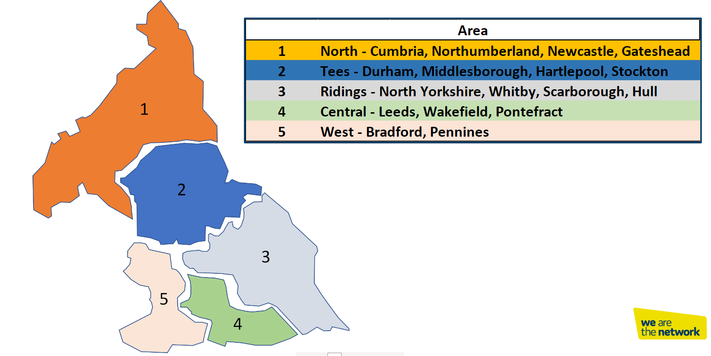

# NGN Core Values

NGNs dream is to become the UK’s most loved, admired and respected company, and to establish a reputation for doing business really well through a united and empowered team that is mind-blowingly great. We recognise the important role that our supply chain partners having in supporting NGN to achieve our dream.

Our dream lies at​​ the centre everything we do and has been translated into a unique set of values that reflect and reinforce our culture.

* Trailblazing
* Intellectually Curious
* Community Focused
* Empowered
* Heartfelt
* Happy

Every member of our team is passionate about the contribution they make to our growing reputation as a pioneering, effective, conscious and enlightened business that is focused on changing the way that things are done.

We expect our suppliers to share our vision and values and our way to support NGN in achieving our goals.

# 

# Scope of Requirements

Northern Gas Networks are initiating a framework of contractors focused on future Capital Expenditure (CAPEX) investments related to our ‘facilities’ building stock.

This strategic approach is designed to streamline our procurement process and enhance our operational efficiency. We aim to appoint suitable contractors who can deliver quality results while adhering to our standards, budgets and timelines.

The scope of works ranges from minor fit outs, various building improvements, through to comprehensive construction projects.

This scope encompass’ a variety of commercial building types focusing on the offices and depots throughout the network.

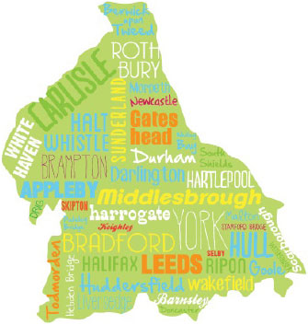

The primary objective of the capital investment is to modernise our existing infrastructure, improve energy efficiency, and address any maintenance needs while maintaining high standards throughout the building stock.

**2.2. Principal Contractor Scope of Services**

The scope of services as defined within this document shall include but will not be limited to:

* Interior and exterior refurbishments
* New build developments
* Planned asset replacement (M&E/ Building Fabric)
* Installation of energy-efficient heating, ventilation, and air conditioning (HVAC)
* Improvements to maintain compliance with safety and building regulations.

Projects under the awarded framework will be scoped on an individual basis, whereby a Principal Designer shall be appointed on each scheme for the purposes of the CDM regulations.

Principal Contractors will be responsible for producing a Fully Quantified Schedule of Rates, in accordance with specific projects requirements, for QS approval.

Principal Contractors will be responsible for undertaking the agreed works and issuing a completion pack (including H&S file, O&M manuals, as build drawings).

Contract Sums will be a fixed price and will not be remeasured, except for any approved client instructions or the reconciliation of defined provisional sums.

Any works required to be quoted are to be market tested - i.e. Framework Principal Contractors are to obtain a minimum of three quotations, as far as is practicable Northern Gas Networks reserve the right to specify nominated suppliers.

During the execution of the Works, access may be required by NGN or by Contractors employed directly by NGN. The Principal Contractor will be required to allow access to such contractors and shall allow for all liaison and co-ordination required to permit access at an appropriate point in the programme.

All specific attendances including, but not limited to; power, craneage, materials handling, rubbish removal, protection, delivery, and installation etc, are to be provided by the principal contractor.

**2.3. Defects**

Principal contractors are to adopt a documented self-snagging process with the intention that defective work is rectified in advance of practical completion.

**2.4. Health & Safety**

All works must be undertaken in accordance with Northern Gas Networks codes of practice, CDM legislation and ACOPS.

All works must be undertaken in accordance with the latest legislation regarding site operating procedures.

Principal Contractors are to identify any hazardous work and submit CPP/ RAMS to the client, in advance of undertaking works.

Principal contractors are to ensure areas including where specific works are being undertaken, remain clear, tidy and free of obstruction at all times. The site should be left clean and tidy at the end of each working day. The principal contractor is responsible for the clearance of all rubbish. This is as much a matter of safety as of good working practice and fire precautions.

Regarding the delivery, unloading and safe storage of goods and materials, this must be done safely, quickly and efficiently.

NGN vehicle movements within depots are to take priority at all times.

All contractors must sign in and out every time they arrive and depart site.

Fire integrity must be maintained at all times. fire doors cannot be wedged or propped open and their closing must not be restricted by trailing leads, cables etc.

All works must comply with the latest health and safety, building and CDM regulations.

Personal protective equipment (PPE) must be provided by the contractor, be fit for purpose and in good condition and worn where appropriate to do so, as identified by risk assessment.

**2.5. Environmental and Sustainability**

All contractors must ensure compliance with specific NGN requirements relating to environmental and sustainability standards.

Contractors are required to incorporate all construction activity for each project within the Employer’s Environment Management System (EMS) accredited under ISO 14001 or equivalent accreditation. (A marked question will be included within the tender event).

Within the RFP is a marked question around NGNs supporting environmental standards document which contains an overview of the expectations but not limited to.

**2.6. KPI/SLA/Deliverables**

The KPI/SLA/deliverables as defined within this document shall include but not be limited to:

* Project Planning and Pre-Construction
* Contractor Management
* Construction Activities
* Cost Control and Financial Management
* Project Completion and Handover
* Risk Management and Reporting
* Sustainability and Environmental Management

**KPI/SLA/Deliverables Definitions:**

**Project Planning and Pre-Construction**

Design and Documentation Review: *Ensure that all design plans, engineering drawings, and project documentation are aligned with the project brief, legislation, and standards.*

Pre-construction Surveys: *Conduct site assessments, including environmental, geotechnical, and topographical, fabric, and M&E surveys where required.*

Permits and Approvals: *Obtain necessary permits and approvals prior to construction works commencing.*

**Contractor Management**

Subcontractor Selection and Management: *Source, evaluate competency, and manage subcontractors, ensuring they meet project requirements in terms of quality, cost, and programme.*

Procurement of Materials: *Oversee procurement of construction materials, ensuring they meet specifications and delivery timelines including advanced orders for long lead items.*

*Health and Safety Compliance: Implement and manage the health and safety plan, ensuring adherence to legislation, regulations, and industry standards.*

**Construction Activities**

Site Setup and Mobilisation:*Prepare the site for construction, including establishing temporary facilities (offices, storage, welfare, waste management, power, water etc.).*

Structural Elements:*Construction of structural elements (e.g., excavation, foundation work, roofing, framing, etc).*

MEP:*Installation of required Mechanical, Electrical, and Plumbing works including coordination.*

Quality Control:*Ensure that construction work is to a high standard meeting all relevant standards and legislation. Regular inspections and testing of materials, workmanship, all works to be self-snagged and defect free at handover.*

Project Documentation:*Maintain all project records, including safety inspections, variation requests, instructions, progress reports, quality inspections, and commercial documents.*

**Cost Control and Financial Management**

Cost Management: Monitor and control costs to keep the project within budget. Ensure timely reporting on project financials, including potential cost overruns.

Programme Management: Ensure that the project progress is reported accurately, and any risks are identified as they become apparent whilst maintaining every effort to maintain the agreed programme.

Change Management: *Manage any variations in scope, cost, or timeline, and coordinate any required amendments to contract documents, drawings and schedules.*

**Project Completion and Handover**

Final Inspections:*Conduct final quality checks to ensure the completed project meets the design and required standards.*

Commissioning and Testing:*Ensure all systems such as HVAC, electrical, plumbing, BMS, Doors etc. are tested, commissioned, and left operational.*

Client Handover:*Deliver the project to Northern Gas Networks, complete with necessary documentation (H&S file, O&M Manuals, User guides etc.)*

Post-Construction Support: *Provide any necessary support during the post-construction phase such as addressing snags and defects in a timely manner and supporting end users with functionality issues.*

**Risk Management and Reporting**

Risk Identification and Mitigation:*Continuously assess potential risks to the project timeline, budget, and quality, and put in place measures to mitigate these risks.*

Regular Reporting: *Provide detailed progress reports as deemed necessary to project stakeholders, including Northern Gas Networks and their appointed representatives.*

**Sustainability and Environmental Management**

Sustainable Practices: *Implement sustainable construction practices in line with NGN standards and policies, including waste management, energy efficiency, and using environmentally friendly materials.*

Environmental Impact Assessments: *Ensure the project complies with environmental regulations and reduces its carbon footprint.*