

Tender
Student Union Building, Bishop Otter Campus: QS appointment to support feasibility study and subsequent delivery of improved external wheelchair access
The University of Chichester

Return by: 16/06/2025 - 09:00

Copyright © 2022 by The University of Chichester. All rights reserved. This document is supplied purely for the purpose of assisting suppliers to respond to this procurement, no part of this document may be reproduced or transmitted in any form, by any means (electronic, photocopying, recording or otherwise) for any other purpose

University of Chichester  College Lane Chichester West Sussex  PO19 6PE | Telephone: Date: Revision: Email | 01243 816000  07/05/25  1.0 Final Tenders@chi.ac.uk

Contents
- Introduction and general background 1
  - Purpose of this tender document 1
  - Background to this tender 1
  - High level requirements 1
  - The bidding process 3
  - Seeking clarification 3
  - Procurement timetable 3
  - Submission details 3
  - The assessment process 4
  - Confidentiality and Freedom of Information 4
  - The template below 4
  - The technical requirements 5
Appendices: 1. Feasibility options for development 2. Topographical survey (CAD file)

Tender Page i

- Introduction and general background

Purpose of this tender document
The purpose of this tender is to enable suppliers to demonstrate expertise and compliance with the University’s requirements, and to enable the University to assess the most advantageous solution to its requirements, using the prescribed tendering methodology for requirements of this size and nature.

Background to this tender
The University of Chichester is looking to procure the services of a quantity surveyor to support the completion of a feasibility study to provide improved access for wheelchairs to its Students Union building on its Bishop Otter Campus. The building is situated on an elevated site to the North of the Campus. The building’s elevated position and distance from other key campus buildings makes it particularly hard to access. The feasibility study will involve the technical exploration of three potential design solutions already identified. This tender exercise will also establish a fee structure for onward downstream delivery of a selected design, should the University decide to implement the project.
In parallel with this exercise to appoint a quantity surveyor the University is securing the services of a civil engineer to lead the design. The appointed quantity surveyor will be expected to work alongside the successful civil engineer in completing this exercise.

High level requirements

Primary requirement (Part 1) – a fixed price, lump sum fee proposal to support the feasibility study, providing the following key duties:

    - Support the civil engineer in undertaking a preliminary assessment of three (3) design solutions currently identified (see Appendix 1 below). This assessment will primarily be on the basis of technical feasibility, but cost or risk could be a factor. As part of this review the consultant is welcome to suggest alternative options (with supporting rationale) for exploration should they consider these to be better than those originally identified. The University shall however have the right to reject these alternative proposals.
    - After agreement with the University, support the civil engineer to develop feasibility proposals for the three (3) selected design options with the supply of associated cost planning data. Feasibility proposals are expected to be developed to RIBA 2.
    - As part of the feasibility process, both the civil engineer and quantity surveyor will be expected to contact any specialist contractors or equipment suppliers identified (including platform lift manufacturers) as necessary to facilitate practical, sufficiently well thought through and robustly costed design proposals for each option.
    - At the end of this process work with the civil engineer to and specialist suppliers to prepare outline cost plans for each of the selected design options for inclusion in a feasibility report.
    - Working also with the civil engineer, specialist suppliers and the university, assist in the development of outline project programmes for each design option – which are to include anticipated design, procurement and construction periods.
    - In co-ordination with the civil engineer, specialist suppliers and the university, help to evaluate the three design options developed and critique each, ultimately allowing a recommended proposed preferred option for inclusion in the feasibility report with supporting explanation.
    - Assist the civil engineer to collate the findings of the above steps (including cost plan data) into a written feasibility report for presentation and submission to the university. The report is to be prepared and submitted in both hardcopy (up to ten (10) copies) and digital formats (PDF); with all electronic source documents (i.e. CAD drawings, Word documents and Excel files etc). used in its creation to also be available for the university to use in their source format on request. In submitting this documentation all consultants involved in its preparation will grant a license to the University to use such documents for the progression of the project, regardless of whether the consultant is appointed to progress such subsequent works or not. Please note the report produced will be expected to feed directly into university business case approvals, and subsequent project delivery.
    - Allow also for key consultant personnel involved with the feasibility study to attend the University of Chichester on up to two separate occasions to formally present the findings of the feasibility study to University colleagues.

Additional Requirement (Part 2) – Percentage fee proposal for implementation of preferred feasibility option

    - The consultant is also asked as part of their tender submission to confirm a percentage fee (as a percentage of net construction cost) to deliver any chosen feasibility option considered by the report through construction, should the University decide to proceed. The submission requirements for this are as detailed below.
    - A further third part to the fee offer is to confirm hourly rates for staff of differing levels of seniority and professional experience. This element of the submission serves however purely for tender evaluation purposes and as a fall-back for valuing any additional services provided which are agreed as falling beyond the scopes of parts 1 and 2.

General

    - The consultant is to be appointed under the NEC4 professional services short contract (PSSC).
    - Bidders must hold a minimum of £5m Professional Indemnity Insurance. Certificates will be requested by the successful consultant as part of the appointment process.
    - The civil engineer will be expected to perform the duties and be appointed Principal Designer under the Construction Design and Management Regulations 2015.

The bidding process
Whether through our tendering advertisements, or where we have contacted you directly to ask for a submission, we ask that you contact us only through the email account tenders@chi.ac.uk. This includes for your submission, and any questions you may have. We are obliged by the Public Contacts Act (2015) and by our own financial regulations to undertake a competitive process. As the tender process will involve financial and qualitative elements section 0.10 sets out submission requirements.
We have allowed 32 days for the return of proposals, and have set a closing date and time of 09:00 on 16th of June. Submission is through tenders@chi.ac.uk

There is an opportunity for a site visit during the tender process. Site visits are highly recommended. Please contact Steve Parker directly to arrange a site visit steve.parker@chi.ac.uk.

Seeking clarification
For all queries please contact us by email tenders@chi.ac.uk . Please note that during the tender period you should not contact University staff directly, as this might be considered canvassing, and in which case the University might need to exclude your organisation from the tender process.
Please note that dependent upon the nature of the enquiry, and in so much as it does not identify your organisation, the answers to any questions you raise may be circulated to all suppliers who have expressed interest in this tender.

Procurement timetable
The procurement project is working to the following timescale:

Stage | Key Dates
Publication of Tender | 12:00 on 14/05/25
Site Visit | w/c 02/06/25
Closing Date for Submission | 09:00 on 16/06/25
Award | w/c 23/06/25

Submission details
You are welcome to notify the University with your ‘Expression of Interest’ but please do send your completed submission (including a completed version of this document) to the University by the closing date (time and date), to tenders@chi.ac.uk.

Please note, we do not accept submissions via file transfer sites. Tenders@chi.ac.uk accepts emails and attachments of up to 35MB and it is acceptable to submit in more than one email.

The assessment process
The University awards contracts on the basis of most advantageous tender, assuming that there is nothing that excludes the tenderer. All documents submitted are assessed by a panel to ensure fairness and understanding. The panel reviews the suppliers submission for;

Criteria | Weighting (marks)
C1 - Coherence and clarity to the University’s requirement (including organisational experience and capability) | 50% (50 marks)
C2 - Cost | 40% (40 marks)
C3 - Environmental and Sustainability performance | 5% (5 marks)
C4 - Corporate Social Responsibility and Social Value | 5% (5 marks)
Exclusion grounds *see (link) | Pass / Fail

Confidentiality and Freedom of Information
All tendering documentation and correspondence are treated as strictly confidential. However, the University is subject to UK Data Protection Legislation, and the Freedom of Information Act 2000. This means that the University can be asked to disclose procurement and contracting information. Please indicate any areas of your submission that you consider should be exempted from any disclosure requests and identify why they should not be disclosed.

Please note that from October 2024, the University will be required to comply with the Public Procurement Act (2023), which requires routine openness and disclosures about any procurements.
  - The template for your submission
We have set out a template below, and ask that you use this to help us understand your submission, in a way that allows us to compare its benefits against others. This anticipates questions we / you may have.
We have deliberately avoided overloading the process with the rigors of (for example) the Crown Commercial Service’s ‘reason for exclusion’, but please note there are a number of requirements we have to ensure before finalising any subsequent contracts. These range from the ownership of the companies we work with, to environmental sustainability and key questions such as your policies and approach to Modern Slavery and equal opportunity.

- Contact Details and Declaration

Please set out the names / contact details for the people you want to be included in any correspondence from the University. Please note as set out above, that no correspondence from your company in relation to this tender, should be sent elsewhere but to tenders@chi.ac.uk

Response

Contact name

Name of organisation

Role in organisation

Phone number

E-mail address

Postal address

- General Questions

C1.1 | Team offer/capabilities (20 marks):  Please provide details of your proposed team and organisational structure for delivering this commission. Please include CVs for key staff identified.  Each CV shall include as minimum:  - Total number of years relevant experience to their role  - Grade/level of seniority in the company  - Relevant experience to this project  - Location of office base  - Year of joining the company.  Maximum one half of one side of A4 in 10-point font for organisational structure and per CV
Enter supplier response here:

C1.2 | Case studies/previous project experience and relevance to this commission: (10 marks)  Please provide details of previous case study projects, highlighting areas of similarity to this project in nature of work or where there is continuity of proposed team members. Photographs of previous projects are welcome  Maximum of 3 case studies, with all three taking up to one side of A4 in total (10-point font)
Enter supplier response here:

C1.3 | Approach and methodology: (10 marks)  Please describe your planned approach to deliver this commission if successful, highlighting particular areas of concern or risk you would wish to see overcome and how you would propose achieving this.  Up to one side of A4 in 10-point font maximum
Enter supplier response here:

C1.4 | Programme commentary: (10 marks)  For the feasibility study element of the commission, please provide a commentary on how long the feasibility study is expected to take; making comment on anticipated timescales for key stages, time allocations for key project staff to deliver these tasks and other workload commitments they will be expected to balance at the same time.  Up to half a side A4 in 10-point font maximum – a tabulated or bullet pointed format is acceptable. (Submission need not include preparation of a formal Gantt chart)
Enter supplier response here:

C2 | Fee offer: (40 marks total)  Please submit your fee offer as follows:  - Part 1 – feasibility study: a fixed price, lump sum fee proposal to deliver the feasibility study with the three wheelchair access options identified appropriately explored and reported upon.  - Part 2 – subsequent project delivery: percentage fee (as a percentage of net construction cost) to deliver chosen option through construction, should the University decide to proceed.  - Part 3 – indicative hourly rates: of staffing levels listed below  - Partner/Director  - Associate/Senior Professional  - Qualified Professional  - Graduate/Trainee  Supplier to respond by populating the following tables below:
Part 1: (20 marks for this part)
A fixed price, lump-sum fee proposal to contribute to the completion of the feasibility study to RIBA workstage 2. With three wheelchair access options agreed, appropriately explored, developed and reported upon | Enter lump sum fee here (exclusive of VAT) £

Part 2: (15 marks for this part)
Percentage fee (as a percentage of net construction cost) to deliver chosen option through construction, should the University decide to proceed. | Enter % of net construction cost
Part 2 fee: to be broken down across RIBA workstages 3-7 as below: | (Total below to add to 100%)
RIBA 3 | Enter % of RIBA 3 - 7 fee
RIBA 4 | Enter % of RIBA 3 - 7 fee
RIBA 5 | Enter % of RIBA 3 - 7 fee
RIBA 6 | Enter % of RIBA 3 - 7 fee
RIBA 7 | Enter % of RIBA 3 - 7 fee

Part 3: (5 marks this part)
Hourly rates (excluding VAT)
Partner/Director |  | Please note: this element of the submission serves purely for the valuation of any additional services delivered during the commission which are agreed as falling beyond the scopes of parts 1 and 2.
Associate/Senior Professional

Qualified Professional

Graduate/Trainee

C3 | Environmental and Sustainability performance: (5 marks)  Bullet point how your organisation embeds good environmental and sustainability practice into its projects and operations as a business. Provide also a bullet pointed commentary on environmental and sustainable construction considerations that can be factored into this specific project.  Up to half a side A4 in 10-point font maximum – in bullet pointed format
Enter supplier response here:

C4 | Corporate Social Responsibility and Social Value: (5 marks)  Briefly explain how your organisation strives to operate in a socially responsible way. Factors to highlight could include:  - The creation of local work opportunities  - Opportunities created for training and skills development  - Equality, Diversity and Inclusion in the workplace  - Improving health and wellbeing  - Tacking modern slavery  Up to half a side A4 in 10-point font maximum
Enter supplier response here:

  - The technical requirements
To comply with the Public Contracts Act 2015 and our own financial regulations, before it makes any final decisions, the University is required to ensure that any supplier meets a number of key characteristics. As well as ensuring suitability and value these include areas, such as how you comply and support the Modern Slavery Act and the various aspects of the Social Value Model.
Please note that during the contacting phase of this procurement, we will ask questions about;

- The status and formation of your company
- The ownership of your company, and any exclusion grounds (for example convictions)
- Any sub-contractors that you might use

- Economic and financial standing
- Technical and professional ability (potentially to access references of relevant existing customers)
- Compliance with statutory obligations (Modern Slavery Act)
- Liabilities Insurance
- How your company supports the Social Value Model (including tackling inequality, fighting climate change, equal opportunity and wellbeing).

Appendix 1 - Feasibility options for development

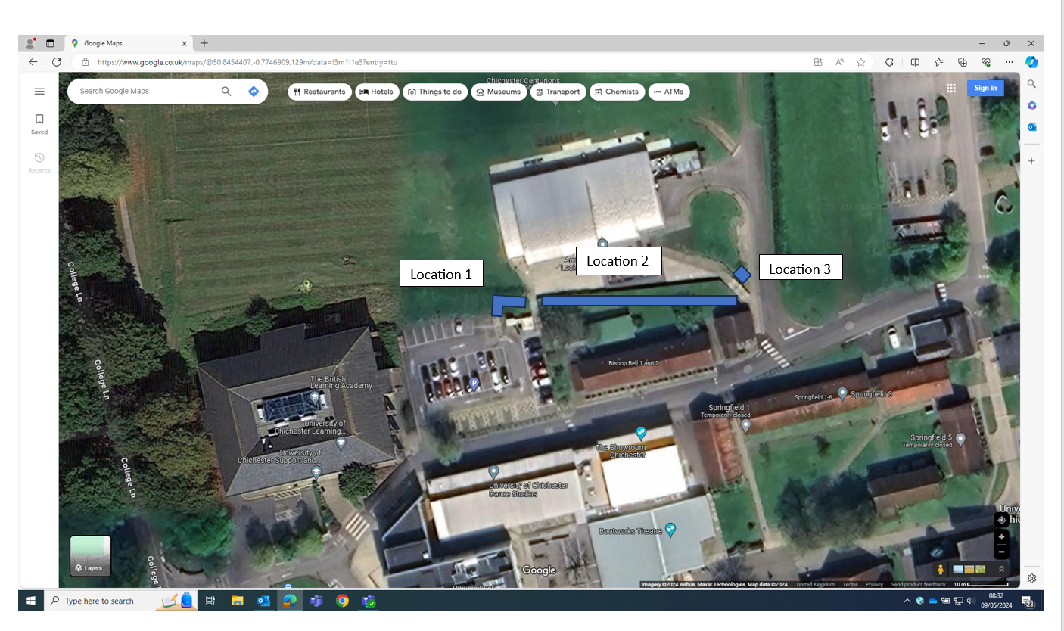

Overview of feasibility options
Location 1: Works to comprise:
- Construction of new set of external steps (to wrap around existing electrical substation)
- Removal of existing external steps and installation of a platform lift in this location.
- Suitable modification to external wayfinding to provide safe wheelchair access to platform lift (through lower car park especially).
Location 2: Works to comprise:
- The installation of a suitably ramped access across the grass embankment behind buildings labelled “Bishop Bell 1 and 2” above – known in reality on campus as Ashling Halls 1 and 2
- Proposed design to take due consideration of maximum gradient and length for external ramped access routes.
- Proposed design to also consider topography and overcoming risk of groundwater seepage onto path (ice risk in winter in particular).
- Design to also consider presence (and mitigation against) buried services under the embankment.
Location 3: Works to compromise:
- The installation of a platform lift next to the existing external steps
- Providing a suitably navigable approach route for wheelchair users to the foot of the existing steps: noting gradient, adverse camber on corner by zebra crossing and scheduled ancient monument under grass strip to East of access road to Student Union building.

Supporting photos:
Location 1 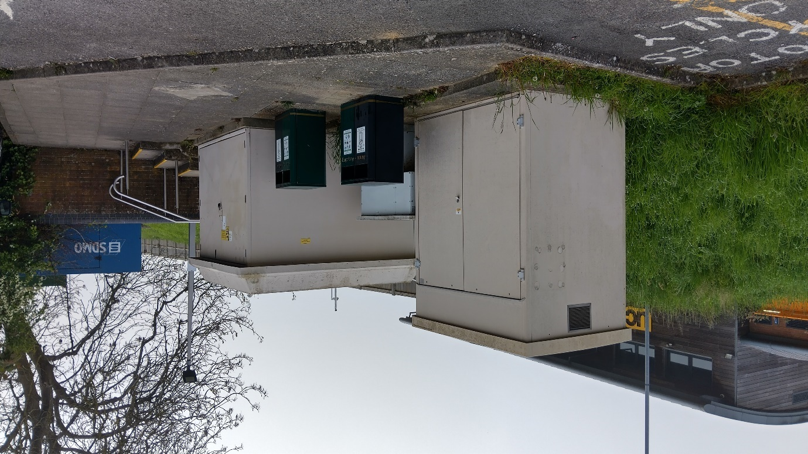

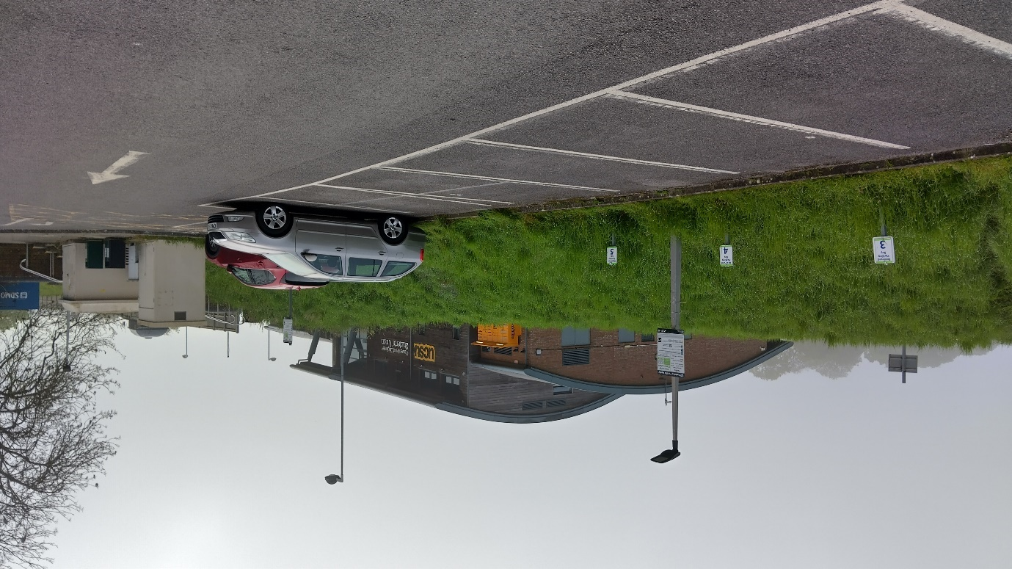

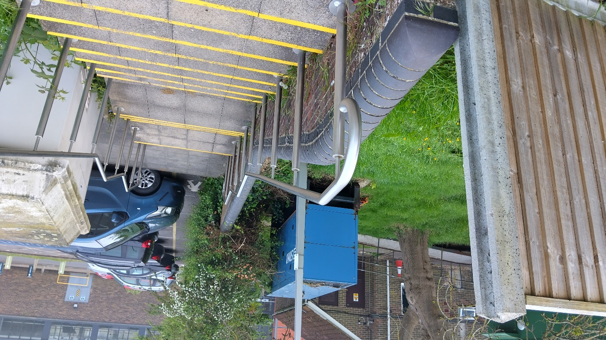

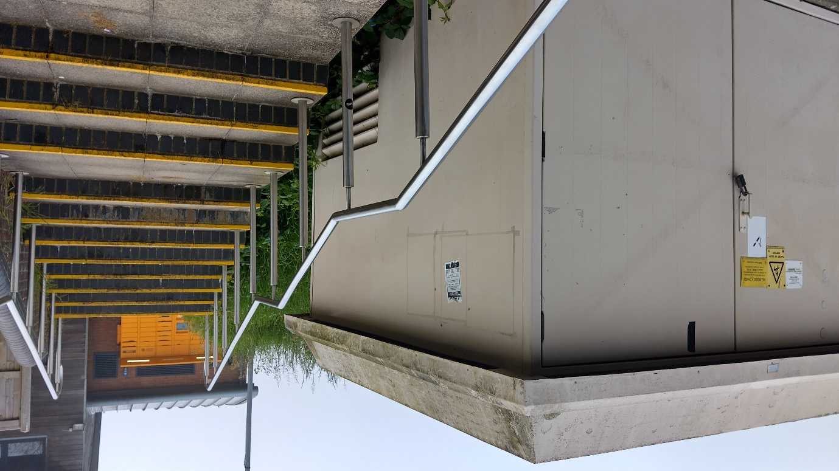

Location 2
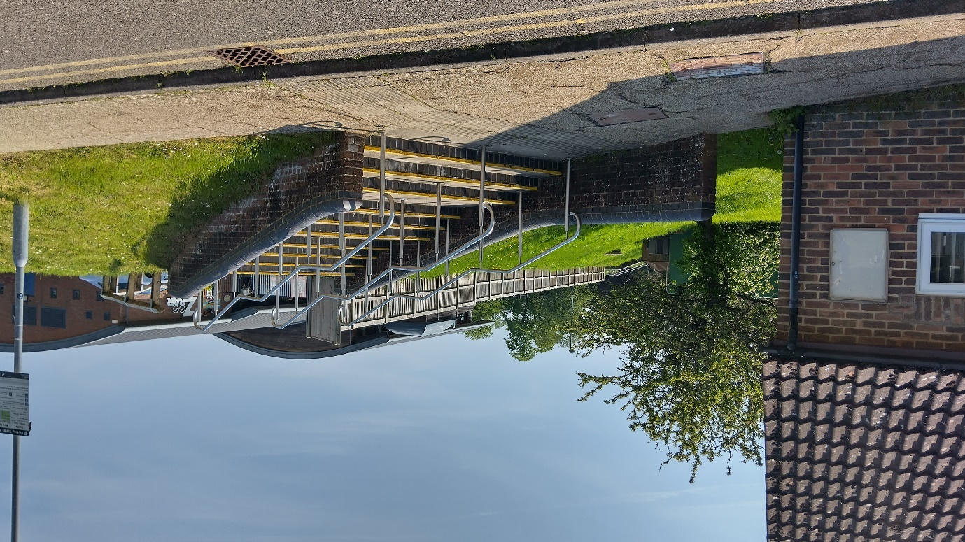

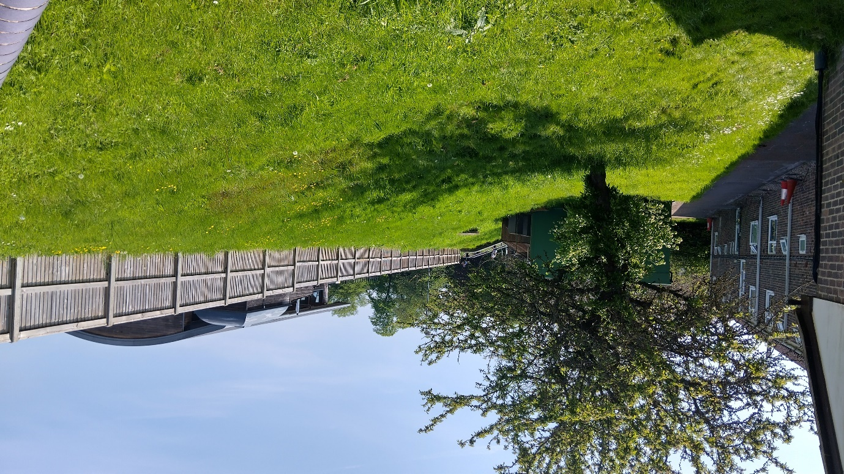

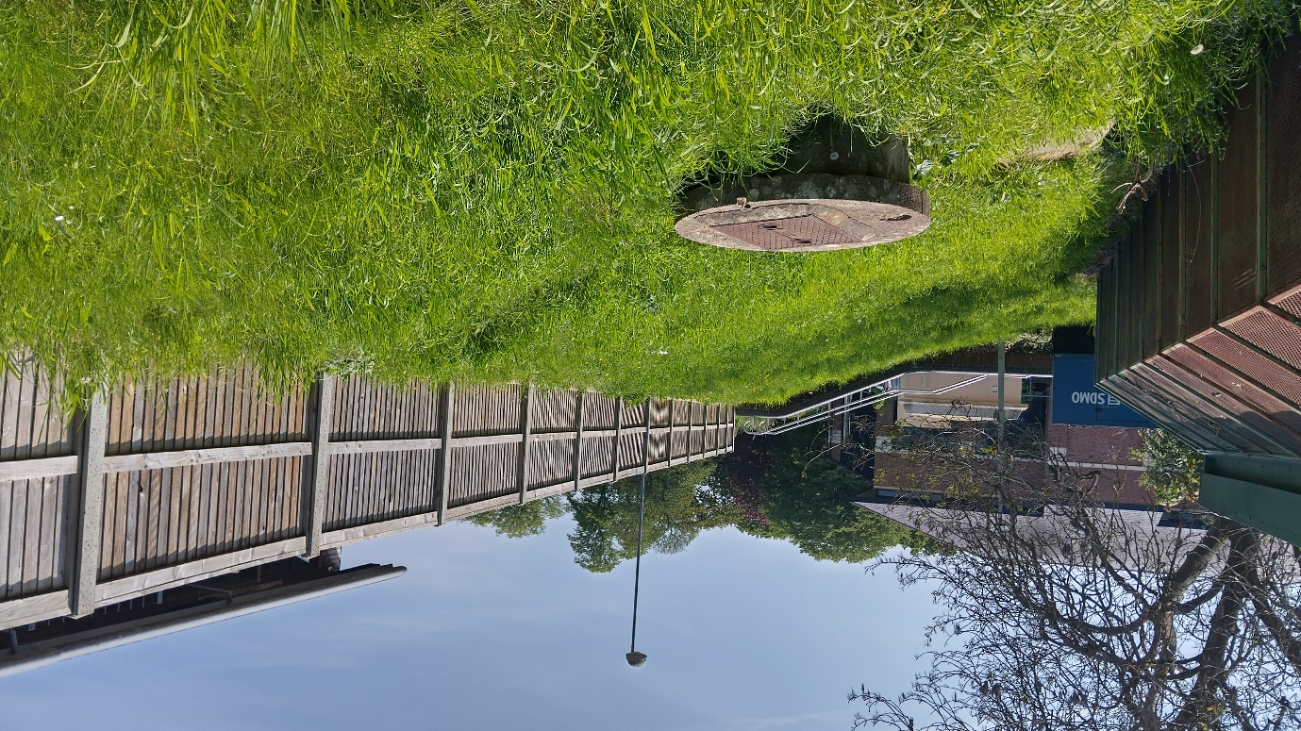

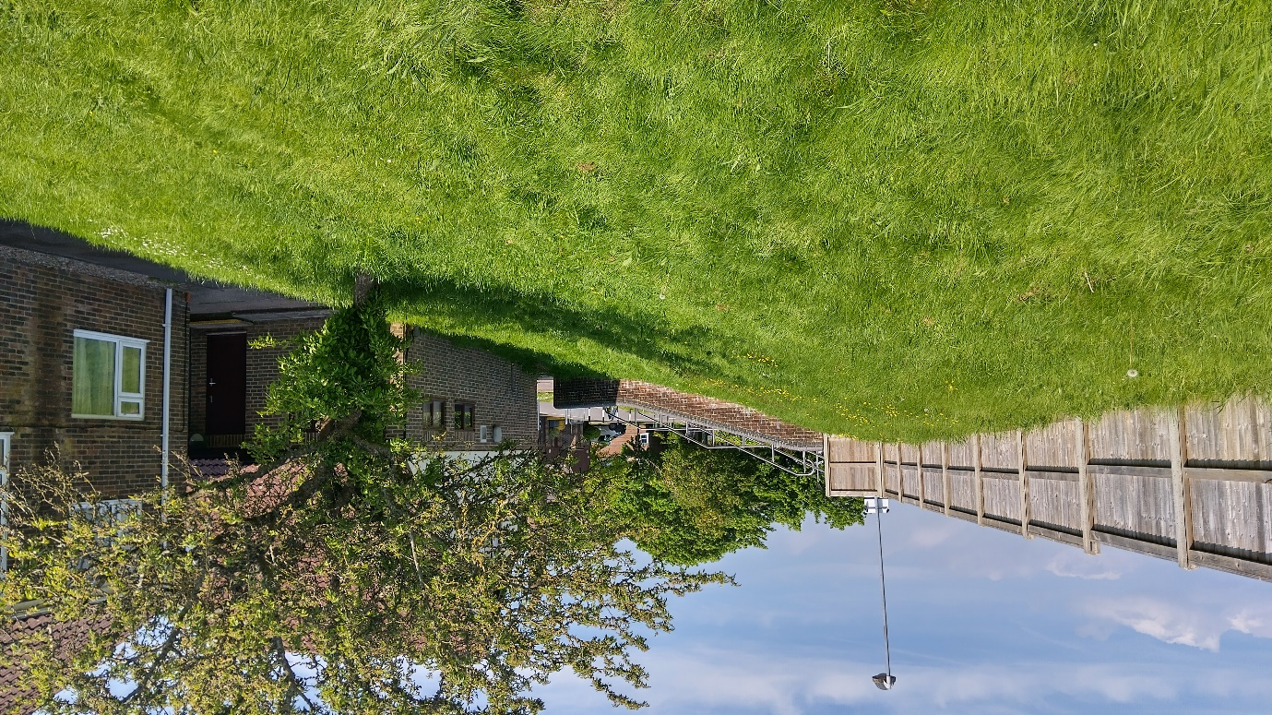

Location 3
