

The Views Play Area, Design and Installation
INTRODUCTION

Fleet Town Council (FTC) invites suitably qualified suppliers to submit design and cost proposals for the redevelopment of The Views Play Area, located in Fleet, Hampshire.

The Council’s vision is to transform the site into a high-quality, safe, inclusive, and engaging play environment for children aged under 8 and 8–12 years. The existing play area currently comprises a mix of grass, concrete, and wet pour surfacing, and the redesign should consider how surfacing can be enhanced to improve accessibility, durability, safety, and overall user experience.

The new design should maximise the opportunities presented by the park’s natural contours to enhance play value, provide appropriate levels of challenge, and create an attractive and usable space for a wide range of abilities.

A key objective of this project is to deliver a genuinely accessible and inclusive play space. The Council is seeking proposals that go beyond minimum compliance standards by incorporating accessible play equipment, inclusive play experiences, and thoughtful layout design to ensure children of all abilities can play alongside one another. Consideration should also be given to pathways connecting the upper and lower levels, surfacing transitions, seating, and social spaces to support parents, carers, and guardians with differing mobility needs.

The Council intends for The Views Play Area to become a central destination playground and community hub within Fleet town centre, a welcoming and vibrant focal point that encourages families to spend time in the area and supports wider town centre activity.

This project will be funded through a Public Works Loan. Shortlisted designs will be subject to public consultation, with the final decision made by the Town Council following consideration of community feedback.


CONDITIONS OF CONTRACT

AGREED TERMS

- INTERPRETATION AND DEFINITIONS
  - Definitions
- Contract Sum: Total payable by the Council to the Contractor as per accepted tender.
- Commencement Date: Start date for services.
- Contractor: As named above.
- Council: Fleet Town Council.
- Authorised Officer: Executive Officer or delegated representative.
- Supervising Officer: Facilities & Open Spaces Manager or delegated representative.
- Contract Manager: Appointed person managing the Contract for the Contractor.
- Services: Design, supply, and installation of The Views Play Area, as described in the tender.
- Site: The Views Play Park, Harlington Way, Fleet, Hampshire GU51 4DH.
  - (What3Words: https://w3w.co/cabs.declines.vertical
- Contract Period: From commencement to completion.
- PWLB means the Public Works Loan Board.

  - Contract Period
This Contract shall commence on the Commencement Date and continue until completion of all Services.

- CONTRACT COMMENCEMENT
  - This contract is dependent on Fleet Town Council securing funding from the Public Works Loan Board (PWLB). If funding is not secured, this contract becomes null and void with no liability to either party.
  - No works may commence, nor contract be considered active, until written confirmation of funding is provided.
  - The price Submitted by the Contractor shall be valid for a minimum of 6 months.

- PAYMENT
  - 30% of contract value when all play equipment delivered to site.
  - 60% on substantial completion of project
  - 10% at the end of the maintenance period.

- COMPLETION AND WARRANTIES
  - Completion Requirements
Upon completion, the Contractor shall provide:
- Final inspection and certification
- Maintenance and inspection manual
- As-built drawings
- Warranty documentation
  - Defects Period
The Contractor shall provide a minimum 12-month defects liability period from the date of completion.

- TERMINATION
This contract may be terminated by:
  - Contractor breach of contract or insolvency
  - Mutual agreement of both parties

- GENERAL
This contract is governed by English law and subject to the jurisdiction of English courts.

This agreement is dated _______________

PARTIES
(1) FLEET TOWN COUNCIL, The Harlington, 236 Fleet Road, Fleet, Hampshire GU51 4BY ("Council").

(2) __________________________________ ("Contractor").

EXECUTED AS A DEED by
FLEET TOWN COUNCIL
acting by:
Councillor 1
Signature: __________________________
Councillor 2
Signature: __________________________
In the presence of:
Executive Officer
Signature: __________________________
Date: __________________________

EXECUTED AS A DEED by
(Contractor Name)
acting by:
Director
Signature: __________________________
In the presence of:
Witness Signature: __________________________
Name of Witness (in block capitals): __________________________
Address of Witness:
Occupation of Witness: __________________________
Date: __________________________

SPECIFICATION

- Project Location

Location Map can be found in Plan 1.
- What3Words: https://w3w.co/cabs.declines.vertical
- Postcode: GU51 4DH
- Address: Harlington Way, Fleet, Hampshire
- Scope of Works

Tenders must include:
  - Complete design and layout plans
  - Removal and responsible disposal of existing equipment, surfacing & spoils.
  - Supply and delivery of all new Play Equipment, Benches & Picnic Benches.
  - All groundworks, including foundation preparation and safety surfacing
  - Installation of gates and secure fencing (if applicable) & replacement of existing gates.
  - Provision and installation of safety signage
  - Post-installation inspection and certification
  - Site reinstatement for any affected areas outside the play footprint
  - Optional maintenance contract or post-build technical support

- Design Requirements

  - Multi-discipline suitability: Equipment for children under 8 and 8–12 years including accessible equipment.
  - Design considerations: to determine appropriate positioning and locations for Accessible Play Equipment.
- Suppliers should consider designs which connect play equipment at the top and bottom of the Play Area.
  - Replacement parts: Must be readily available for future maintenance
  - Safety compliance: Must meet UK safety standards and be CE marked
  - Inclusive design: Accessibility and inclusive features for diverse users
  - Social area: Picnic Benches, Social Seating options.
- There is marginal scope for the footprint of the existing play area to be extended into the main park should Suppliers wish to explore this option. A small section has been identified by the Council which could serve as a possible social seating area. See Plan 2 – highlighted RED.
  - Use of site contours: Make effective use of the park’s natural features
  - Access consideration: Provide an additional gate at the lower part of the park near the cycle path, allowing for a secondary access option.
  - Upper and Lower-level connection pathway.
- The Council has identified a potential location for a suitable pathway. See indicative location highlighted in RED in Plan 3.
  - Year-round use: Must be a useable space in wet weather.
  - Equipment Material Considerations: Longevity is an important factor to the Council.
- Long lasting materials are more favourable over materials such as wood which would split over time.
- Colourful, Vibrant and Attractive materials favoured.

- Design Submission Requirements

  - £200,000 Maximum Contract Value (Exclusive of VAT)
  - Each proposal must include:
- Visual representations (renders or 3D models). Digital and A3 Hard Copies to be provided.
- Scaled layout drawings – Digital and A3 Hard Copies to be provided.
- Written design rationale and description of user experience
- Itemised cost breakdown (equipment, groundwork, installation, signage, etc.)
- Maintenance requirements and warranty periods
- Timeline for delivery (including key milestones)
- Confirmation of post-installation inspection certificate
- Community Accessibility: Designs that clearly show Accessibility & Inclusivity
- Bill of Quantities
  - Final Tender Document Submission to: procurement@fleet-tc.gov.uk

- Insurance & Compliance

Contractors must provide:
- Public Liability Insurance: Minimum £10 million
- Employer’s Liability Insurance: Minimum £5 million
- Documentation Required:
  - Proof of insurance cover
  - Site-specific Health & Safety Plan
  - Risk Assessment & Method Statement (RAMS)
  - Confirmation all equipment is CE marked and compliant
- Additional Considerations

  - Site Visit: Strongly encouraged prior to submission
  - Community Engagement: Final shortlisted designs will be shared for public consultation
  - Contractor Responsibilities: Include fencing of the site, welfare facilities, and site cleanliness
  - Defects and Liability: Minimum 12-month defects period; warranty details to be included
  - Handover Documentation: Include maintenance manual, as-built drawings, and warranties
  - Environmental Impact: Contractors encouraged to use sustainable practices and minimise environmental impact

- Submission Requirements

  - Company profile and relevant experience
  - Proposed timeline and delivery schedule
  - Compliance and insurance documentation
  - Contactable references
  - Added Value: Value engineering alternatives, environmental commitments, or aftercare options
  - Completion of the Pre-Qualification Standard Selection Questionnaire.

- Evaluation & Decision Process

- 95% Method and 5% Price.
Proposals will be evaluated on:
- Section 1. Experience and References
- Section 2. Methodology and Programme
- Section 3. Accessibility & Inclusivity
- Section 4. Quality & Compliance
- Section 5. Maintenance & Longevity
- Section 6. Public preference via consultation - The Council will make the final decision based on consultation results and evaluation criteria.

- Timescales

  - Submission deadline: 12noon – 11th May 2026
  - Public consultation: 18th may – 1st June 2026
  - Final decision: 3rd June 2026

- Contact & Queries

Facilities & Open Spaces Manager
Fleet Town Council
The Harlington
236 Fleet Road
Fleet, Hants
GU51 4BY
Tel: 01252 625246

info@fleet-tc.gov.uk

procurement@fleet-tc.gov.uk

Plan 1
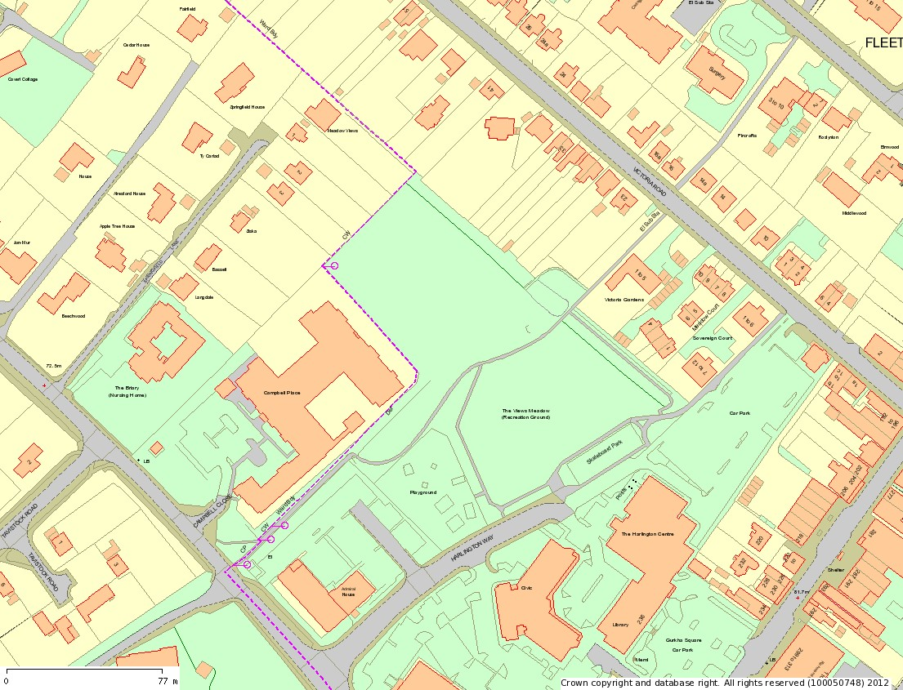

Plan 2

Plan 3

