

REQUEST FOR QUOTATION FOR PHYSIOTHERAPY SERVICES

REFERENCE NUMBER: 3147-2025

TENDERER: ---------------------------------------------------------------------------------
CONTENTS

SECTION ONE: INSTRUCTION TO TENDERERS

SECTION TWO: SPECIFICATION

SECTION THREE: PRICING SCHEDULE

SECTION FOUR: TECHNICAL QUESTIONS

SECTION FIVE: ORGANISATION & CONTACT DETAILS

SECTION SIX: GENERAL TERMS AND CONDITIONS

SECTION SEVEN: CERTIFICATE & DECLARATION

SECTION ONE: INSTRUCTIONS TO TENDERERS

- INSTRUCTIONS

  - Humberside Police (HP) Occupational Health department are seeking quotations from suitably
experienced companies to provide a reliable and successful service for the goods/services
described in Section 2 of this document.

  - The value of this requirement is between £30,000 to £100.000.

  - It is anticipated that the Contract(s) shall be awarded in August 2026.

  - The duration of the contract will be 36 months. HP may extend the contract period by up to 1 x 12 months, however the overall value of the contract will not exceed £100.000.

  - It is essential to observe and comply with the following instructions in the preparation and submission of your quotation. The Police and Crime Commissioner (PCC) reserves the right to reject a quotation that does not fully comply with these instructions.
  - All correspondence including your quotation and clarifications in relation to this RFQ must be submitted through the PCC’s eTendering system please register at: https://sell2.in-tend.co.uk/blpd/home
  - It is the Tenderers responsibility to ensure the appropriate person is selected as the main point of contact on the eTendering system and that their email address is accurate. All correspondence in relation to this RFQ will be sent electronically via the eTendering system to this person. Further instructions on how to use the tender exchange facility are given on the site. If you experience any problems or are unable to comply with this request, please contact the Procurement Representative detailed below.
  - The Terms & Conditions of this document will apply to this agreement.

  - The Person(s) Responsible for this process is Laura Waller. All Contact with the named
individual(s) in relation to this RFQ must be made through the eTendering system.

2.0 REQUESTS FOR CLARIFICATION OR FURTHER INFORMATION

2.1 Tenderers shall note that all reasonable efforts have been made to ensure that accurate and correct technical and functional terminology has been used in the preparation of this quotation document. There is an absolute obligation on the tenderer to resolve any ambiguity, whether actual or potential, in the use of technical and functional terms used in this request for quotation and any, and all associated documents.

2.2 In the event that a tenderer may wish to obtain clarification or further information then please direct your request by 1700 hours on 11/03/2026 via the eTendering system. All clarification questions and answers shall be circulated to all tenderers invited to submit a RFQ, unless they are deemed specific to a tenderers solution.

3.0 RETURN OF QUOTATION AND VALIDITY

3.1 Your quotation must be completed and submitted through the eTendering system. The quotation must be completed in English and in the format requested (i.e. word, pdf, excel etc).

3.2 The closing date for receipt of the completed quotation is 1700 hours on 20/03/2026.

3.3 Quotations received after this time will NOT be considered unless the Person Responsible as identified in 1.9 above has formally extended the closing date for receipt of quotations.

- PRICE SCHEDULE

  - The price schedule shall be submitted as a separate attachment to the quotation response for the goods/services. Please refer to Section Three.

  - The prices or charges as appropriate should be shown net of National “Value Added Tax”.

  - The Currency is to be quoted in Pounds Sterling.

- EVALUATION CRITERIA

5.1 The evaluation panel will consider the factors listed below as part of the evaluation process.

1 | PRICE | 50 %
2 | QUALITY | 50 %

5.2 The above evaluation criteria will be marked in-line with the following scoring guidelines
Score 0 The response does not satisfy the requirement. An unacceptable or irrelevant response. No response provided.
Score 1 A poor response. There are significant gaps in the detail/supporting evidence
Score 3 The response meets most elements of the requirement. There are some gaps in explanation/detail or supporting evidence.
Score 5 Response meets the requirement in full. Response has been fully explained and supported with relevant evidence
5.3 Quality is divided into individual question’s, each scored using the scoring guidelines detailed above based on the evaluation panel’s considered view on their importance to this project and in terms of the organisations requirement as a whole.
5.4 Price will be evaluated on the overall cost for all services as detailed above to establish the cheapest overall cost. The lowest overall cost will be awarded [50%] and all subsequent bids will receive a proportion based on the lowest overall submission.
(Cheapest bid received divided by the bid being evaluated multiplied by %)

- SUB CONTRACT/JOINT VENTURE/PARTNERSHIP

  - The tenderer shall submit with its quotation a list of any major Sub-Contractors it intends to use and of the supply services, that each will provide. The tenderer in the response will identify sole Tenderers or proprietary items.

7.0 RESULTS OF QUOTATION

7.1 The tenderer will be notified of the outcome of their quotation at the earliest possible time available through the eTendering system by the Person Responsible. No useful purpose will be served by communication with the Person Responsible following the quotation submission unless invited to do so.

7.2 Any tenderer who directly or indirectly canvasses any member or officer or representative of the Authority other than the person named at 1.9 above of the instructions for Tenderers, concerning the award of the Contract or any other quotation or proposed quotation may be disqualified. Such decision shall be at the sole discretion of the Person Responsible as identified at 1.9 above.

8.0 QUOTATION COSTS

8.1 There shall be no liability on the Person Responsible as identified at 1.9 above to defray any cost incurred by the tenderer as a result of this procedure.

SECTION TWO
SPECIFICATION FOR THE PURCHASE/PROVISION OF PHYSIOTHERAPY SERVICES

SPECIFICATION

The purpose of this service is to provide timely physiotherapy assessment and treatment for employees experiencing issues, affecting their day-to-day ability at work, with the aim of reducing pain, improving mobility, and supporting return-to-work or full duty outcomes.

Service Requirements

The range of services we require to be delivered are;
- Assessment and treatment of work-related and general musculoskeletal conditions
- Hands-on therapy, including soft-tissue techniques and joint mobilisation
- Exercise rehabilitation tailored to job demands and individual needs
- Posture and movement coaching to reduce strain and improve comfort
- Return-to-work support following injury or sickness absence
- All services to be delivered by a qualified physiotherapist who holds a BSc in physiotherapy, with post qualification experience in musculoskeletal.
Service delivery model.

Services to be provided through one of the below options.

Contractor based offices appointments, accessible for Humberside Police staff, within a 15-mile radius of Humberside Police stations.

Contractor based offices map and table

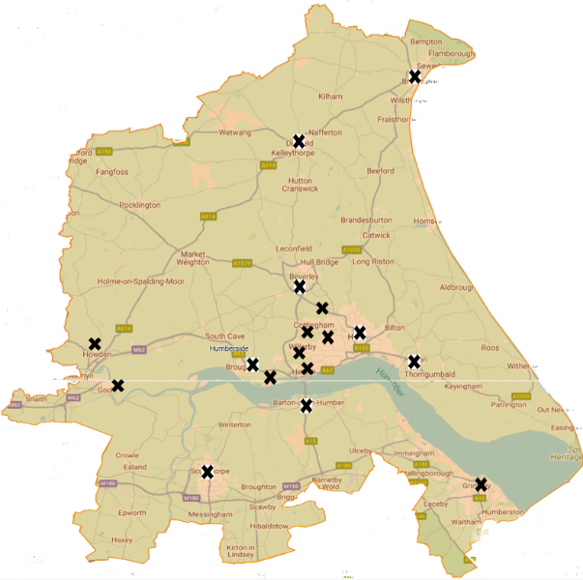

Lot 1 – Melton
Lot 2 – Clough Road
Lot 3 – Hedon
Lot 4 – Beverley
Lot 5 – Bridlington
Lot 6 – Goole
Lot 7 – Epworth
Lot 8 – Scunthorpe
Lot 9 – Brigg
Lot 10 – Grimsby

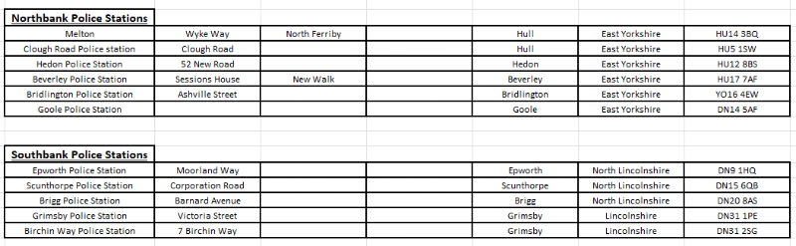

- Following referral to the supplier, the first appointment should be confirmed within 7 calendar days, with an appointment date that is within 14 calendar days from date of referral.

- Initial assessment – This session is to be delivered face to face with the employee. This is to be an explorative assessment of the problem and what treatment is required. Appointment time is expected to be between 30 and 60mins long. Following the initial assessment, the physio is to report back on proposed treatment plan, including number of sessions anticipated.
- Standard number of treatment sessions is up to 5 sessions, following initial assessment (please note the initial assessment is classed as session 1). These sessions are to be made up of the treatment identified in the initial assessment.
- The standard total number of sessions is a block of 6. If upon completing the agreed sessions, the Contractor identifies that additional time over and above the 6 sessions is required for the case, they will communicate with the force no less than 7 (seven) calendar days, following the 6th session.
- Upon completion of the agreed number of sessions, a report will need to be submitted. The force would require from this, information regarding outcome of treatment, success of treatment and if any further interventioin is required.
- Services to be invoiced upon completion of agreed number of sessions.

SECTION THREE
PRICING SCHEDULE (50%)

PRICING SCHEDULE

Tenderers are required to provide a fully detailed breakdown of all costs including all travel and subsistence expenses where applicable for the provision of Physiotherapy Services.

The breakdown of costs should clearly identify any additional costs.

1. Assessment
Service | Duration | Description | Price
Initial Physiotherapy Assessment | 30-60 minutes | Comprehensive assessment, diagnosis, treatment plan, and first treatment session | £
Follow-Up Appointments | 30 minutes | Ongoing treatment and exercise progression | £

Please complete the below table, to show which locations you can cover

Lot Description | Mark with an (X) which area's you are bidding for | Postcode of your office within the 15mile radius
Lot 1 – Melton
Lot 2 – Clough Road
Lot 3 – Hedon
Lot 4 – Beverley
Lot 5 – Bridlington
Lot 6 – Goole
Lot 7 – Epworth
Lot 8 – Scunthorpe
Lot 9 – Brigg
Lot 10 – Grimsby

SECTION FOUR: TECHNICAL QUESTIONS FOR CONTRACTOR BASED APPOINTMENTS

In order to pass this section of the evaluation, valid information relating to the question must be provided. This information must be appropriate and relate to the question/specification requirements. If the information provide is not relevant to the question this may render your submission invalid. Please do not submit any sales and marketing information.

Your statements should be concise, in 11 point font and no more than the 3 single pages of A4 per question, excluding any diagrams. You may expand the text boxes in the template to fit your responses.

Question 1

Describe how you will deliver high‑quality physiotherapy services that meet the needs of the client population.

This question carries a score of 14.29%

Question 2

Provide details of your staffing model, including qualifications, experience, and professional registration. Within your response please provide proof of the qualifications held.

This question carries a score of 21.43%

Question 3

Please describe your organisation’s experience in delivering physiotherapy or musculoskeletal services to blue light organisations or similar. In your response, outline the scope of services provided, the specific needs of the personnel you have supported, any measurable outcomes achieved, and how this experience will inform the delivery of this contract.

This question carries a score of 14.29%

SECTION FIVE : ORGANISATION & CONTACT DETAILS

Organisation and Contact Details
Full name of organisation tendering (or of organisation acting as lead contact where a consortium bid is being submitted)

Organisation Details
Registered office address | Company or charity registration number
 | VAT registration number
 | Name of immediate parent company
 | Name of ultimate parent company
Type of organisation  Please mark ‘X’ in the relevant box to indicate your trading status | i) a public limited company
 | ii) a limited company
 | iii) a limited liability partnership
 | iv) other partnership
 | v) sole trader
 | vi) other (please specify)
Please mark ‘X’ in the relevant boxes to indicate whether any of the following classifications apply to you | i)Voluntary, Community and Social Enterprise (VCSE)
 | ii) Small or Medium Enterprise (SME)
 | iii) Sheltered workshop
 | iv) Public service mutual

SECTION SIX : TERMS AND CONDITIONS

Please find refer to the attached copy of the terms and conditions which govern this quotation exercise and any resulting contract.

SECTION 7: CERTIFICATE & DECLARATION

Certificate and Declaration
I/We hereby certify that the information supplied in this request for quotation and any supporting documents is accurate to the best of my/our knowledge and I/we accept the conditions and undertakings requested in the application. I/we understand that false information could result in my/our exclusion from the Forces future procurement opportunities.
I/We also understand that it is a criminal offence punishable by imprisonment to give or offer any gift or consideration whatsoever, as an inducement or reward, to any servant of a public body, and that any such action will empower the Forces to cancel any contract currently in force, and result in my/our exclusion from the Forces future procurement opportunities.
I/We understand that the Forces, or their agents, will not accept any charges by the Tenderer, its sub-contractors or any other party for:

- Work in responding to this RFQ
- The completion of the Pricing Schedule if required
- Any other associated activity
I/We understand that this RFQ, will not in any way bind the Forces to enter into a Contract with the Bidder (you), or involve the Force in any financial commitment whatsoever in this respect. The Bidder is also advised that the Force does not bind itself to accept any of the submitted documents in whole, or in part.
The parties here to acknowledge and agree that any information requested under the Freedom of Information Act 2000 may be disclosed, provided such disclosure is appropriate and in accordance with the said Act.
I/We hereby apply for consideration in connection with the (Physiotherapy Services) for the Office of the Police and Crime Commissioner (OPCC), and confirm that I am/we are prepared to answer any questions relating to this RFQ Submission, if so required

Signed: |  | Date:
Name (Block Capitals): |  | For, and on behalf of:
Position in Tenderer: |  | Telephone Number:
Email Address:
Full Address:

Before returning this questionnaire, please ensure that you have:
- signed the above undertaking.
If your RFQ is successful, this application will be incorporated in the contract awarded to you.

See EU definition of SME: http://ec.europa.eu/enterprise/policies/sme/facts-figures-analysis/sme-definition/

