

Seaford Town Council
Cleaning Contract Specification

May 14th 2026 – May 14th 2029
(with a possible 2-year extension until 14th May 2031)

Section: | Pages: | Content:
1 | 2 | Introduction
2 | 2 | Contract Term
3 | 3 | Scope of Service
4 | 3-6 | Remit
5 | 6 | Quality Control & Documentation
6 | 7-9 | Standards, Compliance & Safety
7 | 9-10 | Supervision & Management
8 | 10-11 | Tender Submission Requirements
9 | 11-12 | Evaluation Overview
10 | 12 | Conditions of Tendering
11 | 12-13 | Contract Conditions
12 | 13-15 | Evaluation Criteria
Appendices | 16 | Key dates, Task table, KPIs, Maps & Site Pictures

1. Introduction
Seaford Town Council (STC or henceforth ‘the Council’) are seeking a cleaning contractor to deliver a high-quality, reliable cleaning service across its public toilet facilities. These include the eco toilets at South Hill Barn, the facilities at Seaford Head Golf Course and the toilet blocks located at the Martello, The Salts Recreational Ground, South Street and the Changing Places Toilets (CPT). Seaford is a vibrant coastal town in East Sussex, serving a resident population of approximately 23,000 and welcoming a significant number of visitors throughout the year. Maintaining clean, safe, and well-presented public conveniences is an important part of supporting both the local community and the town’s wider visitor economy.

2. Contract Term
- Initial Term: Three (3) years from the Start Date.
- Extension Option: The Council may, at its sole discretion, extend the Contract for a further period of up to two (2) years. Satisfactory performance is a prerequisite for any extension but does not oblige the Council to grant one.
- Performance Criteria for Extension:
  - Compliance with Key Performance Indicators (KPIs)
  - Audit reports
  - Issue resolution records
Performance information will be reviewed monthly.

3. Scope of Service
The contractor shall provide a full toilet and washroom/changing room cleaning service, carried out seven (7) days per week, including all labour, cleaning materials, chemicals, PPE and any other equipment necessary to meet and exceed the required standards. The contractor shall also supply and replenish toilet rolls and hand soap, hand sanitiser and sawdust (site dependant) daily.
The frequency and duration of cleaning required are subject to change, and STC reserves the right to vary the facilities included in the contract upon giving a minimum of four (4) weeks’ written notice.
Contractors are expected to work bank holidays not including Christmas day (364 days p/y).
Please see Appendix B for full details of sites and work required; please note that toilets are expected to be cleaned before they are unlocked for public use.
For more information about Changing Places toilets, please visit their website: Changing Places Toilets and our information here STC-Changing-Places-leaflet.pdf
STC reserves the right to add or remove facilities from the Contract during its term. Where a facility is removed, the Contract Sum shall be reduced in accordance with the corresponding site rate set out in the Pricing Schedule. No additional compensation shall be payable in respect of such reduction.

4. Remit
4.1 Daily Cleaning Duties
Washroom Fixtures & Fittings
All washroom fixtures and fittings shall be cleaned, sanitised, and left in a hygienic condition. This includes:
- Wash basins, including removal of limescale from taps and fittings
- Toilet bowls (W.C. pans), fully cleaned and sanitised
- Toilet seats, cleaned and sanitised on both sides
- Urinals, cleaned externally and sanitised
- Splashbacks and tile surrounds, cleaned and dry buffed
- Bright metals, including taps, pipes, and flushing mechanisms, cleaned and sanitised
- Mirrors, dusted and spot-cleaned
- Hand dryers, cleaned and sanitised, including underneath units, with water marks and dirt removed from surrounding tiles
- Radiators, dusted and sanitised where accessible
- Cobwebs shall be removed from all areas.
Floors
- All hard floor surfaces shall be swept then damp mopped using a suitable disinfectant.
- Floors shall be left free from dirt, dust, chewing gum, staining, and build-up, including around edges and corners.
- Wet floor signs must be displayed at all entrances and exits whilst floors are wet.
Horizontal & Vertical Surfaces (up to 6ft) including Doors & Touch Points
- All horizontal and vertical surfaces up to 6ft shall be fully cleaned and left free from build-up, dirt, dust, fingerprints, smudges, and stains.
- Doors, door surrounds, handles, and all door furniture shall be spot-cleaned and sanitised.
- Finger marks shall be removed from doors and surrounding areas.
Waste & Replenishment
- Consumables, including toilet tissue, blue roll, hand soap, hand sanitiser and sawdust shall be checked daily and replenished as required to ensure adequate supply at all times.
- The Contractor shall empty all waste bins provided by STC (currently at Seaford Head Golf Course only). Bin type and location will be confirmed at mobilisation.
- The introduction of additional bins of a comparable type and reasonable quantity during the Contract period shall not, in itself, constitute a variation to the Contract.
- All waste arising from the delivery of the Services shall be removed from site by the Contractor and disposed of lawfully in accordance with applicable waste legislation. Waste shall not be deposited in public litter bins or other Council waste facilities unless expressly authorised in writing by STC.
- The Contractor shall comply with all applicable duty of care requirements and shall hold and maintain a valid waste carrier licence where required.
- Sanitary, clinical, or hazardous waste encountered in the course of the Services shall be handled and disposed of in accordance with relevant legislation and recognised guidance.
- The Contractor shall notify STC where additional waste capacity appears necessary due to usage levels.
4.2 Weekly Cleaning Duties
- Skirting boards shall be washed using a disinfectant.
- Walls shall be maintained in a clean condition, with marks removed as required.
- W.C. pans shall be deep cleaned weekly to remove scale.
4.3 Monthly and Periodic Cleaning Duties
- Door tops, high ledges and high-level horizontal and vertical surfaces (above 6ft) shall be cleaned at least monthly using appropriate equipment, such as extendable poles.
4.4 Sustainability & Environmental Considerations
Tenderers are encouraged to demonstrate the use of environmentally friendly cleaning products, efficient use of water and chemicals, and waste reduction practices. These measures will be considered positively as part of the evaluation of tender submissions, but compliance with mandatory cleaning standards and health and safety requirements remains the primary obligation.
4.5 Locking, Unlocking and Key Management
The contractor shall be responsible for locking and unlocking the toilets, detailed as per Appendix B, seven (7) days per week. These hours may be subject to change with four (4) weeks’ written notice from STC. In exceptional circumstances, STC reserves the right to vary opening hours at shorter notice.
The contractor shall also be responsible for all keyholding and site security arrangements, ensuring that:
• All keys are kept secure at all times
• Keys are not labelled in a manner that identifies the sites they access
• Providing replacement keys lost or damaged at the contractor’s expense
• Immediate notification to the Council of any lost or compromised keys
• Ensuring staff who leave employment do not retain keys
When locking or unlocking sites, the contractor shall:
- Report defects, damage, or signs of unauthorised entry as soon as it’s discovered
- Cooperate fully with any investigations
- Remain aware of surroundings and personal safety at all times
- Carry out all lone working and keyholding activities in accordance with the contractor’s Health and Safety policies, lone working procedures, and the requirements set out in Section 6.

5. Quality Control & Documentation
The Contractor shall be responsible for managing and completing the Services to a consistently high standard in accordance with this Contract.
This shall include the implementation and use of site-specific cleaning schedules and checklists, which shall be maintained onsite and completed daily to evidence that all duties have been carried out and that service standards are being monitored.
The Contractor shall ensure that all consumables (including, but not limited to, soap, toilet paper, and paper towels where applicable) are adequately stocked at all times. Applicants able to supply and install replacement dispensers where required may be preferred.
The Contractor shall notify STC without delay where access to any site is restricted due to severe weather, vandalism, or other unforeseen circumstances and shall cooperate fully with STC to agree appropriate alternative arrangements.
5.1 Cross-Contamination Control
The contractor shall operate a colour-coded cleaning equipment system to prevent cross-contamination between toilet pans, urinals, and other washroom surfaces.
The system shall align with recognised UK best practice (including NHS cleaning standards or BICSc guidance) and shall be supported by appropriate staff training and site-specific cleaning schedules.
Cleaning equipment shall be maintained in a hygienic condition and replaced as necessary.
5.2 Record Retention, Audit & Corrective Action
Any damage, defects, vandalism, safeguarding concerns, or health and safety issues identified during the provision of the Services shall be reported to STC promptly and, in any event, no later than the same working day.
STC reserves the right to request copies of completed cleaning schedules, inspection records, and related documentation at any time, including any additional records retained outside of the Civic.ly app. The Contractor shall retain all such records for a minimum period of three (3) months and shall make them available to STC upon request for auditing, monitoring, or compliance purposes.
Where any deficiencies in performance are identified, the Contractor shall take prompt corrective action at no additional cost to STC.
5.3 Digital Reporting Systems
Checklists and evidence of work completed should be completed and photographs uploaded to the Civic.ly app which the Town Council will provide access to. The Contractor may choose keep additional records.
Any damage, defects, vandalism, or health and safety concerns identified during cleaning shall be reported to STC promptly through the Civic.ly app (if not urgent), or via Civic.ly and by phone call for issues that cause immediate health and safety concerns.
5.4 Complaints Procedure
The Contractor shall maintain a clear and documented procedure for responding to complaints raised by STC or members of the public.
All complaints notified by STC shall be acknowledged and responded to in accordance with the timescales set out in Appendix B.

6. Standards, Compliance and Safety
The contractor shall comply with all relevant legislation, regulations, and standards in the provision of cleaning services. This includes, but is not limited to:
- Health and Safety at Work etc. Act 1974
- Management of Health and Safety at Work Regulations 1999
- Control of Substances Hazardous to Health (COSHH) Regulations 2002
- Reporting of Injuries, Diseases and Dangerous Occurrences Regulations (RIDDOR) 2013
- Provision and Use of Work Equipment Regulations (PUWER) 1998
- Personal Protective Equipment at Work Regulations 1992
- Equality Act 2010
- Environmental Protection Act 1990 and Waste (England and Wales) Regulations 2011
- Relevant British Standards and Codes of Practice
- Seaford Town Council and Lewes District Council policies, where applicable
The contractor shall ensure that all staff engaged in the contract are appropriately trained, competent, and supervised. This shall include:
- Health & Safety training, including awareness of workplace risks (such as lone working) and safe systems of work
- COSHH training relevant to all substances and chemicals used
- Safe use of cleaning equipment and provision of suitable personal protective equipment (PPE)
- Safeguarding awareness appropriate to staff working in public areas
- Professional conduct at all times while on duty, including wearing full, recognisable branded uniform and required PPE correctly at all times while on site, and displaying name badges where appropriate. Uniform must be worn appropriately and not altered or removed whilst undertaking duties. Staff must be respectful and courteous to members of the public, staff, and councillors, and must be mindful that they are representing STC. Unacceptable behaviour includes, but is not limited to, swearing, aggressive behaviour (verbal or physical), or the use of language or conduct that may be considered offensive or discriminatory toward any protected group or characteristic.
- Staff shall be trained to clean accessible toilets and changing facilities with appropriate sensitivity and awareness of equality and accessibility considerations. This shall include an understanding of the purpose and correct positioning of accessibility features (such as emergency pull cords, grab rails, alarms, and specialist fittings). Emergency pull cords must never be tied up, shortened, or otherwise rendered inaccessible, and shall be left fully extended and reachable at all times following cleaning.

The contractor shall provide to Seaford Town Council, upon request:
- A current Health & Safety Policy
- Risk Assessments and Method Statements
- COSHH assessments and Safety Data Sheets
- Staff training and competency records
- Evidence of safeguarding awareness and procedures
- Copies of relevant insurance certificates, including Public Liability Insurance
6.1 Cleaning Products and COSHH Compliance
All cleaning products, disinfectants, and chemicals used under the contract shall be suitable for use in public toilet environments and used in accordance with manufacturers’ instructions and the Control of Substances Hazardous to Health (COSHH) Regulations.
The contractor shall ensure that up-to-date COSHH assessments and Safety Data Sheets (SDS) are in place for all substances used, and that staff are trained in their safe use and provided with suitable PPE.
Chemicals shall be stored, handled, and disposed of safely so as not to endanger staff, members of the public, or the environment.
The use of bleach or other strong disinfectants shall be supported by suitable COSHH assessments and safe systems of work, and incompatible chemicals shall not be mixed.
STC reserves the right to request details of all products used and to require the removal or replacement of any product deemed unsuitable or non-compliant.
6.2 Blood and Bodily Fluid Contamination
The contractor shall have a documented procedure for the safe cleaning and disinfection of blood, bodily fluids, and other potentially infectious materials.
Procedures shall comply with COSHH Regulations and recognised guidance from the Health and Safety Executive (HSE) and UK public health bodies, and shall include appropriate disinfectants, equipment, PPE, staff training, and safe waste disposal.
Any incidents involving blood or bodily fluid contamination shall be dealt with promptly to minimise risk to staff and the public.
Where sharps (including needles or other items capable of causing puncture wounds) are encountered, the contractor shall not attempt to handle them unless appropriately trained and equipped to do so. The contractor shall have a documented procedure for the safe management and disposal of sharps, in accordance with HSE guidance, including the use of approved sharps containers and suitable PPE. Any sharps found shall be reported to STC promptly and made safe as a priority to minimise risk to staff and the public.
6.3 Data Protection
The contractor shall comply with all applicable data protection legislation, including the UK General Data Protection Regulation (UK GDPR) and Data Protection Act 2018, in relation to any personal data processed under this contract.

7. Supervision & Management
Prior to the commencement of the contract, the successful tenderer shall attend a mobilisation meeting with Seaford Town Council to confirm service arrangements, cleaning schedules, site-specific requirements, reporting procedures, clarification on compliance with above policies and lines of communication.
Following contract commencement, the contractor shall attend management review meetings with STC every month for the first six (6) months of the contract, or sooner if needed, to review performance, address any issues, and agree any necessary improvements or adjustments to the service.
Additionally, an STC officer will hold meetings every other week with the contractor throughout the duration of the contract.
The contractor shall ensure continuity of service at all times, including provision of suitable cover in the event of staff absence, sickness, or leave. Failure to provide agreed service levels due to staffing shortages will not be considered an acceptable excuse for non-performance.
Monthly inspections shall be carried out by the Contractor’s Area Manager/Site Supervisor.
Contractor’s Area Manager/Site Supervisor’s responsibilities include:
• Acting as the main point of contact
• Liaison between onsite cleaners, contractor management and STC staff
• Inspection and control of cleaning standards
• Allocation and oversight of work schedules

8. Tender Submission Requirements
Method Statement Requirements
In the Application Form, please answer the following: |  | Weight (%)
1 | Service Delivery: Describe how you will deliver the daily, weekly, monthly, and periodic cleaning services in accordance with this Specification, including staffing levels, shift arrangements, and contingency cover. | 35
2 | Quality Control: Explain how cleaning standards will be monitored, recorded, and maintained, including use of checklists, inspections, and corrective actions, and what system would be used to do so. | 25
3 | Supervision & Management: Describe your proposed supervision and management structure for this contract, including site supervision and escalation arrangements. | 15
4 | Health & Safety & COSHH: Describe how you will manage health and safety risks, including COSHH compliance, staff training, and safe systems of work. | 15
5 | Mobilisation: Explain how you will mobilise the contract, including pre-start meetings, site familiarisation, staff induction, and readiness to commence services by the contract start date. | 5
6 | Environmental Practices: Describe any environmentally responsible practices you will apply when delivering the service. | 5

8.1 Administrative Requirements
Tenderers must provide a complete submission addressing all requirements outlined in this specification. Submissions must include:
- Completed Application Form – fully completed and signed where required.
- Pricing Schedule – fully itemised pricing in accordance with the format provided by the Council.
- Payment Terms – contractors shall propose in the application form how STC will invoice, payment schedule, and procedures for disputed or unsatisfactory work.
- References – at least two relevant references demonstrating prior experience of delivering similar cleaning contracts or business contracts held.
- Conflict of Interest declaration – fully completed and signed (in application pack).
All submissions must be complete and submitted by the stated deadline. Incomplete or late submissions may not be considered.

9. Evaluation Criteria
Tenders will be evaluated against the following criteria:
- Experience & Capability - demonstrated track record in cleaning services, staff competence, and ability to deliver services at the required standard.
- Cleaning Methodology & Quality Control - clarity, feasibility, and robustness of proposed cleaning methods, schedules, and quality control measures.
- Price & Value for Money - competitiveness of the pricing structure, transparency, and cost-effectiveness.
- Sustainability - use of environmentally friendly cleaning products, efficient use of water and chemicals, and waste reduction practices (as encouraged in the Sustainability & Environmental Considerations section).
- Health & Safety - compliance with Health & Safety legislation, COSHH, staff training, PPE, and safeguarding measures.
The Council may give higher weighting to submissions demonstrating innovation, added value, or additional benefits beyond the minimum requirements.
Detailed evaluation methodology is set out in Section 12.

10. Conditions of Tendering
- The Council is not obliged to accept the lowest or any tender.
- The Council may seek clarification or additional information from tenderers at any stage of the evaluation process.
- Late submissions will not be accepted.
- Tenderers shall ensure that all information provided is accurate and complete. Any misleading or false information may result in disqualification.
- Submission of a tender constitutes acceptance of all terms and conditions of the tender process.
- Tenderers are responsible for ensuring that their prices fully reflect the requirements of this Specification and the conditions at each site. Failure to undertake a site visit will not be accepted as grounds for additional payment or contract variation.

11. Contract Conditions
The successful tenderer will enter into a formal service contract with Seaford Town Council, which will include, but is not limited to:
- Key Performance Indicators (KPIs) – Appendix D provides guidance and examples of the expected standards and is not intended to be exhaustive. Issues will be considered in context and categorised appropriately, applying common sense and reasonable judgement. Failure to meet the required standards or frequencies may constitute a breach of contract and result in corrective action or penalties.
- Monitoring Arrangements – reporting, inspections, and submission of cleaning checklists for audit purposes.
- Termination Provisions – rights of the Council to terminate the contract for breach, non-performance, or other reasonable causes.
- Health, Safety & Compliance Obligations – adherence to all statutory requirements including Health & Safety at Work etc. Act 1974, COSHH Regulations, safeguarding requirements, and any Council policies.
- Environmental Considerations – the contractor shall endeavour to use environmentally friendly products, reduce waste, and use resources efficiently where possible.
- Subcontracting – the successful contractor shall not subcontract, assign, or delegate any part of the services awarded under this contract without the prior written consent of Seaford Town Council. Any attempt to subcontract work without approval may be treated as a breach of contract and may result in termination. All services shall be carried out directly by the contractor unless prior written consent is obtained from STC. Any unapproved subcontracting will constitute a breach of contract.
- Where cleaning standards are not met, the contractor shall carry out all corrective or repeat cleaning at no additional cost to the Council.
- The successful tenderer shall allow for a mobilisation period, including site familiarisation, staff induction, and handover arrangements. Services must commence by the agreed start date without disruption to toilet availability.
- Travel expenses are not included unless explicitly stated and itemised within the tender submission and deemed cost-effective by the Council.

12. Evaluation Methodology
Tenders will be evaluated on the basis on 40% price (based pricing schedule), 60% quality (based on section 8 responses), taking into account responses and compliance with the requirements set out in this Specification. The Council is not obliged to accept the lowest or any tender.
Only submissions that are complete and compliant with the Tender Submission Requirements (see Section 8) will be evaluated.
12.1 Scoring Methodology
Each quality criterion will be scored on a scale of 0 to 5, in accordance with the descriptors below. Scores will be multiplied by the applicable weighting to determine the total score.
Score Descriptor
0 | No response provided, or response wholly fails to meet the requirement.
1 | Very poor response. Fails to demonstrate understanding of the requirement and/or provides insufficient detail. Significant concerns regarding ability to deliver.
2 | Poor response. Partially addresses the requirement but lacks clarity, detail, or credibility. Material weaknesses identified.
3 | Acceptable response. Meets the minimum requirements with adequate detail and demonstrates a basic understanding of the service requirements.
4 | Good response. Clearly meets the requirements, with relevant detail, sound methodology, and evidence of capability. No significant weaknesses identified.
5 | Excellent response. Fully meets and exceeds the requirements, demonstrating a thorough understanding, robust methodology, and added value or innovation.

Example bidder scores:
Each section will be scored between 0-5, the score will be multiplied by the weighting % to produce a number. All of those numbers will be added up together, then divided by 500 (the maximum possible score), then multiplied by 100 to get an overall %. This is an example calculation:
- Service Delivery: 4 (score) × 30 (%) = 120
- Quality Control: 5 x 20 = 100
- Supervision & Management: 3 x 10 = 30
- Mobilisation: 4 x 10 = 40
- Health & Safety: 5 x 10 = 50
- Service Resilience: 2 x 7 = 14
- Environmental Practices: 5 x 3 = 15
Total weighted score = 369
To get a percentage out of 100, divide by the maximum possible weighted score:
- Maximum possible score = (5×30) + (5×20) + (5x10) + (5×10) + (5×10) + (5x7) + (5x3) = 450
Now calculate percentage:
- Score = 369 ÷ 450 × 100 = 82%
Therefore, this bidder would score 82/100.
12.2 Price Evaluation
Price will be assessed separately and scored on a comparative basis against all compliant submissions. The lowest compliant price will receive the maximum score for this criterion, with other prices scored proportionately.
The Council will assess whether pricing represents value for money, taking into account transparency, completeness, and alignment with the service requirements.
12.3 Council Clarification Questions
The Council reserves the right to:
- Seek written clarification of any aspect of a tender submission.
- Verify information provided by tenderers.
- The Council is not obliged to accept the lowest or any tender.
12.4 Contractor Clarification Questions
- Any clarification questions must be submitted in writing to projectsandfacilities@seafordtowncouncil.gov.uk no later than 16th March.
- Responses to clarification questions will be uploaded publicly to Seaford Town Council’s website (www.seafordtowncouncil.gov.uk/contracts-and-tenders) to ensure fairness.
- Verbal enquiries will not be accepted.

Appendix A: Key Dates and Contact Information
Deadline to ask questions: | 16th March 2026
Application deadline: | 21st March 2026
Bidders notified by: | 13th April 2026
Mobilisation meeting: | 14th April 2026
Contract start date: | 14th May 2026
Application pack website: | Contracts and Tenders
Submit questions to: | projectsandfacilities@seafordtowncouncil.gov.uk
Submit application to: | tenders@seafordtowncouncil.gov.uk
Submission requirements: | - Completed & signed application form  - A copy of your Health & Safety policies  - A copy of your Equality, Diversity and Inclusion policies  - All required certificates of insurance including Public Liability  - Dynamic and/or task based risk assessments for all activities  - Copies of COSHH assessments for substances used  - Emergency response procedures

Appendix B: Scope of Services
Location | Female | Male | Accessibility | Extras | Frequency | Duration  (proposed) | Locking Requirements
South Street Toilets (BN25 1HG) | 2 cubicles | 1 cubical  1 urinal | No | No | Sep-Mar: 1 per day  April-Aug: 2 per day | 30 minutes | Yes  Sep-Mar: 8am-6pm  April-Aug: 8am-8pm
The Salts Recreational Grounds (BN25 1DR) | 4 cubicles | 2 cubical  1 urinal | 1 | No | Sep-Mar: 1 per day  April-Aug: 2 per day | 30 minutes | Yes  Sep-Mar: 8am-6pm  April-Aug: 8am-8pm
Martello Toilets (BN25 1JH) | 5 gender neutral cubicles |  | 2 | No | Sep-Mar: 2 per day  April-Aug: 3 per day | 1 hour | Yes  Sep-Mar: 8am-6pm  April-Aug: 8am-8pm
South Hill Barn Eco Toilets (BN25 4JQ)  Please note: no water or electricity is at this site. | 4 gender neutral cubicles |  | 2 | No | Sep-Mar: 1 per day  April-Aug: 2 per day | 30 minutes | Yes (unlocking only)  Sep-Mar: 9:30am  April-Aug: 9am
Seaford Head Golf Course Toilets, Changing Rooms & Locker Room (BN25 4JS) | 3 cubicles  2 shower units  1 changing area | 2 cubical  3 urinal  1 shower unit  1 changing area |  | 1 locker room | Toilet cubicles – 1 per day  Locker & shower rooms – 1 per week | 1+ hour | No
Changing Places Toilet (BN25 1JH) | 1 gender neutral |  |  | All available equipment detailed here: STC-Changing-Places-leaflet.pdf | Daily spot check and cleaned as per Appendix A |  | No

Appendix C: Cleaning Frequency Table
All frequencies represent minimum service levels. The contractor shall carry out additional cleaning where necessary to maintain the required levels of cleanliness, hygiene, and presentation.

Cleaning Item | Description of Task | Frequency (site dependant, see section 3)
WCs, Urinals & Handwash Units | Clean, sanitise and dry all fixtures and fittings. | Daily
Metalwork & Mirrors | Clean and polish taps, pipes, flushing mechanisms and mirrors. | Daily
Floors (internal) | All hard floor surfaces shall be swept then damp mopped using a suitable disinfectant. | Daily
Horizontal & Vertical Surfaces (up to 6ft) | Fully clean and free from build-up, dirt, dust, fingerprints and stains. | Daily
Waste Bins | Empty and clean internally and externally if soiled; replace liners. | Daily
Surfaces | Skirting boards shall be washed using disinfectant and walls shall be maintained in a clean condition. Remove all cobwebs. | Weekly
Toilets | W.C. pans shall be deep cleaned weekly to remove scale. | Weekly
High surfaces | Door tops, high ledges and high-level horizontal and vertical surfaces (above 6ft). | Monthly

Appendix D: Key Performance Indicators Examples:
Breach / Issue | Severity | Corrective Action | Rectification Time
Delayed locking/unlocking of facilities during agreed opening hours without authorisation | A | Immediate meeting scheduled, contingency plan in place to avoid repeat occurrences | Within 30 minutes
Failure to clean bodily fluids (e.g. vomit, blood, faeces) posing an immediate health risk | A | Immediate meeting scheduled; review contractor management, staffing and training | Within 30 minutes
Discovery of sharps (needles, broken glass) inside the contracted areas | A | Immediate meeting scheduled; review contractor management, staffing and training | Within 30 minutes
Inadequate cleaning resulting in unsanitary and unhygienic condition following scheduled cleaning (refer to daily/weekly duties – site dependant) | A | Immediate re-clean to contracted specification, meeting arranged if STC feel necessary | Within 30 minutes
Cleaning checklists/schedules incomplete or not submitted | B | Complete checklists to be submitted and contingency plan arranged to avoid repeating | Within 24 hours
Staff not wearing approved uniform or identification while on site | B | Contractor to remind all staff of uniform and ID policy, STC to monitor compliance | Within 24 hours

Severity Rating Explained
Categorisation of Issues
- Category A (Critical Issue): Immediate risk to public safety, security, or significant environmental harm.
- Category B (Major Issue): Significant service failure with no immediate public safety risk.
Rectification Timescales
- Category A (Critical): Made safe immediately (within 30 minutes) and fully resolved within 24 hours.
- Category B (Major): Rectified within 24 hours.
Escalation Process
- First occurrence: Written notice and agreed corrective action plan.
- Second occurrence (same issue within 6 months): Service credit applied.
- Third occurrence: Formal warning, service credit applied, and potential breach notice.
Corrective action must include both immediate remediation and any necessary follow-up (e.g. inspection or retraining).
Failure to Comply
Failure to meet rectification timescales may result in:
- Financial deductions in accordance with the contract
- Withholding of payment
- Early termination of contract for repeated breaches
Service Credits Procedure
- Category A (Critical): Any single unresolved issue beyond the rectification timescale triggers a service credit.
- Category B (Major): Two or more occurrences of the same issue within a 12-month period trigger a service credit.
- Service credits will be calculated in accordance with the Pricing Schedule for the affected work.
Repeat Breaches and Further Escalation
Where breaches persist or corrective actions are not completed within the specified timescales, STC may escalate the matter. This may include:
- Formal notice or written warning outlining the breach and required actions
- Increased monitoring and/or inspections
- Financial or contractual penalties as set out in the contract specification
- Contract review or termination in accordance with contractual terms

Appendix E: Toilet Location Map
Please see the map below detailing STC’s toilets for this contract:
https://www.google.com/maps/d/u/0/edit?mid=1wVuoddjQK8E09DOCAf9s5OF8NYMpGvI&usp=sharing

Appendix F: Site Pictures (Seaford Golf Club)
All toilets in this tender are public (except Seaford Head Golf Course) and can be viewed by potential bidders during the day.
Pictures of Seaford Head Golf Course facilities included in this contract below:

Ladies W/C:
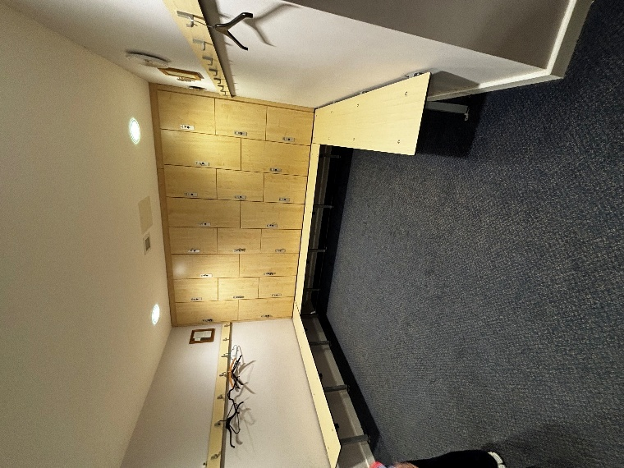
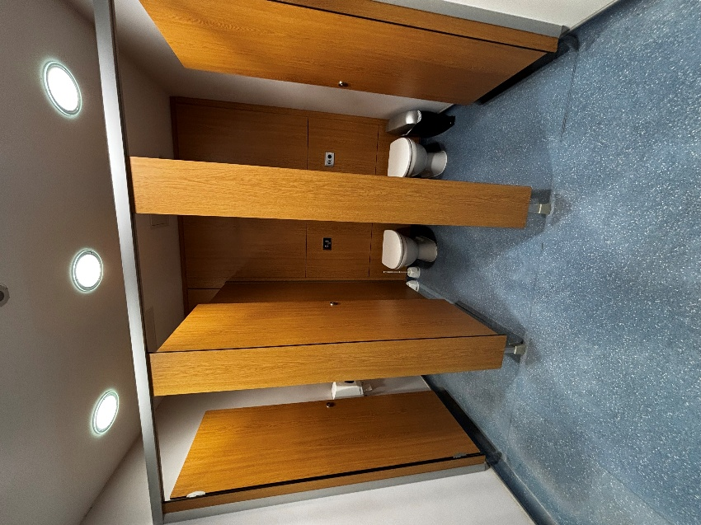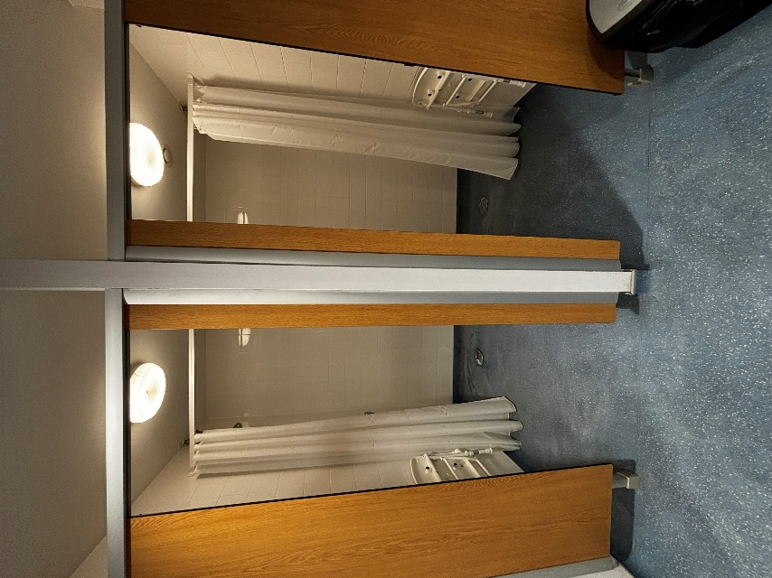

Gents W/C:
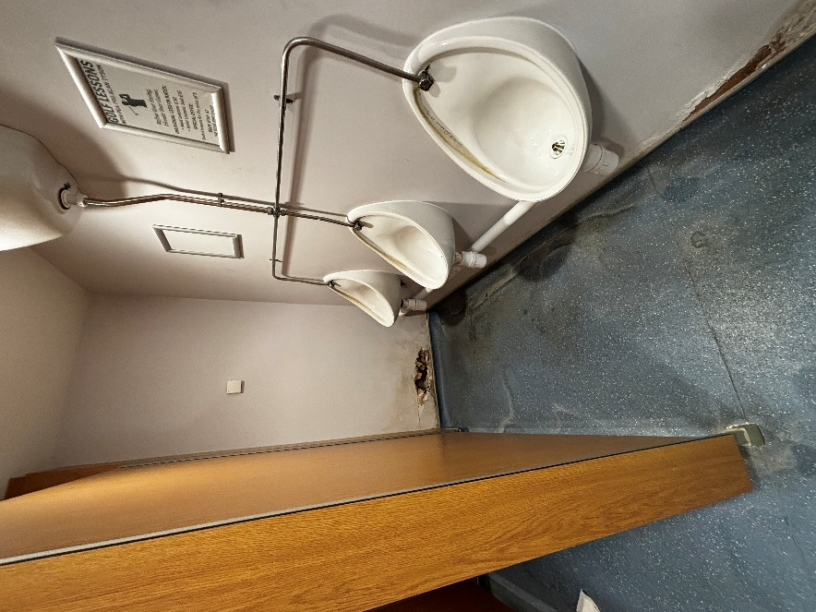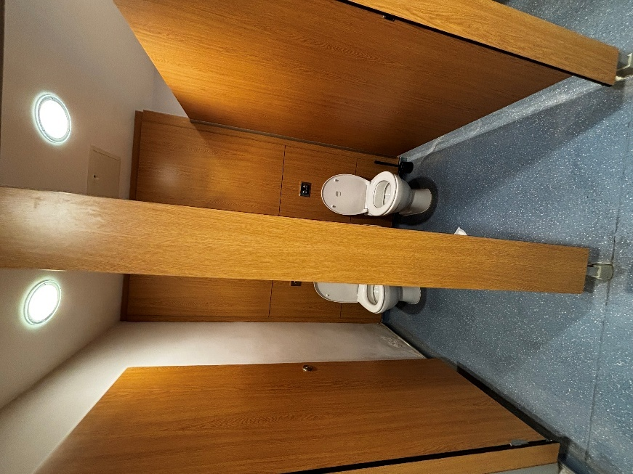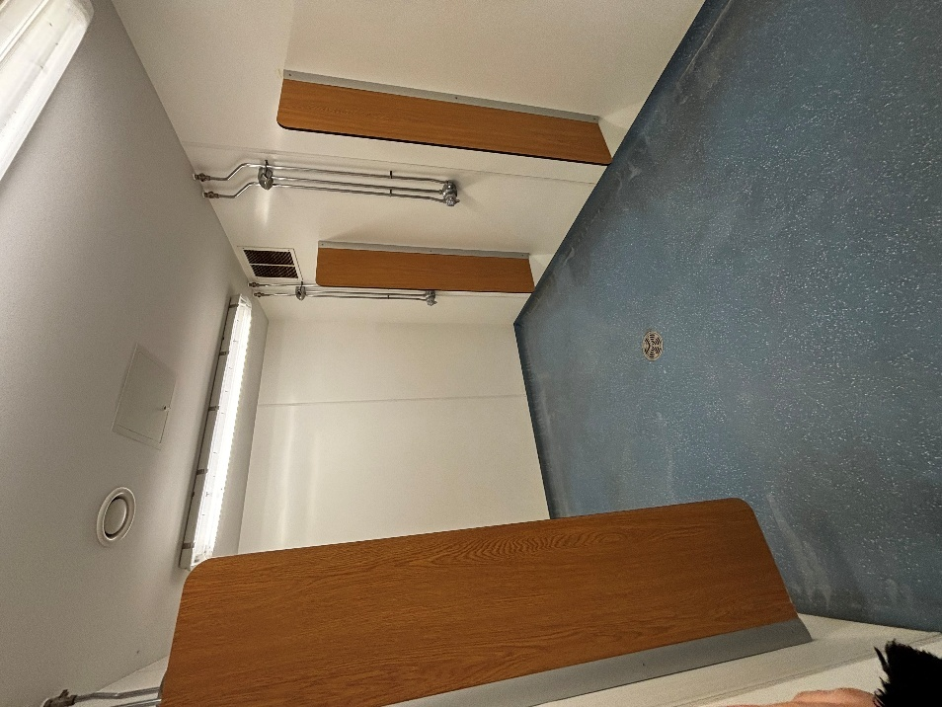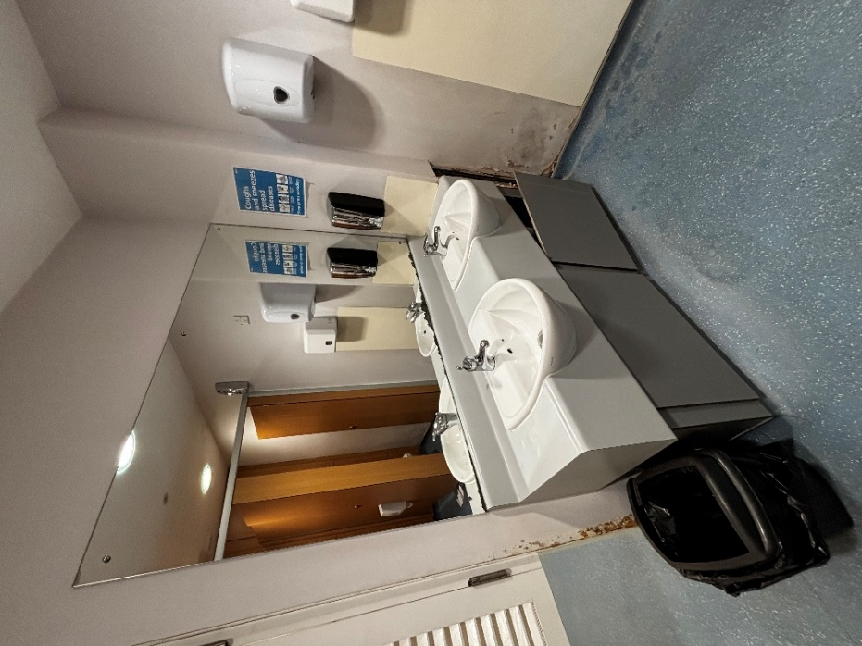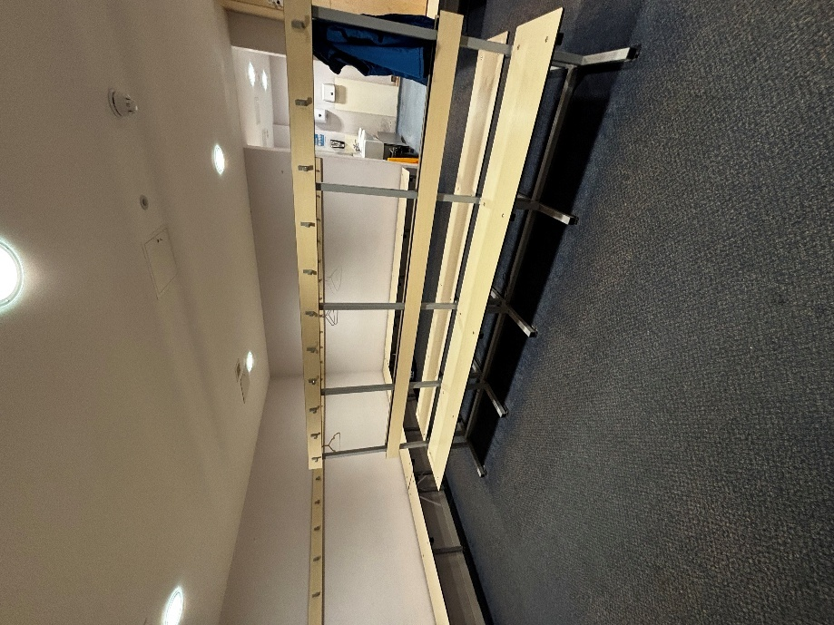

Locker Room:
