Clewer Green First School – Cold Water services upgrade.
Project Outline
Upgrading the existing water services to comply with all legislation and omit present legionella issues. Remove the inaccessible cold water storage takes. Put the cold-water feeds on mains supply. Renew the ceiling, lights and flooring after gaining access to remove the old tanks

The existing water service installations related to the original parts of the Victorian school building are in poor condition, they are life expired. There are issues with Legionella compliance which cannot be readily resolved due to the health and safety implications with both inspecting, maintaining and servicing the water storages installations as demonstrates in photos below.
The Main Cold-Water services require replacing as the existing water services installations and cold-water storage provisions provided are life expired and do not meet current compliance and regulations in respect to Legionella control and management.

Project Requirements
Description | Cost £
- Disconnection of existing F&E and main storage tanks, stripping out and removal of the associated redundant pipework etc.

- Upgrading and replacement of incoming water supply from meter to water intake position C/W new main stopcock.

- Upgrading of distribution pipework complete with insulation of services ( approx. 60 no CWS connections)

- Replacement of life expired and non-compliant local electrical water heaters (11 no)

- Builders work related to replacement of existing classroom ceilings.

- Replacement of classroom flooring
- Contingency
- Prelims

Photographic Records
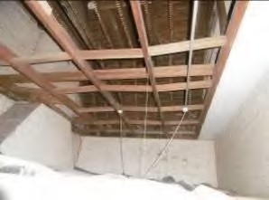 | 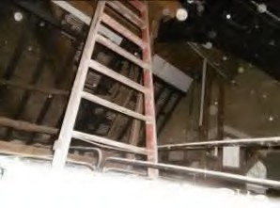
Access up to water tank through suspended ceiling | Access up to water tank through suspended ceiling and up timber ladder
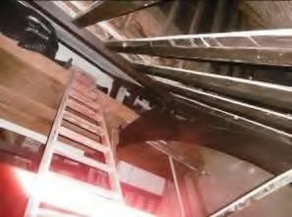 | 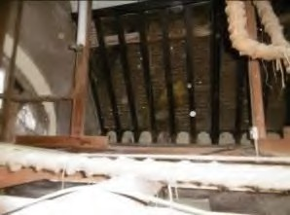
Access up to water tank through suspended ceiling and up timber ladder | Access up to water tank through suspended ceiling and up timber ladder
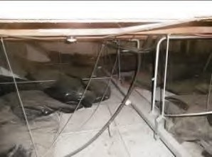 | 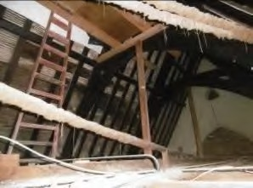
Access up to water tank through suspended ceiling and up timber ladder, plus lack of  insulation above suspended ceiling tiles | Access up to water tank through suspended ceiling and up timber ladder

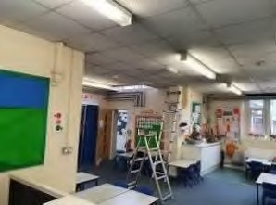 | 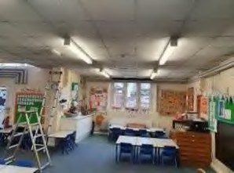
Classroom area ceiling photo 1 to demonstrate the ceiling condition above which is located the Water services storage  Tanks. | Classroom area ceiling photo 2 to demonstrate the ceiling condition above which is located the Water services storage Tanks.
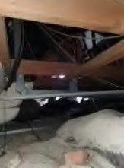 | 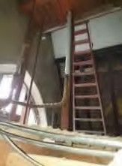
Example of existing ceiling suspension  method and degree of insulation apparent ion the area accessed. equipment room. | Access provisions to the high-level storage  tanks and extent of pipework insulation on the rising services.
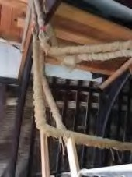 | 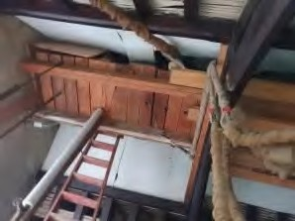
Extent of cold water down service pipework insulation and isolation, together with a typical example of the exiting roof void construction | Water services tanks support arrangements and local supplementary insulation provisions which offer little to deal with the ambient temperatures which would be experienced in  the roof void

