Scope

Description
Tenders are invited for the management of the public toilets for the period 1st April 2026 to the 31st of March 2029. Tenders are invited for both Option 1 and Option 2.
Opening times
The public toilets are open daily, every day of the year including all bank holidays.
Toilets all have time locks and are set to open at 08:00 and close at 20:00.
Option 1 April 1st to March 31st. (Excluding Christmas Day and Boxing Day)
Daily: Full clean of four toilet sites in Chippenham, (cleaned as required, consumables topped up, bins emptied as required, sharps boxes replaced as required), daily health & safety checking.
Daily: Complete daily attendance sheets (to be returned to Chippenham Town Council Monthly). H&S checks to ensure no hazards exist to staff or members of public.
Scheduled Maintenance and servicing
The access control and timed access controls to be serviced and maintained at all times.
Reactive Maintenance/Repairs
Minor repairs within Contractor capability shall be completed within 24 hours of identification.
Defects outside Contractor capability must be reported to the Council within 2 hours.
An hourly rate for reactive maintenance must be submitted and shall remain fixed for the duration of the Contract (subject to RPI adjustment only).

Option 2 April 1st to March 31st. (Excluding Christmas Day and Boxing Day)
Daily: Full clean of four toilets in Chippenham, twice a day, one visit AM and then one visit PM (with a minimum of 5 hours between cleans) cleaned as required, consumables topped up, bins emptied as required, sharps boxes replaced as required, daily health & safety checking.
Daily: Complete daily attendance sheets (to be returned to Chippenham Town Council weekly). H&S checks to ensure no hazards exist to staff or members of public.
Scheduled Maintenance and servicing
The access control and timed access controls to be serviced and maintained at all times.
Reactive Maintenance/Repairs
Minor repairs within Contractor capability shall be completed within 24 hours of identification.
Defects outside Contractor capability must be reported to the Council within 2 hours.
An hourly rate for reactive maintenance must be submitted and shall remain fixed for the duration of the Contract (subject to RPI adjustment only).
General
- The contractor will provide all their own equipment, cleaning equipment, consumables and toilet paper. Environmentally sensitive products to be used in line with the Councils Environmental Scope. Contractors must comply with the current legislation for the management of hazardous substances. MSDS to be provided and kept in toilet service corridor for use by operatives.
- The contractor will remove all waste materials from toilet cubicles daily and dispose correctly from site weekly.
- The contractor will have full public liability insurance, a health & safety policy and appropriate risk assessments in line with current Health & Safety Legislation. Any sub-contractor employed by principal contractor must also hold full public liability insurance. Valid copies of these documents to be provided to Chippenham Town Council.
- A waste carrier Licence is required by the successful Contractor.
PAYMENT TERMS
- Payment monthly in arrears
- Valid VAT invoice required
- 30-day payment terms from receipt of correct invoice
- The Council reserves the right to withhold payment proportionately in respect of services not delivered.

The rates agreed at commencement of contract will increase annually in line with the government official RPI as quoted for March at the end of each contract year. (Ordinarily published in April).
Contact with this Council is the nominated Council representative who will be responsible for the day-to-day supervision.
TERMINATION
The Council may terminate the Contract:
Immediately for:
- Material breach
- Insolvency
- Failure to maintain insurance
- Repeated KPI failure
With 3 months’ written notice for convenience.
The Contractor may terminate with 3 months’ written notice.
The Contract will run from 1st April 2026 to 31st March 2029.

For further details interested parties should contact:

Will Tidmarsh
Head of Environmental Services

07875664690
Email: wtidmarsh@chippenham.gov.uk

Chippenham Town Council
Town Hall
High Street
Chippenham
Wiltshire
SN15 3ER

Tel: 01249: 446699
Email: enquiries@chippenham.gov.uk

Toilet Sites
- Bath Road Car Park Toilets SN152SA
1 cubicle consisting of 1 traps, 1 baby change and 1 Wallgate hand wash
- Monkton Park Toilets SN153PE
Building consisting of Ladies 3 traps, 1 baby change and 1 Wallgate hand wash.
Gents 1 trap, 1 urinal and 1 Wallgate hand wash.
Accessible 1 trap, 1 sink and 1 hand dryer.
- Borough parade Car Park Toilets SN153ED (Under refurbishment)
2 cubicles consisting of 1 traps, 1 baby change and 1 Wallgate hand wash (TBC)
- Timber Street Toilets (Bus Station) SN153GD (Due for replacement to a 2-cubicle structure)
2 cubicles consisting of 1 trap, 1 baby change and 1 Wallgate hand wash (TBC)

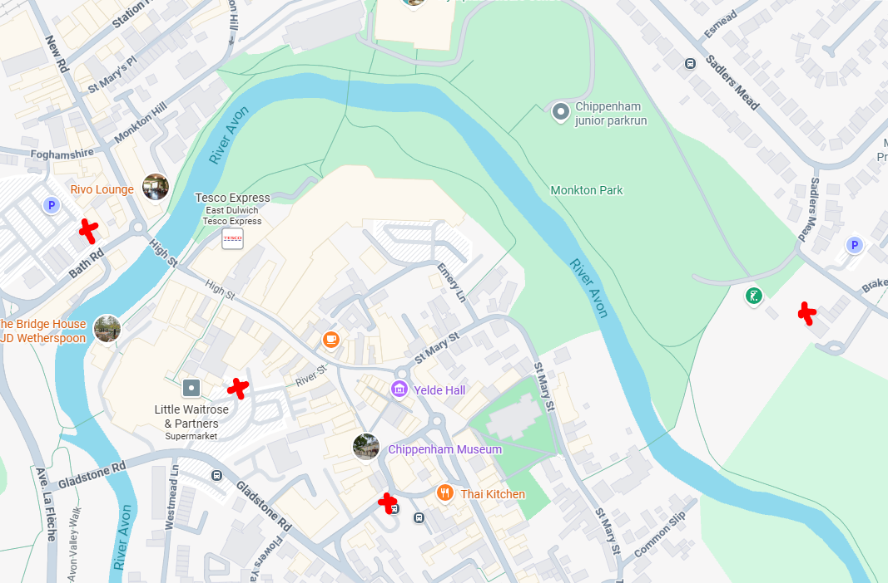

Tenders will be assessed using the scoring method
50% Price
40% Quality
10% Environmental
Estimated Tender Value £45,000
Terms and Conditions:

All prices tendered are to be net of VAT which is to be added by the successful tenderer at invoice stage.

A Chippenham Town Council Purchase Order will be issued to the successful tenderer as confirmation of the works order and as soon as is practically possible after Council approve the order.

The Council includes the products and services it procures in its carbon footprint to measure and take responsibility for its impacts on the climate and biodiversity. Only Tenders that fill out the Environmental Scoping assessment will be considered.

Reservation: The Town Council reserves the right to not accept the lowest, or any Tender.
Tenders must be returned either:
In an envelope addressed to Chippenham Town Council CEO, The Town Hall, High Street, Chippenham, Wiltshire, SN153ER, and Marked : TOILET CLEANING TENDER
Or emailed to procurement@chippenham.gov.uk
- Failure to do this will lead to disqualification from the quotation process.

TENDER FORMS MUST BE RETURNED BY: 12 Noon 20 March 2026.

