Specification for the provision of Third-party treatment and disposal of Mixed Municipal Waste
Contract Reference
1013902451

- Introduction
LondonEnergy Ltd provides sustainable energy, recycling and resource management and operates the second largest waste contract in the UK operating on behalf of Seven North London Boroughs.
Based in Edmonton, North London, The LondonEnergy EcoPark is comprised of our Energy-from waste facility (EfW) which treats 750,000 tonnes of North London’s waste and recycling each year helping to power over 80,000 homes across the capital. Operating alongside our EfW is a state-of-the-art Resource Recovery Facility designed for the sorting and treatment of North London’s waste and recycling.
LondonEnergy also operates two waste transfer stations and seven Household Reuse and Recycling Centers (RRC’s) providing recycling services to residents across North London.
LondonEnergy is a private company wholly owned by the North London Waste Authority.
- Definitions
The words and phrases that may be used in this Specification or Schedule shall bear the same meanings as defined in the contract, save that the following words shall be assigned the following meanings for the purposes of interpreting this Schedule in the context of this contract:
  - LEL – LondonEnergy Limited
  - EfW - Energy from Waste Facility
  - ERF – Energy Recovery Facility
  - WDF – Waste Dataflow

- The Service
LondonEnergy wish to invite suppliers to bid for the acceptance, treatment and disposal of the following service and/material streams: Mixed Municipal Waste 20 03 01
The tender shall be split into four LOTs
- The contract term for LOTS 1-3 shall run from 6th April 2026 - 1st September 2026
- The contract term for LOT 4 shall run from 1st April 2026 – 31st March 2027
1. | Borough Delivery of Mixed Municipal waste – 10,000t  - Scope: Local Authority collection teams to deliver 10,000t mixed municipal waste  - Duration: 6th of April – 1st September 2026  - Delivery: Delivery via Local Authority RCV, approx. payload 5t  Suppliers should be situated no further than 5 miles of NW10 OUX  or 5 miles from N18 3AG  - Frequency: Weekly delivery is equivalent of c. 500t  - Treatment: Where not directly delivered to EfW, all non-recyclable fractions must be treated via Energy from Waste
2. | Borough Delivery of Mixed Municipal waste – 10,000t  - Scope: Local Authority collection teams to deliver 10,000t mixed municipal waste  - Duration: 6th of April – 1st September 2026  - Delivery: Delivery via Local Authority RCV, approx. payload 5t  Suppliers should be situated no further than 5 miles of NW10 OUX  or 5 miles from N18 3AG  - Frequency: Weekly delivery is equivalent of c. 500t  - Treatment: Where not directly delivered to EfW, all non-recyclable fractions must be treated via Energy from Waste
3. | LondonEnergy Delivery of Mixed Municipal waste – 12,500t  - Scope: LondonEnergy Bulk Haulage to deliver 10,000t mixed municipal waste  - Duration: 6th of April – 1st September 2026  - Delivery: Delivery via LondonEnergy Bulk Haulage, approx. payload 24t  Suppliers should be situated within 80 miles of NW10 OUX  - Frequency: Weekly delivery is equivalent of c. 750t per week  - Treatment: Where not directly delivered to EfW, all non-recyclable fractions must be treated via Energy from Waste

4 | Ad-hoc Delivery of Mixed Municipal waste – 10,000t  - Scope: LondonEnergy to deliver 10,000t mixed municipal waste to support unplanned outage  - Duration: 1st April 2026 – 31st March 2027  - Frequency: No set weekly volume. Volumes to be agreed weekly in advance with a guarantee of 10,000t delivered by the end of the contract term.  Delivery method (Bulk haulage/RCV) based on proximity of supplier.  - Delivery: Suppliers should be situated within 80 miles of NW10 OUX  - Treatment: Where not directly delivered to EfW, all non-recyclable fractions must be treated via Energy from Waste

- Frequency of collection/Service/Testing
Weekly delivery volumes are indicative. The contract manager will confirm expected volumes with suppliers each week. While every effort will be made to meet anticipated weekly supply, suppliers should allow for a ±4-week variance to accommodate any shortfalls and ensure the total contracted tonnage is achieved.
- Project timeline
Date | Action
Monday 26th January | Premarket Engagement - Tender Specification hosted on MultiQuote for supplier review (1 week)
Monday 2nd February | Go live - Tender documents uploaded to Delta Portal (2 weeks)
Monday 16th February | Closing date for supplier clarification questions
Monday 23rd February | Completed tender documents to be returned
Monday 2nd March > Wednesday 4th March | Evaluation of bids
Thursday 5th March | Moderation of bids
Monday 9th > Weds 11th March | Interviews
Thursday 12th March | Evaluation of Interviews and final scoring
Monday 16th March | Notification of award followed by 8-day standstill period (8 working days)
Thursday 26th March | Confirmation to successful bidders
Monday 6th April | Contract start

- Key Performance Indicators
The three leading KPI’s that will support this contract are:

- Service continuity & Contingency planning:
  - The contractor shall maintain sufficient capacity for the full duration of the contract, using the facilities and treatment methods outlined in its bid. A robust contingency plan must be in place, identifying alternative delivery points and, where relevant, alternative treatment methods to ensure uninterrupted service in the event of operational issues.
  - The contractor must provide early notification of any market or supply chain issues that may affect delivery locations or treatment processes. In the event of a service breakdown, contingencies must ensure that scheduled collections occur within 48 hours of the planned date.
  - If any named contingencies become unavailable, resulting in changes to disposal facilities, treatment methods, or pricing, the supplier must notify LondonEnergy in advance so a collaborative solution can be agreed, prioritising recycling performance and environmental compliance.

- Environmental compliance and reporting:
The contractor shall provide detailed monthly reports demonstrating a robust and fully compliant supply chain for the treatment of Mixed Municipal Waste and any fractions extracted during pretreatment.
Supplier responses must include:
- A clear Waste Acceptance Criteria defining acceptable and compliant materials
- A contingency plan that maintains service continuity during breakdowns and enables a minimum 95% recycling rate during such events
- Suppliers unable to currently meet the required recycling rate may still submit a bid. However, scoring will reflect their current performance and their commitment to future improvements through research and development
- Zero waste to Landfill:
Any constituent parts or Fractions of the waste stream e.g. non-compliant waste that cannot be recycled must be treated via Energy from Waste. There will be Zero waste to landfill.
- Environmental compliance
The contractor shall:
      - Provide a clear proposal that outlines treatment methods of the waste, and where applicable, any recyclable fractions extracted from the waste stream
      - Ensure environmental compliance and provide complete traceability of end destinations & treatment processes used to support in Waste Dataflow reporting.
      - Ensure all non-recyclable fractions are treated via Energy Recovery.
      - Provide clear monthly data to support invoicing in line with LondonEnergy Standard Terms and conditions. Invoicing for material collected should be based on tonnes collected rather than by unit.
      - Operate an Environmental Management System such as ISO 14001 or equivalent and undertake an annual review of its operations and working practices in order to minimise any impact on the environment.

- Provide a clear waste acceptance criteria that outlines permissible waste types , acceptable levels of contamination and outlines channels for the communication and remediation of the non-conformance.

      - Effectively communicate any non-conformities in the material stream in real time that result in a breach of health and safety or where additional charges may arise as a result of these non-conformances.
      - A glossary of indicative charges for non-conforming waste to be supplied at the start of the contract.
      - The contractor shall provide a clear breakdown of how material and haulage rates are calculated and the trading platform used for benchmarking purposes.
- Health, Safety and Environment
The contractor shall:
      - Ensure that all personnel delivering on behalf of this contract receive a suitable induction upon first entry to the suppliers’ facilities
      - Ensure that all personnel working on behalf of the contractor suitably trained and are inducted via LondonEnergy’s Induction systems before starting work
In addition to the above, the contractor shall:
  - Operate an Environmental Management System such as ISO 14001 or equivalent and undertake an annual review of its operations and working practices in order to minimise any impact on the environment
  - The Company regards the provision of a safe and healthy working environment on its sites as a principal objective. This objective can only be achieved by the co-operation of its employees, Suppliers, Contractors and sub-contractors. Co-operation must be at all levels within these different organisations
  - The Company managers and supervisors are responsible for the safety of employees, Contractors, Suppliers and Visitors in their charge and must ensure that policies and procedures are made known and are observed. It is their responsibility to ensure the effective delegation of these duties during their absence
  - Employees, Suppliers, Contractors, and Visitors to site are responsible for observing the Company policies and procedures and for ensuring that at all times they work in a manner consistent with the safety of themselves and others
  - The effectiveness of health and safety measures will be monitored continuously in order to ensure that both policy and practice are appropriate at all times to the activities of the Company
- Specific arrangements

To support the bid, the contractor will identify the significant hazards that remain after all contract considerations have been implemented and therefore will require risk assessment to be undertaken by the Contractors.
Note, this is not exhaustive and does not relieve the Company or Contractors of their responsibilities or requirements under the Health & Safety at Work Act 1974, Management of Health & Safety at Work Regulations, Construction Design and Management Regulations and any other applicable statutory requirements.

- Work Area | - Weil’s disease
- Hazard Throughout site. | - Slips, Trips & Falls
- Traffic  - Segregation of traffic and persons | - Waste
- Waste Disposal & containment | - Dust
- Machinery/mobile plant | - Extreme weather
- Noise | - Manual handling

- COSHH

  - The Contractor will provide all information required under the Control of Substances Hazardous to Health Regulations (COSHH), relating to any chemical products they will be using, to the Company prior to delivery to site, including a material safety data sheet and their COSHH assessment.

  - No Contractor will be allowed to bring onto site any substances that are not approved by the Company.
- Sustainability and Social Value
To support the bid, contractor will be required to complete a quality questionnaire that outlines any current and future initiatives that promote sustainability and support the local economy. Please refer to the tender documents for more information.
- Contract review
The contractor shall attend quarterly performance reviews remotely or in person with LondonEnergy every three months from the date of the commencement of the contract.
- Benefits of the NEC form of Contract (for use in public procurement activities)
The NEC suit of contracts are specifically intended to be used as a project management tool, rather than purely as a legal document for the allocation of risk and responsibility and is best used for public procurement activities, since the alternatives allow for less flexibility and are more akin for use in traditional procurement activities.
The main benefits of the NEC form of contract is it aims to create a collaborative and non-adversarial relationship between the Parties (Client and the Contractor), despite its peculiarities – odd numbering system, use of present tense, absence of cross-referencing, italicised terms, simplistic or 'loose language’ (legal precision has been consciously subordinated to the desire to promote proactive and "modern" management processes). This means it enables equity across different sizes of companies.
The flexibility of the NEC form Contracts means:
The Client can:
- Give a scope (and outline design if applicable), a statement of purpose – making it easier for Contractor’s to interpret
- Specify the performance requirements of the asset
- If applicable, design the work itself or through a third party
- Use any combination of the above
The Contractor:
- Has clear instructions on what is required (clear scope and statement of purpose)
- Can set out the order and timing of the operations for the provision of the work/service – clear and regular lines of communications between the parties
- Can set out plans to meet each Condition stated for the Key Dates and to complete other work needed to allow the Client and Others to do their work
- Other
Participating organisations shall not take advantage of any error or omission contained within this Information Pack or within subsequent tender documents and shall review all documentation and promptly report any error, inconsistency or omission to LEL.
These shall be considered by LEL and if appropriate, shall be addressed through written clarifications addressed to all participating organisations during the submission period.
Clarifications shall include additions, alterations, or deletions to the documentation, and any other instructions, as appropriate.

EcoPark 10 mile radius
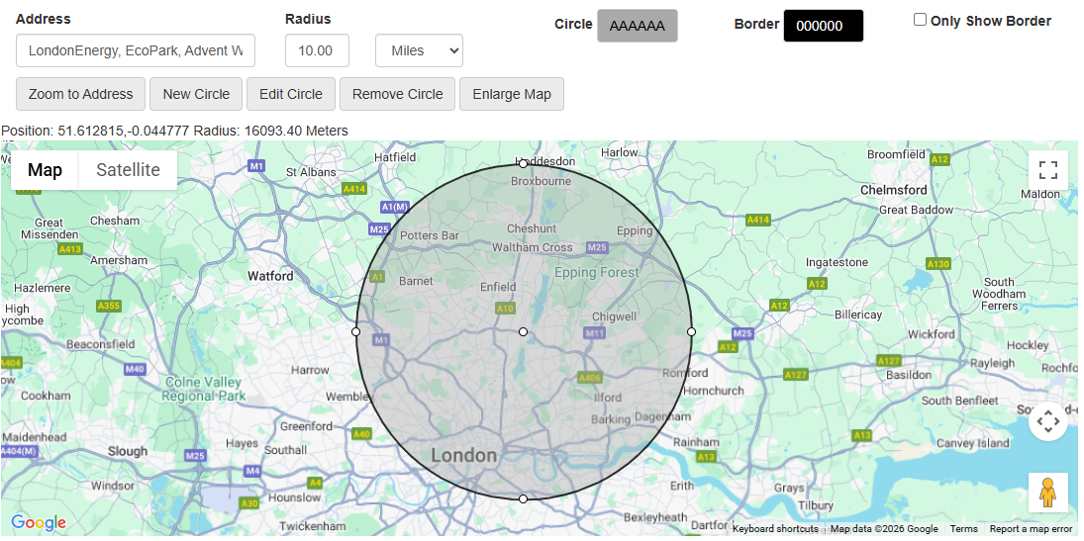
Wembley 10 mile radius

