Tender Notice for
The Provision of Services Beyond the Meter

Issue Date: 12/02/2026
Closing Date and Time: 09/03/2026 17.00

NGN Primary Contact: Elle Flood
eflood@northerngas.co.uk

NGN Secondary Contact: Joanna Palmer
jpalmer@northerngas.co.uk

Contents
Guidance. Please read carefully on how to proceed with event 3
Introduction…………………………………. 4
Northern Gas Networks Geographic Area 5
NGN Core Values 5
Scope of Requirements 6

Guidance
This Tender Notice is issued by Northern Gas Networks (NGN) and is live until 09/03/2026.
The aim of this Tender Notice is to:

* Ensure we provide bidders with adequate information to determine if they wish to proceed with this tender event.

* Provide NGN with a more detailed understanding of the interest within the market.

The Tender Notice process is the first stage of multistage procurement process.
All interested suppliers must follow the below steps in order to proceed with the conditions of participation and PQQ stages of this procurement event:

Sign up or sign in to NGNs Tendering Portal – Market Dojo. Follow this link to do so: sign-up - Market Dojo

When you have logged in to your dashboard, you'll need to click the 'Show all or enter invite code' button under the Event Invitations section, as per below screenshot:
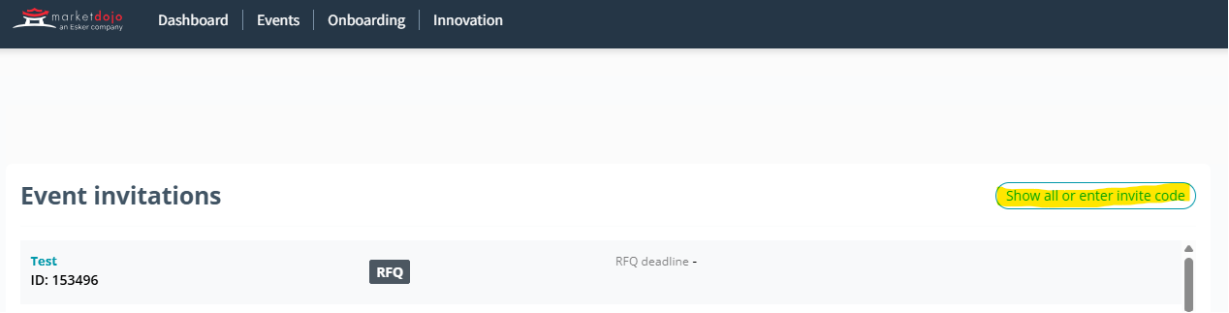

You’ll need to enter this code: 9AC10CCEC0

It will then notify NGN to approve you onto the tender event. Once approved you will be given access to the event, where you’ll be taken to the Conditions of Participation stage, this stage is a pass/fail and will be locked until after the PQQ submission deadline. Any supplier who fails this stage will automatically be withdrawn from the process and will not gain access to the PQQ. All suppliers who pass this stage will be automatically taken to the PQQ where they will be given a deadline and detail to complete.

Once the PQQ has been evaluated by NGNs internal evaluation team all those who meet the criteria will be sent to the RFP stage where NGN will assess against award criteria.

Introduction

Northern Gas Networks Limited (NGN) is the company responsible for distributing gas to homes and businesses across the North of England. As part of the restructuring of the gas distribution business in England, NGN successfully acquired the North of England gas Distribution Network (DN) and took control of the assets on 1st June 2005. NGN has been responsible since then for the transportation of gas to the North of England via 36,000Km of pipelines.

The DN is located in the North of England and extends south from the Scottish border to South Yorkshire and has coastlines on both the East and West sides of the region. The DN contains a mixture of large cities such as Newcastle, Middlesbrough, Leeds and Bradford and a significant rural area including North Yorkshire and Cumbria. The area covers around 6.7 million inhabitants and has approximately 2.5 million customers. The DN is supplied via 23 off takes from the national Transmission System.

Northern Gas Networks Geographic Area

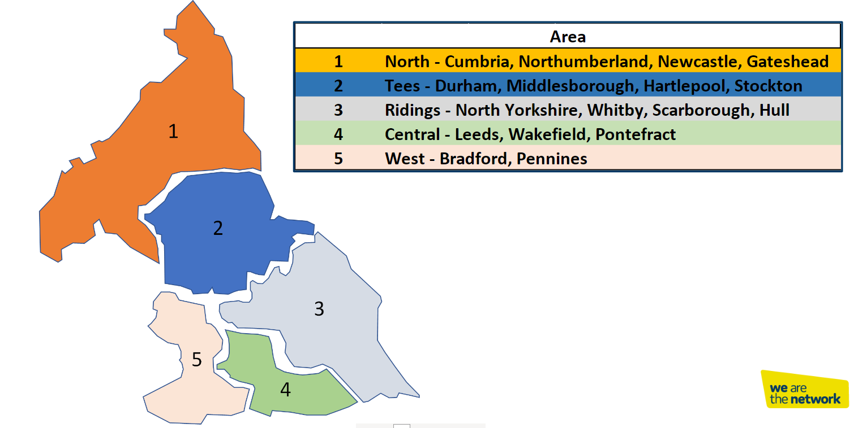

NGN Core Values

NGNs dream is to become the UK’s most loved, admired and respected company, and to establish a reputation for doing business really well through a united and empowered team that is mind-blowingly great. We recognise the important role that our supply chain partners having in supporting NGN to achieve our dream.

Our dream lies at​​ the centre everything we do and has been translated into a unique set of values that reflect and reinforce our culture.
- Trailblazing
- Intellectually Curious
- Community Focused
- Empowered
- Heartfelt
- Happy

Every member of our team is passionate about the contribution they make to our growing reputation as a pioneering, effective, conscious and enlightened business that is focused on changing the way that things are done.

We expect our suppliers to share our vision and values and our way to support NGN in achieving our goals.

Tender specific Scope of Requirements
It is at the discretion of NGN to amend requirements of the scope if there is a need to do so. Any changes to the scope will be communicated to all Bidders.

Please note that substantial amendments will not be made.

Scope of Requirements

Service Overview
OFGEM have provided funding, to the Services Beyond the Meter team, to support vulnerable customers, subject to meeting eligibility criteria, who have had their gas supply / appliance isolated due to a gas leak or the detection of carbon monoxide.

Northern Gas Networks are looking for contract partners to help deliver gas appliances work within the homes of vulnerable customers who have met the eligibility criteria. Primarily work would be focused on the larger and more complex installations and in addition support with workload overflow and to provide contingency in the event of network incidents.

Services Required
- Installation of natural gas central heating boilers and associated plumbing works.
- Replacement of natural gas central heating boilers and associated plumbing works. (Heat only to Heat only, Combination to Combination, plus conversions as required)
- Installation of domestic gas cooking appliances (Freestanding and built in)
- Installation of domestic gas space heaters (fires)
- Repair of domestic gas central heating boilers.
- Repair of domestic gas cooking appliances (freestanding and built in)
- Repair of domestic gas space heaters (fires)
- Repair & replace pipework
- Supply materials associated to the above.
- Remove and dispose of waste (including appliances)
- Provide a reasonable aftercare period in relation to the above carried out works, including adherence to the following timescales:
  - Repair/ Service within 14 days of a request
  - Installation of heating system / boiler (2 years)
  - Installation of anything else (1 year)

Contractor Specification
The specification of contractor must align with OFGEM governance, and the following are essential for any potential company submitting a bid.

- Gas Safe Registered and hold competence for
- CCN1 (Domestic Core Gas Safety)
- CENWAT (Domestic central heating & hot water boilers)
- CKR1 (Domestic Cooking Appliances)
- HTR1 (Domestic space heating appliances)
- Must have a waste carrier licence
- Ideally possess BSI standards PAS 2030 & PAS 2035 or equivalent
- Experience of working within a regulated environment
- Be willing for NGN to carry out audits and inspections on work carried out on its behalf.

Product Specification
Northern Gas Networks want to ensure that the appliances installed on the network for our vulnerable customers meets the below specifications as a minimum. This is supplementary to standard industry guidance as all work carried out must adhere to manufacturer’s instructions, industry standards and guidelines with specific attention to building regulations.

Central Heating Appliances
- Manufacturer with good industry standing.
- Minimum of 5 years manufacturer warranty or guarantee.
- Heating system cleaned and prepared to BS7593
- Appliance controls with a minimum 5-year warranty which meet current standards for building regulations, such as optimisation or smart.

Domestic Cooking Appliances
- Manufacturer with good industry standing.
- Minimum of 12-month manufacturer warranty or guarantee.
- Flame Failure Devices on all burners.

Domestic Space Heating (Fires)
- Manufacturer with good industry standing.
- Minimum of 12-month manufacturer’s warranty or guarantee.

Service Level Agreements

Installation suppliers
Suppliers are expected to agree to the following SLAs.

- Planned Works
All works that have been identified and passed to the contracted partner.
SLA agreement is 120 mins to agree, contact the customer within 24 hours to arrange a mutually convenient time to access the property, quote to be received within 48 hours of the customer visit, works completed within 7 days from approval of the SBtM team. Notification of start date to be sent to SBtM team.

- Photographic Evidence
Suppliers are expected to email SBtM team with evidence that works have been completed and appliance registered, with photographic evidence sent.
SLA – within 48 hours of works being completed.

- Recalled jobs
Suppliers are expected to return to customers property to rectify defects
SLA – within 48 hours of receiving notification from the SBtM team

Supply only suppliers

- Delivery Performance / Stock Availability
Suppliers are expected to have available a variety of makes and models
SLA – within 24 hours or order being placed, (timeframe to be extended only at the request of customers)

The Supplier is to provide the following:
- Fully qualified resource for the provision of awarded service
- Vehicles to be fit for purpose.
- Sufficient tools and equipment including PPE for your Operatives to complete the work specified.
- Management of your own workforce

