Background to Natural England
Natural England are the government agency for nature conservation. Part of our remit is the management of National Nature Reserves. To undertake this work we require tools, machinery, equipment & services.

Morris’ Bridge NNR car park & shed works.
The Marches Mosses BogLIFE project (LIFE15 NAT/UK/000786) was a six-year project started in October 2016 and concluded on 31 December 2022. The project aimed to restore Britain’s 3rd largest lowland raised peat-bog, comprised of the complex of Fenn’s, Whixall & Bettisfield Mosses NNR’s and Wem Moss NNR all located near Whitchurch, Shropshire and Wrexham in Wales, in total approaching 1000ha (see Map, Annex 1.1). The LIFE project was led by Natural England working in partnership with Natural Resources Wales and the Shropshire Wildlife Trust. The project was financially supported by LIFE, a financial instrument of the European Commission and the Heritage Lottery Fund. It is imperative that the control of birch (and scrub) is continued following on from the end of the project in order to aid the continuing restoration process.
- Site/Access:

The work site is at the southern edge of Fenn’s, Whixall, Bettisfield Mosses National Nature Reserve (NNR).
- Invitation:
You are invited, to submit a quotation for the requirement described in the specification below.
Please confirm, by email, receipt of these documents and whether you intend to submit a quote.
Your response should be returned to the following email address by:
Email: nathan.brake@naturalengland.org.uk
copied to: peter.bowyer@naturalengland.org.uk
Date: 18th February 2026.
Time: 09:00am
Ensure you state the reference number and ‘Final Submission’ in the subject field to make it clear that it is your response.
NOTE depending on available funding, not all the work may be commissioned.
Contact Details and Timeline
Nathan Brake will be your contact for any questions linked to the content of the quote pack or the process. Please submit any questions by email and note that, unless commercially sensitive, both the question and the response will be circulated to all tenderers.
Action | Date
Date of issue of RFQ | 30th January 2026
Viewing dates | 9th February 11am 2026
Deadline for receipt of Quotation | 18th February 9am 2026
Intended date of Contract Award | 19th February 2026
Intended Contract Start Date | 2nd March 2026
Completion Date | 27th March 2026

- Requirement:
- 3.1 – Vegetation is to be scraped back to the car park edges or the toe of any embankment. An existing brash pile by the disabled parking bays is also to be moved. Spoil and brash are to be taken to the nearby former scrap yard and deposited in area that will be identified by Natural England staff. Stone is to be put in any potholes, around car park edges & in the car park entrance/approach NOT across all the car park surface. The stone is to be 20mm to dust inert granite, rolled and levelled. Contractor to supply stone. Note - limestone is not to be used.
- 3.2 – Vegetation is to be scraped back to the edge around Picnic bench area. The surface is to be re-surfaced with 6mm to dust inert granite, rolled and levelled. The path area adjacent to the bench is to be amended slightly to allow for extra manoeuvrability with a base of 20mm to dust inert granite, rolled and levelled topped with 6mm inert granite, rolled and levelled. Contractor to supply stone. Note - limestone is not to be used. Bench to be left in situ during works (not temporarily moved).
- 3.3 – Vegetation is to be scraped back to the edge on the access ramp from the car park to the tow path. At the base of the ramp, the ramp is to be splayed to 2000mm and the path area leading to the bench is to be amended slightly to allow for extra manoeuvrability with a base of 20mm to dust inert granite, rolled and levelled topped with 6mm inert granite, rolled and levelled. The existing path surface is to be re-surfaced with 6mm to dust inert granite, rolled and levelled. Contractor to supply stone. Note - limestone is not to be used. Obsolete wooden post to removed and disposed of by contractor.
- 3.4 – Remove old car park entrance barrier infrastructure (4 x units) and installation of x 1 new 5metre entrance barrier. Disposal of concrete lump by grit bin. Contractor to dispose of disused barriers & concrete. Contractor to supply postcrete or equivalent. Natural England will supply the new barrier.
- 3.5 – Installation x 1 new dog waste bin and 1x bag dispenser. Existing bag dispenser in car park to be levelled upright. Contractor to supply postcrete or equivalent. Natural England will supply the new dog waste bin & bag dispenser and specify location.
- 3.6 – Steps from car park to ramp to be re-instated with an additional third step. Steps to be kept in current location. The top step to be at the level of the re-surfaced path so as not to be a trip hazard. Treads and risers are to be installed as per the following specification: Recommended maximum riser height: 150-170mm. Maximum tread depth: 300-450mm. The steps are to have box edges. Steps are to be timber 50mm x 200mm x 1800mm. 50mm x 50mm wooden stobs are to be used to secure steps with the tops chamfered away from the riser. Stobs are to be used at equal spacings per riser and are to match the other risers, so they line up. The steps are to be 1800mm wide finished with 6mm to dust inert granite over a base of 20mm to dust inert granite, rolled and levelled. There should be a front-fall on the tread of no more than 1:50. One handrail only to be installed; this is to be on left hand side of steps (As you are facing towards direction of canal). The handrail is to use 100mm x 100mm x 2400mm wooden posts and a 100mm x 100mm eased edge top rail. Handrail to be positioned at 900–1000mm from the pitch line of the step – Timber half round mid rail positioned at 600–750mm. Continue the handrail for 300mm beyond the end of the bottom of the ramp. Contractor to supply all timber & dispose of disused timber materials. Contractor to supply postcrete or equivalent.
- 3.7 – Fencing, revetment and the gate along the access ramp and picnic bench are to be removed and reinstated to the following specification: Posts 100mm x 100mm x 2400mm. Revetment boards 200mm x 50mm x 3600mm. Eased edge timber top rail positioned at 900–1000mm from the pitch line of the ramp – Timber half round mid rail positioned at 600–750mm. Revetment is to be 100mm proud of ramp level. The revetment to be at the same level of the re-surfaced path so as not to be a trip hazard ONLY where it is adjacent to the gate. Gate to be wooden construction 1200mm wide. Gate to have the top hanging pin downwards and the bottom hanging pin upright (to stop it being lifted off). Gate hanging post and latch post to be wooden 2100mm high x 150mm x 150mm 4-way weather top. The gate is to be installed so that it is in the centre of the set of steps. Contractor to supply all timber, gate and gate fixings and dispose of disused timber materials. Contractor to supply postcrete or equivalent. Note – A separate quote can be provided for recycled plastic as an alternative to timber – but not instead of.
- 3.8 – Re-setting of interpretation panel by bench towards the bank in a location specified by Natural England. Height of middle of the board to be between 750-1200mm. Contractor to supply postcrete or equivalent.
- 3.9 – Removal of all asbestos from the shed adjacent to the car park – All asbestos is to be removed and disposed of as per current guidelines.
- 3.10 – Removal and disposal of concrete pipes.
- 3.11 – Removal and disposal of all debris and litter, a skip can be located at SJ 49479 35260 ///outer.vehicle.earpiece This is dependent on a permit being in place for use of the canal bridge -see NB below
- 3.12 – Removal and disposal of all metal framework.
- 3.13 – Work site to be left clean and level.
N.B – Morris’ bridge is owned by the Canal & Rivers Trust (CRT) and is a Grade II listed structure. It has been assessed as suitable for vehicles up to 3 tonnes only. The height and width are limited and both approaches are steep. A contractor would need to put measures in place in their RAMS to protect the bridge and canal and towpath users.
A permit will be required from CRT prior to works commencing martin.teague@canalrivertrust.org.uk
Note - Natural England will liaise with CRT, the CDM co-ordinator & the successful contractor to organise this.
N.B – Natural England will require waste disposal tickets for any material removed from site including asbestos and skip materials ie timber/metal/waste.
N.B – Natural England will require all conveyance notes for imported materials (stone).
N.B - The successful contractor is responsible for checking all services before work commences.
N.B – An ecological clerk of works will be required for part of the works detailed in points 3.8 to 3.11. Natural England will appoint an appropriate contractor. A Preliminary Ecological Appraisal has been commissioned which will be made available to the successful contractor.
N.B – Note this project needs to comply with the Construction, Design & Management Regulations 2015 and as such an external company will be appointed to oversee CDM on behalf of the client and will co-ordinate this with the successful contractor. Natural England will appoint an appropriate contractor.
N.B – All timber should have FSC accreditation (or equivalent) and be sustainably sourced. All timber to be pressure treated/tanelised timber (Tanalith E). No use of creosote or equivalent. A separate quote can be provided for recycled plastic as an alternative to timber – but not instead of.
N.B – An accessibility audit report is included as appendix A along with a design specification guidance for steps etc as appendix B

- Contractor obligations:

Where work is alongside tracks open to the public, appropriate signage must be put on the tracks. The work area needs to cordoned off from the public and left in a safe condition at the end of each day.
The contractor is expected to provide first aid kits and an adequate number of trained first-aiders.
Appropriate PPE to be always worn by the contractor and workers. Warning signs to be erected on approach tracks. Copies of First Aid Training Certificates are to be included in the Tender. Training certificates need to be included for any operatives who are to use power tools or machinery stated in the methodology - ie chainsaws, tractors, roller, dumper, whacker plate & excavators.
The contractor shall indemnify Natural England & Natural Resources Wales against all reasonable claims arising out of his/her operations and shall insure against all claims made as a result of these operations either by Natural England/Natural Resources Wales or third parties.
All work must comply with with relevant regulations including HASAW, COSHH, HAVS, CDM, Noise and FEPA regulations. Care must be taken because of the presence of members of the public, ditches, brash, brambles, adders and other animals on site.
No smoking on site.
A list of site hazards is attached below. The contractor must submit their Method Statement and example Risk Assessments in the Tender but full site-specific Risk Assessments before starting the Contract. These must be approved prior to the commencement of work. Natural England examples of operational Risk Assessments are included as examples - ANNEX 4. Risk Assessments.
The contractor must inform the Reserve manager by email or text as to when work is being carried out and by whom so that work progress can be inspected and any issues discussed.
No dogs or other animals to be brought onto site.
7. SITE HAZARDS Include:
a. The area includes adjacent drainage ditches which may be hidden by vegetation & the Llangollen canal and towpath.
b. Vegetation (particularly bracken and purple-moor grass litter) poses a fire risk in dry and windy conditions all year round. No smoking.
c. Adders, midges, horseflies and other biting insects are present on site.
d. Due regard must be exercised when working near public rights of way for walkers, dogs and horse-riders especially regarding chemical use/use of machinery/vehicles/plant.
e. Potential biohazards such as dog faeces may be present.
f. Services – A telephone line is present adjacent to the car park. The successful contractor is responsible for checking all services before work commences.
g. Public vehicle access to the car park will be restricted for the duration of the programme, however vehicles will still be present in the surrounding area.

Contract Evaluation:
The contract will be evaluated on the basis of cost 50% and on the basis of quality of the bid 50%.
Quality will be assessed on:
The quality of the bid (50% of the total evaluation score) will be assessed on the below information being provided
40% | Methodology | State method & equipment to be used, fuelling (if applicable), transport, communication, sub-contracting, and measures to minimise damage to adjacent water courses. State capacity to get project completed. Methodology to include control measures for protection of the Morris’s bridge structure.
25% | Experience | Provide a work force list with relevant qualifications & copies of training certificates/CPCS cards, together with details of CPD training (continuous professional development) and their employment status (e.g., permanent staff, contractor/temporary, sub-contractor). Detail previous experience on working on similar projects eg: Groundworks, car park surfacing, fence installation, step installation, asbestos removal. (This also applies for any sub-contractors being used). Personal information should be removed from any info submitted.
25% | Health & Safety | Provide a site- specific emergency plan including transport, pollution, and fire prevention measures. Provide a Health and Safety Policy & copies of Employees and Public Liability Insurance. Provide relevant examples of Risk Assessments & Method Statements (RAMS).  Note this project needs to comply with the Construction, Design & Management Regulations 2015 and as such an external company will be appointed to oversee CDM on behalf of the client and will co-ordinate this with the successful contractor.
10% | Sustainability / environmental / social | Provide detail on how sustainability is embedded in your supply chain. This should include your use of sustainable, environmentally friendly materials and practices. Provision of an environmental Policy. Detail any social value initiatives you would employ on this project.

Score | Justification
For a score of hundred (100): | Excellent - Response is completely relevant and excellent overall. The response is comprehensive, unambiguous and demonstrates a thorough understanding of the requirement and provides details of how the requirement will be met in full.
For a score of seventy (70): | Good - Response is relevant and good. The response demonstrates a good understanding and provides details on how the requirements will be fulfilled.
For a score of fifty (50): | Acceptable - Response is relevant and acceptable. The response provides sufficient evidence to fulfil basic requirements.
For a score of twenty (20): | Poor - Response is partially relevant and/or poor. The response addresses some elements of the requirements but contains insufficient / limited detail or explanation to demonstrate how the requirement will be fulfilled.
For a score of zero (0): | Unacceptable - Nil or inadequate response. Fails to demonstrate an ability to meet the requirement.

Invoicing:
Invoices should be submitted by the end of March 2026 – NO LATER. Contractors shall make no financial investment in the project and, therefore, shall not benefit from any intellectual property rights arising from the project. The Purchase Order number must be included on the invoice or it will be rejected. It should be received before the end of March 2026.
Site Visits
Site visits with Reserve manager Nathan Brake will be held on 9th February 2026. Meeting at Morris Bridge car park, SY13 2PQ. BNG SJ 49325 35409 W3W ///aside.acrobatic.incoming. Unguided return visits are permitted as long as notice is given to the Reserve Manager/s. Instructions will be sent out to those who book.
If you are unable to make any of these dates, please contact the reserve manager to arrange an alternative.
Prices
Prices must be submitted in £ sterling, inclusive of VAT.
It is anticipated that this contract will be awarded for a period of 4 weeks ending no later than March 27th. Prices will remain fixed for the duration of the contract award period. We may at our sole discretion extend this contract to include related or further work. Any extension shall be agreed in advance of any work commencing and may be subject to further competition.
Pricing schedule:
For works detailed in the specification above. NOTE depending on available funding, not all the work may be commissioned.

Quotation: Morris Bridge car park refurbishment & removal of asbestos out building works. FULL DETAILS OF WORKS LISTED ABOVE.
Morris Bridge Works: |  | Fixed Price (excl. VAT)
3.1 -Vegetation is to be scraped back to the car park edge or the toe of any embankment.
3.2 -Vegetation is to be scraped back to the edge around Picnic bench.
3.3- Vegetation is to be scraped back to the edge on the access ramp from the car park to the tow path. Obsolete post to removed
3.4- Remove old car park entrance barrier infrastructure (3 x units) and install x 1 new entrance barrier.
3.5- Install x 1 new dog waste bin.
3.6- Steps from car park to ramp to be removed and re-instated with an additional third step & handrails.
3.7- Fencing and the revetment along the access ramp are to be removed and reinstated.
3.8- Re-setting of interpretation panel with awning to 750.
3.9- Removal of all asbestos from the shed adjacent to the car park.
3.10- Removal and disposal of concrete pipes.
3.11- Removal and disposal of all debris and litter.
3.12- Removal and disposal of all metal framework.
3.13- Work site to be left clean and level.
Total Price excluding VAT
VAT
Total Price including VAT

I can commence work by ………………………………………………………………….
I attach a copy of relevant CPCS Cards, First-aid, chainsaws, tractors, roller, dumper, whacker plate, excavator and insurance certificates ………………………………………….………………………………………………
I attach a copy of my method statement and example risk assessment for the job including use of all machinery / vehicles ………………………………………………………………..

I can do all/ part of the work (please specify) …………………………………………….

I envisage that I can complete the work within the required timescale .......................

Signed ……………………………………………………………………………………….

Position ………………………………………………………………………………………

Date ……………………………………………………………………………………

- Sustainability
Natural England protects and improves the environment and is committed to reducing the sustainability impacts of its activities directly and through its supply chains. We expect the Contractor to share this commitment and adopt a sound, proactive sustainable approach in keeping with the 25 yr environmental plan/our commitments compliant with all applicable legislation. This includes understanding and reducing direct and indirect sustainability impacts and realising opportunities, including but not restricted to; resilience to climate change, reducing greenhouse gas emissions, water use and quality, biosecurity, resource efficiency and waste, reducing the risk of pollution, biodiversity, modern slavery and equality, diversity & inclusion, negative community impacts.
As a delivery partner, the successful contractor is expected to pursue sustainability in their operations, thereby ensuring the Contracting Authority is not contracting with a supplier whose operational outputs run contrary to the Contracting Authority’s objectives. The successful contractor will need to approach the project with a focus on the entire life cycle of the project

Annexes:
Annex 1.1 Location map
Annex 1.2 Fenn’s, Whixall & Bettisfield Mosses NNR Management Sections
Annex 2.1 Access to Work Area
Annex 3 Sample Risk Assessment (for guidance)
Annex 4 Link to terms and conditions
Annex A Accessibility audit report
Annex B Specs & diagrams steps etc

Annex 1.1: Location Map
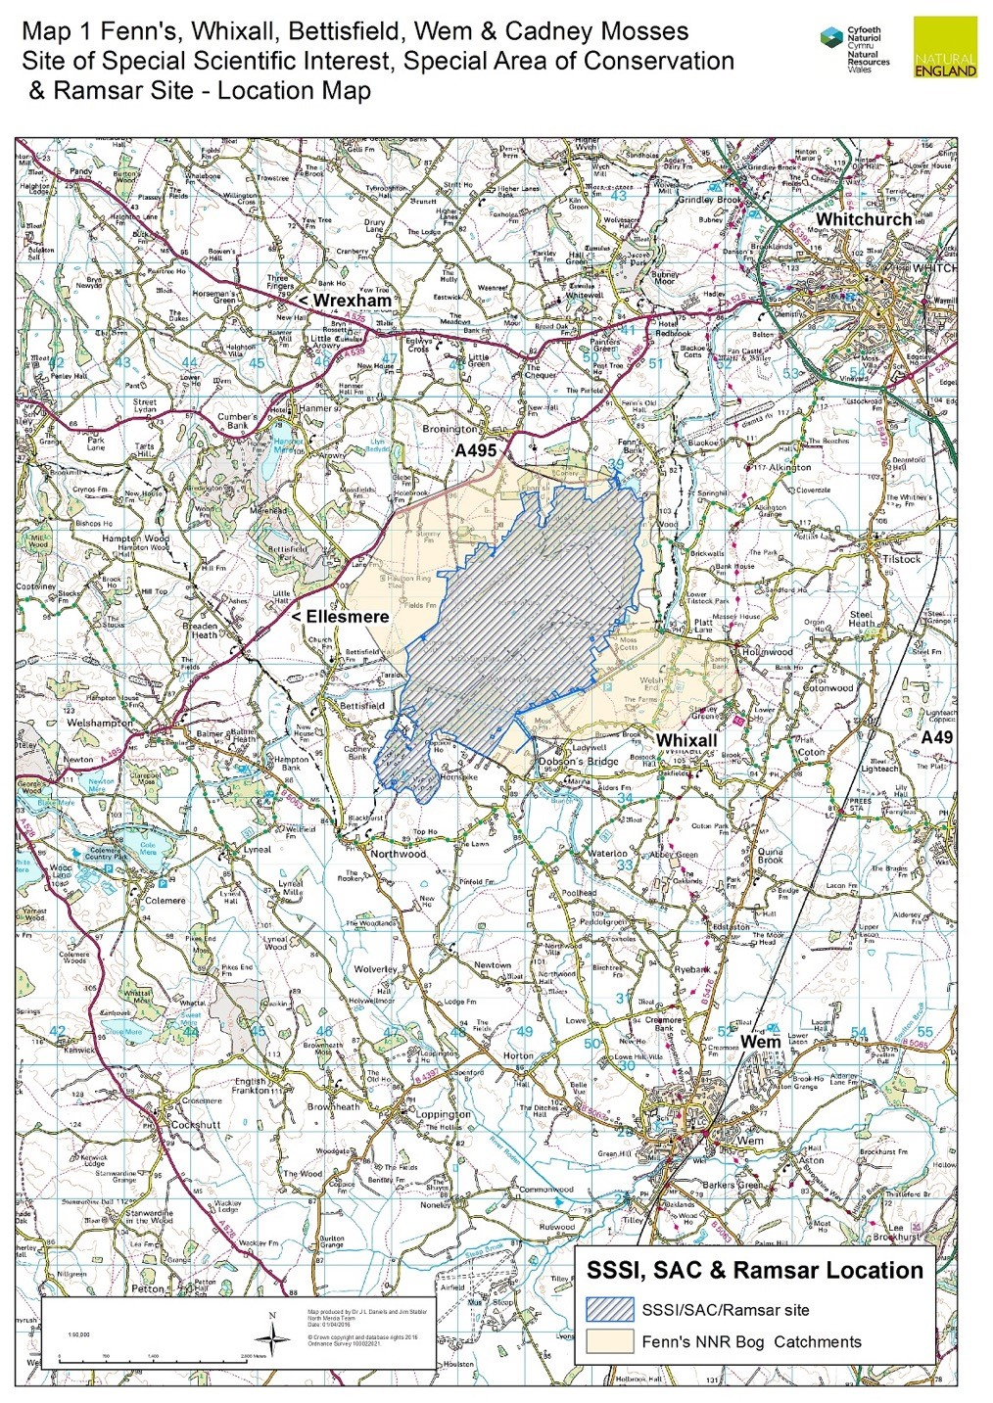

Annex 1.2: NNR Management Sections
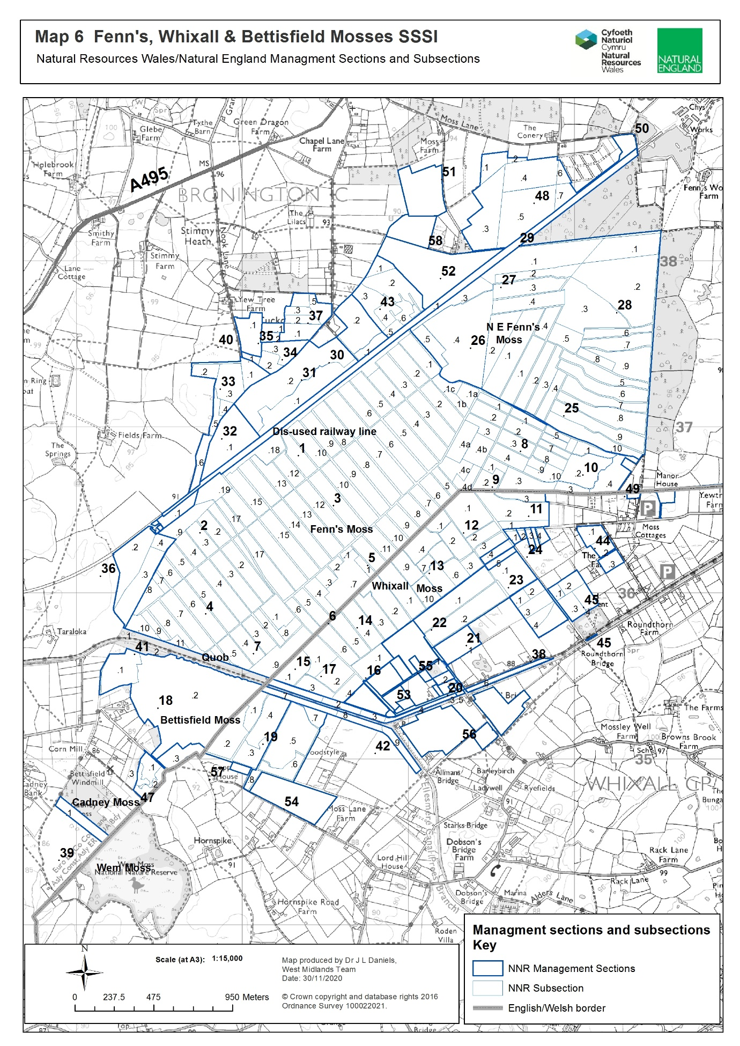

Annex 2.1: Access to work area.
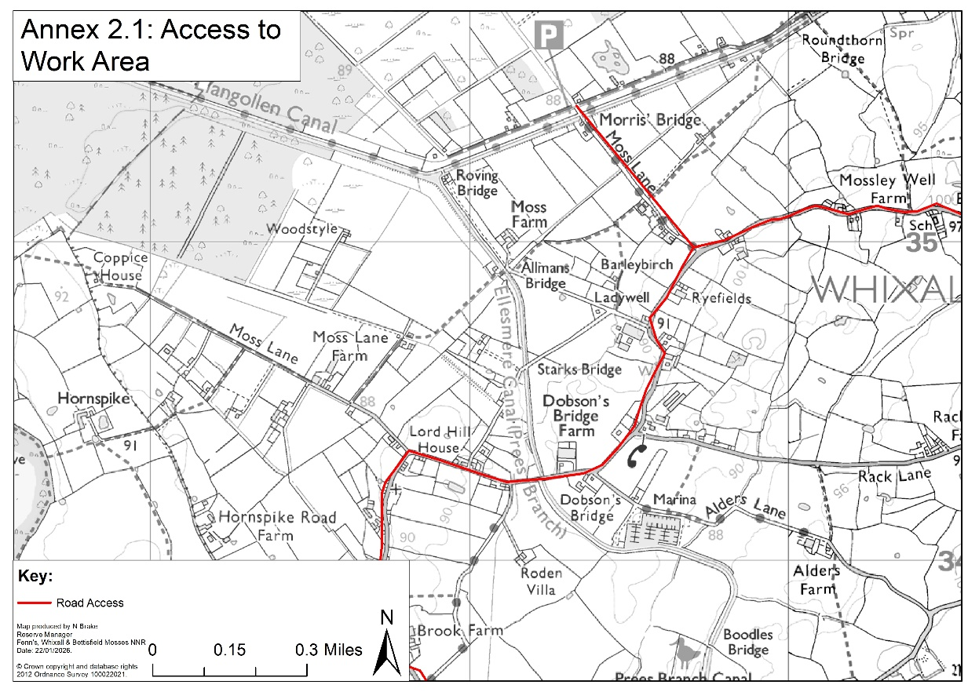
Annex 3: Sample Risk Assessment

Risk Assessment Template (H&S) NNRs
NNRs covered by this risk assessment: | Fenn’s, Whixall and Bettisfield Mosses NNR |  | Date completed: | 21/4/2023
Assessment of (e.g. Activity, Equipment, Individual) | Working on Peatlands |  | Review date (max 1 year): | 21/4/2024
Training required? Tick all that apply |  |  | Signed off by (SRM/ Line Manager): | P Bowyer  SRM
Training course: |  |  | Mandatory/Optional | Applicable?
First Aid at Work |  |  | Mandatory | p
Other (Please specify):
Notes (e.g. mandatory safety precautions) | Site safety maps are kept in all NNR vehicles. This map together with site safety information is emailed to third parties as appropriate.  Vodafone signal on NE Phones is generally good. Third parties to check phone signal whilst on site. Emergency contacts card in all NNR Vehicles & NE first aid kits.  Follow NE lone working policy as appropriate.  Risk assessments are available for all related operations – refer to these as necessary. In particular refer to:  - General safety - Personal  - General safety - Site (Fenn’s, Whixall and Bettisfield Mosses)  First aid kit in all NNR vehicles & each member of staff has a personal NE Kit. Eyewash in all NNR First aid kits & NNR Vehicles.  Note: young persons, new & expectant mothers etc., a separate risk assessment should be recorded.
Minimum PPE/RPE requirements | - Work Gloves  - Rubber gloves and Nitrile Examination Gloves – when working with water  - Steel toe capped high ankle boots/ wellingtons (EN ISO 20345:20011)
What are the hazards common to all? | Who might be harmed and how? | What precautions are you already taking? | What additional local precautions are required?
Uneven, often soft terrain, particularly on rehabilitated cuttings. Old peat pits. | Staff, Volunteers and Contractors  Slips and Trips | Where possible avoid work in the wettest areas over the winter season.  Wear suitable footwear (waterproof if necessary) with a firm grip. | Pre-plan works using site maps to determine where heavily cut areas are in the work area.  Walk over site with caution in-case peat pits are over grown/covered by brash.
Danger of machinery bogging down and overturning. Uneven tracks. Vehicles tip sideways when one pair of wheels is kept on the firm track side and the other is in soft peat. | Staff, Volunteers and Contractors  Cuts, Bruises, Whip Lash, Concussion | Only trained drivers to drive machinery.  Fill track holes with peat/chip.  Protect personnel in vehicles and goods on trailers.  Tractor link-boxes must not be used for personnel carriage.  Cover blades of all sharp tools. All small or sharp-edged tools in trailers/tractor link boxes must should be carried in a tool box.  First Aid kits in every vehicle. | Pick routes to avoid known wet spots on tracks and peat cuttings.
Ditches, bog pools, fire pools, pits Fenn’s Main drain weir, wide U-pipes and other watercourses.  Minor ditches 0.5-1 m deep. Main drains >1 m deep. Overhanging and floating plants, sides unstable. Soft, ‘bottomless’ base to dammed cuttings | Staff, Volunteers and Contractors.  Drowning, Hypothermia | Maintain official crossing places and make personnel and others aware of their positions. | Otherwise cross established peat dams Ensure workers know the drain pattern in the work area.  No lone working on very soft saturated areas, by the main drain & Sect. 14 south and 11.1  Avoid the Fenn’s weir and ensure netting is maintained on large U-pipes.  Maintain safety fencing at the Fenn’s Old Works railway culvert, the Marl Allotment ditch and Bettisfield pond.  Bring throw line when working close to main drains.  Leave the Moss at dusk unless on special monitoring tasks.  One side of fire pools is graded to permit escape. Keep spare set of clothing at NNR Base in case of falling in ditches. Emergency shower at NNR base.  Maintain deep drain, weir, crossing point and fire pool signs and posts.
Deep pools/ borrow pits by dams and bunds | Staff, Volunteers and Contractors  Drowning, Hypothermia |  | Warn users crossing dams or walking on bunds.  Test dams/bunds before crossing.  Don’t step off dams/bunds into water where you can’t see the ground beneath.
Slippery ditch crossings/ ragged mesh covering | Staff, Volunteers and Contractors  Slips, Trips, Cuts and Bruises | Replace rotten sleepers and maintain bridge marker posts and mesh on walkways.  Remove and replace any loose mesh.  Walk over crossings with caution. | Inspect for and clear of peat regularly.
Main Drain - polluted water and deep silt in base, half full downstream of wear so hard to climb out of. | Staff, Volunteers and Contractors  Weil’s disease, Sporotrichosis, Hypothermia and Drowning. | Wear rubber gloves with nitrile examination gloves underneath when working in ditches.  Wash hands before eating or drinking if they have been working in ditch.  Workers to be made aware of their flu like symptoms. | No lone working involving the Main Drain, without regular telephone contact with another worker.  Take throw-line if working by the Main Drain.  Be aware of shallower 100 yd interval side drains.
Unstable shallow-rooted trees prone to windblow. | Staff, Volunteers and Contractors  Crush injuries, Concussion, Cuts and Bruises. | Check the weather forecast prior to work near trees. | Keep out of unstable peat areas.  No lone working and wear waders in unstable carr area on 14.1, 11.1 and along the Quob. Be aware that trees can flip if being winched.  Avoid trees on peat in high winds. If unavoidable wear a hard hat.
Adders | Staff, Volunteers and Contractors  Inflammation, Pain, Bruising, Nausea, Fast Heart Rate, Sweating, Breathing Difficulties, Confusion and Dizziness | Look before touching the ground/sitting down.  Wellingtons/high boots should be worn at all possible times.  Check for adders in areas where work is being carried out.  First aid procedure if bitten:  -Remain calm and keep the part of the body that been bitten as still as possible to prevent the spread of venom around the body.  -Remove jewellery/watches from around the bitten limb.  -Loosen clothing if possible.  -Keep the casualty still and calm.  -Seek immediate medical attention by dialling 999. | Signs on noticeboards explaining the first aid procedure.  Wear gauntlet gloves when lifting brash and rubbish.
Stings and Bites – Insects/Plants | Staff, Volunteers and Contractors  Irritation, Illness and Inflammation | Wear long sleeves/full length trousers.  Use Insect repellent.  Use anti-inflammatory on any effected areas.  Wear work gloves when working with stinging/ thorny plants.
Slippery irregular brash mats. Brash obscuring ditches. Roots can project from tracks. Projecting tree/bush stumps, obscured by vegetation. | Staff, Volunteers and Contractors  Slips and Trips | Warn public to keep off the brash tracks.  Trail routes are to be inspected regularly for projecting roots, overhanging trees etc.  Noting if tree work has previously taken place in that work area.
Projecting metal | Staff, Volunteers and Contractors  Cuts, Bruises, Slips and Trips | Inspect work areas.  Wear work gloves if moving metal.  Wear steel toe capped boots/wellingtons on site, especially if working near known metal.  Inform others wear metal has been found. Mark on annual audit.

What are the hazards specific to your site/ staff/ equipment? E.g. site features such as steep slopes, individual issues such as new starters, equipment features such as known complexities. | Who might be harmed and how? | What precautions are you already taking? | What additional local precautions are required?
Turnover of trainees, volunteers, work placement students | New starters | Ensure new starters to be briefed on safe practices whilst working on the peatland during their induction. New starters should be accompanied by staff during their first few weeks on the reserve. Staff to highlight hazards and safe working practices.
Please add more lines if required.
General comments:

ANNEX 4: Link to Terms and Conditions

Standard goods and services terms and conditions (£10,000 to £50,000) - GOV.UK

