Invitation To Tender
The Charter Schools Educational Trust (TCSET)
February 2026

Contents
Section | Page number
About The Charter Schools Educational Trust (TCSET) | 3
Other Information about Charter Finance | 4
Scope of the tender | 4
The Tender Process & Timelines | 5
Evaluation Criteria | 7
Evaluation Scoring | 8
Mandatory Requirements | 10
Submission Checklist | 10
Appendices
Appendix 1 – Organisation Chart for Charter Finance Team | 11
Appendix 2 – Typical Year End Timetable | 11
Appendix 3 – Mandatory Requirements | 12

About The Charter Schools Educational Trust (TCSET)

We are a 9 school multi academy trust (MAT) based in Southwark & Lambeth (South London).
We started in 2016 when Charter North Dulwich & the newly opened Charter East Dulwich school first opened.
Our schools are listed below.
School | Phase | Address
Charter North Dulwich | Secondary (inc 6th form) | Red Post Hill, London, SE24 9JH
Charter East Dulwich | Secondary (inc 6th form) | Jarvis Road, East Dulwich, London, SE22 8RB
Charter Bermondsey | Secondary | Keeton's Road, Southwark, London, SE16 4EE
The Belham Primary School | Primary | 65 Bellenden Road, London, SE15 4DG
Charles Dickens Primary School | Primary (inc nursery) | Toulmin Street, London SE11AF
Dulwich Hamlet Junior School | Primary | 40-44 Dulwich Village, London, SE21 7AL
Loughborough Primary School | Primary (inc nursery) | Minet Road, Brixton, London, SW9 7UA
Lyndhurst Primary School | Primary (inc nursery) | Denmark House, Grove Lane, Camberwell, London, SE5 8SN
Streatham Wells Primary School | Primary (inc nursery) | 50 Palace Road, London, SW2 3NJ.

We are also home to the London South Teaching School hub, and we have other grant supported teams namely the Early Years Practice hub & a Research team that utilise a number of grants, largely from the Education Endowment Fund (EEF).

To learn a little more about us and our ethos please follow the link below.
The Charter Trust - Better Futures for Children & Young People

Other Information about Charter Finance
The team is a centralised & based in our Chater North Dulwich school.
We use PSF accounting for our actuals & use ACCESS for budgeting. The latter system is likely to be reviewed in the contract period.
We currently maintain our fixed assets on spreadsheets but would hope to move that onto PSF in the contract period.

Scope of the tender

We are looking for the following services to be delivered & the dates from which we would like delivery to commence.

Area | Commencement Date | Notes
External audit & assurance on regularity | With interim prior to 2025/26 audit | Year end 31/8.  Final meeting include attendance at Audit Committee, Board meeting & AGM.
Preparation of the statutory accounts | For 2025/26 audit
Preparation of the Annual Accounts Return (AAR) | Jan 2027
Assurance on the AAR | Jan 2027
Assurance on Teachers’ Pension scheme returns | Year ended March 2026 | For 9 schools plus the central team
Assurance on Annex G for the Teaching School | Dec 2026 | Annual cycle
Assurance on Annex G for the Early Years Stronger Practice hub. | May 2027 | Annual cycle
Corporation tax return (in applicable years) | tbc | Last filed for 31/8/24.

We are looking for a 3-year contract plus 2 optional 1-year extensions (3 + 1 +1).
The Tender Process & Timelines

The table below is the timetable for our process.

For the bids we are expecting the documents to be no longer than 20 pages of word or powerpoint although summary CVs of your likely team can be on top of that. Note the font must be no smaller than size 10.
In the proposal document we would like you to explain your qualities & why they would be ideal to support Charter; the specific evaluation criteria are below but your proposal may well cover details outside of that.
Relevant information would be.
- Company overview & relevant experience
- Key personnel & summary CVs
- Approach & methodology for supporting Charter
- Proposed transition plan, timing & interim audit (Potentially include GAANT chart).
- Clarity on the annual approach to the renewal/engagement process & timings.
- References

Bidders should send their draft terms & conditions that they would expect us to sign up to on award.
Further we will require the names & contact details for 2 references that we will take up for those down selected.
The documents should be delivered electronically to alynn@tcset.org.uk by 5pm Thursday 12 March. Late submissions will not be considered.

Once the bids are received, we anticipate that we will down select to 3 or 4 bidders for the presentation phase.
The down select will be based on the evaluation of criteria items 1-3.
Once the down select has been confirmed we will take up your references.
The presentation slot will be for up to 90 minutes (including questions) on site at Charter East Dulwich.
We would expect the bidders to bring to life how it would work & why you are the best choice for us to make. You should touch on all aspects of your proposal.
Any clarification questions whilst developing your bids should be directed to Andrew Lynn on alynn@tcset.org.uk
No further clarification questions will be accepted after 28 February.

Please Note:
- Charter reserves the right to cancel the tender process at any point.
- Charter is not liable for any costs resulting from any cancellation of this tender process nor for any other costs incurred by those tendering for this Contract.
- Charter reserves the right to issue supplementary documentation at any time during the tender process to clarify any issue or amend any aspect of the ITT.
- During the evaluation period, we reserve the right to seek clarification from any or all of the Tenderers, to assist it in its consideration of their Tenders. Please note that responses to any queries or clarification requests may be circulated to all tenderers.
- We would appreciate it if tenderers could acknowledge receipt of this invitation to tender and confirm whether they intend to bid for this opportunity as early in the process as possible. Should you not wish to participate for any reason, it would be appreciated if you could provide us with feedback as to the reasons why.

Evaluation Criteria
Each proposal will be assessed by the Charter finance team and scoring will be against the following categories.
No | Evaluation Category | % of evaluation | Key Criteria
1 | Price & value for money | 40% | - The absolute price for the 3 fixed years.
1a | Price & value for money | 5% | - Rate cards for other works beyond this tender, including non-audit services.  - Extra costs for the tender should we add new schools.  - Proposals for how pricing might increase in years 4 or 5.
1b | Price & value for money | 5% | - Areas where extra value services, events, resources are made available to Charter staff & Trustees.  - Acceptability of terms & conditions.
2 | Technical ability & Sector Knowledge | 10% | - Depth of current clients in the Education, Charities & particularly multi academy trusts (MAT).  - Familiarity with separate grant funded activity especially a Teaching School hub plus experience of the non-audit services we have requested.  - Range of other non-audit services covered & their education experience e.g. VAT & tax matters.
3 | Approach | 20% | - Understanding of the approach from interim through to filing.  - Details on what will be on site, hybrid working or fully remote.  - Understanding of tools used & the flexibility that can be shown during the audit process.  - Clarity on what is required of the Charter team.  - Particular approach for transition.
4 | Delivery team & impact of presentation | 20% | - Depth of team with experience in education & MATs or other not for profit clients. Include how you avoid staffing shortfalls & deal with unforeseen absences?  - Range of grades & size of the team servicing these sectors.  - Cultural fit – largely to be determined in the presentation phase & through references taken.

Evaluation Scoring
On absolute price (criteria 1) the scoring will award 40% to the lowest price & the others will be awarded scores according to distance from that.
For example: If Supplier A tenders the lowest price of £50,000, they would be awarded the maximum 40%. Supplier B tenders the next lowest price of £52,000 they would be awarded 38%.

Example | Example Score
If Tenderer A submits the lowest price of £50,000 | 40%
Tender B price = £52,000
=£50,000/£52,000 = 96%
Tenderer B score = 96% * 40% | 38% rounded to the nearest whole number

Where a submitted price exceeds the lowest price submission by more than 100%, this will result in the tenderer being awarded a 0 for price

For the criteria excluding absolute price the scoring will be according to the grid below & then converted into the % in the evaluation table.
SCORING METHODOLOGY
QUESTION RESPONSES | MARKS
An Excellent Response, where the tenderer:  Demonstrates a comprehensive understanding of the requirement(s); and meets the requirement(s) in all areas; and  demonstrates the ability to deliver the requirement(s) to a high standard; and provides comprehensive evidence provided relating to the requirement(s) is detailed and demonstrating high quality;  and could not be expected to answer more comprehensively or appropriately. | 10
A Good Repsonse, where the tenderer:  demonstrates a good understanding of the requirement(s); and  meets the requirement(s) in all areas; and  demonstrates the ability to deliver the requirement(s) above a basic standard; and provides good detail and evidence in relation to the requirement(s) demonstrating good quality. | 8
An Acceptable Response, where the tenderer:  demonstrates at least a basic understanding of the requirement(s); and  meets the requirement(s) in all areas; and demonstrates the ability to deliver the requirements to at least a basic standard; and provides detail and evidence in relation to the requirement(s) demonstrating acceptable quality. | 5
A Poor Response, where the tenderer:  does not demonstrate at least a basic understanding of, or misunderstands some parts of, the requirement(s); and/or does not meet the requirement in at least one area; and/or does not demonstrate the ability to deliver the requirement(s) to at least a basic standard; and/or provides insufficient detail and/or evidence in relation to the requirement(s) to demonstrate acceptable quality. | 2
An Unacceptable Response, where the tenderer:  has failed or refused to provide a response; or provides a response not relevant to the requirement; or provides a response which causes the evaluator concern that accepting the response would damage the reputation of the Customer. | 0

For the presentation it should be noted that the scoring will be as explained and a key focus is criteria number 4 but following the presentation it is anticipated that categories 1b/2/3 might also have their scoring revised as further clarity or understanding is provided.

Mandatory Requirements
Note there are a few questions that we require affirmative responses to, in order for a bidder to be considered – see appendix 3.

Submission Checklist
To be returned
Proposal in up to 20 pages.
Draft terms & conditions
Names & contacts for 2 references
Completed appendix 3 – Mandatory Requirements

Appendix 1 – Organisation Chart for Charter Finance Team
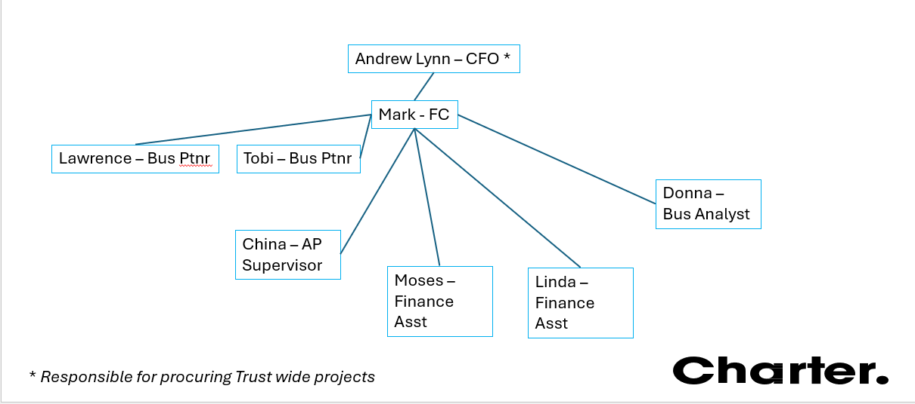

Appendix 2 – Typical Year End Timetable

Interim audit | June
Close Year end | September
Compile details of the prepared by client list | Sept to mid Oct
Commence audit | October half term
Report to Audit committee | 1st week December
Approval of accounts by Trust Board | 2nd week December

Appendix 3 – Mandatory Requirements
MANDATORY REQUIREMENTS
Requirement | Insert (x) into the appropriate box
Please confirm that you can meet the specification. | YES (PASS)
Please confirm that you can meet the specification. | NO  (FAIL)
Prices tendered must include all costs associated with delivering the service including all labour costs.  There must be no additional charges either quoted or added to invoices.  Please confirm your acceptance. | YES (PASS)
NO
(FAIL)
All charges/prices must be expressed in pounds sterling and shall be exclusive of VAT.  Please confirm your acceptance. | YES (PASS)
NO
(FAIL)
The Customer reserves the right to reject any submissions where prices are deemed unsustainable.  Please confirm your acceptance. | YES (PASS)
NO
(FAIL)
The bidder can make the presentation stage on either 18 or 19 March on location in East Dulwich.  Please confirm your acceptance. | YES (PASS)
NO
(FAIL)

