REQUEST FOR QUOTE; RFQ

Provision for Lee Valley White Water Centre Bridge Repairs
Contract Reference: LVRPA2025/04

NAME OF TENDERER:

Lee Valley Regional Park Authority

- Introduction AND BACKGROUND
  - The Requirement
  - Lee Valley Regional Park Authority (hereinafter “the Authority”) has a requirement for the repair of 3 x bridges at the White Water Centre, Station Road, Waltham Cross, EN9 1AB, more particularly defined in the Specification set out in SCHEDULE 5.
  - You are invited to submit a Proposal in response to the contents of this Request for Quotation (hereinafter “RFQ”).
  - This document sets out the information and instructions for the submission of Proposals. Bidders should refer to and must comply with the specification at SCHEDULE 5 when responding to this RFQ.
  - The Authority will be the contracting authority for the purposes of any Contract resulting from this RFQ. This Procurement is conducted as a below threshold procurement for the purpose of procuring the Works.
  - Certain words in this RFQ are capitalised. These are defined in the Glossary at Schedule 6.
  - Background Information
    - The Lee Valley Regional Park Authority was established by Act of Parliament in 1966 (the “Act”). It has a statutory duty to develop, improve, preserve and manage for the purposes of recreation, sport, entertainment and the enjoyment of leisure an area adjoining the River Lea. The Act requires the Authority to protect and enhance the environment and biodiversity, to create public open space for leisure and recreation and to deliver sports facilities of regional significance.
    - The Park is a unique entity, extending over 26 miles along the course of the River Lea, from the banks of the Thames in the heart of east London, extending through the site of the 2012 Olympics, on through north London and into Hertfordshire and Essex before ending in Ware, Hertfordshire. In all, the Park includes some 10,000 acres of land of which the Park Authority owns and manages some 4,000 acres.
    - The Authority currently owns a number of world class sporting venues, outstanding parklands, internationally valuable wildlife sites and a host of recreation facilities and visitor attractions. Our venues and open spaces attract more than 6 million visitors a year.
    - Further information on Lee Valley Regional Park Authority can be found at: www.leevalleypark.org.uk
  - The National Procurement Policy Statement
    - The Authority has had regard to the National Procurement Policy Statement in the design of this Procurement.
  - The Authority’s Requirement
    - The Authority has a requirement for the repair and painting of 3 x bridges at The Lee Valley White Water Centre. The bridges are suffering from the normal effects of wear and tear and need some miscellaneous repairs. Some of the paintwork on and under all of the bridges looks jaded, and in certain areas is missing or flaking. This in turn has led to certain areas of bare metal interacting with the elements, such as wind / rain / splashes from the white-water course, and some rusting has started to occur. Please reference the full specification annexed at SCHEDULE 5.
  - The Contract
    - The successful Bidder will be required to enter into the Authority’s Contract. Set out at SCHEDULE 5.
    - The Authority is not able to accept any alternative forms of contract.

  - Value of the Contract
    - The Authority has a fixed budget of £85,000 for this Proposal for the full duration of the Contract. If a Bidder’s Proposal exceeds this budget, the Bidder’s Proposal will not be eligible to be awarded the Contract.
  - Contract term
    - The Contract(s) will be offered on a basis of:
      - 10 weeks.
    - The anticipated commencement date of the Contract is Friday 1st August 2025.
- TERMS AND CONDITIONS OF THIS Request for QUOTation
  - The following terms and conditions set out how the Authority will conduct and how the Bidder will participate in the Procurement. By submitting a Proposal, Bidders agree to be bound by these terms and conditions.
  - The Authority may require Bidders to confirm that their Proposal remains accurate at any stage of the Procurement and to take appropriate action should that no longer be the case.
  - Bidders must submit their completed Proposal using the In-Tend portal by Tuesday 10th June 2025 @ midday.
  - A completed Proposal must include:
    - A completed Bidder Questionnaire (SCHEDULE 1).
    - Your Written Quality Submission (SCHEDULE 2).
    - Your Pricing Submission (SCHEDULE 3).
      - Your Pricing Submission must be in pounds sterling.
      - Bidders must provide a fixed price quote and breakdown of all costs for the delivery of the Works to the Authority including all costs and expenses (excluding VAT).
    - Your Form of Proposal (SCHEDULE 4).
The Authority’s minimum requirements
  - In the award of a Contract, the Authority may consider any relevant information on the Debarment List about the Bidder and any identified subcontractor, subconsultant, group or consortium member which the Bidder intends to rely upon to perform the Contract (each a ‘Relevant Entity’). The Authority may disqualify a Bidder if the Bidder or a Relevant Entity has been entered onto the Debarment List having regard to the reasons for the debarment.
  - To be eligible to be awarded a Contract, the Bidder must meet certain minimum requirements. The successful Bidder will be required to maintain the minimum requirements for the duration of the Contract as set out below:
    - Public Liability: £10,000,000
    - Public Indemnity: £1,000,000
    - Employers Liability: £5,000,000
  - Bidders will also be required to comply with the following minimum requirements to participate in this Procurement and the awarded Contract:
    - The Authority requires that all contractors who submit tenders for these works are already Constructionline registered.
  - Proposals must be completed and submitted in their entirety via In-tend by the deadline set out in the Procurement Timetable at section 2.9.
The Procurement Timetable
  - Set out below is the proposed indicative Procurement timetable for the award of the Contract. The Procurement Timetable is given below but may be changed by the Authority at any time. Any changes to the timetable will be communicated to Bidders via In-Tend as soon as practicable.
Event | Date
Request for Quote (RFQ) Advertised | Tuesday 6th May 2025
Deadline for Clarifications and Queries | Tuesday 3rd June 2025 @ Midday
Deadline for Receipt of Electronic Submissions | Tuesday 10th June 2025 @ Midday
Submission Evaluation Period | Wednesday 11th June – Tuesday 8th July 2025
Award Notifications | Thursday 10th July 2025
Voluntary Standstill Period | Thursday 10th – Tuesday 22nd July 2025
Contract Commencement | Friday 1st August 2025

  - The Authority may at any time amend this RFQ, suspend or terminate the Procurement or procure the Contract by other means, to award a contract without prior notice, to change the basis, the procedures and the timescales set out in this Procurement.
Clarifications or Queries relating to the Procurement
  - Any questions or other requests for information in relation to this requirement should be submitted via the In-Tend portal by the deadline for Clarifications and Queries set out in the Procurement Timetable – Tuesday 3rd June 2025 @ midday.
Bidder must keep its information up to date
  - The Bidder is responsible for maintaining and ensuring any information supplied to the Authority (whether through the Central Digital Platform or In-Tend) is kept up to date. The Bidder must notify the Authority of any changes to the information supplied immediately. The Authority reserves the right to request any additional information or disqualify a Bidder from the Procurement where the updated information affects the Bidder’s Proposal.
Not An Offer
  - By issuing the RFQ, the Authority is not bound in any way and does not have to accept any Proposal. The Authority is not obliged to accept the lowest priced Proposal.
The Authority is not responsible for costs
  - Bidders are solely responsible for their costs and expenses incurred in connection with the preparation and submission of their Proposals and any further stages of the Procurement. Under no circumstances (including circumstances where the Authority cancels or varies the Procurement) will the Authority or any of its advisers be liable for any costs or expenses borne by the Bidders or their advisers.
Errors in Proposal submissions
  - The Authority has no liability to Bidders arising from any errors in a Bidder’s Proposal or if the Authority does not identify or notify a Bidder of an error in a Bidder’s Tender.
Disqualification for inducement
  - The Authority reserves the right to disqualify (without prejudice to any other civil remedies available to the Authority and any criminal liability which such conduct may attract) any Bidder who does anything which would constitute a relevant breach of the Bribery Act 2010 or attempts (or whose advisers attempt) to influence the Procurement in any way.
Disqualification for collusion
  - The Authority reserves the right to disqualify any Bidder:
    - who enter into any agreement or arrangement with any other person as to the form or content of any other Proposal, or offer to pay any sum of money or valuable consideration to any other person to effect changes to the form or content of any other Proposal; or
    - who enter into any agreement or arrangement with any other person that has the effect of prohibiting or excluding that person from submitting a proposal, or affect the price submitted in the Proposal by the Bidder or any other person.
Validity of your Proposal
  - Proposals must remain valid and capable of acceptance for 90 days from the closing date for receipt of Proposals.
Request for Information by the Authority
  - The Authority reserves the right to request any information in relation to a Bidder’s Proposal at any time during the Procurement, including but not limited to:
    - documentary evidence relating to those aspects of the Bidder’s Proposal which are based on self-certification;
    - documentary evidence on the Bidder’s eligibility to tender and qualifications; or
    - financial data, such as audited accounts.
  - The Bidder must provide the requested information within 5 working days of the Authority’s request unless otherwise specified by the Authority.
Variant Proposals
  - Bidders who submit a variant Proposal will be disqualified. A bidder which attempts to amend the Contract will be disqualified.
Publicity
  - Bidders are not permitted to undertake any publicity activities regarding the Works or the award of any Contract during the Proposal without the prior written approval of the Authority.
Abnormally low proposals
  - If it appears to the Authority that any Proposal may be abnormally low, then the Authority may ask the Bidder to explain its price or costs. If following the Bidder's explanations, the Authority is not satisfied with the Bidder's account for the low level of price or cost in the Proposal, the Authority may treat the Proposal as non-compliant and disqualify it.
Confidentiality and Freedom of Information
  - The Authority is required to publish certain contracts in accordance with its transparency obligations.
  - If a Bidder considers part of its Proposal is commercially sensitive, it should inform the Authority via In-tend and:
    - identify any such information as commercially sensitive;
    - explain the potential implications of disclosure of such information; and
    - provide an estimate of the period of time during which the Bidder believes that such information will remain commercially sensitive.
  - If a Bidder identifies information as commercially sensitive in accordance with 2.25 above, the Authority will try to maintain confidentiality over it. However, notwithstanding the Bidder has identified information as commercially sensitive, the Authority:
    - Routinely publishes the details of its contracts and the identities of its suppliers on its website in its contract register. Contracts register | Lee Valley Regional Park Authority;
    - is subject to the Environmental Information Regulations 2004 and has adopted the processes in the Freedom of Information Act 2000 and all information supplied to the Authority may be disclosed in response to a request made pursuant to the Freedom of Information Act 2000 or the Environmental Information Regulations 2004;
    - is required to publish information relating to the Contract in accordance with Government policy on the disclosure of information relating to public contracts.
    - may disclose the content of any references sought from banks, existing or past clients, or other referees submitted by the Bidder to other contracting authorities (as defined by Procurement Act 2023); and
    - may disclose within the Authority and to other contracting authorities any Proposal documents or information in them to assist performance monitoring and enforcement of the Procurement Act 2023.
  - All information supplied to Bidders by the Authority, including this RFQ and all other documents relating to this Procurement, either in writing or orally, must be treated in confidence (unless the information is already in the public domain) and must not be disclosed to any third party other than is strictly necessary for the purposes of preparing a Proposal.
  - The Authority is required to publish contracts in accordance with its transparency obligations. The Authority may, at its sole discretion, redact some sections to protect commercially sensitive information or other information which it considers inappropriate to publish. The successful Bidder may specify information it wishes to be redacted in the Commercially Sensitive Information schedule of the Contract.
Third Parties

  - Nothing in these terms is intended to confer any rights on any third party under the Contracts (Rights of Third Parties) Act 1999.
Disqualification

  - The Authority reserves the right, at its discretion, to reject or disqualify a Bidder where:
    - a Bidder contravenes any of the terms and conditions of this Procurement;
    - the Proposal is submitted late, completed incorrectly, is in any way incomplete or fails to meet the requirements which have been notified to Bidders;
    - the Bidder no longer meets the Authority’s minimum requirements;
    - the Bidder is guilty of serious misrepresentation or of negligently providing misleading information in relation to its Proposal or the Procurement;
    - the Bidder has obtained an unfair advantage, either through participation in market engagement or through a conflict of interest, that cannot otherwise be avoided; or
    - the Bidder breaches the terms and conditions for use of In-Tend.
- BIDDER QUESTIONNAIRE
  - Bidders must complete the Bidder Questionnaire in SCHEDULE 1 and submit as part of their Proposal.
- EVALUATION AND CONTRACT AWARD
  - Any Contract awarded as a result of this Procurement will be awarded on the basis of the offer that is the most advantageous proposal to the Authority. Proposals will be evaluated on:
    - The Written Quality Submission, weighted 40%; and
    - The Price Submission, weighted 60%.
Evaluation of the Written Quality Submission
  - Bidders must complete SCHEDULE 2 (Written Quality Submission). The following matrix will be used to assess the Written Submission.
Assessment | Score | Marking Criteria
Unacceptable | 0 | The information required is either omitted or fundamentally fails to meet and address the relevant submission requirements or there is insufficient demonstration of the Authority’s requirements to enable the Authority to evaluate.
Weak | 1 | The information submitted provides a demonstration that a minority of the Authority’s requirements relevant to the question can be met. The Authority has major concerns.
Poor | 2 | The information submitted provides a demonstration that that a majority but not all of the Authority’s requirements relevant to the question can be met. The Authority has some major concerns.
Acceptable | 3 | The information submitted provides a demonstration that all the Authority’s requirements relevant to the question can be met subject to minor concerns. The Authority has no major concerns.
Good | 4 | The information submitted provides a demonstration that all the Authority’s requirements relevant to the question can be met. The Authority has no concerns.
Outstanding | 5 | The information submitted provides a demonstration that all of the Authority’s requirements relevant to the question can be met. The bidder’s proposal adds value which is relevant to the Contract. The Authority has no concerns.

  - The Written Quality Submission will be evaluated by using a weighted scoring system with 100 marks available, and the highest scoring Written Quality Submission will be awarded 100 points.
All other tenders are scored:
Highest Quality / 100 x Tenderer Quality Mark = Quality Score
This Quality Score is weighted as per the tender evaluation (e.g. 50%) to give a project Quality Weighting x Quality Score.
Example:
Tender A: Scored 95 marks Tender B: Scored 80 marks
Tender A = 100 points Tender B = 100 x 80 / 95 = 84.21 points
Project Quality weighting = 50%
Tender A total Quality score is 100 x 50% = 50%
Tender B total Quality score is 84.21 x 50% = 42.10%
  - The total qualitative score of 40% will be evaluated under the headings shown in the table below:
EVIDENCE | 50%
METHODOLOGY | 20%
RISK | 20%
SOCIAL VALUE / SUSTAINABILITY | 10%
TOTAL | 100%

The Price Submission
  - The price submitted must be inclusive of all costs payable by the Authority under the Contract. Bidders must complete SCHEDULE 3 (Pricing Submission).
  - The Price Submission will be evaluated by awarding the lowest price tender 100 points.
All other tenders are scored:
Lowest Price / 100 x Tender Price = Price Score
The Price Score is weighted as per the tender evaluation (e.g. 50%) to give a project Price Weighting x Price Score.
Example:
Tender A: £30,000 Tender B: £35,000
Tender A = 100 points Tender B = 100 x 30,000 / 35,000 = 85.71 points
Project Price weighting = 50%
Tender A total price score is 100 x 50% = 50%
Tender B total price score is 85.71 x 50% = 42.86%

- AWARD OF CONTRACT AND NOTIFICATION
  - Once the Authority has reached a decision in respect of a contract award, it will notify all bidders of that decision.
  - Contract award is subject to the formal approval process of the Authority. Until all the necessary approvals are obtained and the standstill period completed, no Contract(s) will be entered into.

BIDDER QUESTIONNAIRE
ORGANISATION DETAILS
Registered and Trading Name of the organisation:

What is your central digital platform unique identifier?
Trading Address:

Town/City:

Post/Zip Code:

Country:

Website:

Contact Name for enquiries about this Tender: *Representative(s)

Position:

Telephone Number:

Email Address (if available):

Website Address (if any):

STATUS
Is your organisation:  (Please tick/mark a minimum of one) | A Sole Trader?
 | A Partnership?
 | A Limited Company?
 | A Public Limited Company?
 | A Local Authority DSO?
A Charity?
(If so, please provide the number)

STATUS
Formation/Registration date:

Place of registration:

Registration number (if any) and registered address:

Certificates enclosed: |  |  |  | Yes No
VAT registration number:

Provide details of any proposed sub consultants/contractors to be used or as part of a group or consortium, including their company name(s), address(es) & Registration number(s).

For each proposed subconsultant, subcontractor, group or consortium member, provide their central digital platform unique identifier or state ‘not registered’, as applicable.

Are any of your proposed sub consultants / contractors, or any member of your group or consortium, on the Debarment List?  This includes Associated Persons and Connected Persons (see Glossary) |  |  |  | [Insert Yes or No]  [If yes, insert details]
Are you applying to be considered for inclusion on the selected tender list under a different name? |  |  |  | Yes No
If so, please list the name(s) of the other trading company:
Are you on the Debarment List? |  |  |  | [Insert Yes or No]  [If yes, insert details]
DETAILS OF HOLDING AND PARENT COMPANY
Is the applicant a subsidiary of another company as defined by the Companies Act 1985? |  |  |  | Yes No
If ‘Yes’ give the following details in respect of the Holding Parent company:

Name:

Registered Office Address:

Registration Number:
ECONOMIC AND FINANCIAL STANDING
INSURANCE
Please provide your insurance details and indicate the level of cover you have currently in force, including details of the issuing company, policy number, cover provided and renewal date(s).
NB: If your organisation is successful, the mandatory insurance levels stated below will be required
Can you confirm that your company as Bidder will have the following levels of insurance cover in place should you be successful in Tendering for this requirement?  (You are required, as a minimum, to provide supporting evidence from your insurance company which confirms that these levels can be obtained by your organisation)  Public / Product Liability: £10,000,000  Public Indemnity: £1,000,000  Employers Liability: £10,000,000 |  |  |  | [Insert Yes or No]  [Insert details of your insurances already in place]  [Insert details of your insurances which would be obtained following contract award (including information on how you will obtain this insurance – e.g. a quote)]  Yes No
Are there any outstanding claims against you (other than routine employment cases)? |  |  |  | [Insert Yes or No]  [Insert information]
Please provide details of your organisation’s financial figures for the three previous financial years (or for the period of your organisation’s existence if shorter):
FINANCIAL PERIOD(S): |  |  | [F/Y 2021/22] | [F/Y 2022/23] |  | [F/Y 2023/24]
Q1 | Bidder’s Turnover | £
Q2 | Bidder’s Profit after Tax | £
Q3 | Bidder’s Current Assets | £
Q4 | Bidder’s Current Liabilities | £
Q5 | Applicant’s Fixed Assets | £
Q6 | If requested would you be able to provide a banker’s reference?
 | Yes No
PROJECT SPECIFIC REQUIREMENTS
Are you Constructionline certified? |  |  |  |  | [Insert Yes or No]

I confirm that:
- to the best of my knowledge the answers submitted, and information contained in the Bidder Questionnaire are complete, accurate and not misleading
- upon request and without delay I will provide any additional information requested of us
- I understand that the response to the Bidder Questionnaire will be used as part of the Authority’s assessment and decision to award a Contract
- I understand that our organisation may be disqualified from the Procurement if requested information has not been provided, if any of this response or any follow up responses are incomplete, inaccurate or misleading, if confidential information has been accessed or if we have unduly influenced your decision-making in this Procurement

Signed
Date
Name
Role
Phone number
Email
Postal address

Written QUALITY Submission

QUESTION | WEIGHTING | RESPONSE
- EVIDENCE:  Please provide evidence of 2 x similar repair projects undertaken by your company within the last five years. Specifically demonstrate how you dealt with the Health and Safety aspect and include dates, addresses, and contract value. | 50%
- METHODOLOGY:  Please outline your proposed methodology and approach for the completion of this project. Refer to the particular risk involved given you will be working above fast-moving water at times. | 20%
- RISK:  Please outline any potential risks on this project and how these will be mitigated. Please note – do not reference generic construction | 20%
- SOCIAL VALUE / SUSTAINABILITY:  Please provide at least 2x examples of how your company demonstrates its ethos and commitment towards social value and sustainability. Examples can also relate to things that your company does within your local community. We require 1x example regarding social value, and 1x example regarding sustainability. | 10%

PRICING SUBMISSION

PRICING SCHEDULE (EXCLUDING VAT)

Project Title: Provision for Lee Valley White Water Centre Bridge Repairs
Contract Reference: LVRPA2025/04

To provide, as detailed within SCHEDULE 5, repairs to 3 x bridges at Lee Valley White Water Centre.

Please complete the below:
PROVISION(S) as per SCHEDULE 5: Specification for Repair | UNIT COST(S) | TOTAL COST(S)
1
2
3
4
5
6
7
8
9
10
11
12
13
14
15
16
17
18
Total for Fixed Price: £

TOTAL FIXED PRICE: £………………………….

Date:
Print name:
Email:
Signed:
For and behalf of:

FORM OF PROPOSAL

CONTRACT REFERENCE: LVRPA2025/04
FORM OF PROPOSAL: PROPOSAL CERTIFICATE
TO: LEE VALLEY REGIONAL AUTHORITY
DATE: [DATE]
PROVISION FOR Lee Valley White Water Centre Bridge Repairs
REFERENCE NUMBER: [CONTRACT NOTICE REFERENCE NUMBER]
We [INSERT NAME[S]] the undersigned, having examined the RFQ and all other schedules, do hereby offer to provide the repair of 3 x bridges at the White Water Centre, Station Road, Waltham Cross, EN9 1AB as specified in those documents and in accordance with the attached documentation to the Authority commencing [Contract commencement date] and continuing for the period specified in the Contract.
We further undertake and it shall be a condition of any Contract, that:
- The amount or content of [my OR our] Proposal has not been devised or calculated by agreement or arrangement with any person other than the Authority and that the content or amount of [my OR our] Proposal has not been communicated to any person until after the closing date for the submission of Proposals and in any event not without the consent of the Authority.
- We have not canvassed and will not, before the evaluation process, canvass or solicit any member or officer, employee or agent of the Authority or other contracting authority in connection with the award of the Contract and that no person employed by us has done or will do any such act.
- We have not offered, promised or given any person working for or engaged by the Authority a financial or other advantage as an inducement or reward for any improper performance of a function or activity relating to this procurement.
We warrant that we have all requisite authority to sign this Proposal and confirm that we have complied with all the requirements of the RFQ.
Signature | _______________________________________________
Name and status | _______________________________________________
Signature | _______________________________________________
Name and status | _______________________________________________
For and on behalf of | [NAME OF COMPANY, PARTNERS OR CONSORTIUM]

REQUIREMENT SPECIFICATIOn:
Lee Valley White Water Centre, EN9 1AB: Bridges 1/2/3 – Specification for repair & some misc. painting of site-specific handrails. Prepared by Lee Alaba

BRIDGE ID NO.183 (BRIDGE NO.1)
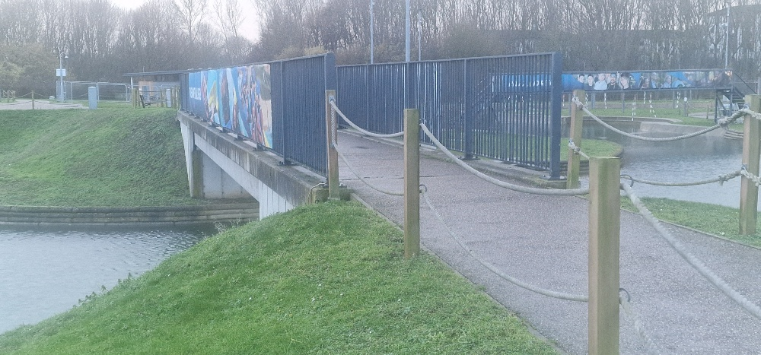

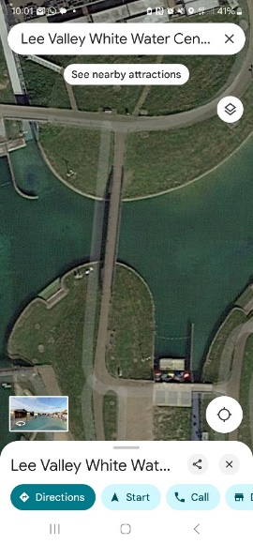
BRIDGE ID NO.184 (BRIDGE NO.2)
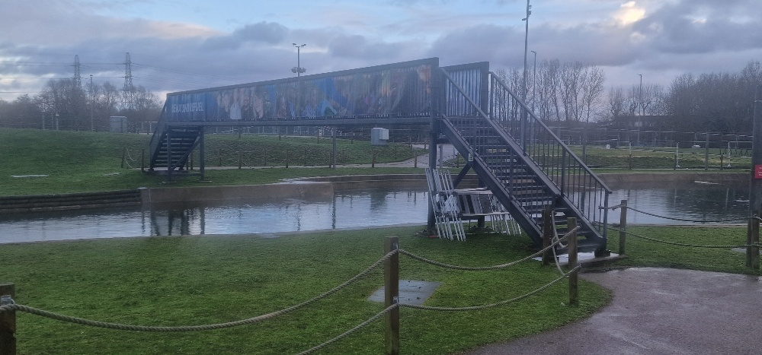
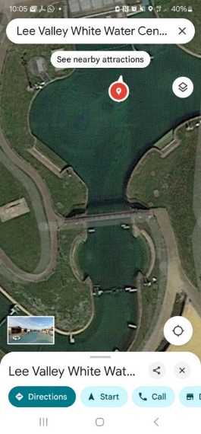

BRIDGE ID NO.180 (BRIDGE NO.3)
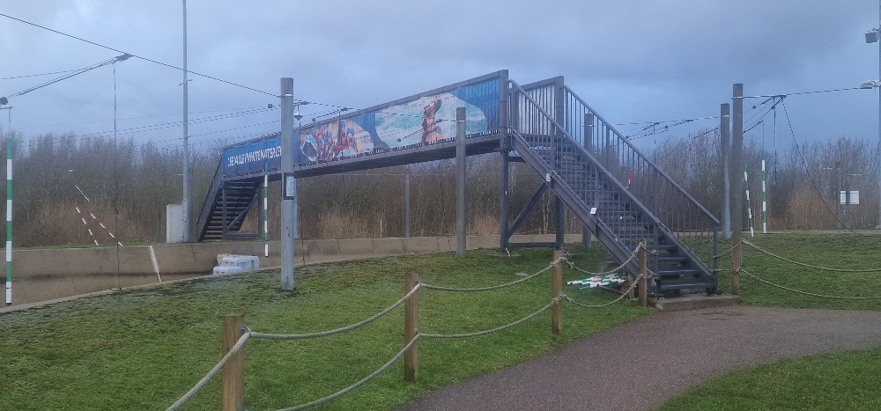

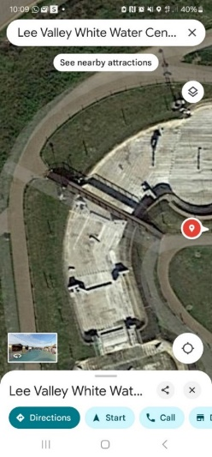

- OUTLINE:

Bridge no.183 will be referred to as Bridge no.1 within the context of the proposed maintenance works as outlined in this document.

Bridge no.184 will be referred to as Bridge no.2 within the context of the proposed maintenance works as outlined in this document.

Bridge no.180 will be referred to as Bridge no.3 within the context of the proposed maintenance works as outlined in this document.

The above-mentioned bridges are suffering from the normal effects of wear and tear and require some miscellaneous repairs. Some of the paintwork on and under all three bridges looks jaded and in certain areas is missing or flaking. This has led to certain areas of bare metal interacting with the elements, such as wind / rain / splashes from the white-water course underneath which has resulted in some rusting starting to occur. Such items will be included within this specification and will need to be treated with a suitable, approved, rust remover solution.

2.0 LOCATION & SITE VISITS:

The 3 x Bridges have location numbers 183 / 184 / 180 and are all located within the Lee Valley White-Water Centre, Station Road, Waltham Cross, EN9 1AB. All contractors MUST arrange a site visit to ascertain the site conditions and nature of the works required before tendering. This can be arranged directly through the Project Lead - Lee Alaba at Lee Valley Regional Park Authority lalaba@leevalleypark.org.uk / 07471 149 063.

3.0 SITE SPECIFIC PROBLEMS:

- There are areas of missing or flaking paint in different areas of the bridges including under the bridge, which unfortunately makes access for essential maintenance slightly problematic.

- There are areas of rusting under the bridge.

- Puddling is starting to occur on the topcoat of the walkway in several different places.

- Some of the paint is starting to flake and peel off the metalwork on the handrails, balustrades, and under associated stairs & bridges. These areas need to be thoroughly checked and redecorated where required.

- All of the treads need to be checked to ensure the anti-slip features are still intact as in certain areas this material has become loose.

- Weep holes need to be drilled along the walkway at regular 1m intervals to help to disperse sitting water.

4.0 SPECIFICATION FOR REPAIR:

Item | Description | Price
4.1 | The contractor is to undertake their own site measurements in order to provide an accurate quote. Only the bridge tops, sides and steps/handrails will be painted at this stage and NOT the undersides of the bridges (to be undertaken by others at a later date). The underside elements of the bridges will not form part of these works due to logistical difficulties.
4.2 | Erect all necessary access equipment in order to carry out the works in a safe manner.
4.3 | Provide signage and barriers to close the bridge (both sides) to the general public for the duration of the works. Allow for signage to be placed on access paths either side of bridge advising of closure and the contract periods involved. Siting to be agreed, allow 10x signs for tendering purposes.
4.4 | It is envisaged that when these works commence, the bridges will be completed one at a time. With an under-bridge tarpaulin set up to catch any falling debris. It is very important that no falling debris, materials, or tools find their way into the course water below.
4.5 | The above-mentioned tarpaulin / canvass material must not reduce the headroom of the bridges (i.e.the underhang) by more than 400mm to minimise any disruption to the canoeists using the course. In addition, any large tarpaulin must be secured very well so that there can be no chance of any canvas blowing away due to potentially strong winds.
4.6 | It is essential that the headroom for the canoeists using the course below is not restricted by more than 400mm due to the course being in use whilst the above-mentioned bridge maintenance works are taking place. To be clear, this means that at times there will be rapidly flowing water beneath the work area and at other times there will be no water at all, simply the concrete channel.
4.7 | Rub down, prime any bare metal, treat any rust with proprietary inhibitor, and paint one full undercoat and two full gloss coats to all previously painted metal surfaces. Paint system to be Dulux Trade Weathershield Exterior. Please be aware that the bridges paint colour is RAL 9007 – Grey Aluminium.
4.8 | Strip up and remove from site any existing surfacing to Bridge No.3 that’s in a poor condition. Remove any old & failing or lifted walkway surface including all trims and fixings. Leave ready to receive new surfacing floor layer. Please discuss any relevant observations with the Project Lead, Lee Alaba.
4.9 | Supply and fix new resin deck finish with anti-slip properties to the walkway surface where needed. This proposed new surface must be an anti-slip standard surfacing layer or similar approved. All to be fixed in accordance with manufacturer’s instructions.
4.10 | Undertake some water testing with a large bucket of water – by throwing it onto the bridge walkway surface to show where any pooling or puddling is occurring.
4.11 | And after this process – please drill small weep holes 7mm in diameter to help to disperse any pooling water. The weep holes need to be located at regular intervals as close to every 1m.
4.12 | Please check the miscellaneous areas of this bridge, especially under the 1st base plate – on top of the padstone (where relevant) to see if there is any breaking up of the concrete fillets surrounding what is protecting the metalwork from potential rusting. Please chip away any loose concrete and apply new concrete that has a suitable plasticiser element included within its mixture.
4.13 | Please also provide within your quote a separate unit figure for 86m linear metres (30m + 22m + 34m referred to on the photos below) of miscellaneous handrail to be redecorated on both sides of the 1m high handrail in various areas within the White Water Centre. Please discuss any proposed handrail areas earmarked for decorating with the Project Lead, Lee Alaba. Allow for 86 linear metres.
4.14 | The above-mentioned railings that need to be redecorated are indicated on the site plan/map of this site and will be labelled for reference purposes as R1 / R2 / R3.
4.15 | Work very closely with not only the Project Lead, Lee Alaba lalaba@leevalleypark.org.uk but also with the White Water Centre management to ensure the minimum amount of disruption to the Centre itself whilst these proposed works are taking place.
4.16 | Clean and clear the site and remove any temporary barriers and signage and reopen the bridge for public usage.
4.17 | The contractor is to wear full PPE including a life jacket with buoyancy when visiting and inspecting this site.
4.18 | For every contractor visiting this site it is expected that they will follow the pre-existing protocol that everyone has to follow when entering beyond the roped off areas. The Project Lead, Lee Alaba and the Centre Manager will provide guidance on this issue.
 | TOTAL

5.0 PHOTO SCHEDULE (RAILING IMAGES):

The various railings that need redecoration have been broken down into 3x distinct and different areas for the purpose of this specification. These areas will be known as R1 / R2 / R3 on the accompanying White Water Centre bridge refurbishments marked-up map.

RAILING R1 IMAGES – 30 LINEAR METRES:

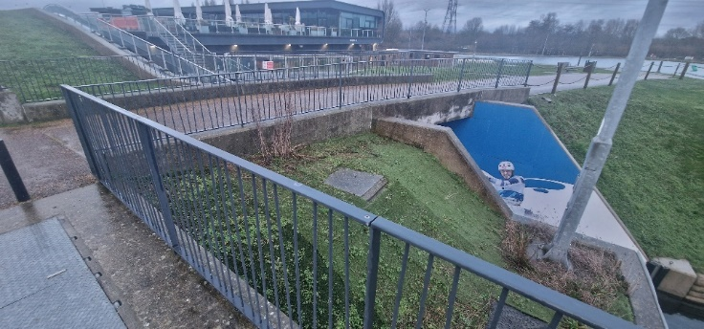
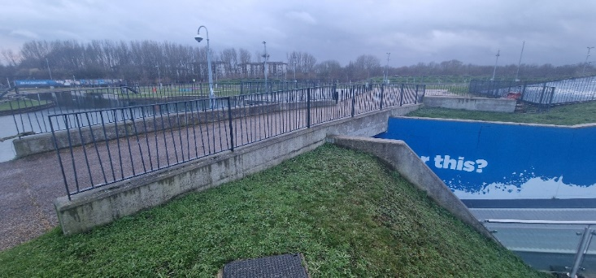

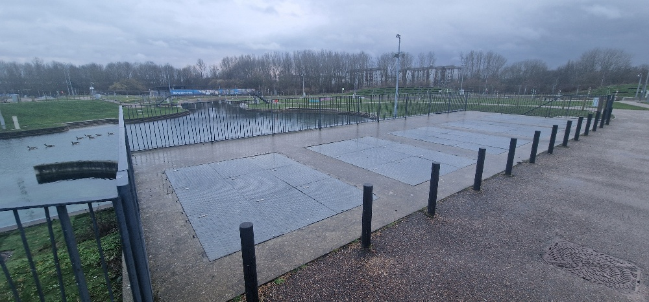
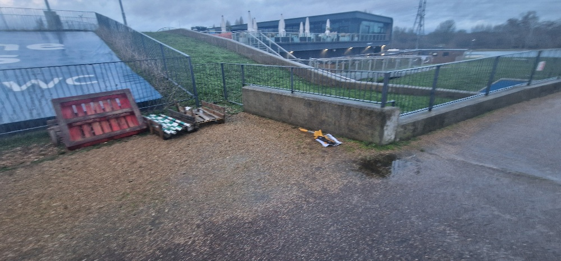
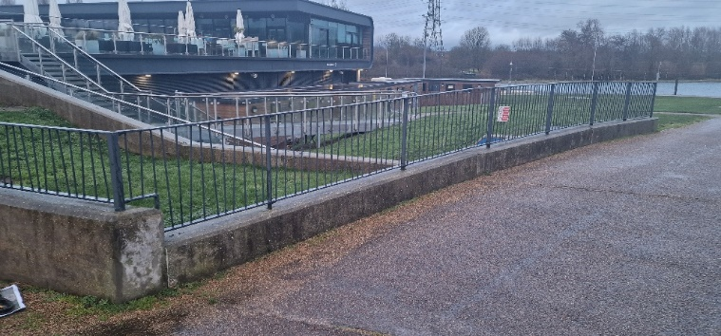
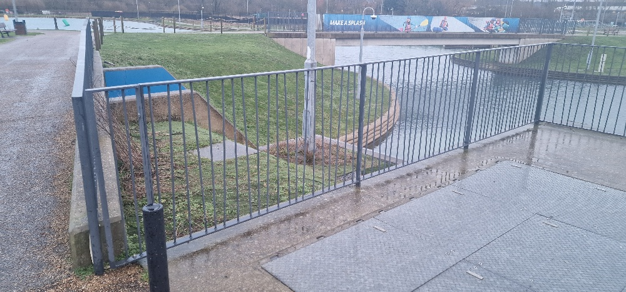
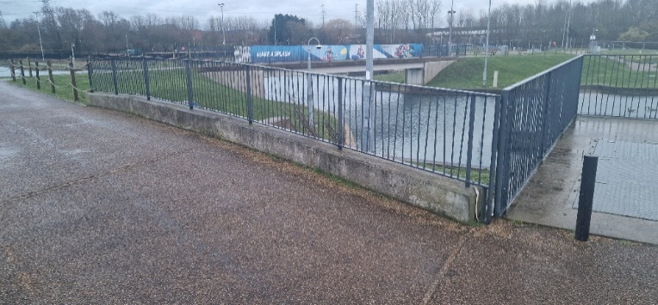

RAILING R2 IMAGES – 22 LINEAR METRES:
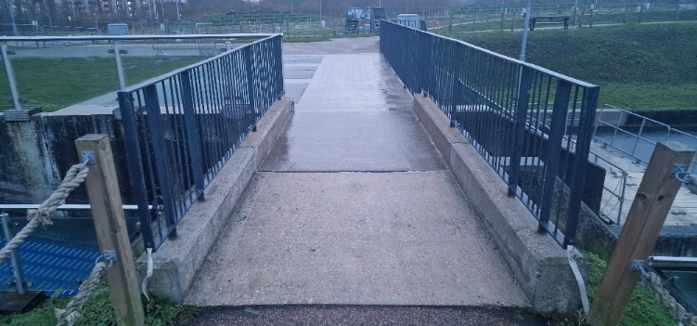
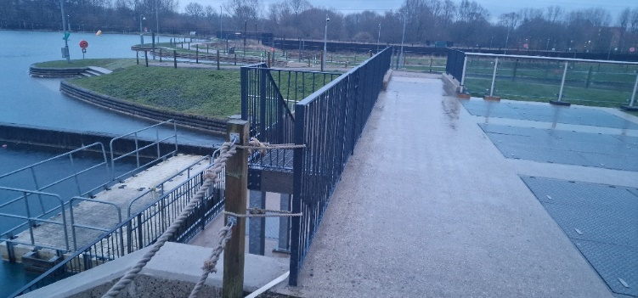
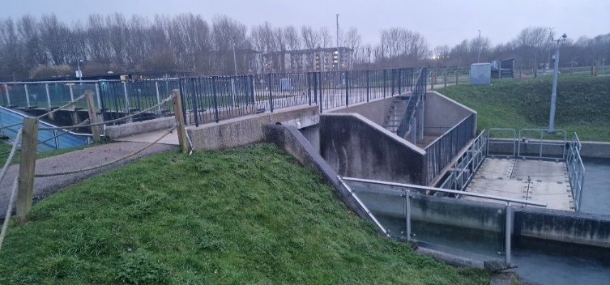
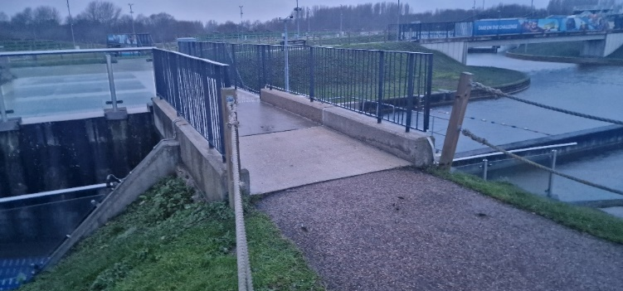
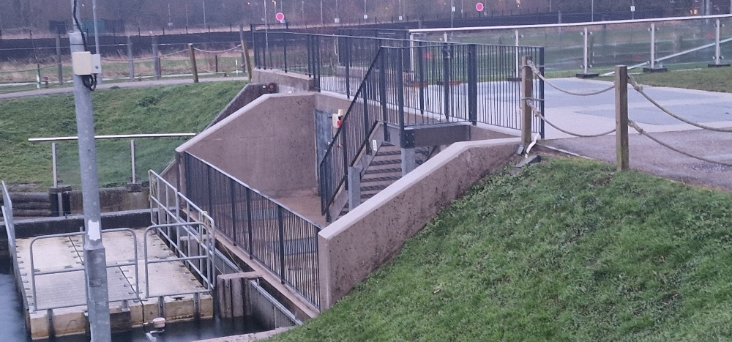
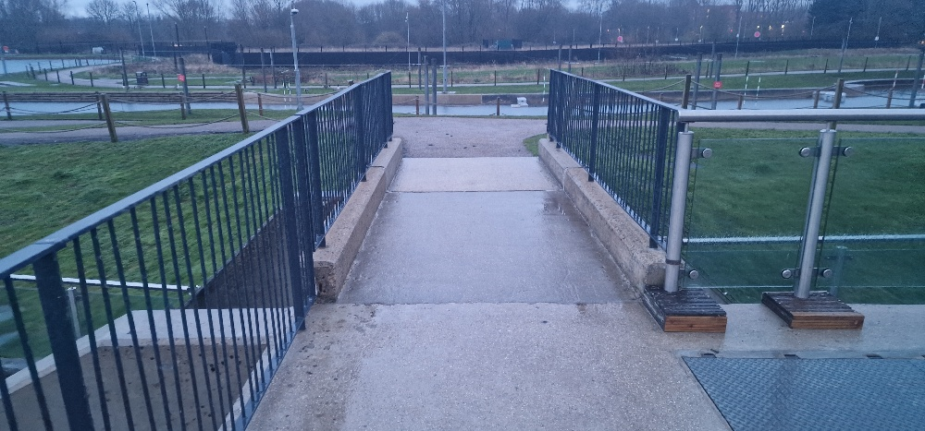
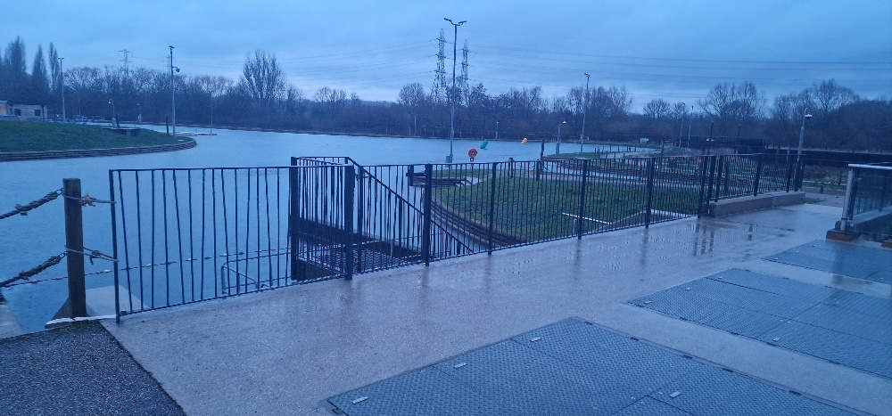
RAILING R3 IMAGES – 34 LINEAR METRES:
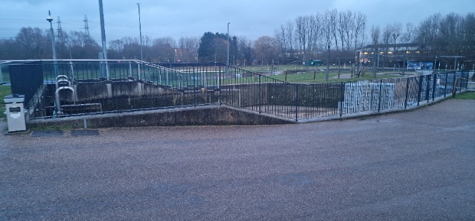
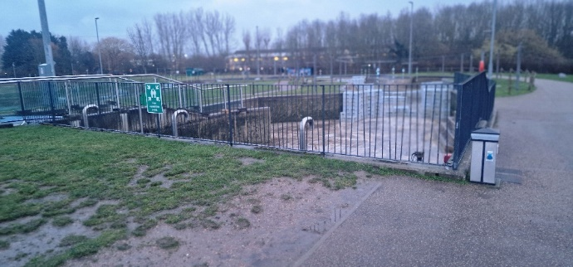
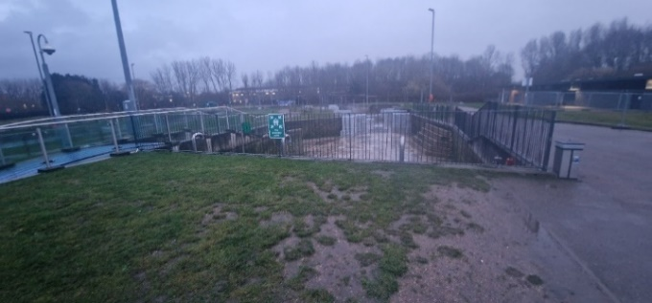

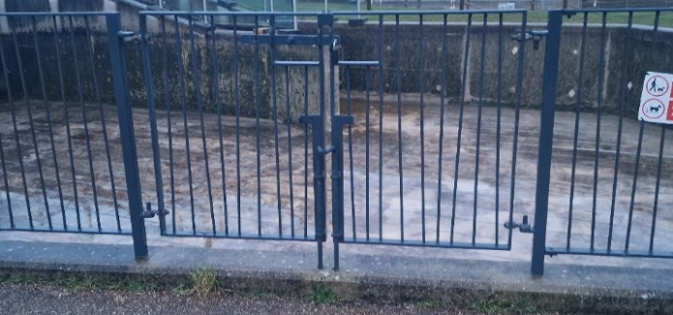
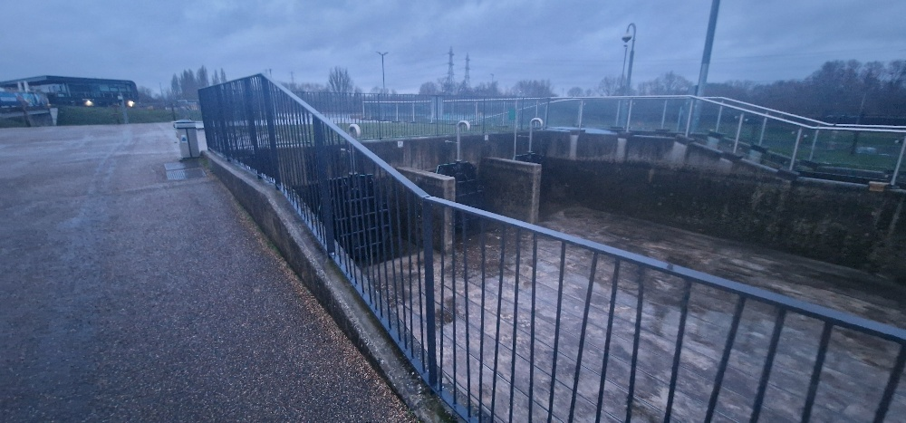
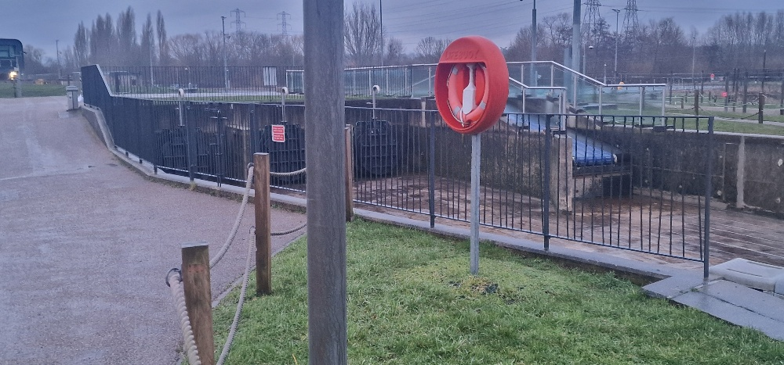
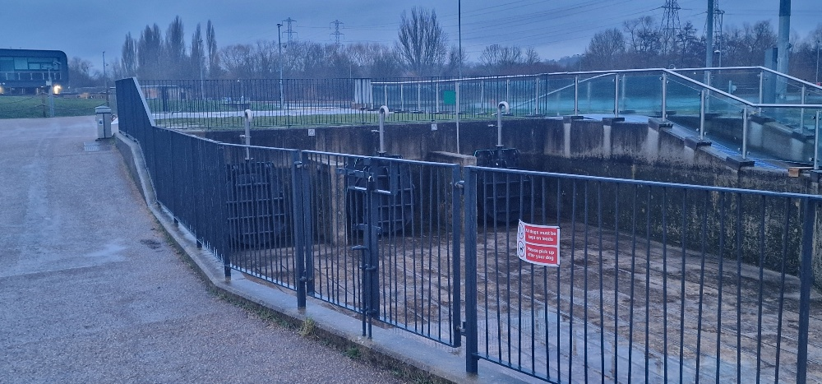
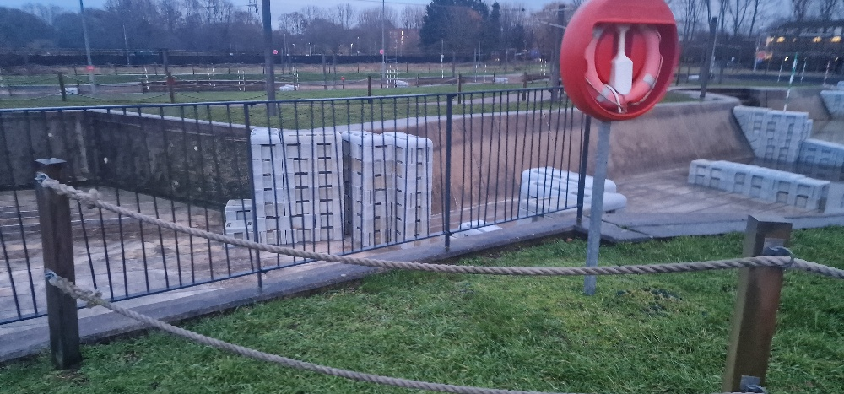

6.0 PREAMBLES / HEALTH & SAFETY:
Please note that the canoeing and rafting course will be fully operational and likely in use when these proposed works are due to take place. No debris or builders’ waste / tools can be dropped into the water either intentionally or by mistake. To prevent this from happening please ensure that you supply and fix a temporary barrier or layer, such as a large tarpaulin, to catch anything that may inadvertently fall from the working area.
Additionally, it is the responsibility of the contractors to allow for and make proposals regarding physical access to treat and paint the sides of the bridges over the waterway, and to make the necessary allowances regarding any restrictions that are applied.
There may be periods during these works when working on the sides of the bridges may have to be paused for a short while due to various on-course activities. It is envisaged that the contractor will use any downtime to work on the miscellaneous handrail R1 / R2 / R3 redecoration instead.
The successful contractor will be expected to produce a POW outlining how they propose to map out the works, including a timescale with workable dates. It is also expected that a full set of site-specific RAMS will be submitted.

7.0 LINK TO DRAFT WORKS CONTRACT: LVRPA2025/04 - DRAFT WORKS CONTRACT
- glOSSARY

Bidder(s) | Those (whether persons, firms or companies) tendering for the Contract.
Bidder Questionnaire | The requirements as set out at 3.1 and Schedule 1 of this RFQ.
Contract | The contract which is entered into by the Authority with the successful Bidder following this procurement as set at SCHEDULE 5 of this RFQ.
Debarment List | The list of suppliers as maintained in accordance with Section 62 of the Procurement Act 2023.
FOIA | Freedom of Information Act 2000.
RFQ | This Request for Quotation including all appendices and schedules.
Price Submission | The requirements as set out at 4.5 - 4.6 and Schedule 3.
Procurement | The procurement of the Works pursuant to Procurement Law in accordance with this RFQ.
Procurement Law | The Procurement Act 2023 and any regulations relating to procurement of goods, works and services to which the Authority must comply (as amended from time to time).
Procurement Timetable | The timetable setting out the key dates for this Procurement, as at Section 2.9 of this RFQ.
Proposal(s) | The proposal(s) submitted by the Bidder(s) in response to this RFQ.
Written Quality Submission | The requirements as set out 4.2 - 4.4 and Schedule 2 of this RFQ.
Works | As defined in the Contract set out in SCHEDULE 5 of this RFQ.

END OF DOCUMENT

